INTRODUCTION CHAPTER-1

Many technological developments occurred in the last

decade that has improvised the concept of precision farming. The adaptability of PF relies on the

integration and utilisation of modern days technologies such new advance farm technologies

with the single system site specific technologies. The technology varies from high speed

connectivity of internet, farmer awareness. PF is an integrated, information and agricultural

management system that is designed to improve the whole farm production efficiency with the

low cost effect while avoiding the unwanted effects of chemical loading to the environment. The

Agricultural production system is an outcome of a complex interaction of seed, soil, water and agro-chemicals (including fertilizers). Therefore, judicious management of all the inputs is essential for the sustainability of such a complex system. The focus on enhancing the productivity during the Green Revolution coupled with total disregard of proper management of inputs and without considering the ecological impacts, has resulted into environmental degradation. The only alternative left to enhance productivity in a sustainable manner from the limited natural resources at the disposal, without any adverse consequences, is by maximizing the resource input use efficiency. It is also certain that even in developing countries, availability of labour for agricultural activities is going to be in short supply in future. The time has now arrived to exploit all the modern tools available by bringing information technology and agricultural science together for improved economic and environmentally sustainable crop production. Precision agriculture merges the new technologies borne of the information age with a mature agricultural industry. It is an integrated crop management system that attempts to match the kind and amount of inputs with the actual crop needs for small areas within a farm field. This goal is not new, but new technologies now available allow the concept of precision agriculture to be realized in a practical production setting.

Many technological developments occurred in the last decade that has improvised the concept of Precision Farming (PF). The adaptability of this technique relies on the integration and utilisation of modern days technologies such new advance farm technologies with the single system site specific technologies. The technology varies from high speed connectivity of internet, farmer awareness. PF is an integrated, information and agricultural management system that is designed to improve the whole farm production efficiency with the low cost effect while avoiding the unwanted effects of chemical loading to the environment. The focus under PF is to gather information regarding the soil and crop condition and capture the sequence on the soil and crop conditions at spatial level.

Many technological developments occurred in the last

decade that has improvised the concept of precision farming. The adaptability of PF relies on the

integration and utilisation of modern days technologies such new advance farm technologies

with the single system site specific technologies. The technology varies from high speed

connectivity of internet, farmer awareness. PF is an integrated, information and agricultural

management system that is designed to improve the whole farm production efficiency with the

low cost effect while avoiding the unwanted effects of chemical loading to the environment. The

focus under PF is to gather information regarding the soil and crop condition and capture the

sequence on the soil and crop conditions at spatial level.

1.1 Motivation

Precision agriculture means application of precise and correct amount of inputs like water, fertilizer, pesticides etc. at the correct time to the crop for increasing its productivity and maximizing its yields. Precision agriculture management practices can significantly reduce the amount of nutrient and other crop inputs used while boosting yields. Farmers thus obtain a return on their investment by saving on phytosanitary and fertilizer costs. The second, larger scale benefit of targeting inputs in spatial, temporal and quantitative terms concerns environmental impacts. Applying the right amount of inputs in the right place and at the right time benefits crops, soils and groundwater, and thus the entire crop cycle. Consequently, precision agriculture has become a cornerstone of sustainable agriculture, since it respects crops, soils and farmers. Sustainable agriculture seeks to assure a continued supply of food within the ecological, economic and social limits required to sustain production in the long term. Precision agriculture therefore seeks to use high-tech systems in pursuit of this goal.

In a developing country like India the use of precision farming can help to boost the economic growth in agriculture via substantial increase in crop yield. The overall cost and infrastructure needed to meet this goal still seems a challenging task to be accomplished. We therefore decided to build an end-to-end solution for precision farming by building a low cost system.

**1.2 System Overview:**

**We aim to design a low cost system to solve the problems discussed above and help the farmers gain better insights of the farms.The system consists of image capturing of the farm by the drone. These images are then uploaded on the server for image processing and analysis. The results of the analysis with proper prescription of the problems are then displayed on the website or android application.The analyzed image is also overlayed on Google Maps for better visualization.**

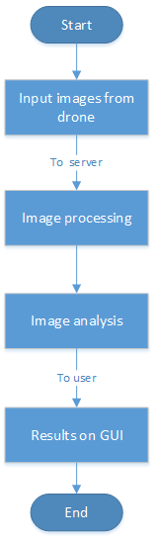

Figure 1.xxx: Flowchart of the system workflow

1.3 Objective

The main objectives of the project are :

* Build a low cost drone with the use of APM X.xxx
* Perform image processing to stitch the images using Open Drone Map
* Perform image analysis with two approaches i.e. Vegetation Index(VI) methods and machine learning on hyperspectral data, and deep learning on RGB data.
* Build a Graphical User Interface(GUI) and an Android Application.

1.3 Organisation of the report

The report is divided into five chapters with each part describing different aspects of the project. The second chapter presents a literature survey on the knowledge obtained on the topic. The third chapter describes the methods and tools used to build/assemble the drone. The fourth chapter provides insights into the image processing techniques applied to achieve the best results. The fifth chapter describes the methods used for image analysis. The sixth chapter deals with the development of the GUI for the end user clients.

LITERATURE SURVEY CHAPTER-2

Non-stop supply of nutritious food production for the ever increasing population as well  
because the challenges of global market have factored in the need for newer efficient  
farming systems. Precision Farming is a scientific approach to enhance the agricultural  
management by adoption of data Technology and satellite primarily based technology to  
spot, analyse and manage the spatial and temporal viability of science parameters. Within  
the field by timely application of solely needed quantity of input to optimise profit,   
sustainability [1] with minimised impact on surroundings. With the progress and  
application of IT in agriculture and IT revolution in developing countries, precision  
agriculture has been progressively gaining attention worldwide.

2.1 Overview of Precision Farming technology

The advanced Precision Farming technology started to develop from the early eighties in  
the developed world. Precision Farming technology today is a combined result of  
development of different sectors, which are discussed below.

2.1.1 Global Positioning System (GPS)

Global Positioning System satellites broadcast signals that allow GPS receivers to compute their location. This information is provided in real time, meaning that continuous position information is provided while in motion. Having precise location information at any time allows soil and crop measurements to be mapped. GPS receivers, either carried to the field or mounted on implements allow users to return to specific locations to sample or treat those areas. Uncorrected GPS signals have an accuracy of about 300 feet. To be useful in agriculture, the uncorrected GPS signals must be compared to a land-based or satellite-based signal that provides a position correction called a differential correction. The corrected position accuracy is typically 63-10 feet.

A ground based network of reference stations providing correction knowledge and  
different info for the users is necessary real time, high accuracy (down to sub-centimetre  
level) GPS positioning. This type of systems usually is called as ground primarily based  
GNSS infrastructure. There are intensive developments of such infrastructures which can  
be useful for future preciseness farming applications [5]. RTK DGPS can give elevation  
accuracy of as sensible as five cm. So additional improvement by the use of precise  
systems and competitive services by totally different countries and organizations will help  
build positioning technology with additional sturdiness, robustness and at a very meagre  
cost.

2.1.2 Variable Rate Technology

Variable rate technology, also known as VRT, is a form of seeder, spreader, sprayer, and planter technology that has been developed over the last 10 years. This technology helps to reduce over seeding, spraying, and spreading on farms by tracking the equipment with GPS location and preventing redundant use of product. Variable rate technology can vary from assisting farmers from seeding, spraying or spreading where they have previously, or this technology can connect with different maps and use GPS to determine what areas need more seed, pesticides / herbicides or spreading of fertilizers and distribute the perfect amount. Variable rate technology is one that is extremely beneficial to the farmer due to the fact that since it is reducing product usage, it is saving farmer’s money.

2.1.3 Mapping Technology

A large piece of precision agriculture rests with the use of many different types of maps. Precision maps can help farmers in a huge amount of ways, as well as increase their productivity, efficacy, and crop yield. There are many different types of maps that can be made with different technologies such as Unmanned Aerial Vehicle's and GPS. With these technological advancements, geo-referencing data is much easier and collecting information into an easy to read map can be done by a computer. Maps can help farmers by showing a great amount of detail, and depending on the resolution size, the farmer could see each plant in his or her field. This amount of information could help the farmer to make a variety of strategic decisions including how much fertilizer or pesticide to use, what crops to harvest, how much nitrogen is in the field, and much more.

2.2 Remote Sensing

The main aim of remote sensing was to make quick, robust and easy farming tools to  
meet the huge demand of crops in various countries around the world. Crop and  
environmental parameters at field scale are not enough for monitoring the actual harvest   
[7]. We must factor in various other parameters such as pollution, air density, moisture  
level, pesticide content, etc. It was difficult to produce timely data support for  
agricultural production and management, which has blocked the development and  
applications of exactitude farming. But, this is not the case nowadays and thence the  
increase in analysis on the topic.

Here some of the techniques and methods used in remote sensing are discussed.

2.2.1 Drought monitoring

Remote sensing uses various indices that can be useful to measure variable parameters.  
Vegetation Heath Index (VHI) and Vegetation Condition Index (VCI) are used to monitor  
drought. These are combined with Temperature Condition Index (TCI) and analysis is  
done on the crops. The values obtained give an insight as to the drought situation in the  
area.

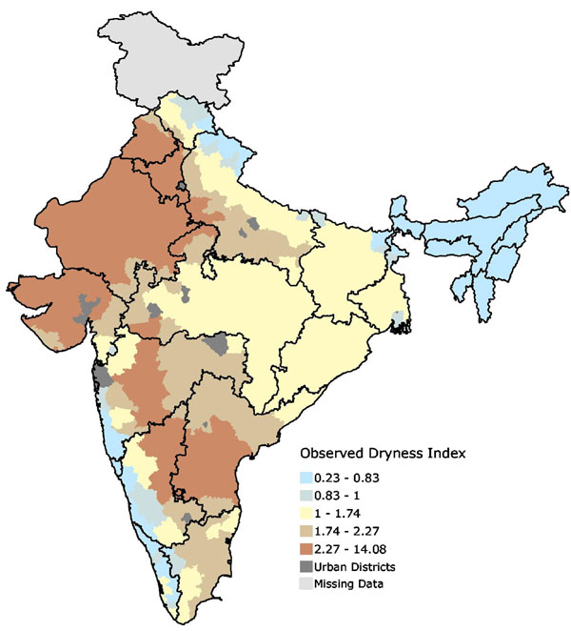

Fig.2.1 Dryness index map

Fig.2.1 shows areas prone to drought in India. The bluish colours indicate areas that get more rain than is evaporated from the heat, while the yellow to brown shades indicate regions where evaporation is greater than precipitation. The browner the colour, the drier the region.

2.2.2 Crop condition monitoring

The health condition of a plant is generally determined by how green it is. This is in turn  
a reflection of the chlorophyll content in the leaves of the plant. NDVI is a tool than can  
determine the chlorophyll content. As a general rule the areas with more chlorophyll  
content are shown green and the lesser ones in the shade of brown. The continuous  
monitoring of these values can show the health condition of plants in real time. If there is  
an increase in the brown concentration, then necessary steps can be taken to deal with the  
matter. Thus the overall crop health is monitored and speedy recovery methods can be  
applied.

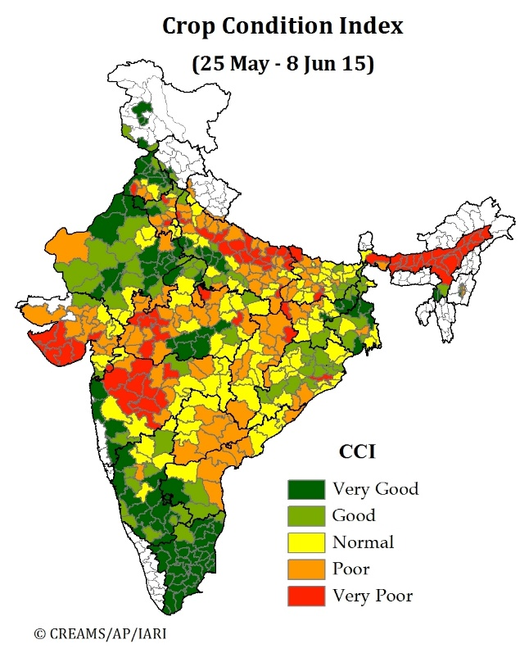

Fig.22 Crop condition index map

Fig.2.2 shows Crop Condition Index (CCI) of India during time period of May and June of 2015.

2.2.3 Crop yield

The ultimate goal of a farmer is to maximize his harvested crop. Various techniques can  
be utilised to calculate the crop yield. One of the novel techniques is the Cop Harvest  
Index (CHI). This technique estimates the biomass present in the given area. As the  
maximum biomass in a field is the crop itself, this can be approximated as the crop yield.  
Another method is to calculate the nitrogen gas content. Fully grown plants continuously  
release nitrogen as a natural process. Hence if the nitrogen content is high, this can also  
be an indicator of good crop yield.

2.3 Geographical Information System (GIS)

GIS describes any information system that integrates, stores, edits, analyses, shares, and displays geographic information. GIS applications are tools that allow users to create interactive queries (user-created searches), analyse spatial information, edit data in maps, and present the results of all these operations. Geographic information science is the science underlying geographic concepts, applications, and systems.

GIS and GPS are intrinsically complementary to one another in their primary functions. Each of

the technologies has its limitations. Only through integration can their strengths be fully utilized.

Integration will not only ease their applications in resource management and environmental

monitoring (e.g ,pest incidences, hot spots), but also broaden the scope to which they are

applicable (e.g., real-time emergency disease response and early warning mechanism). As a matter

of fact, the integration of GPS, remote sensing, and GIS in combination with ground monitoring

systems has proved to be an efficient method of managing, analyzing, and outputting spatial

data for regional water resources management (Chen et a]., 1997). Such integration is

indispensable in devising an effective approach for selectively applying pesticides and fertilizers

to improve farming efficiency and reduce environmental hazards (Runyon, 1994).

GIS and GPS are intrinsically complementary to one another in their primary functions. Each of

the technologies has its limitations. Only through integration can their strengths be fully utilized.

Integration will not only ease their applications in resource management and environmental

monitoring (e.g ,pest incidences, hot spots), but also broaden the scope to which they are

applicable (e.g., real-time emergency disease response and early warning mechanism). As a matter

of fact, the integration of GPS, remote sensing, and GIS in combination with ground monitoring

systems has proved to be an efficient method of managing, analyzing, and outputting spatial

data for regional water resources management (Chen et a]., 1997). Such integration is

indispensable in devising an effective approach for selectively applying pesticides and fertilizers

to improve farming efficiency and reduce environmental hazards (Runyon, 1994).

GIS and GPS are intrinsically complementary to one another in their primary functions. Each of

the technologies has its limitations. Only through integration can their strengths be fully utilized.

Integration will not only ease their applications in resource management and environmental

monitoring (e.g ,pest incidences, hot spots), but also broaden the scope to which they are

applicable (e.g., real-time emergency disease response and early warning mechanism). As a matter

of fact, the integration of GPS, remote sensing, and GIS in combination with ground monitoring

systems has proved to be an efficient method of managing, analyzing, and outputting spatial

data for regional water resources management (Chen et a]., 1997). Such integration is

indispensable in devising an effective approach for selectively applying pesticides and fertilizers

to improve farming efficiency and reduce environmental hazards (Runyon, 1994).

GIS and GPS are intrinsically complementary to one another in their primary functions. Each of

the technologies has its limitations. Only through integration can their strengths be fully utilized.

Integration will not only ease their applications in resource management and environmental

monitoring (e.g ,pest incidences, hot spots), but also broaden the scope to which they are

applicable (e.g., real-time emergency disease response and early warning mechanism). As a matter

of fact, the integration of GPS, remote sensing, and GIS in combination with ground monitoring

systems has proved to be an efficient method of managing, analyzing, and outputting spatial

data for regional water resources management (Chen et a]., 1997). Such integration is

indispensable in devising an effective approach for selectively applying pesticides and fertilizers

to improve farming efficiency and reduce environmental hazards (Runyon, 1994).

GIS and GPS are intrinsically complementary to one another in their primary functions. Each of the technologies has its limitations. Only through integration can their strengths be fully utilized. Integration will not only ease their applications in resource management and environmental monitoring, but also broaden the scope to which they are applicable (e.g. real-time emergency disease response and early warning mechanism). As a matter of fact, the integration of GPS, remote sensing, and GIS in combination with ground monitoring systems has proved to be an efficient method of managing, analysing, and outputting spatial data for regional water resources management. Such integration is indispensable in devising an effective approach for selectively applying pesticides and fertilizers to improve farming efficiency and reduce environmental hazards.

There are various GIS software available for post processing like ArcGIS, QGIS, uDig, GRASS etc. Among these ArcGIS is closed source and paid and others are free and open sourced. We used QGIS for our application as it is user friendly and provides powerful tools for processing and has large community support. It runs on all major platforms like Linux, Windows and Mac. PyQGIS is an object-oriented Python Application Programming Interface (API) for QGIS. PyQGIS offers interfaces to QGIS modules and functionality, as well as to vector and raster data.

2.4 Image Analysis :

2.4.1. VI and Machine Learning:

Over the years, a number of vegetation indices (VIs) have been developed by combining two or more wavebands in the hyperspectral images in ratios and/or differences, to highlight various crop conditions. However, one of the problems in applying VIs to crop yield estimation is the difficulty in choosing the most appropriate vegetation index in a specific situation (Barrett and Curtis 1999). In fact, various environmental factors, such as background effects and crop canopy conditions, have been shown to be potential sources of noise, which affect the spectral reflectance in canopy level (Aparicio et al., 2000).

Artificial intelligence and especially machine learning have contributed to the creation of control systems in agriculture. There are a lot of machine learning algorithms like Support Vector Machines(SVM), Simple Multivariate Linear Regressions(SMLR), Decision Trees(DT), Neural Networks(NN), etc. available that can be utilized for recognizing intricate patterns in data.

Applying machine learning models in addition to the VI based methods have resulted in great results as shown by Farid Melgani and Lorenzo Bruzzone in the paper “Classification of Hyperspectral Remote Sensing Images With Support Vector Machines”[].

We utilized the potential of softmax regression model along with VI for image analysis.

2.4.2. Deep Learning

# Deep Neural Networks (DNNs), have generated a strong interest in their potential effectiveness in estimating various field and crop conditions from remotely sensed images as well as RGB images.

*A lot of work has been done in this field during recent years with the release of many open source datasets like the PlantVillage dataset[].Most recent of them include the one done by*

Sharada Prasanna Mohanty, David Hughes, and Marcel Salathe in the paper “Using Deep Learning for Image-Based Plant Disease Detection”[].Many models have been prepared for the task of image classification using frameworks like Torch, Caffe,Theano. We chose to build the model using Google’s Tensorflow with the concept of Transfer Learning to an already trained inception v-3 model for better results and fast training. Tensorflow helps us to visualize the build model in Tensorboard for better fine-tuning.

2. 5Image Stitching

Various tools available in the community for opensource development are dronemapper[], agisoft photoscan[], opendronemap[]. We used opendronemap because it is opensource, has good quality results and has strong community support.

2.4 Summary and review

In the literary review, we have enlisted the various techniques that are currently being  
used in precision farming. Previously remote sensing was primarily used for calculation  
of precision farming indices. But this is very costly and thus not viable for all the farmers.  
The role of GIS in different agricultural scenarios has also been discussed. These  
traditional methods have served as an inspiration for the current project. The model and  
approach for an agricultural system can be easily noted by analysis of past work. Thus  
such literature allows for an essay yet fast approach towards a complete prototype.

IMAGE PROCESSING CHAPTER-3

The part of image processing in this project is to take the hyperspectral images from the drone as explained in the previous stage and stitch them and make them suitable for further analysis by deep learning or NDVI Analysis.

We require a well-structured dataset for the proper functioning of this system. The dataset consists of hyperspectral images order to get information about the image on a wider range of spectrum. Information in the near infrared region can give us great deal of insight in the critical parameters which help us in determining crop health. The dataset should consist of a serial of overlapping images taken of the farm field in all four directions. Overlapping is an essential condition as we require it to increase the accuracy of image mosaicing.

The final stitched image will act as our map over which we plan to perform image  
indexing algorithms like NDVI to detect important crop parameters like  
chlorophyll content, soil nutrient content etc. This data is imposed on to our map of the farm in the form of different raster layers using open source GIS libraries in python and software like QGIS.

The important steps in the algorithm are listed in Fig.3.1 to give the reader an intuitive  
understanding of the algorithm.

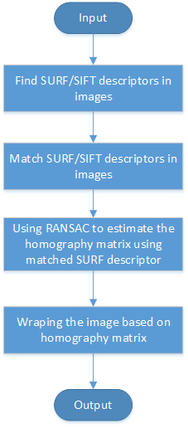

Fig.3.1 Image Mosaicing and Ortho-rectification process

**3.1 Image Mosaicing and Ortho- rectification**

We need to stitch together our georeferenced images now to get an overall image of the  
farm land. This we can treat as the base map raster layer for our operations and we will  
perform a series of image processing algorithms on it to get pertinent data.

The problem of image mosaicing is a combination of three problems:

(1) Correcting geometric deformations using image data and/or camera models.  
(2) Image registration using image data and/or camera models.  
(3) Eliminating seams from image mosaics.

**3.1.1 Geometric corrections**

A geometric transformation could be a mapping that relocates image points. Transformations can be world or native in nature. Global transformations square measure sometimes outlined by a single equation that is applied to the complete image. Local transformations square measure applied to a half of image and those square measure tougher to specific briefly.

The complications due to parallax that square measure determined within the case of  
change of location motion of a plate like camera are often avoided by employing a one  
dimensional camera to scan scenes. This action can be emulated victimization standard cameras by combining strips taken from a sequence of 2-D pictures as a series of neighbouring segments. These cameras can directly acquire cylindrical (with a rotating motion) and writing (with change of location motion) maps. They can conjointly acquire pictures on Associate in nursing whimsical path. The strips that should be taken from 2-D pictures square measure known because the ones perpendicular to the image flow in. This family of strips can handle a wide form of motions together with motion and optical zoom. Additional formulation is developed in for these sophisticated cases of motion.

**3.2 Image Registration**

Image registration is the task of matching two or a lot of pictures. It has been a central  
issue for a range of problems in image process like seeing, monitoring satellite pictures,  
matching stereo images for reconstructing depth, matching biomedical pictures for  
designation, etc.

Registration is also the central task of image mosaicing procedures. Carefully tag  
Associate in nursing pre-recorded camera parameters might be wont to eliminate the  
necessity for an automatic registration. User interaction also is a reliable supply for  
manually registering pictures (e.g. by choosing corresponding points and using necessary  
transformations on screen with visual feedback). Automated strategies for image  
registration used in image mosaicing literature will be categorized as follows:

1. Feature based methods
2. Intensity based mosaicing

**3.2.1 Feature based methods**

In feature-based technique (Fig.3.1), all main feature points in an image pair is compare with all features in the other image by using one of the local descriptors. For image stitching based on feature-based techniques, feature extraction, registration, and blending are different steps required for doing image stitching. Feature-based methods are used by establishing correspondences between points, lines, edges, corners or any other shapes. The main characteristics of robust detectors includes invariance to image noise, scale invariance, translation invariance, and rotation transformations.

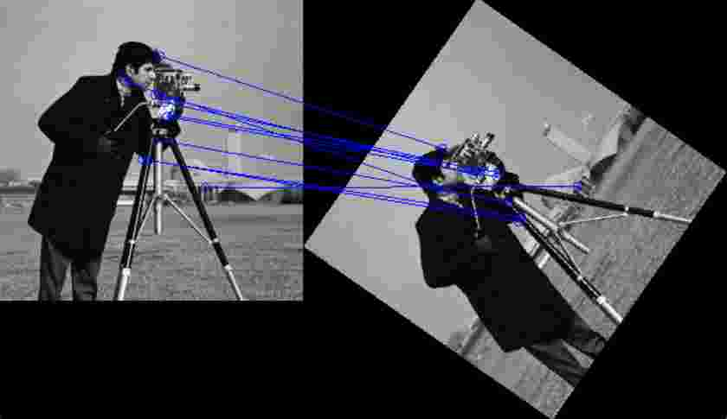

Fig.3.1 Feature based detection

3.2.2 Intensity based mosaicing

Iteratively adjusting camera-motion parameters leads to local minimums unless a reliable  
initial estimate is provided. Initial estimates can be obtained using a coarse global search  
or an efficiently implemented frequency domain approach. Algorithm is as follows:

1) For each pixel at (x, y) in the first image, we compute the corresponding pixel in the second image equal to (x’, y’).

2) Compute the error density function between corresponding pixels using

3) The problem is solved iterative to converge the error function towards the global minima

3.3 Image Compositing

Images aligned once undergoing geometric corrections most seemingly need additional  
process to eliminate remaining distortions and discontinuities. Alignment of images might  
be imperfect as a result of registration errors ensuing from incompatible model  
assumptions, dynamic scenes, etc. Furthermore, in most cases images that want to be  
mosaiced don't seem to be exposed equally as a result of dynamical lighting conditions,   
automatic controls of cameras, printing/scanning devices, etc. These unwanted effects can  
be mitigated throughout the compositing method.

The main downside in image compositing is that the problem of decisive however the  
pixels in Associate in nursing overlapping space ought to be delineated. Finding the best  
separation border between overlapping images has the potential to eliminate remaining  
geometric distortions. Such a border is likely to traverse around moving objects avoiding  
double exposure. The uneven exposure problem will be resolved by bar chart feat, by  
iteratively distributing the edge effect on the border to an outsized space, or by a smooth  
mixing perform.

3.4 Ortho-Rectification of images

The camera mounted on the drone is susceptible to different array of forces when the drone is airborne. This may result in changing of the orientation of the camera and hence the all the images may not be in the same plane. This can make the process of image mosaicing inaccurate and the final result we get will be a far off approximation of the real map of the field. To compensate for these errors, we need to implement some kind of pre-processing to account for this discrepancy in order to improve the efficiency of image mosaicing. Ortho-rectification is one of the ways to implement this compensation and is known to have good results for aerially acquired images. It is has an efficient implementation and so it requires less amount of processing time. This makes it compatible for real-world processing systems which is great advantage.

The process of ortho-rectification (Fig.3.2) involves mapping of via aircraft non-inheritable pictures on a map of a similar size victimisation many geo-reference management points (GCPs) [1]. The topographical variations in the surface of the world and also the tilt of the camera have an effect on the gap with that options on the aerial image area unit show. The more topographically various the landscape, the more distortion inherent in the photograph. As a result, real world distances don't seem to be represented uniformly on the photograph.  
For example in a very steep area would relate to a way longer distance than an inch  
measured over a flat surface like a visible. Ortho-rectification is the name of the method  
accustomed removes these sources of distortion to equilibrate pic units with world  
distances. Once an aerial pic has been ortho-rectified, it is commonly cited as associate  
degree ortho-photo. A fascinating facet note is whereas ortho-rectification removes  
horizontal distortion; vertical relief displacement continues to be maintained. For  
example, the sides of a building would still contain distortion.

In some cases, a simple rectification method like removing the consequences of the lean  
of the camera is also all that's necessary. This is very rare and in most cases a lot of  
concerned method is needed. After removing the impact of the camera tilt, removing the  
effects of relief should be accomplished by knowing the elevation of the piece of land  
higher than (or below) the mapping plane must be identified [2].

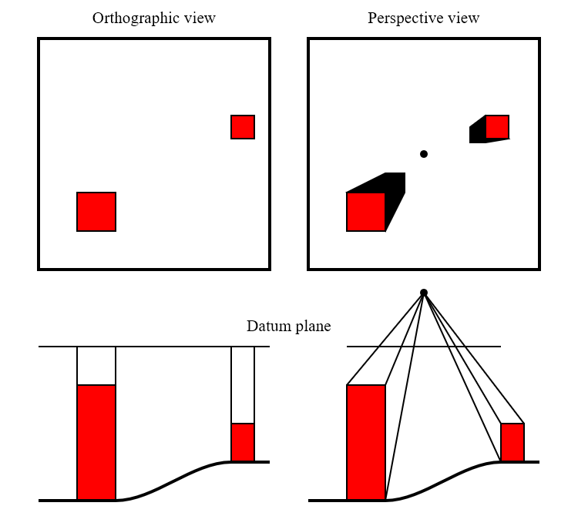

Fig.3.2 Ortho Rectification

3.4.1 Methods used in ortho-rectification

There are two ways by that rectification of associate degree aerial photograph will occur.  
In the first case, Ground Control Points (GCP) are determined either typical ground  
surveys, from published maps, by Global Positioning System (GPS) surveys, or by aero triangulation. These points are taken at visible physical options on the landscape. On the  
corresponding image, the x, y photo coordinates are then determined for every  
corresponding GCP. Depending on the sort of recursive correction to be used, a minimum  
of 3 to five GCP should be established. The relationship of the x, y photo coordinates to the real world GCP is then wont to confirm the algorithmic program for resampling the  
image.

The second method of ortho-rectification is to use DEMs. These elevations are collected  
from stereoscopic models by photogrammetric ways to kind a digital elevation model   
(DEM). As with using GCPs, the mathematical relationship between the real worlds  
coordinates and also the scanned aerial photograph is set and also the digital image is  
resampled to form the rectified image. For both cases, the resampling of the digital image  
involves warping the image thus that distance and space are uniform in relationship to  
world measurements. This means that with the resampled image, an in. on the image  
currently measures an equivalent distance on steep tract because it will during a field.  
Depending the on the desires of the aerial mental imagery within the GIS system, there  
are blessings and disadvantages to mistreatment either technique. GCP ortho-rectification  
is a faster method and may be accomplished mistreatment existing paper maps to  
ascertain the GCPs. Using DEMs for ortho-rectification is a lot of correct method by that  
to geocode digital mental imagery however need associate degree existing DEM or DTM  
for process. Once an image has been ortho-rectified it is often used with vector and  
formation information of an equivalent organization. This image can currently have broad  
outlines and street names overlay onto it. As mentioned before, spatial information will  
additionally currently be accurately measured in terms of distances and space, allowing  
for a lot of advanced spatial analysis [2].

All the above mentioned method work separately for image mosaicing and ortho-rectification. We can use the SIFT (Scale Invariant Feature Transform) and SURF (Speeded-Up Robust Features) algorithms to simultaneously ortho-rectify the images and also stitch them.

3.5 SIFT and SURF

• SIFT Detector:

Lowe proposed the Scale Invariant Feature remodel (SIFT). It has four computational phases that includes: scale-space extrema detection, key-point localization, orientation assignment, and defining key-point descriptors. The first stage is to spot location and scales of key point’s exploitation scale house extrema within the DoG (Difference-of-Gaussian) functions. In the key point localization (Fig.3.3) step, key point candidates are localized and refined by eliminating the key points wherever they rejected the low distinction points. In the orientation assignment step, the orientation of key point is obtained primarily based on native image gradient. In key-point descriptors stage, SIFT computes the local image descriptor for every key purpose supported image gradient magnitude and orientation at every image sample purpose in a very region focused at key purpose. These samples build a 3D histogram of gradient location and orientation, with 4×4 array location grid and eight orientation bins in each sample. SIFT provides a 128-element dimension of key point descriptor.

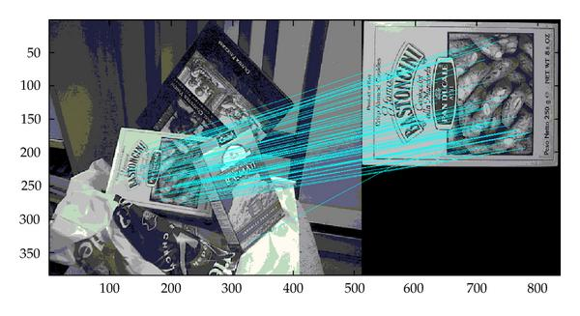

Fig.3.3 SIFT Based feature detection

• SURF Detector:

The Speed-up Robust Feature detector (SURF) rule is based mostly on multiscale area theory and Speeds-up its computations by quick approximation of boot matrix and descriptor exploitation “integral images”. SURF uses three feature detection steps namely; detection, description, and matching. SURF speeded-up the SIFT’s detection process by keeping in read of the standard of the detected points (Fig.3.4). It gives a lot of focus on speeding-up the matching step [13]. The Hessian matrix is used alongside descriptors low spatial property to considerably increase the matching speed. SURF is widely used in the pc vision community. SURF has proven its potency and hardiness in the invariant feature-localization.

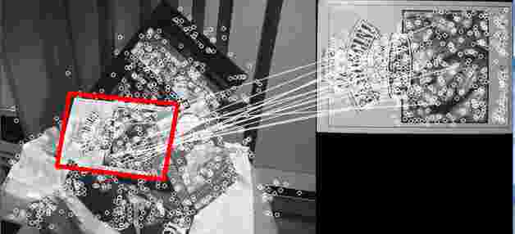

Fig.3.4 SURF Based feature based detection

3.6 OpenDronemap based Image Processing

OpenDroneMap is a tool to postprocess drone, balloon, kite, and street view data to geographic data including orthophotos, point clouds, & textured mesh.

Docker is the world’s leading software container platform. Developers use Docker to eliminate “works on my machine” problems when collaborating on code with co-workers. Using containers, everything required to make a piece of software run is packaged into isolated containers. Unlike VMs, containers do not bundle a full operating system - only libraries and settings required to make the software work are needed.

We used opendronemap to achieve the step of image stitching robustly. We used docker as a container for easier installation and cross-platform support across all different OS and platforms.

The main command to start the procedure is :

1.`docker build -t opendronemap:latest .`

This command builds the docker image using dockerfile.

`docker run -it --rm -v img_loc:/code/images -v odm_orthophoto:/code/odm_orthophoto -v /odm_texturing:/code/odm_texturing my_odm_image_2`

2. This command creates a container that is used to generate the stitched image using georef coordinates.