CampusCare
A Mobile Application for University Facility Management

Updated Software Requirements Specification (SRS)

INCS 617 — Software Engineering for Business Informatics

Name | Student ID
Mostafa Amer | 13001482
Youssef Tamer | 13007100
Mohamed Haitham | 13007066
Nariman Sherif | 13006930
Habiba Elwi | 13001343
Hla Ezzeldin | 13001687
Vania Abdelghafar | 13007464
Israa Haggag | 13004569

Note: This document is the updated SRS. The README, API Documentation, and Setup Guide are maintained separately.

1. Introduction
CampusCare is a mobile application designed to improve facility management within a university campus. The system connects students and staff with the Facility Management Team through a centralized digital platform enabling efficient reporting and real-time handling of maintenance issues.
Problems such as damaged furniture, electrical faults, or plumbing issues often go unreported or are communicated through unclear channels, leading to delayed maintenance and poor communication. CampusCare addresses these challenges with a structured system where users report issues, track status, and receive updates in real time.
This document defines the functional and non-functional requirements of the CampusCare system and reflects the final implemented state of the project, including the correction of the database technology from MongoDB (stated in Phase 1) to Supabase/PostgreSQL (actually used).

1.1 Product Vision & Scope
CampusCare digitalizes campus maintenance reporting. Community members (students and staff) submit tickets with photos, location, category, and description. Facility managers receive, assign, and track issues through a dashboard. Workers act on assignments and update progress. Admins manage the full user base.
The scope covers maintenance issues within the campus: electrical, plumbing, infrastructure, and general facility problems. The goal is faster response times, improved transparency, and better communication between users and administrators.

1.2 Definitions and Acronyms
Term | Definition
SRS | Software Requirements Specification
Ticket | A digital record representing a reported maintenance issue
RBAC | Role-Based Access Control — permissions assigned by user role
MVP | Minimum Viable Product — initial version with essential features only
JWT | JSON Web Token — used for stateless user authentication
REST | Representational State Transfer — architectural style for the API
ERD | Entity Relationship Diagram — visual model of the database schema
API | Application Programming Interface — HTTP endpoints for frontend-backend communication
Supabase | Hosted PostgreSQL database-as-a-service used in this project

2. Functional Requirements
Requirements are organized by user role. Each FR maps to a user story in the product backlog.

2.1 User Stories
Community Member
- US-CM-01: As a Community Member, I should be able to Create an account to be able to log in to the application.
- US-CM-02: As a Community Member, I should be able to Log in using email and password to access the application.
- US-CM-03: As a Community Member, I should be able to Submit an issue with location, photo, and category so the problem is reported accurately.
- US-CM-04: As a Community Member, I should be able to Add a description to an issue so the worker understands the problem clearly.
- US-CM-05: As a Community Member, I should be able to View submitted issues to track their status.
- US-CM-06: As a Community Member, I should be able to Log out to keep data secure on shared devices.
- US-CM-07: As a Community Member, I should be able to View the status of an issue (Pending / In Progress / Resolved) to know the progress.

Facility Manager
- US-FM-01: As a Facility Manager, I should be able to Create an account to be able to log in to the application.
- US-FM-02: As a Facility Manager, I should be able to Log in using email and password to access the application.
- US-FM-03: As a Facility Manager, I should be able to Log out to keep data secure on shared devices.
- US-FM-04: As a Facility Manager, I should be able to View all submitted issues to assign them to workers.
- US-FM-05: As a Facility Manager, I should be able to Update an issue's status so the system reflects the current state.
- US-FM-06: As a Facility Manager, I should be able to Assign an issue to a worker so the worker can start fixing it.
- US-FM-07: As a Facility Manager, I should be able to Close an issue after it is resolved so the system reflects completion.

Worker
- US-W-01: As a Worker, I should be able to Create an account to be able to log in to the application.
- US-W-02: As a Worker, I should be able to Log in using email and password to access the application.
- US-W-03: As a Worker, I should be able to Log out to keep data secure on shared devices.
- US-W-04: As a Worker, I should be able to View assigned issues to start working on them.
- US-W-05: As a Worker, I should be able to Comment on an issue to indicate the work is completed so the facility manager can update its status.
- US-W-06: As a Worker, I should be able to Mark an issue as 'In Progress' so the facility manager and community member know it is being worked on.
- US-W-07: As a Worker, I should be able to Upload a photo after fixing an issue so the facility manager can verify the work.

System Admin (Optional)
- US-SA-01: As a System Admin, I should be able to Log in to access the application.
- US-SA-02: As a System Admin, I should be able to Log out to keep data secure on shared devices.
- US-SA-03: As a System Admin, I should be able to Activate or deactivate any account to ensure all users follow system rules.
- US-SA-04: As a System Admin, I should be able to View all registered users to manage the system.

2.2 Functional Requirements by Role
Community Member
FR ID | Name | Description
FR-CM-01 | Account Creation | The system shall allow a Community Member to create an account with name, email, and password.
FR-CM-02 | Authentication | The system shall allow a Community Member to log in with a valid email and password.
FR-CM-03 | Issue Submission | The system shall allow submission of an issue with: location, photo, category, and description.
FR-CM-04 | Issue Description | The system shall allow a Community Member to add a textual description when submitting an issue.
FR-CM-05 | View Own Issues | The system shall allow a Community Member to view a list of their submitted issues.
FR-CM-06 | Logout | The system shall allow a Community Member to log out of the application.
FR-CM-07 | View Issue Status | The system shall display the current status of an issue: Pending | In Progress | Resolved.

Facility Manager
FR ID | Name | Description
FR-FM-01 | Account Creation | The system shall allow a Facility Manager to create an account.
FR-FM-02 | Authentication | The system shall allow a Facility Manager to log in with a valid email and password.
FR-FM-03 | Logout | The system shall allow a Facility Manager to log out of the application.
FR-FM-04 | View All Issues | The system shall allow a Facility Manager to view all submitted issues.
FR-FM-05 | Update Issue Status | The system shall allow a Facility Manager to update the status of any issue.
FR-FM-06 | Assign Issue | The system shall allow a Facility Manager to assign an issue to a specific worker.
FR-FM-07 | Close Issue | The system shall allow a Facility Manager to close a resolved issue.

Worker
FR ID | Name | Description
FR-W-01 | Account Creation | The system shall allow a Worker to create an account.
FR-W-02 | Authentication | The system shall allow a Worker to log in with a valid email and password.
FR-W-03 | Logout | The system shall allow a Worker to log out of the application.
FR-W-04 | View Assigned Issues | The system shall allow a Worker to view issues assigned to them.
FR-W-05 | Comment on Issue | The system shall allow a Worker to add a completion comment to an issue.
FR-W-06 | Mark In Progress | The system shall allow a Worker to mark an assigned issue as In Progress.
FR-W-07 | Upload Completion Photo | The system shall allow a Worker to upload a photo after completing work.

System Admin (Optional)
FR ID | Name | Description
FR-SA-01 | Admin Authentication | The system shall allow a System Admin to log in.
FR-SA-02 | Logout | The system shall allow a System Admin to log out.
FR-SA-03 | Account Management | The system shall allow a System Admin to activate or deactivate user accounts.
FR-SA-04 | View Registered Users | The system shall allow a System Admin to view all registered users.

2.3 Product Backlog
Backlog ID | User Story ID | Priority | Category
PB-01 | US-CM-01 | High | Core System
PB-02 | US-CM-02 | High | Core System
PB-03 | US-CM-03 | High | Core System
PB-04 | US-CM-04 | High | Core System
PB-05 | US-CM-05 | High | Core System
PB-06 | US-CM-07 | High | Core System
PB-07 | US-FM-01 | High | Core System
PB-08 | US-FM-02 | High | Core System
PB-09 | US-W-01 | High | Core System
PB-10 | US-W-02 | High | Core System
PB-11 | US-FM-04 | High | Issue Management
PB-12 | US-FM-06 | High | Issue Management
PB-13 | US-W-04 | High | Issue Management
PB-14 | US-W-06 | High | Issue Management
PB-15 | US-W-05 | Medium | Issue Management
PB-16 | US-W-07 | Medium | Issue Management
PB-17 | US-FM-05 | High | Issue Management
PB-18 | US-FM-07 | High | Issue Management
PB-19 | US-CM-06 | Medium | Authentication & Security
PB-20 | US-FM-03 | Medium | Authentication & Security
PB-21 | US-W-03 | Medium | Authentication & Security
PB-22 | US-SA-01 | Low | System Admin (Optional)
PB-23 | US-SA-02 | Low | System Admin (Optional)
PB-24 | US-SA-03 | Low | System Admin (Optional)
PB-25 | US-SA-04 | Low | System Admin (Optional)

2.4 UML Use Case Diagram
The diagram below shows all actors and their interactions with the CampusCare system.

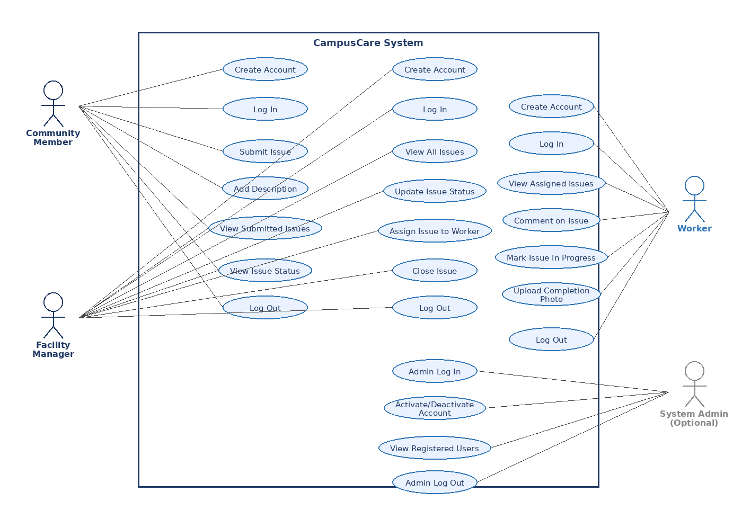
Figure 1 — CampusCare UML Use Case Diagram

3. Non-Functional Requirements
NFR ID | Category | Requirement
NFR-01 | Performance | The system shall maintain response and loading times under three seconds under normal conditions.
NFR-02 | Scalability | The system shall support at least 500 simultaneous users without performance degradation.
NFR-03 | Security | The system shall implement secure authentication (bcrypt + JWT), input validation, and protection against unauthorized access.
NFR-04 | Usability | The system shall provide a simple and intuitive interface enabling users to submit a ticket within one minute.
NFR-05 | Reliability | The system shall ensure stable performance and reliable image uploads even under unstable network conditions.
NFR-06 | Availability | The system shall be accessible at all times except during scheduled maintenance.
NFR-07 | Backup & Recovery | The system shall perform regular backups and support data recovery in case of failure.
NFR-08 | Maintainability | The system shall be designed with modular components to allow easy updates and maintenance.
NFR-09 | Compatibility | The mobile application shall support common Android and iOS devices.
NFR-10 | Data Integrity | The system shall ensure accuracy and consistency of stored data at all times.

4. Constraints
- Platform Constraint: The system must be a mobile application compatible with both Android and iOS devices.
- Technology Constraint: Implemented using React Native (frontend), Node.js/Express (backend), and Supabase/PostgreSQL (database).
- Time Constraint: The project must be completed within the academic semester timeline, limiting scope to essential features.
- Resource Constraint: Developed by a student team with limited resources, which may restrict advanced feature implementation.
- Network Dependency: The application requires an internet connection for real-time updates, issue submission, and synchronization.
- Device Limitation: Performance may vary depending on the user's device capabilities (camera quality, storage, processing power).
- Security Constraint: Authentication and data protection must comply with basic security practices to prevent unauthorized access.
- Integration Constraint: The system operates as a standalone application without integration with existing university systems in the initial version.

5. Technology Stack
The following reflects the actual technology stack used in the implemented system. Note: The Phase 1 SRS listed MongoDB as the database. This has been corrected to Supabase (a hosted PostgreSQL service), which was adopted during implementation for its relational model, foreign-key enforcement, and ease of integration with Express.

5.1 Frontend
Technology | Version | Purpose
React Native | 0.81.5 | Cross-platform mobile framework for Android and iOS
Expo | SDK 54 | Development toolchain and build system
React Navigation | 7.x | Screen navigation (native stack & tab navigators)
Axios | 1.16.0 | HTTP client for REST API requests
Expo Image Picker | 17.x | Camera & gallery photo selection
AsyncStorage | 2.2.0 | Local JWT token and session persistence

5.2 Backend
Technology | Version | Purpose
Node.js | 18+ | Server runtime environment
Express | 5.2.1 | Web framework and REST API routing
Supabase (PostgreSQL) | — | Hosted relational database — stores users, issues, comments, photos, and audit logs
bcrypt | 6.0.0 | Secure password hashing
jsonwebtoken | 9.0.3 | JWT generation and verification for stateless auth
Helmet | 8.1.0 | HTTP security headers middleware
Morgan | 1.10.1 | HTTP request logging
CORS | 2.8.6 | Cross-origin resource sharing
dotenv | 17.4.2 | Environment variable management
Docker | — | Containerized backend deployment (node:18 base image)

5.3 Development & Design Tools
Tool | Purpose
Visual Studio Code | Primary code editor
Postman | API endpoint testing and documentation
GitHub | Version control and team collaboration
Docker | Containerized backend deployment
Figma (optional) | UI/UX design and prototyping

6. Project Structure Overview
The CampusCare repository is divided into two primary directories: frontend (the React Native mobile application) and backend (the Node.js/Express API and database layer).

6.1 Backend Architecture
The backend follows an MVC-like pattern with clear separation between routing, business logic, and middleware.

Directory / File | Responsibility
backend/config/db.js | Establishes and manages the connection pool to the Supabase/PostgreSQL database.
backend/controllers/ | Core business logic. authController.js handles password hashing, credential validation, and JWT signing. issueController.js manages issue CRUD operations.
backend/middleware/authMiddleware.js | Interceptor functions: authenticate() verifies JWTs; requireRole() enforces RBAC before requests reach route handlers.
backend/routes/ | Modular route definitions: authRoutes.js, issueRoutes.js, adminRoutes.js, workerRoutes.js. Maps HTTP methods and paths to controllers with appropriate middleware.
backend/sql/issues_schema.sql | PostgreSQL schema and migration scripts. Defines all tables (users, issues, issue_photos, comments, status_history, account_actions).
backend/app.js | Sets up Express, applies global middleware (CORS, Helmet, Morgan), and mounts all route handlers.
backend/server.js | Entry point — binds the Express app to the configured network port.
backend/Dockerfile | Container definition: base node:18, exposes port 3000, entry point node server.js.

6.2 Frontend Architecture
The frontend is a React Native application built with the Expo framework, organized by feature.

Directory / File | Responsibility
frontend/navigation/ | React Navigation stack and tab navigators controlling all screen transitions.
frontend/screens/AdminDashboard.js | Admin role landing page — user management and system overview.
frontend/screens/ManagerDashboard.js | Facility Manager landing page — view and assign all issues.
frontend/screens/WorkerDashboard.js | Worker landing page — view and update assigned tasks.
frontend/screens/CommunityDashboard.js | Community Member landing page — browse all campus issues and statuses.
frontend/screens/SubmitIssue/ | Screens for composing and submitting a new maintenance issue (location, photo, category, description).
frontend/screens/IssueDetailsScreen.js | Detailed view of a single issue with full history and comments.
frontend/screens/AssignIssueScreen.js | Facility Manager screen for assigning an issue to a worker.
frontend/screens/LoginScreen.js | User login form.
frontend/screens/RegisterScreen.js | User registration form.
frontend/services/ | Axios utility functions for all API calls — separates data-fetching from UI components.
frontend/App.js & index.js | Root components that initialize the app, load providers, and render the primary navigation stack.
frontend/app.json | Expo configuration: metadata, icons, splash screen, and device permissions (camera, storage).

7. Entity Relationship Diagram
The following ERD represents the final Supabase/PostgreSQL database schema. All relationships are enforced via foreign keys.

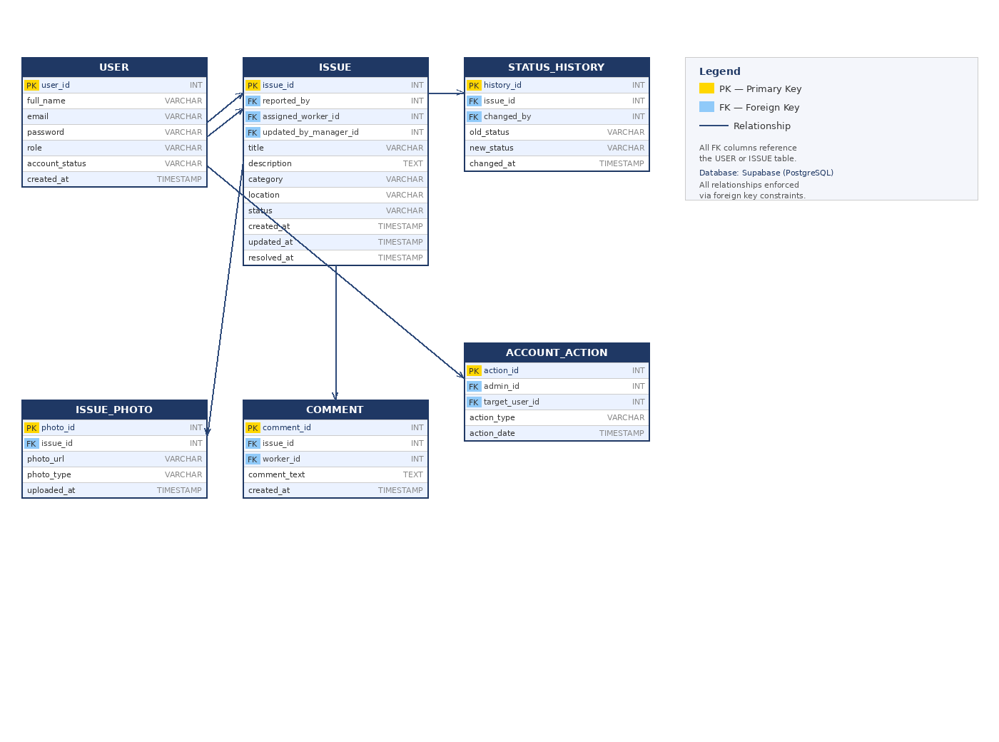
Figure 2 — CampusCare Entity Relationship Diagram

7.1 Table Descriptions
USER
Column | Type | Key | Description
user_id | INT | PK | Unique user identifier (auto-increment)
full_name | VARCHAR | — | User's full name
email | VARCHAR | UNIQUE | Login email address
password | VARCHAR | — | Bcrypt-hashed password
role | VARCHAR | — | community_member | facility_manager | worker | admin
account_status | VARCHAR | — | active | inactive (managed by admin)
created_at | TIMESTAMP | — | Account creation timestamp

ISSUE
Column | Type | Key | Description
issue_id | INT | PK | Unique issue identifier
reported_by | INT | FK → USER | Community member who submitted the issue
assigned_worker_id | INT | FK → USER | Worker assigned to fix the issue (nullable)
updated_by_manager_id | INT | FK → USER | Manager who last updated the issue (nullable)
title | VARCHAR | — | Short issue title
description | TEXT | — | Detailed description of the problem
category | VARCHAR | — | Electrical | Plumbing | Cleaning | Other
location | VARCHAR | — | Campus location of the issue
status | VARCHAR | — | Pending | In Progress | Resolved
created_at | TIMESTAMP | — | Issue submission timestamp
updated_at | TIMESTAMP | — | Last update timestamp
resolved_at | TIMESTAMP | — | Resolution timestamp (nullable)

ISSUE_PHOTO
Column | Type | Key | Description
photo_id | INT | PK | Unique photo identifier
issue_id | INT | FK → ISSUE | Issue this photo belongs to
photo_url | VARCHAR | — | URL/path of the stored image (up to 12 MB)
photo_type | VARCHAR | — | submission | completion
uploaded_at | TIMESTAMP | — | Upload timestamp

COMMENT
Column | Type | Key | Description
comment_id | INT | PK | Unique comment identifier
issue_id | INT | FK → ISSUE | Issue this comment belongs to
worker_id | INT | FK → USER | Worker who posted the comment
comment_text | TEXT | — | Comment content
created_at | TIMESTAMP | — | Comment creation timestamp

STATUS_HISTORY
Column | Type | Key | Description
history_id | INT | PK | Unique record identifier
issue_id | INT | FK → ISSUE | Issue whose status changed
changed_by | INT | FK → USER | User who triggered the status change
old_status | VARCHAR | — | Previous status value
new_status | VARCHAR | — | New status value
changed_at | TIMESTAMP | — | Timestamp of the change

ACCOUNT_ACTION
Column | Type | Key | Description
action_id | INT | PK | Unique action identifier
admin_id | INT | FK → USER | Admin who performed the action
target_user_id | INT | FK → USER | User whose account was affected
action_type | VARCHAR | — | activate | deactivate
action_date | TIMESTAMP | — | Timestamp of the admin action

8. User Roles & Permissions (RBAC)
Role | Permissions
Community Member | Report issues · Add description & photo · View own submitted issues · View issue status (Pending / In Progress / Resolved) · Browse Community Dashboard · Log out
Facility Manager | All Community Member permissions · View all submitted issues · Assign issues to workers · Update issue status · Close resolved issues · Access Manager Dashboard
Worker | Log in/out · View assigned issues · Mark issue as In Progress · Add completion comments · Upload completion photo · Access Worker Dashboard
Admin (Optional) | Full system access · Manage users (activate/deactivate) · View all registered users · View all dashboards · All CRUD operations · Admin Dashboard

9. Future Scope
- Push Notifications: Real-time alerts for status updates and new worker assignments.
- Live Issue Tracking: Track issue progress on a live map or visual timeline.
- Rating System: Community members rate the quality of completed maintenance work.
- Priority Levels: High / Medium / Low priority classification for triage.
- Analytics Dashboard: Insights on issue trends, response times, and team performance.
- University System Integration: SSO and connection to existing campus identity and facility systems.
- Gamification: Reward users for reporting valid issues to encourage engagement.
- Offline Mode: Draft and queue issue submissions offline; sync when reconnected.
- AI-Based Predictions: Predict recurring issues and suggest preventive maintenance actions.

Appendix — Revision Log (Phase 1 → Phase 2)
Change | Phase 1 (Original) | Phase 2 (This Document)
Database | MongoDB | Supabase (PostgreSQL) — actual technology used in implementation
Team member name | Israa Hagag | Israa Haggag (corrected spelling)
UML Diagram | Included as image in SRS | Reproduced and embedded in Section 2.4
ERD | Included as image in SRS | Reproduced and embedded in Section 7 with full table descriptions
Project Structure | In README only | Added as Section 6 with backend and frontend architecture tables
API Endpoints | Listed in README | Maintained in README and separate API documentation (not duplicated here)
Setup Guide | In README only | Maintained in README (not duplicated here)
Technology Stack | MongoDB listed | Updated to Supabase/PostgreSQL; all versions match implemented stack

