**User manual for Inxeption ChatGPT**

**Prepared by: Mosami Pulujkar**

In order to use ChatGPT, you need to go through six basic steps:

Step 1 -

First Connect VPN (Virtual Private Network)

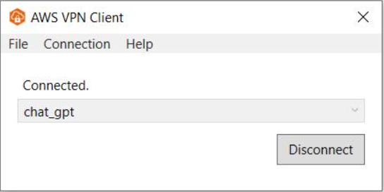

Step 2 -

Go to <https://inx-chat.inxeption.net/> link for ChatGPT. You are visible

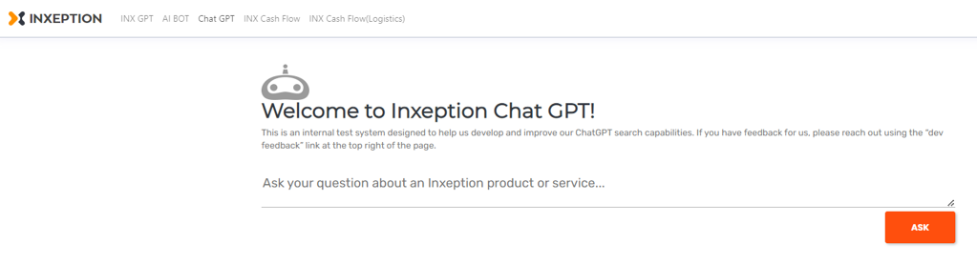

Step 3 -

You have to select ChatGPT option from here.

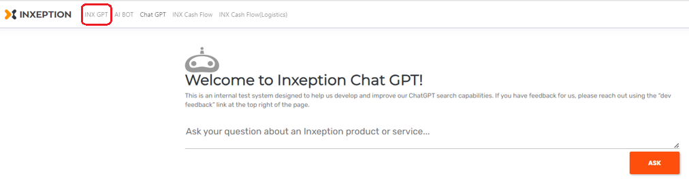

Step 4 -

Go ahead and ask ChatGPT your first question.

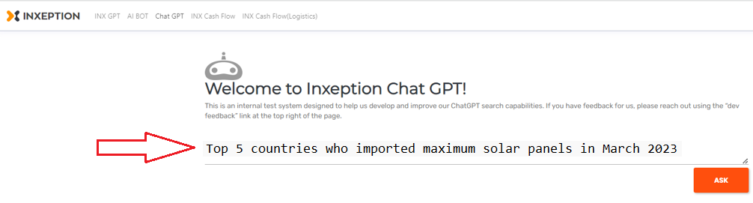

Step 5 –

Hit Ask button for responses.

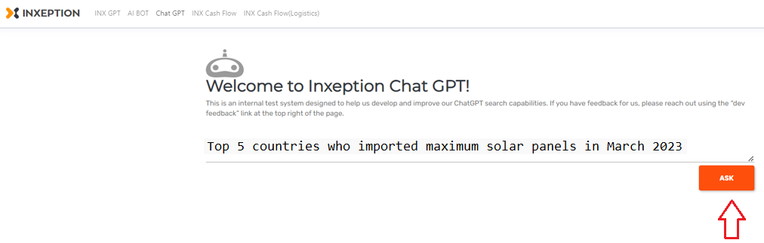

Step 6 -

Response from ChatGPT

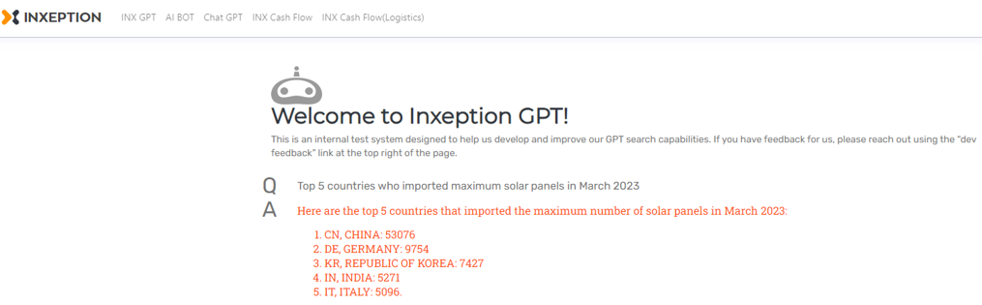

While communicating with ChatGPT, please keep in mind to be specific and clear, ask one question at a time, and form your queries in a way that requires a direct answer. Vague inquiries or multiple questions might lead to irrelevant or misleading responses.

Here we imported all data for solar panel product from product catalog and it offers comprehensive information on US import data

Here are few questions for **Solar panels**

1 What is Inxeption

2 My usage is low which solar panel is suitable for my home

3 US based solar panel brands

Questions for **US import** data are as follows

1 Top 5 countries who imported maximum solar panels in March 2023

2 How many solar panels are imported by Germany in march 23

3 How much weight imported by 845430

4 Tell me busiest port for unloading in mar23

5 Tell me no of unloading from 2704, LOS ANGELES, CA port in mar23

6 Provide details for DELTA S EDGE SOLAR LLC

7 Least used port for unloading in March 2023

8 No of unloading from 4670, UPS, NEWARK, NJ port

9 US-based solar panel manufacturers

10 TURKEY based consignee's list for solar panel in March 2023