Uml Diagram

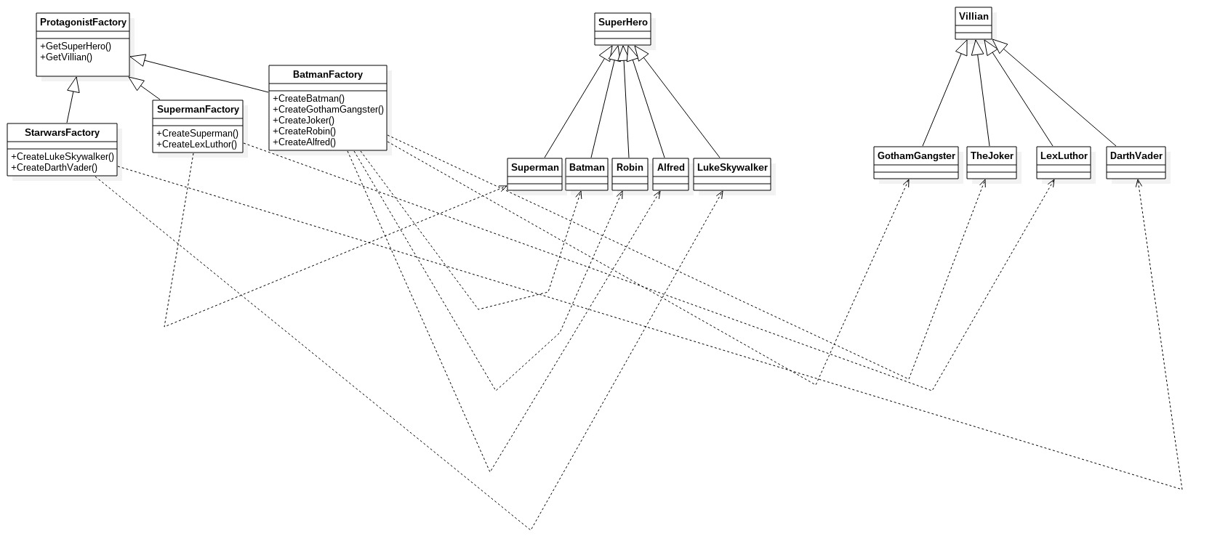
Notes
The idea behind the design is that any Saga will consist of a main protagonist (Superhero) , a nemisis (The main Villian) and both may have sidekicks.
A concrete example would be the Batman factory where the Villian would be a Concrete Joker or a Concrete Gotham Gangster. The hero of course would be a Concrete Batman. We could consider sidekicks like Robin, Alfred, Catwoman.

