|  |  |  |  |  |  |  |
| --- | --- | --- | --- | --- | --- | --- |
| |  | | --- | | **School of Engineering & Physical Sciences**  **Department of Electrical and Computer Engineering (ECE)** |  |  | | --- | | **CSE 482: Internet and Web Technology**  **Project Proposal: Group - 09**  **Section – 01**  **Spring 2022** |   **Submission deadline:- 22 February 2022**   |  |  | | --- | --- | | **Submitted By** | **Submitted to** | | Name: K.M.H. Mubin  ID: 1621802042  Name: Mosarrat Shazia Kabir  ID: 1831228642  Name: Syeda Karishma Naaz  ID: 1831270642 | **Course Faculty:**  Md. Naqib Imtiaz Hussain  (NQH) Sir  **Lab Instructor:**  Farjana Alam | |

**Table of Contents**

Table of Contents 2

Introduction 3

Background and Product Context 4

User Story 5

Use Case 1: 5

Use Case 2: 5

Use Case 3: 5

Solution Description 6

Architecture 6

Front-end plan 7

Back end development 8

Development Plan 9

Checkpoint 1 9

Deliverables: 9

Checkpoint 2 9

Deliverables: 9

CheckPoint 3 9

Deliverables: 9

Checkpoint 4 9

Deliverables: 9

Collaboration Plan 10

Project Schedule 10

Use Case Diagram 11

**Introduction:**

The introduction is about a website where students of NSU will share their ideas, communicate with each other or post their blogs. The website will contain a homepage where students of NSU can post and all posts will be visible, the will be users’ accounts and admin’s accounts. Users have the authority to edit, delete and share their posts and admins will have the rights to approve user’s accounts, blogs, and delete posts if anyone reports about that post. This website will maintain the communication among NSU students. Students will be able to get help from others. The website will maintain all the privacy of users.

This website will help all the students of NSU. It will bring all students in one frame. It will help each and every student of NSU. This website builds good communication among NSU students. This website will ensure security of users.

**Background and Product Context:**

From the beginning till now, there is always a gap in communication. It doesn’t matter whether it is a reputed organization or not. The communication gap has been seen in students. It’s a common issue among students. This is the lacking which has been seen frequently in students when they go for job interviews. Communication is key — especially in the workplace, where people need to be on the same page and be working toward the same ultimate bigger-picture goals. Working remotely can bring unique challenges to good communication as well. But, often, this skill is lacking which can lead to a whole host of issues at work.

Communication gap is the reason why students cannot communicate in their work life. Behind the communication gap, platform plays an important role. There is no platform where students can communicate with others. To communicate, students need the right platform to share their ideas, get help from others. In Bangladesh, there is no such a platform where students can communicate. There is a Facebook group where students share their thoughts, posts and communicate, especially in North South University. There are around 60K students in the group but there are so many problems students have to face in student life. As all we know, a larger group means problems in maintaining. Firstly, many important posts are not visible in groups because social media shows the post according to time. As a result, Maximum posts disappear. So students miss important notifications. They face some problems just because of social media maintenance. Secondly, students of NSU cannot share their ideas. It happens because sometimes students feel that they need the right platform where other students can see and give their feedback. Lastly, new students face some difficulties in new places. It is obvious because it is a new place, new environment and full of unknown people. However, they need a platform to get a chance to know about those places. In NSU, fresher get confused in so many things. They cannot get help from others but if they get any platform, it will be helpful for them to adjust in a new place.

Students of NSU need such a right platform to increase their communication skills, get help from others, and post their ideas and thoughts without hesitation. The Student blogging website for sharing ideas, posts and communication will increase their communication skills, and bring students in one frame. This website will be the right platform for NSU students. The website will not only help in communication, but also help with other things like non-academic help. The website will be a guide tool for NSU students. Students will get Academic and non-Academic help, career related guidance, and a friendly environment to share their problems. They can give their feedback. If a student has any questions, they will get help from this website. In short, the website will become a community which can bring NSU students in one frame.

**User Story:**

**Use Case 01:**

Anika Tabassum (Students of NSU in pharmacy dept). She needs to know about Financial Aid Recipients. She has two options.

1. Go to a website and search about financial aid recipients which will show her all the posts which have been posted on the website like this semester, previous semesters etc. She will be able to see all the posts and if she needs help from the previous semester. She will get all the help from the website.
2. She can post on the website and within a few hours, she will get help from students and admin as well. If she needs to edit or delete the post, she will get the freedom to edit the post or delete the post from the website.

**Use Case 02:**

Farhad Ahmed (Student of NSU in BBA dept.). He needs to know about Ramadan Class timing. He also has two options.

1. Search the website and get from the post which has been posted in last year Ramadan.
2. Go to the website and post on the website if he needs to know urgently.

**Use Case 03:**

Nabila Nur (Student of NSU in ECE dept). She wants to be a research assistant. But she has no idea about research. So, she has also two option

1. Search on the website and see all the posts which have been posted in previous or semester. She will have some ideas regarding research.
2. She can post on the website and she can add or delete information if she needs. There will be editing option.

**Solution Description:**

**Architecture diagram:**

This diagram illustrates how users can interact with the website and also the interaction between the frontend and backend. Aside from that, it reflects the connection between the web server and the file system and database.

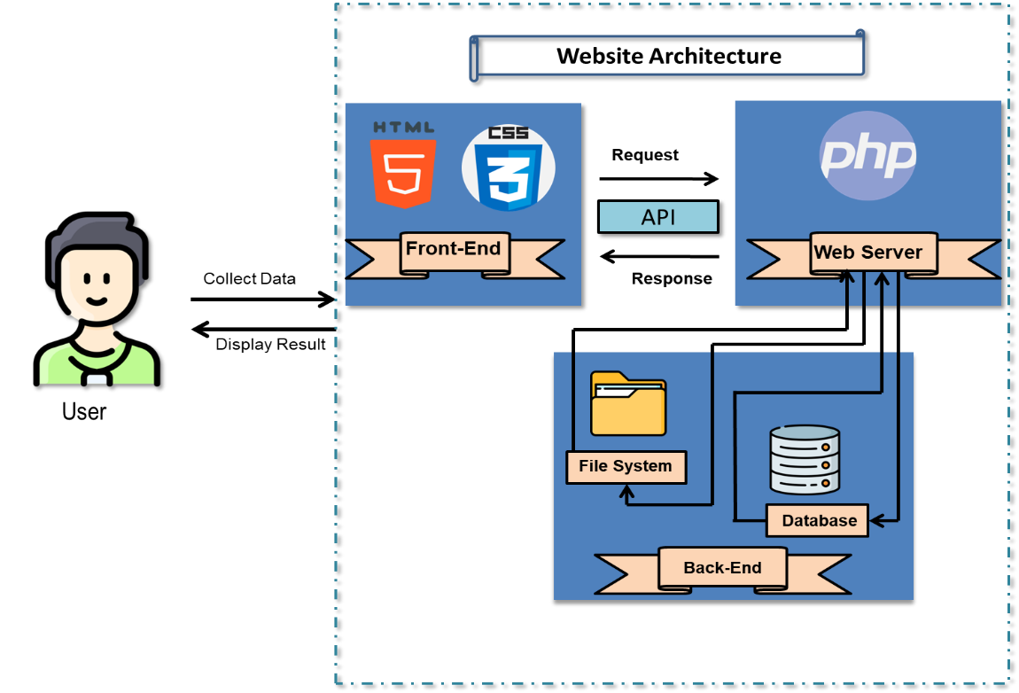

Figure-01: The Architecture Diagram for Blogging website

To design our blogging website front-end we will be using HTML5 and CSS for all the web pages. For all the forms we will be using javascrip.

For backend development we will be using PHP programming language version 7.4.16. The purpose of using PHP programming language was, it can be embedded, into HTML and it is easier to add functionality to web pages without needing to call external files for data.

As for database we have planed to use MySQL workbench v8.0.

**Front-end Plans:**

A total of 10 page-templates in plan (as of February 22, 2022)

1. Home page
2. Search result page
3. User profile
4. User Dashboard
5. Register/login page
6. Edit Profile
7. Post Blog
8. Edit/Delete blogs
9. About us
10. Contact us

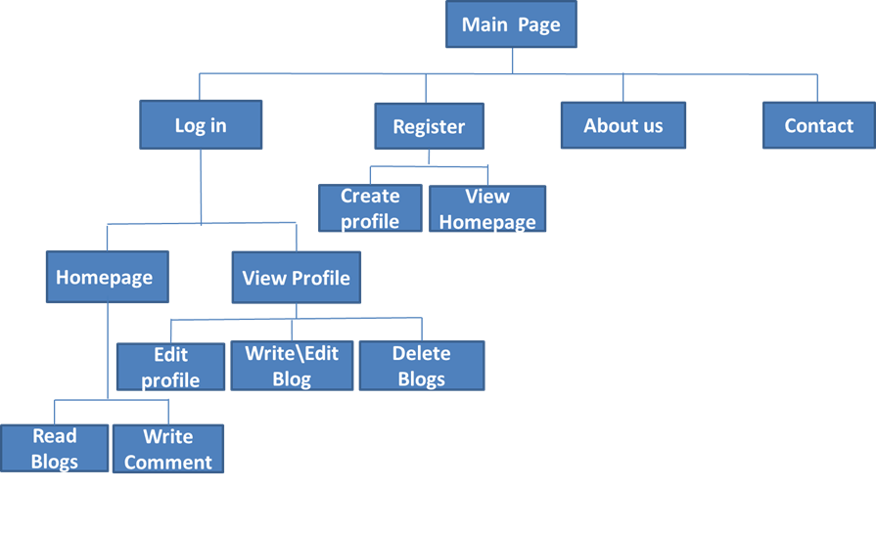

Figure-02: Front-end hierarchy of a Blogging Website

**Back-end Development:**

A total of 9 page-templates in plan (as of February 22, 2022)

1. Admin dash board
2. Admin profile
3. Request page
4. Users list
5. Blog history
6. Reports
7. Search result page
8. Register/log in
9. MySQL database

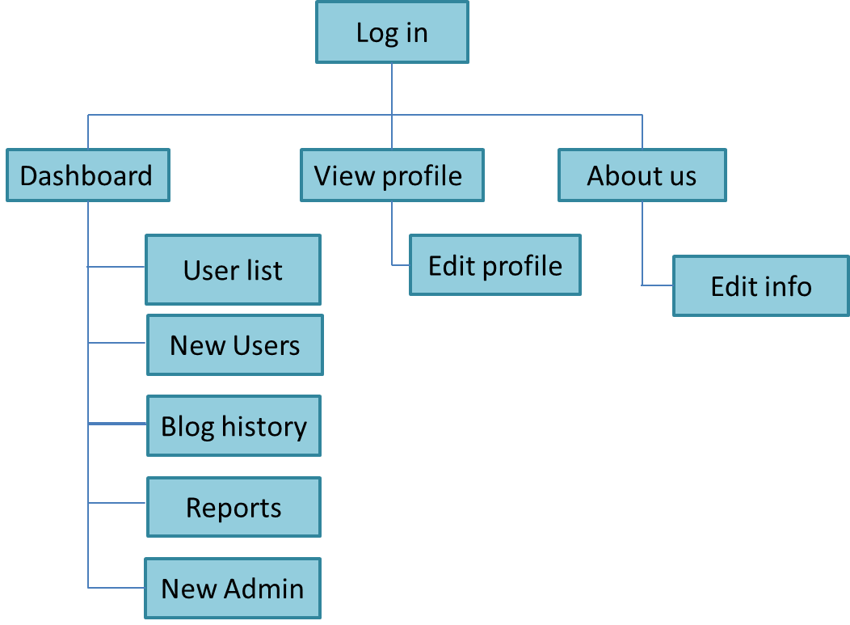

Figure-03: Back-end hierarchy of a Blogging Website

**Development Plan:**

Development methodology will adopt the agile methodology. Each cycle will complete in exactly 2 weeks (10 working days).

**Checkpoint 1**

Duration: We will design a prototype of how the front end would look like. It will take a total of 2 weeks design the frontend of the website.

Deliverables:

At the end of this phase, we will start developing our website with the design in mind.

**Checkpoint 2**

This phase shall develop a basic and initial frontend. This phase is the lay foundation of the product. It will take 2 weeks to design the front end.

Deliverables:

At the end of this phase, the user will receive a fully deployed functional website with acceptable performance and user experience.

**Checkpoint 3**

This phase shall develop the backend of the website. This phase will develop the database structure and connection to the database.

Deliverables:

At the end of this phase, the user will search the destination and other things through the database.

**Checkpoint 4**

This phase shall connect with APIs and hosting the website on the Internet. It will make the website live and can access from anywhere.

Deliverables:

At the end of this phase, the user can access the website from anywhere in the world.

**Collaboration Plan:**

All task to be reported on the GitHub Issue system. It provides the team for raising issues as the development progresses. Here is the dedicate task assign to all the members evenly.

|  |  |  |
| --- | --- | --- |
| Task Front-End Back-End | Front-End | Back-End |
| Homepage | Mosarrat Shazia Kabir | Mosarrat Shazia Kabir |
| Article Page | K. M. H. Mubin | K. M. H. Mubin |
| Profile Page | Syeda Karishma Naaz | Syeda Karishma Naaz |
| User Dashboard | Syeda Karishma Naaz | Syeda Karishma Naaz |
| About Us | K. M. H. Mubin | K. M. H. Mubin |
| Contact Us | Mosarrat Shazia Kabir | Mosarrat Shazia Kabir |
| Admin Dashboard | Mosarrat Shazia Kabir | Mosarrat Shazia Kabir |
| Sign up/ in page | K. M. H. Mubin | K.M. H. Mubin |

**Project Schedule:**

It will take a total of 12 weeks from the day of start to complete the project.

|  |  |  |  |  |  |  |  |  |  |  |  |  |
| --- | --- | --- | --- | --- | --- | --- | --- | --- | --- | --- | --- | --- |
|  | **Weeks** | | | | | | | | | | | |
| **Tasks** | 1-2 | | 3-4 | | 5-6 | | 7-8 | | 9-10 | | 11-12 | |
| Project Proposal |  | |  |  |  |  |  |  |  |  |  |  |
| Front-end Design |  |  | | |  |  |  |  |  |  |  |  |
| Back-end Development |  |  |  | | | | | | | |  |  |
| Finalizing & Refactoring |  |  |  |  |  |  |  |  |  |  | |  |
| Deployment |  |  |  |  |  |  |  |  |  |  |  | |

**Use Case Diagram:**

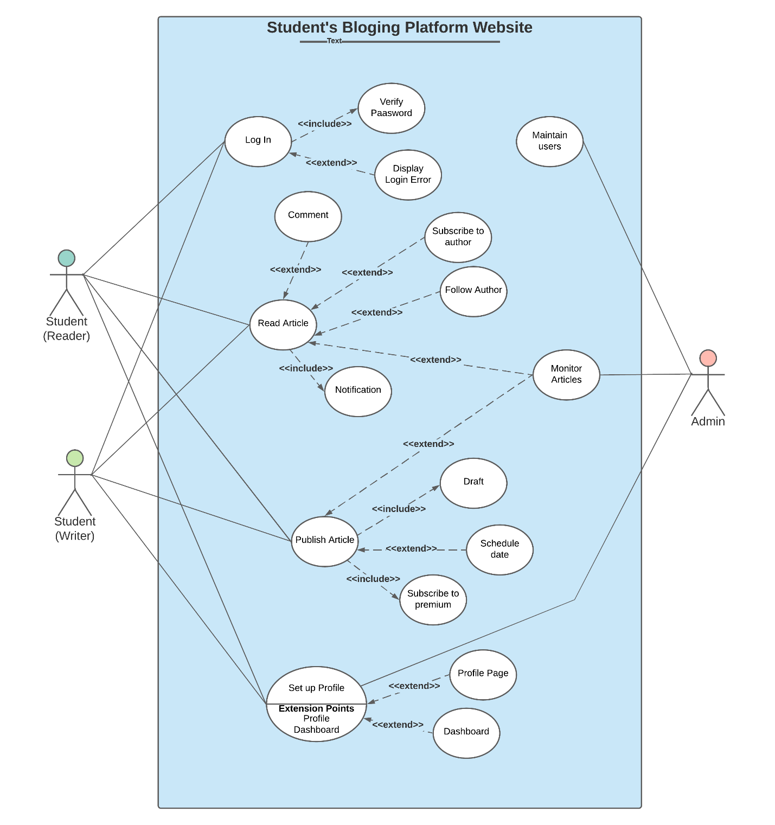

Figure-03: Use Case Diagram of a Blogging Website