Executive Summary
(As of YYYY_MM_DD)
Weekly Direction | Influencing Factors | Current Environment
[[weekly_direction]] | - [[influencing_factors]] | 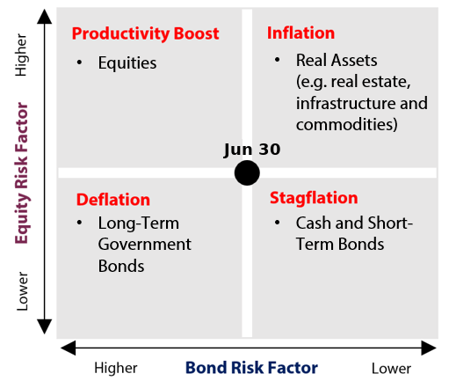

Theme | Status | One-line development
1. Fiscal Expansion & Deregulation | [[Status word]] | [[One-line development]]
2. Currency Debasement | [[Status word]] | [[One-line development]]
3. Energy & the Energy Transition | [[Status word]] | [[One-line development]]
4. Artificial Intelligence | [[Status word]] | [[One-line development]]
5. Geopolitics & Trade | [[Status word]] | [[One-line development]]
6. Domestic Investing Pressures | [[Status word]] | [[One-line development]]

Theme 1 — Fiscal Expansion & Deregulation
(As of YYYY_MM_DD)
Status:
[[Status word (Escalating / Held / Deescalating) ▸ what decided it, with the data; the read woven in as a clause.]]
Insert fiscal_chart_1 | What changed this week  - [[Development 1 — the week's story, facts first, every number with prior/expectation/trend context.]]
Insert fiscal_chart_2
Key Development of the Week:

Implication for the theme  [[2–3 sentences tying the week to the thesis and the asset-class read.]] | Watch next week  - [[Named release/event — falsifiable, dated.]]

Theme 1 Appendix — Monetary Policy Tracker
(As of YYYY_MM_DD)
Status:
[[Status word (Escalating / Held / Deescalating) ▸ what decided it, with the data; the read woven in as a clause.]]
Insert monetary_1 | What changed this week  - [[Development 1 — the week's story, facts first, every number with prior/expectation/trend context.]]
Central Bank | Key Policy Rate | Expected Cycle / Note
[[cb_bank]] | [[cb_rate]] | [[cb_cycle]]

Implication for the theme  [[2–3 sentences tying the week to the thesis and the asset-class read.]] | Watch next week  - [[Named release/event — falsifiable, dated.]]

Theme 2 — Currency Debasement
(As of YYYY_MM_DD)
Status:
[[Status word (Escalating / Held / Deescalating) ▸ what decided it, with the data; the read woven in as a clause.]]
What changed this week  - [[Development 1 — the week's story, facts first, every number with prior/expectation/trend context.]] | Insert currency_1
Insert currency_2 | Insert currency_3
Key Development of the Week:

Implication for the theme  [[2–3 sentences tying the week to the thesis and the asset-class read.]] | Watch next week  - [[Named release/event — falsifiable, dated.]]

Theme 3 — Energy & the Energy Transition
(As of YYYY_MM_DD)
Status:
[[Status word (Escalating / Held / Deescalating) ▸ what decided it, with the data; the read woven in as a clause.]]
Insert energy_1 | What changed this week  - [[Development 1 — the week's story, facts first, every number with prior/expectation/trend context.]]
Insert energy_2
Key Development of the Week:

Implication for the theme  [[2–3 sentences tying the week to the thesis and the asset-class read.]] | Watch next week  - [[Named release/event — falsifiable, dated.]]

Theme 4 — Artificial Intelligence
(As of YYYY_MM_DD)
Status:
[[Status word (Escalating / Held / Deescalating) ▸ what decided it, with the data; the read woven in as a clause.]]
Insert AI_1 | What changed this week  - [[Development 1 — the week's story, facts first, every number with prior/expectation/trend context.]]
Insert AI_2
Key Development of the Week:

Implication for the theme  [[2–3 sentences tying the week to the thesis and the asset-class read.]] | Watch next week  - [[Named release/event — falsifiable, dated.]]

Theme 5 — Geopolitics & Trade
(As of YYYY_MM_DD)
Status:
[[Status word (Escalating / Held / Deescalating) ▸ what decided it, with the data; the read woven in as a clause.]]
Insert geo_1 | What changed this week  - [[Development 1 — the week's story, facts first, every number with prior/expectation/trend context.]]
Insert geo_2
Key Development of the Week:

Implication for the theme  [[2–3 sentences tying the week to the thesis and the asset-class read.]] | Watch next week  - [[Named release/event — falsifiable, dated.]]

Theme 6 — Domestic Investing Pressures
(As of YYYY_MM_DD)
Status:
[[Status word (Escalating / Held / Deescalating) ▸ what decided it, with the data; the read woven in as a clause.]]
What changed this week  - [[Development 1 — the week's story, facts first, every number with prior/expectation/trend context.]] | Insert domestic_1  Insert domestic_2
Key Development of the Week:

Implication for the theme  [[2–3 sentences tying the week to the thesis and the asset-class read.]] | Watch next week  - [[Named release/event — falsifiable, dated.]]

Lights Guide Appendix
Each theme carries a coloured light showing the direction of the theme this week, not whether it is good or bad for the portfolio.
Green (Escalating) means more of the theme: the trend is reinforcing and the signals are getting stronger. Amber (Held) means mixed or null developments, no material change. Red (Deescalating) means less of the theme: the outlook is fading.
What more and less mean is theme-specific. Fiscal: more spending and deregulation. Currency Debasement: weaker dollar confidence. Energy: more transition and electrification. AI: more buildout. Geopolitics and Trade: more conflict and worse trade. Domestic: more domestic or protectionist policy.
The Status Dashboard light is the theme-level read. The Key Risks register tracks each named risk separately.
References
[[Only sources cited this week. Deduplicate. Include retrieval date. Do not reproduce the AIP references.]]
  - [[Source name. “Title.” Publication date. URL. Retrieved [date].]]

