Executive Summary
(As of 2026_07_03)
Weekly Direction | Influencing Factors
Moderating inflation expectations and held growth. | - Hiring is slowing: June payrolls showed the softest month this year, with April and May revised down.  - Euro inflation cooled to 2.8% from 3.2%, and WTI slid to $67.59, the lowest since February, with OPEC+ adding supply and urea down about 21% in a month.  - The 2-year yields fell with jobs report, the dollar slipped off a 15-month high, gold reclaimed $4,000.
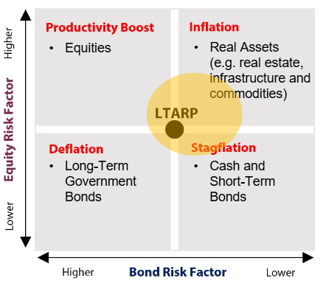

07/03
06/25
Theme | Status | One-line development
1. Fiscal Expansion and Deregulation | Escalating | More defence money: the UK expanded its investment plan; NATO's 5% roadmaps land July 7-8. China austerity still offsets with lower fiscal spending.
2. Currency Debasement | Escalating | Gold back above $4,000 as hike bets slowed; the dollar slipped from a 15-month high; the yen held near 160 unaided. A slightly less hawkish pricing showed dollar still strongly vulnerable to macroeconomic developments.
3. Energy and the Energy Transition | Held | Grid capital keeps flowing, GRID ETF near doubled in a year to $11.2B; Spain shows the cost of a lack in infrastructure buildout. US summer grid strain led to emergency act firing up non-renewables to meet demand.
4. Artificial Intelligence | Held | South Korea put $880B behind AI hardware and Q2 DRAM contracts rose up to 89%, but markets are pricing in over-building, and Semis saw a steep decline amid liquidation, putting the theme on hold and at risk if continued.
5. Geopolitics and Trade | Held | US-Iran war leg keeps cooling and Ukraine conflict gains momentum. CUSMA not renewed and set for yearly reviews and China-Europe talks raise concerns over widening trade deficit.
6. Domestic Investing Pressures | Held | April GDP +0.5%, the best month since July 2025, softens the recession story; the Major Projects pipeline keeps building.

Key Developments | Implication for Themes
- The US labour market showed signs of weakness. June payrolls rose 57,000 against a 115,000 consensus, the weakest month this year, and April and May were revised down a combined 74,000 to 148,000 and 129,000. Unemployment slipped to 4.2% from 4.3%, but for the wrong reason: participation fell 0.3 points to 61.5%. Wages behaved, up 0.3% on the month and 3.5% on the year. The 2-year yield fell about 5bp to 4.11% as the summer hike is no longer priced. | - This is the slower-growth half of the call landing. A Fed that was debating a hike is now debating how long to hold, which caps the dollar, helps duration and takes pressure off risk assets. This had strong implications for the currency debasement (weakening dollar) and potentially longer hold led to equities gain, supporting growth at the margin.
- CUSMA was not renewed. At the first joint review on July 1 the US declined to extend, so the pact rolls into annual reviews until its 2036 sunset unless leaders later agree otherwise. USTR pointed at deficits and unresolved shortcomings, a third US-Mexico round comes the week of July 20, and Canada reaffirmed it wants renewal. | - The AIP base case, serial annual reviews and no 2026 deal has materialized. The uncertainty taxes long-horizon Canadian capex, keeps autos, steel and aluminum exposed, and hands Ottawa another argument for building at home.
- The war premium finished unwinding in the markets. WTI settled at $67.59 Thursday, down 1.4% on the day and the lowest since late February, with Brent at $70.60. Hormuz flows are back above 10 mb/d, indirect US-Iran talks in Qatar are advancing, and OPEC+ is expected to add about 188 kb/d for August at its July 5 meeting, a third straight monthly increase. Even urea has collapsed, down 21% in a month to $368/t. | - Supply is being added into a soft tape while the last war channels let go, fertilizer included. That is a building disinflation impulse for the second half and the cleanest support for the moderating-inflation call. Development conducive to less concern of inflation, and coupled with softer labour data also implying repriced hawkishness.
- The AI buildout went sovereign. South Korea lined up 1,350 trillion won, about $880B and roughly 5% of its GDP: 800T won of Samsung and SK fabs plus 550T won for 8.4 GW of AI data centres by 2029. SK Hynix priced its $29.65B Nasdaq raise for July 10, and Q2 DRAM contracts rose up to 51% on DDR4 and 89% on mobile memory after a record Q1. | - Demand and financing keep developing the buildout thesis. The new information is cost: memory is now an inflation channel of its own, and Microsoft books $25B of its 2026 capex as pure component inflation. The backdrop had a negative impact on semis as a whole due to oversupply concern and liquidations.

Theme 1 — Fiscal Expansion and Deregulation
(As of 2026_07_03)
Status:
Escalating ▸ The defence-fiscal leg hardened: the UK wrote £298B over four years into its investment plan and every NATO member's 5% roadmap lands July 7-8. Russia-Ukraine conflict ramps up prior to Ankara summit.
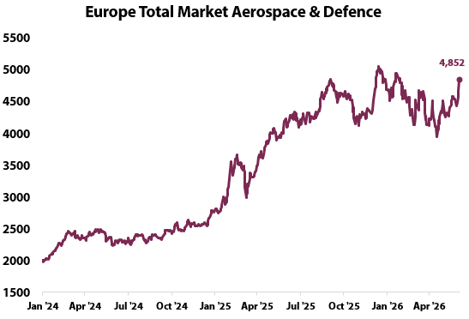 | What changed this week  - “Most massive” attack on Kyiv from Russia kills at least 20 people. Ministries and officials are putting support for Ukraine as a top priority ahead of Ankara summit, supporting the defence spending theme.  - The July 7-8 summit collects every member's national roadmap to 5% by 2035. The starting point is strong: all 32 allies cleared the old 2% floor in 2025, European allies and Canada lifted spending about 20% in real terms in a single year, and a few members reach 5% already this year. The push is for larger spending from EU/Canada and continued support for Ukraine.  - The UK’s Defence Investment Plan commits £298B over four years, £15B of it new money for 2026-27 through 2029-30 and about £60B above the pre-2024 path, a 27% real increase from 2023-24 to 2029-30. Core NATO spending reaches 2.7% of GDP from 2027-28, third in the alliance behind the US and Germany.  - New CIA Director Ratcliffe promised faster deployment of AI and quantum computing, calling emerging tech a rewrite of geopolitics: about 400 tech contracts signed in six months, acquisition timelines cut from 24 months toward six. Defence-tech procurement is becoming a large source of fiscal spending and geopolitical warfare.  - China stayed the offset in terms of spending but June's official manufacturing PMI rose to 50.3 from 50.0, above the 50.1 expected and a third month of expansion, carried by high-tech export demand.  - On the deregulatory front, the Trump administration called for a proposal which raises the bar for an energy regulatory action to pass which would develop the “Unleashing prosperity through deregulation” in Trump’s campaign but the proposal is still under assessment from the Executive Branch.
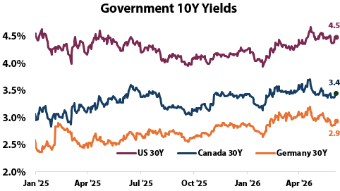
Implication for the theme  The continued spending and defence narrative remains a key narrative, and geopolitical developments in Ukraine tie in ahead of a relevant checkpoint in Ankara for defence spending. The summit will be comprised of all NATO members, and if the push for Europe/Canada defence spending and support persists in the agenda the narrative gains strong momentum. | Watch next week  - NATO Ankara summit July 7-8  - China's stimulus posture after three months of falling spending; next CBO and Treasury refunding updates.

Theme 1 (Appendix) — Monetary Policy Tracker
(As of 2026_07_03)
Status:
No fed moves, but the jobs miss repriced the Fed: the summer hike came out of the market amid softer jobs data.
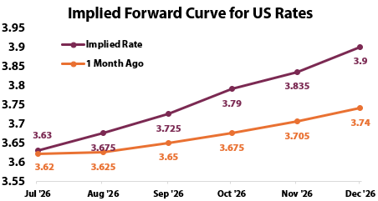 | What changed this week  - Payrolls rose 57,000 against a 115,000 consensus, the softest print this year, and revisions took another 74,000 out of April and May, now 148,000 and 129,000. Unemployment fell to 4.2% from 4.3%, but participation fell 0.3 points to 61.5%, so the improvement came from a shrinking labour force. Wages data was moderate, up 0.3% on the month and 3.5% on the year.  - Markets repriced within hours and every asset told the same story: the 2-year fell about 5bp to 4.11% from 4.18% as the summer hike came out of the curve, the dollar slid off Wednesday's 15-month high toward 100.75, and gold jumped back through $4,000  - The rest of the labour tape argues stall, not break, which is why the read is a longer hold rather than cuts. May openings held at 7.6 million, a two-year high against roughly 7.0 million expected, initial claims fell to 215,000 against 219,000 expected, and ADP counted 98,000 private jobs, just under forecast. Low layoffs, slow hiring.  - June ISM manufacturing printed 53.3, down from 54.0 and below the 54 expected, a sixth straight month of expansion consistent with about 2% GDP growth, and its prices-paid index fell 9.1 points to 73.0, the largest monthly drop since 2022, though 15 of 18 industries still report paying more.  - Policy makers split around the data. Warsh would not validate the move, calling inflation too high while admitting easing expectations encourage him, and the Supreme Court kept Governor Cook at the Fed 5-4, so the independence tail risk faded.  - Euro flash inflation cooled to 2.8% from 3.2% with energy down to 8.7% from 10.8%, euro unemployment held at 6.2% in May, and Japan's Tankan (business survey) hit an eight-year high at +22 from +17 with record 2.6% corporate inflation expectations, feeding the BoJ hike case after June's move to 1.00%.
Central Bank | Key Policy Rate | Expected Cycle
US (Fed) | 3.50-3.75% | Hold; hike bias fading
Canada (BoC) | 2.25% | On hold, decides July 15
ECB | 2.25% | Hike path softening
Japan (BoJ) | 1.00% | Hiking; Tankan feeds next move
China (PBoC) | 3.00% | Easing
Brazil | 14.25% | Holding
England (BoE) | 3.75% | On hold
Hungary (MNB) | 6.00% | Cutting
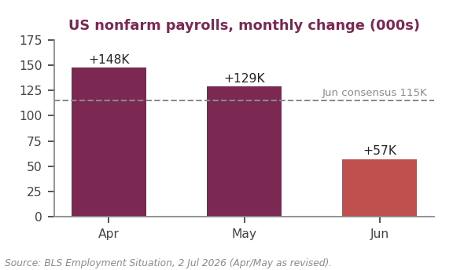

Theme 2 - Currency Debasement
(As of 2026_07_03)
Status:
Escalating ▸ Gold reclaimed $4,000 as hike bets faded and the dollar slipped from a 15-month high; the yen held 160 without help. Macro take: softer US data means a softer dollar prop; the debasement bid breathes again without a structural break.
What changed this week  - Gold quoted as high as $4,135 intraday Thursday with futures settling near $4,079. It is still down about 7% over a month and up about 24% over a year. The driver has flipped from war hedging back to rate pricing. As yields moved lower and dollar lost value gold gained momentum.  - Real rates frame the rally. The 10-year TIPS yield near 2.2% is still restrictive and 10-year breakeven near 2.2% stay anchored, so the gold bid is a front-end and dollar story, not an inflation-expectations break. That keeps it rate-sensitive both ways.  - The yen held near 160 unaided, and the ground may be shifting under it. These developments (lower fed rate hike and strong business in Japan) ease the need for intervention, as both the carry unwind and softer dollar help relieve the yen's crash. | 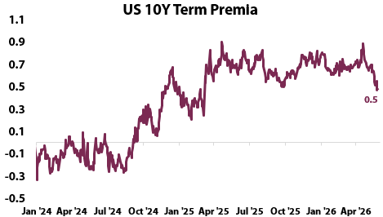Calculated by Fed Economists to reflect the premium associated with longer maturities; >0 implies compensation from holding longer term maturities. <0 implies cost, longer bonds serve as a hedge.
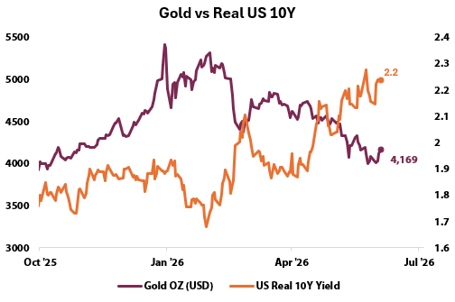 | 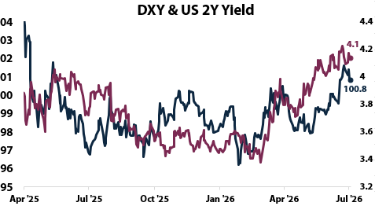
Implication for the theme  Last week's call that debasement was on pause is already softening: the bid returns whenever the dollar's rate support slips. Keep gold as the cleanest expression. The yen is turning two-sided: a BoJ on the move narrows the carry gap and eases the disorderly-selling tail risk on Treasuries. | Watch next week  - IMF COFER Q1 (USD share versus 56.77%); May TIC data.  - USD/JPY against 160-162 and BoJ signals after the Tankan; gold through the Fed minutes.

Theme 3 - Energy and the Clean transition
(As of 2026_07_03)
Status:
Held ▸ GRID sees rotation as the AI theme slows down. Power sees surge in price amid US heat strike and calls for non-renewable energy expansion to meet constraint.
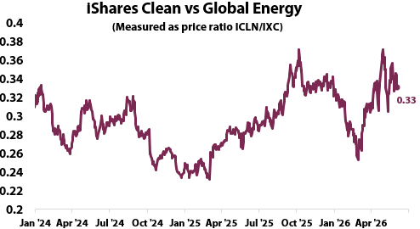 | What changed this week  - The grid trade is getting crowded. GRID, the smart-grid infrastructure ETF, has taken in $3.1B this year and reached $11.2B of assets by June 28, roughly double a year ago, riding AI power demand into Eaton, Schneider, ABB and Quanta. The large influx of capital is extremely contingent and tied to the AI theme.  - The US declared a level 2 national emergency as extreme heat led to a surge in power demand. The measure allows for generators to produce at over-capacity to meet demand constraints, underscoring the general grid capacity shortage.  - Spain showed why the grid thesis matters. Bloomberg's June 29 profile of the solar and wind boom turned investor bust counts nearly 9 TWh of renewables curtailed without compensation in the first eleven months of 2025, about 3% of national demand. Building generation faster than grid and returns evaporate; it is the same lesson the AI buildout is pricing from the demand side.  - Copper, the transition's other proxy, eased to about $13,400 a tonne from May's record near $14,800, cooling with the softer growth data rather than with the theme. Towards the end of the week as the rates repriced and dollar slid, copper gained some strength as it tends to be correlated with lower borrowing costs and a weaker dollar.  - India's $109B transmission plan, last week's anchor, stays the reference case; no tenders crossed in-window and the FERC and IEA checks came back null. The theme idles until the next dated grid commitment.
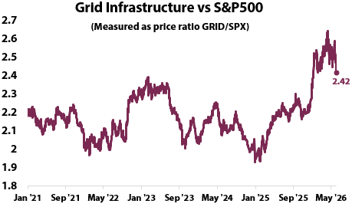
  - The GRID v SPX slid due to broad equity gains and rotation away from infrastructure took place, as the liquidation from AI providers took place.

Implication for the theme  Grid-enabling assets, equipment, transmission and storage, as the cleanest expression of the transition. A decline in GRID has implications for the AI theme because the buildout and extreme valuations were under the assumptions of large increases in GRID to meet excess demand caused by AI. If the theme slows or is pushed back, pricing will reflect that and lead to lower growth and financing. | Watch next week  - India transmission tender flow; FERC action on large-load interconnection.  - Spain's policy response to curtailment; IEA mid-year electricity update.

Theme 4 – Artificial Intelligence
(As of 2026_07_03)
Status:
Held ▸ Korea put about $880B behind hardware, SK Hynix priced $29.65B and Q2 DRAM contracts rose up to 89%, but markets see concern of oversupply and liquidated positions. The buildout is now big enough to show up in inflation; memory and components are a rising cost channel.
 | What changed this week  - The buildout found its biggest sponsor yet. South Korea lined up about 1,350 trillion won, near $880B and roughly 5% of GDP: Samsung and SK chip plants, two each plus a Gwangju memory hub and HBM packaging sites, and 550T won for 8.4 GW of AI data-centre capacity by 2029 with Naver and others.  - Memory is where the demand shows up as price. Q2 DRAM contracts rose up to 51% on DDR4 and 89% on mobile LPDDR5X after a record Q1, suppliers are locking buyers into second-half contracts, and Micron's HBM remains sold out into 2028.  - However, the buildout was received as a liquidating signal from the market; The SOX slid as oversupply concerns in memory were raised. The end of the first half of the year also cause profit liquidations, leading to steep corrections.  - On the other hand, the SPX (compared in both charts) saw a positive headwind from a slightly less hawkish reprice, suggesting a rotation on the theme, as mega-caps and cyclicals benefited, netting out the Semis slide.
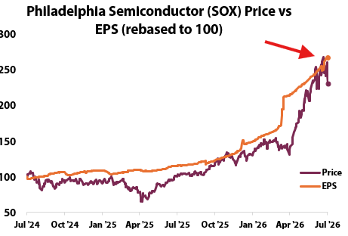
Key Development of the Week:
The market repriced the buildout. Meta's July 1st announcement that it will sell surplus AI compute and host models through a new Meta Compute unit broke the scarcity premise the trade had been built on. The SOX fell 5.4% Thursday, its sharpest single-day drop since March 2020, with semis down 12% over two sessions. The liquidation was concentrated in infrastructure providers, memory (Micron −13%, SanDisk −14%), semi equipment (KLAC −12%, LRCX −10%), and neoclouds (CoreWeave −14%, Nebius −17).
Implication for the theme  The liquidation of positions and continued buildout reflect market concerns of potential buildout. If this trend continues over the next week, growth is expected to stall as the primary support for high valuations fades. | Watch next week  - SK Hynix Nasdaq debut around July 10: the cleanest financing-appetite test.  - Hyperscaler Q2 capex guidance; the FTC probe's scope; OpenAI and Anthropic IPO timing.

Theme 5 – Geopolitics and Trade
(As of 2026_07_03)
Status:
Held ▸ On US-Iran the war leg kept cooling, WTI at $67.59 and even fertilizer let go reducing food-transmission channel concern. Russia-Ukraine development conflict led to geopolitical unease prior to Ankara summit. The trade leg hardened with CUSMA unrenewed, and China-Europe talks underscore one of the most important trade imbalances in current international trade.
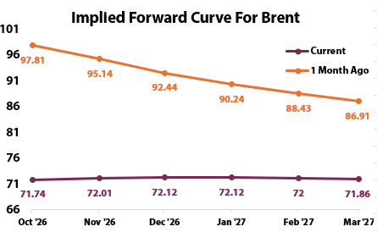 | What changed this week  - CUSMA was not renewed from 2036, as the first trilateral joint review on July 1 the US declined to extend. USTR Greer cited deficits and unresolved shortcomings, a third US-Mexico round is set for the week of July 20, and Minister LeBlanc reaffirmed Canada wants renewal. The July calendar stays loaded: USTR's Section 301 hearing on July 7 and the flat 10% tariff expiring July 24.  - WTI settled at $67.59 on Thursday, down 1.4% on the day and the lowest since late February, with Brent at $70.60, as Hormuz flows held above 10 mb/d with US military support and indirect US-Iran talks in Qatar advanced. OPEC+ is expected to add about 188 kb/d for August at its July 5 meeting, a third straight monthly increase into a falling market.  - The war's stickiest channel gave way. Urea traded flat at $368/t on June 30, down about 21% in a month and 10% below a year ago, a full retreat from March's four-year high near $726 when Hormuz disruption had the World Bank warning of a 60% annual surge. Sulphur is normalizing off its late-2025 peak. The fertilizer-to-food transmission risk is fading with it.  - Commissioner Sefcovic met China's commerce minister Wang Wentao on June 29, with the Commission calling the 360 billion euro deficit, growing at nearly a billion a day, unsustainable; Chinese imports into Europe are up 45% over five years and a diversification instrument is being drafted.
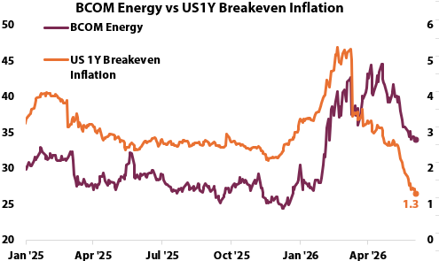
Key Development of the Week:
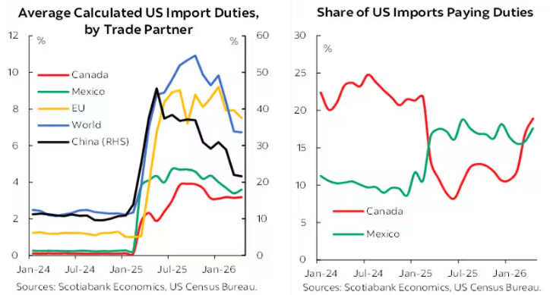
The CUSMA review landed exactly on the AIP base case, serial annual reviews and no extension. That is a regime, not an event: tariffs stay, the review calendar never closes, and every summer now carries renewal risk. Canada benefited from the lowest import duties due to the CUSMA agreement, and friction in this theme causes strong recessionary implications for Canada given the trade reliance. US however has strategic dependences on Canada, so the risk is not extreme.

Implication for the theme  Annual reviews tax long-horizon cross-border capex, keep autos, steel and aluminum the exposures to hedge, and add another push toward domestic deployment. Both China and USCMA outcomes are inflationary and anti-growth, since trade fragmentation eliminates gains from trade, rising prices and diminishing output. Cheap oil and fertilizer are the offsets on the theme’s implications. | Watch next week  - USTR Section 301 hearing July 7; Section 122 tariff expiry July 24; US-Mexico round week of July 20.  - OPEC+ July 5 decision; Hormuz flow data; the oil passthrough in June CPI.

Theme 6 – Domestic Investment Pressures
(As of 2026_07_03)
Status:
Held ▸ April GDP +0.5%, the best month since July 2025, blunts the recession story while the state pipeline keeps building. Growth picked up mostly from commodities, policy unchanged; the domestic push is structural, not cyclical.
What changed this week  - Last week's technical-recession framing met better data. Real GDP rose 0.5% in April, the strongest month since July 2025 after March's 0.1% dip, with 14 of 20 sectors up. The thing to note is: mining, quarrying and oil and gas led at 2.9%, the sector's best since February 2024 and mostly an oil-sands maintenance rebound (+6.6%), and the May advance reads just +0.1%. This is stabilization, not takeoff.  - Underneath, the same release carries the theme's fingerprints. Construction rose 0.7% for its first gain in five months, non-residential building extended a ten-month run, and defence services grew a seventh straight month. Where policy pushes, the data is starting to follow.  - The machinery rolled on regardless of the print. The Major Projects Office tally stands at 15 referred projects and six strategies across nuclear, LNG, critical minerals and transport corridors; the Canada Strong Fund is drawing governance scrutiny ahead of first deployments, with its retail product expected in the fall. And CUSMA's non-renewal (Theme 5) hands Ottawa a fresh argument for steering capital home.  - The currency still tells the softer story. The loonie ended the week at 1.4216 per US dollar, its weakest in a year and down about 2.3% over a month as the greenback rode the hawkish-Fed run; a cheaper currency cushions exporters heading into the CUSMA uncertainty. | 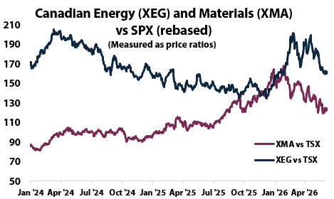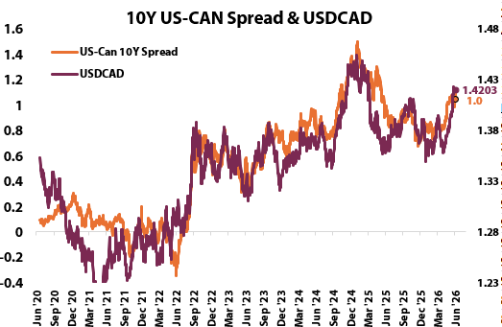
Key Development of the Week:
Key development: the growth floor held without changing the story. April's +0.5% is the strongest month in nine and pushes against the technical-recession framing that anchored last week, but the gain leaned on a volatile oil-sands rebound and May's advance is only +0.1%. What matters for the theme is that the policy machinery, Major Projects, Darlington, the Strong Fund, moves on its own schedule regardless of the cycle. That is exactly what makes the pressure structural. | 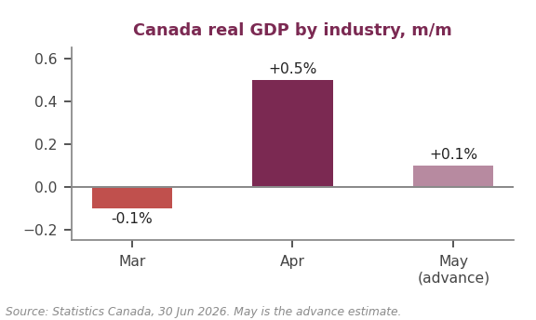  Chart: Statistics Canada

Implication for the theme  A firmer economy lowers the urgency but not the direction: with CUSMA unrenewed, the case for steering capital home strengthens either way. For pension capital the test remains deployment quality; Macklem's misallocation warning is still the benchmark. | Watch next week  - Official May GDP on July 31; BoC decision July 15 after the growth surprise.  - Canada Strong Fund board and first deployments; the next Champagne round-table; peer-plan disclosures.

Lights Guide Appendix
Each theme carries a coloured light showing the direction of the theme this week, not whether it is good or bad for the portfolio.
Green (Escalating) means more of the theme: the trend is reinforcing and the signals are getting stronger. Amber (Held) means mixed or null developments, no material change. Red (Deescalating) means less of the theme: the outlook is fading.
What more and less mean is theme-specific. Fiscal: more spending and deregulation. Currency Debasement: weaker dollar confidence. Energy: more transition and electrification. AI: more buildout. Geopolitics and Trade: more conflict and worse trade. Domestic: more domestic or protectionist policy.
The Status Dashboard light is the theme-level read. The Key Risks register tracks each named risk separately.
References
Only sources cited this week, deduplicated, grouped by section. Each item states its tier. Retrieved 2 July 2026.
Executive Summary — Weekly Direction & Key Developments
  - (Tier 1) U.S. Bureau of Labor Statistics. The Employment Situation, June 2026 (payrolls +57,000; unemployment 4.2%; participation 61.5%). 2 July 2026. https://www.bls.gov/news.release/empsit.nr0.htm. Retrieved 2 July 2026.
  - (Tier 1) Institute for Supply Management. Manufacturing PMI, June 2026 (53.3; prices paid 73.0, -9.1pts). 1 July 2026. https://www.ismworld.org/supply-management-news-and-reports/reports/ism-pmi-reports/. Retrieved 2 July 2026.
  - (Tier 1) Eurostat. Euro area flash HICP, June 2026 (2.8% from 3.2%). 1 July 2026. https://ec.europa.eu/eurostat/web/products-euro-indicators/w/2-01072026-ap. Retrieved 2 July 2026.
  - (Tier 2) CNBC. 2-year Treasury yield eases as light jobs report reduces Fed hike expectations (2-year 4.108%). 2 July 2026. https://www.cnbc.com/2026/07/02/us-treasury-yields-rise-as-investors-await-june-jobs-report.html. Retrieved 2 July 2026.
  - (Tier 2) TheStreet. Stock market today, July 2 2026 (WTI $67.59; Brent $70.60; gold futures ~$4,079; claims 215,000; Dow Jones consensus 115,000). 2 July 2026. https://www.thestreet.com/stock-market-today/stock-market-today-dow-jones-sp-500-nasdaq-updates-july-2-2026. Retrieved 2 July 2026.
  - (Tier 2) Trading Economics. Gold spot ($4,135.60 intraday, 2 July) and urea ($368/t, -21% m/m) pages. https://tradingeconomics.com/commodity/gold. Retrieved 2 July 2026.
  - (Tier 1) Federal Reserve Bank of St. Louis (FRED). 10-Year Breakeven Inflation Rate, 2.21-2.22% at 29-30 June 2026; CBOE VIX 16.59 on 2 July 2026. https://fred.stlouisfed.org/series/T10YIE. Retrieved 2 July 2026.
  - (Tier 1) FRED / ICE BofA. US corporate OAS: investment grade ~80bp, high yield ~280-285bp (17th percentile of ten years), late June 2026. https://fred.stlouisfed.org/series/BAMLH0A0HYM2. Retrieved 2 July 2026.
Theme 1 — Fiscal Expansion & Deregulation
  - (Tier 1) GOV.UK. The Defence Investment Plan, funding explainer (£298B over four years; +£15B new money; 2.7% of GDP core NATO from 2027-28). 2026. https://www.gov.uk/government/publications/the-defence-investment-plan/the-defence-investment-plan-funding-explainer. Retrieved 2 July 2026.
  - (Tier 1) NATO. Overview, 2026 NATO Summit in Ankara (July 7-8; national 5% roadmaps; all 32 met 2% in 2025). 2026. https://www.nato.int/en/news-and-events/events/2026/07/overview---2026-nato-summit-in-ankara-. Retrieved 2 July 2026.
  - (Tier 2) Bloomberg. AI advances drive CIA to overhaul tech strategy and acquisition timelines (Ratcliffe; ~400 contracts; 24 months to 6). 30 June 2026. https://www.bloomberg.com/news/articles/2026-06-30/cia-aims-to-speed-tech-adoption-as-ai-is-rewriting-conflict. Retrieved 2 July 2026.
  - (Tier 2) The Washington Post. CIA to accelerate its use of AI and other advanced technologies. 30 June 2026. https://www.washingtonpost.com/national-security/2026/06/30/cia-accelerate-its-use-ai-other-advanced-technologies/. Retrieved 2 July 2026.
  - (Tier 2) CNBC. China factory activity grows faster than expected in June on tech export demand (NBS PMI 50.3 vs 50.1 expected; high-tech 53.5; employment 48.4). 30 June 2026. https://www.cnbc.com/2026/06/30/china-factory-activity-june-tech-export-demand-pmi-nbs.html. Retrieved 2 July 2026.
  - (Tier 2) Bloomberg. China pursues austerity with first fiscal gap cutback since 2023 (May spending -3.9% y/y, third monthly decline; carried anchor). 23 June 2026. https://www.bloomberg.com/news/articles/2026-06-23/china-pursues-austerity-with-first-fiscal-gap-cutback-since-2023. Retrieved 2 July 2026.
  - (Tier 2) CNBC. European defense stocks consolidation (Stoxx Aerospace & Defence -1.2% YTD vs Stoxx 600 +4.8%; 30 May) and Rheinmetall F126 fallout (25 June, sector-wide selling). https://www.cnbc.com/2026/06/25/rheinmetall-defense-stocks-germany-f126.html. Retrieved 2 July 2026.
Monetary Policy Tracker
  - (Tier 1) U.S. Bureau of Labor Statistics. The Employment Situation, June 2026 (all payroll, unemployment, participation and wage figures). 2 July 2026. https://www.bls.gov/news.release/empsit.nr0.htm. Retrieved 2 July 2026.
  - (Tier 1) U.S. Bureau of Labor Statistics. Job Openings and Labor Turnover Survey, May 2026 (openings 7.6 million, two-year high vs ~6.975 million expected). 30 June 2026. https://www.bls.gov/news.release/jolts.nr0.htm. Retrieved 2 July 2026.
  - (Tier 1) Institute for Supply Management. Manufacturing PMI, June 2026 (53.3 vs 54.0 prior and 54 expected; prices paid 73.0; ~2% GDP-consistent). 1 July 2026. https://www.ismworld.org/supply-management-news-and-reports/reports/ism-pmi-reports/. Retrieved 2 July 2026.
  - (Tier 1) Eurostat. Flash HICP June 2026 (2.8%) and euro area unemployment May 2026 (6.2%, unchanged). 1-2 July 2026. https://ec.europa.eu/eurostat/web/products-euro-indicators/w/2-01072026-ap. Retrieved 2 July 2026.
  - (Tier 1) Bank of Japan. Tankan, June 2026 survey (large manufacturers +22 from +17, highest since March 2018; inflation expectations 2.6%; capex +11.5%). 1 July 2026. https://www.boj.or.jp/en/statistics/tk/yoshi/tk2606.htm. Retrieved 2 July 2026.
  - (Tier 1) Bank of Canada. Policy interest rate (2.25%, held since October 2025). https://www.bankofcanada.ca/core-functions/monetary-policy/key-interest-rate/. Retrieved 2 July 2026.
  - (Tier 2) CNBC. Fed Chief Kevin Warsh declines to hint at July decision, says inflation too high (ECB forum). 1 July 2026. https://www.cnbc.com/2026/07/01/kevin-warsh-ecb-forum-live-updates.html. Retrieved 2 July 2026.
  - (Tier 2) CNBC. Supreme Court rules Trump cannot fire Fed Governor Lisa Cook for now (5-4, due process). 29 June 2026. https://www.cnbc.com/2026/06/29/supreme-court-lisa-cook-trump-federal-reserve.html. Retrieved 2 July 2026.
  - (Tier 2) TheStreet. Initial jobless claims 215,000 vs 219,000 forecast; ADP +98,000. 1-2 July 2026. https://www.thestreet.com/stock-market-today/stock-market-today-dow-jones-sp-500-nasdaq-updates-july-2-2026. Retrieved 2 July 2026.
  - (Tier 2) Nikkei Asia / Reuters. BOJ Tankan signals firmer business mood, builds case for rate hikes. 1 July 2026. https://asia.nikkei.com/economy/bank-of-japan/boj-s-tankan-survey-signals-firmer-business-mood-in-japan. Retrieved 2 July 2026.
Theme 2 — Currency Debasement
  - (Tier 2) Trading Economics. Gold spot quotes, 30 June to 2 July 2026 ($4,018 / $4,025 / $4,135 intraday) and US dollar index (15-month high near 101.6). https://tradingeconomics.com/commodity/gold. Retrieved 2 July 2026.
  - (Tier 2) CNBC. Gold rises on soft jobs data and weaker oil. 2 July 2026. https://www.cnbc.com/2026/07/02/gold-rises-on-soft-jobs-data-weaker-oil-as-focus-shifts-to-us-payrolls.html. Retrieved 2 July 2026.
  - (Tier 2) TheStreet. Gold futures near $4,079 on 2 July. https://www.thestreet.com/stock-market-today/stock-market-today-dow-jones-sp-500-nasdaq-updates-july-2-2026. Retrieved 2 July 2026.
  - (Tier 2) Yahoo Finance (Citigroup research). Japan likely to hold off on fresh yen intervention until USD/JPY nears 160-162, targeting 155-157. 25 June 2026. https://finance.yahoo.com/markets/currencies/articles/japan-likely-hold-off-fresh-132155677.html. Retrieved 2 July 2026.
  - (Tier 1) Bank of Japan. Tankan, June 2026 (see Monetary Policy Tracker; feeds the BoJ hike case and the yen read). 1 July 2026. Retrieved 2 July 2026.
  - (Tier 2) Fortune. Current price of Bitcoin, June 30 2026 ($58,504; -18% on the month; ~half the all-time high). 30 June 2026. https://fortune.com/article/price-of-bitcoin-06-30-2026/. Retrieved 2 July 2026.
  - (Tier 1) FRED / US Treasury. 10-year TIPS real yield ~2.15-2.2% and 10-year breakeven ~2.2%, 29-30 June 2026. https://fred.stlouisfed.org/series/T10YIE. Retrieved 2 July 2026.
Theme 3 — Energy & the Clean Transition
  - (Tier 2) Bloomberg. Clean energy ETF GRID draws $3.1 billion in inflows on AI power demand (AUM ~$9.8B late April). 27 April 2026. https://www.bloomberg.com/news/articles/2026-04-27/clean-energy-etf-pulls-in-giant-inflows-this-year-esg-investing. Retrieved 2 July 2026.
  - (Tier 1) GRID fund data. Assets under management $11.20B as of 28 June 2026; top holdings Eaton, Schneider, ABB, Quanta. https://stockanalysis.com/etf/grid/holdings/. Retrieved 2 July 2026.
  - (Tier 2) Bloomberg. Spain's solar and wind power boom is an investor bust. 29 June 2026. https://www.bloomberg.com/news/articles/2026-06-29/spain-s-solar-and-wind-power-boom-is-an-investor-bust. Retrieved 2 July 2026.
  - (Tier 3, converted) pv magazine, citing Aurora Energy Research. PV curtailment above 3.8% average, >37% in Badajoz; ~9 TWh curtailed in 11 months of 2025; elevated through 2027. Corroborates the Bloomberg piece. https://www.pv-magazine.com/2026/04/22/pv-curtailment-exceeds-3-8-in-spain-over-past-nine-months/. Retrieved 2 July 2026.
  - (Tier 2) Trading Economics. Copper $6.10/lb (~$13,400/t) on 1 July 2026, off the May 2026 record near $14,800/t. https://tradingeconomics.com/commodity/copper. Retrieved 2 July 2026.
Theme 4 — Artificial Intelligence
  - (Tier 3, converted) TechSpot / GuruFocus / TradingView, mutually corroborating reports of the government and company plans. South Korea's 1,350T won (~$880B) AI hardware push: 800T won fabs, 550T won for 8.4 GW of data centres by 2029. https://www.techspot.com/news/112926-south-korea-betting-880-billion-next-ai-race.html. Retrieved 2 July 2026.
  - (Tier 2) CNBC. SK Hynix plans to raise $29B via Nasdaq listing as soon as July 10. 24 June 2026. https://www.cnbc.com/2026/06/24/sk-hynix-nasdaq-adr-listing-south-korea.html. Retrieved 2 July 2026.
  - (Tier 3, converted) TradingKey, corroborated by CNBC filing coverage. SK Hynix ADR priced at 255,500 won (~$166), 17.79M new shares, ~$29.65B, +5.5% post-pricing. https://www.tradingkey.com/analysis/stocks/us-stocks/261987094-samsung-skhynix-adr-dram-sndk-tradingkey. Retrieved 2 July 2026.
  - (Tier 2) Digitimes. Memory suppliers lock down buyers as contract prices continue surging in 2H26. 30 June 2026. https://www.digitimes.com/news/a20260630PD218/dram-electronics-2026-price-flash.html. Retrieved 2 July 2026.
  - (Tier 3, converted) TrendForce data via TweakTown, cross-checked with Digitimes. Q2 2026 DRAM contract prices +51% (DDR4), +89% (LPDDR5X). https://www.trendforce.com/price/dram/dram_spot. Retrieved 2 July 2026.
  - (Tier 2) Yahoo Finance. Dow closes above 52,000 for the first time; Nasdaq-100 +2% Monday as tech rebounds. 29 June 2026. https://finance.yahoo.com/markets/stocks/live/stock-market-today-monday-june-29-224230573.html. Retrieved 2 July 2026.
  - (Tier 3, converted) CryptoBriefing, corroborated by Fortune, TIKR and Investing.com. Microsoft's worst June on record: ~-24% YTD near $365, ~35% max drawdown June 25; $190B 2026 capex incl. $25B component inflation. https://cryptobriefing.com/microsoft-stock-historic-june-rout-ai-spending/. Retrieved 2 July 2026.
  - (Tier 2) Computerworld. FTC opens antitrust investigation into Microsoft's cloud, AI and cybersecurity practices (CIDs to 6+ rivals). 2026. https://www.computerworld.com/article/3614495/ftc-opens-antitrust-investigation-into-microsofts-cloud-ai-and-cybersecurity-practices.html. Retrieved 2 July 2026.
Theme 5 — Geopolitics & Trade
  - (Tier 1) Global Affairs Canada. Statement by Minister LeBlanc following the trilateral CUSMA joint review meeting. 1 July 2026. https://www.canada.ca/en/global-affairs/news/2026/07/statement-by-minister-leblanc-following-trilateral-cusma-joint-review-meeting.html. Retrieved 2 July 2026.
  - (Tier 2) CBC News. What July 1 means for CUSMA (US declines renewal; annual reviews; Greer statement; US-Mexico round week of July 20). 1 July 2026. https://www.cbc.ca/news/politics/cusma-usmca-july-1-canada-us-mexico-trade-trump-tariffs-9.7253789. Retrieved 2 July 2026.
  - (Tier 2) TheStreet. WTI $67.59 (-1.44%), Brent $70.60 (-1.36%), July 2. https://www.thestreet.com/stock-market-today/stock-market-today-dow-jones-sp-500-nasdaq-updates-july-2-2026. Retrieved 2 July 2026.
  - (Tier 2) CNBC. Hormuz crude flows above 10 mb/d; Kushner-Witkoff indirect talks in Qatar. https://www.cnbc.com/2026/06/19/oil-prices-wti-brent-crude-us-iran-deal-strait-hormuz-shipping-recovery.html. Retrieved 2 July 2026.
  - (Tier 3, converted) VT Markets, citing Reuters sourcing. OPEC+ expected to add ~188 kb/d for August at the July 5 meeting, matching June and July. https://www.vtmarkets.com/en-asia/live-updates/wti-slides-towards-pre-conflict-levels-as-hormuz-flows-recover-and-opec-hike-looms/. Retrieved 2 July 2026.
  - (Tier 2) Trading Economics. Urea flat at $368/t on 30 June, -20.7% m/m, -10.5% y/y. https://tradingeconomics.com/commodity/urea. Retrieved 2 July 2026.
  - (Tier 1) World Bank (Open Data blog). Fertilizer price surge and 2026 projections (urea +60% annual average; March peak $725.6/t), the anchor the June collapse is measured against. https://blogs.worldbank.org/en/opendata/fertilizer-prices-surge-as-strait-of-hormuz-disruptions-tighten-. Retrieved 2 July 2026.
  - (Tier 1) European Commission. Statement on the Sefcovic-Wang Wentao meeting (anti-dumping measures, safeguards). 29 June 2026. https://ec.europa.eu/commission/presscorner/detail/en/statement_26_1480. Retrieved 2 July 2026.
  - (Tier 2) Euronews. EU Commission to develop diversification instrument, von der Leyen says (deficit ~€360B, imports +45% over five years). 19 June 2026, context. https://www.euronews.com/my-europe/2026/06/19/eu-commission-to-develop-diversification-instrument-von-der-leyen-says. Retrieved 2 July 2026.
Theme 6 — Domestic Investing Pressures
  - (Tier 1) Statistics Canada. Gross domestic product by industry, April 2026 (+0.5%; March -0.1%; May advance +0.1%; sector detail). 30 June 2026. https://www150.statcan.gc.ca/n1/daily-quotidien/260630/dq260630a-eng.htm. Retrieved 2 July 2026.
  - (Tier 2) The Globe and Mail. Canada's GDP rebounds from first-quarter contraction to post 0.5% monthly gain in April. 30 June 2026. https://www.theglobeandmail.com/business/economy/article-canada-gdp-april-2026-statistics-canada/. Retrieved 2 July 2026.
  - (Tier 1) Privy Council Office, Major Projects Office. 15 projects referred and six strategies in development since September 2025. https://www.canada.ca/en/one-canadian-economy/. Retrieved 2 July 2026.
  - (Tier 3, converted) National Observer (opinion). Governance scrutiny of the Canada Strong Fund ahead of first deployments. 24 June 2026. https://www.nationalobserver.com/2026/06/24/opinion/canada-strong-fund-protection-framework. Retrieved 2 July 2026.
  - (Tier 2) Trading Economics / Bank of Canada. USD/CAD 1.4216 on 2 July 2026, the Canadian dollar's one-year low, down about 2.3% in a month. https://tradingeconomics.com/canada/currency. Retrieved 2 July 2026.

