Executive Summary
(As of 2026_07_17)
Weekly Direction | Influencing Factors
Firming inflation expectations and moderating growth. | - China's second-quarter GDP grew 4.3% against 4.5% expected, while the Bank of Canada cut its 2026 growth forecast to 0.7% from 1.2%.  - WTI rose more than 11% over the week, Brent moved above $85 per barrel and Asian spot LNG reached about $20.20/MMBtu as Hormuz traffic fell sharply.  - The 10-year Treasury yield returned toward 4.6%, copper fell to a one-week low and the SOX semiconductor corrected from its June high.
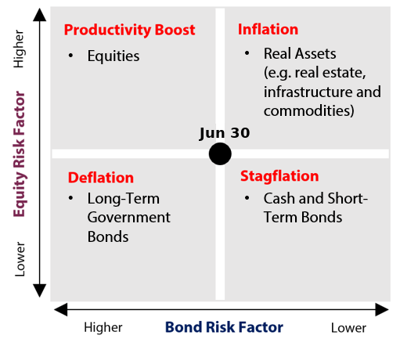
Note: The referenced chart is respective to the AIP Jun 30th Macroeconomic environment;
07-17
Theme | Status | One-line development
1. Fiscal Expansion & Deregulation | Held | A $95B US defence framework, four confirmed deregulatory actions and new Canadian defence contracts added to the pipeline
2. Currency Debasement | Deescalating | The dollar's reserve share rose to 57.13%, long-bond demand was strong and gold fell during a geopolitical shock.
3. Energy & the Energy Transition | Escalating | Hormuz disruption lifted oil and Asian LNG, while a record PJM capacity auction still missed its reliability
4. Artificial Intelligence | Held | TSMC raised 2026 capex to $60B-$64B0 but the SOX approached correction territory amid profit taking
5. Geopolitics & Trade | Escalating | US-Iran fighting expanded for six consecutive as geopolitical tensions resurfaced
6. Domestic Investing Pressures | Escalating | Canada moved from programme design toward deployment through new defence manufacturing contracts

Key Developments | Implication for Themes
- US-Iran fighting expanded through six consecutive nights of US strikes, a naval blockade moved into enforcement and commercial Hormuz traffic fell toward a fraction of normal levels. WTI ended near $80 and Brent traded around $86, with Asian LNG at a four-month high. | - The war has again become a supply-side inflation shock. It escalates Geopolitics & Trade, strengthens the Energy constraint and reduces central-bank room to respond to weaker growth.
- US June CPI fell 0.4% month over month and core CPI was flat, followed by a 0.3% decline in producer prices. The releases pre-date the renewed oil shock, leaving policy makers with improving backward-looking inflation and a worsening forward energy impulse. | - The Fed is likely to hold while it separates temporary energy effects from persistence. The divergence supports lower near-term inflation but raises the risk that the next CPI and inflation-expectations data reverse direction.
- TSMC reported record results and raised 2026 capex guidance to $60B-$64B, yet the regional chip complex sold off after the Bank of Korea's surprise hike. The SOX fell 4.3% on 16 July and approached a 20% decline from its June high. | - The AI buildout is continuing, but the tape is no longer rewarding capex alone. Power availability, financing costs and monetisation now determine which layers can sustain valuation support.
- The Bank of Canada held at 2.25%, cut its 2026 growth forecast to 0.7% and raised its inflation forecast to 2.5%. Macklem kept additional tightening available if higher oil prices persist. | - Canada faces the clearest version of the week's regime tension: weaker underlying growth with a renewed imported-energy shock. Domestic fiscal deployment becomes more important, but less efficient projects would compound inflation without solving weak productivity.
- IMF COFER showed the dollar's share of allocated reserves rising to 57.13% from 56.42%, while the 30-year Treasury auction drew a 77.74% indirect-bidder share. Gold nevertheless fell more than 3% during the renewed conflict. | - Reserve diversification remains gradual rather than disorderly. The week's evidence challenges an accelerating-debasement call even though central banks continue to buy gold and the dollar weakened after softer inflation data.
- The House Budget Committee advanced a roughly $95B defence and domestic-support framework, while the Senate's NDAA cloture vote failed and June's federal deficit reached $120B. Four US deregulatory actions were confirmed through primary agency releases. | - Fiscal support remains large, but implementation and legislative capacity are now the binding constraints. Deregulation is moving faster than the biggest spending packages.

Theme 1 — Fiscal Expansion & Deregulation
(As of 2026_07_17)
Status:
Held ▸ The US advanced a roughly $95B defence framework and Canada added a $2B armoured-vehicle partnership, but the Senate NDAA stalled and market confirmation was mixed; fiscal impulse remains large, while execution and financing limit the weekly acceleration.
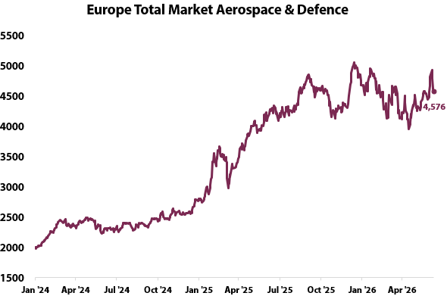 | What changed this week  - The US recorded a $120B June deficit against a $27B surplus a year earlier, bringing the fiscal-year deficit through June to $1.367T. Gross interest outlays reached $185B in June, up 28% from a year earlier, keeping the cost of financing central to the fiscal story.  - The House Budget Committee advanced a roughly $95B reconciliation framework on 16 July, including defence, intelligence, agriculture and voter-identification funding. The Senate's roughly $1.15T NDAA failed cloture 50-46 two days earlier, leaving the larger defence authorisation path unresolved.  - Four deregulatory actions moved from proposals to concrete action. These included delaying CME’s planned 24-hour WTI contract, reviewing rules to make it easier to offset margin requirements across markets and proposing lower FDIC fees for larger banks.  - For context, European implementation was already uneven before the monitoring window: Germany was behind its infrastructure-fund schedule and France was adding spending restraints. This week's market confirmation was also mixed. European defence equities sold off after the NATO summit, while the US 30-year auction cleared at 5.058%, its highest yield in roughly two decades, but strong indirect demand showed that funding stress has not become an absorption problem.
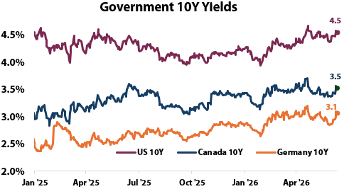
Key Development of the Week:
The constraint shifted from announced money to deployable money. Defence and deregulation remain expansionary, but stalled legislation, German underspending and high long yields show that delivery speed and financing cost will decide how much of the headline impulse reaches growth.
Implication for the theme  Defence procurement and deregulation still support medium-term activity, industrial capacity and selected infrastructure exposures. The near-term growth effect is smaller than the headline commitments imply, while larger deficits and elevated term yields keep an inflation and duration offset attached to the theme. | Watch next week  - US-Mexico CUSMA negotiating round beginning the week of 20 July.  - US Section 122 tariff expiry on 24 July and any replacement Section 301 measures.  - US 20-year Treasury auction on 23 July and progress toward a House vote on the $95B framework.

Theme 1 Appendix — Monetary Policy Tracker
(As of 2026_07_17)
Status:
Central banks held where expected, but the policy problem became less comfortable: US inflation data cooled before the renewed oil shock, the BoC lowered growth and raised inflation, and the Bank of Korea's surprise hike exposed the market sensitivity of the AI complex.
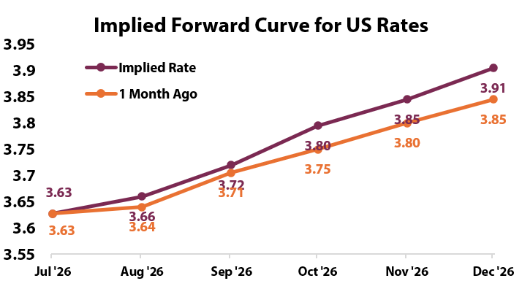 | What changed this week  - US June CPI fell 0.4% month over month against a smaller decline expected, while core CPI was flat and slowed to 2.6% year over year. Producer prices then fell 0.3%. Treasury yields declined after the releases, but the 10-year returned toward 4.6% as oil climbed and policy makers kept the focus on inflation persistence.  - Fed Chair Warsh used his first semiannual testimony to defend independence and maintain zero tolerance for persistent inflation. Governor Waller and Dallas Fed President Logan leaned hawkish, while Vice Chair Jefferson and Governor Cook retained a more data-dependent posture. The policy split is about how quickly the oil shock can reverse the improvement in goods and producer prices.  - The Bank of Canada held at 2.25% for a sixth consecutive meeting. It cut 2026 growth to 0.7% from 1.2%, raised the inflation forecast to 2.5%, and said a series of hikes remains possible if the energy shock persists. The July decision therefore shifted the Bank from a straightforward hold toward a conditional stagflation response.  - The Bank of Korea raised its policy rate 25bp to 2.75%, its first increase since early 2023. The move triggered a broad Asian technology selloff and showed that tightening in a smaller market can transmit globally when positioning is concentrated.
Central Bank | Key Policy Rate | Expected Cycle / Note
US Federal Reserve | 3.50%-3.75% | Hold remains the base case for 28-29 July; softer inflation competes with the renewed oil shock.
Bank of Canada | 2.25% | Held for a sixth meeting;
European Central Bank | Deposit 2.25%; | Hiking bias; next decision 23 July.
Bank of Japan | 1.00% | Hiking bias; next meeting 30-31 July.
People's Bank of China | 1-year LPR 3.00%; 5-year LPR 3.50% | Easing bias after the Q2 growth miss
Reserve Bank of India | 5.25% | Hold;
Bank of Korea | 2.75% | Raised 25bp

Implication for the theme  The policy path is becoming more state-dependent and less synchronised. Higher energy costs are inflationary and anti-growth, while soft underlying prices are the offset; front-end duration remains sensitive to each inflation print, and Canada carries the clearest risk of weaker growth with renewed tightening pressure. | Watch next week  - PBoC loan-prime-rate decision around 20-21 July.  - European Central Bank decision on 23 July.  - Canada CPI on 20 July and Fed communications ahead of the 28-29 July FOMC meeting.

Theme 2 — Currency Debasement
(As of 2026_07_17)
Status:
Deescalating ▸ IMF COFER showed the dollar share rising to 57.13%, Treasury auctions retained strong foreign demand and gold fell during a geopolitical shock; a softer DXY and continued central-bank gold buying preserve the gradual-diversification thesis, but the week did not show accelerating dollar rejection.
What changed this week  - The dollar's share of allocated reserves rose to 57.13% in the first quarter from 56.42% in the fourth quarter. The euro and yen shares both fell, while the renminbi edged only slightly higher to 1.99%. The move challenges the idea that reserve diversification accelerated at the start of 2026.  - Official gold demand remained firm underneath that result. World Gold Council data showed 41 tonnes of net central-bank purchases in May, while China added 14.93 tonnes in June for a twentieth consecutive month of buying.  - Markets provided the week's sharper challenge. Gold fell from above $4,100 to around $4,000 and was on track for a weekly loss greater than 3% despite the renewed US-Iran conflict. The dollar index eased toward a one-month low after soft CPI and PPI, but bitcoin also softened into filing day and USD/JPY remained near 162 without confirmed intervention.  - Treasury demand remained resilient. The 30-year reopening cleared at 5.058%, but indirect bidders took 77.74% and the bid-to-cover ratio was 2.44. Reported May TIC data also suggested China's Treasury holdings rebounded to about $659B from $651B in April, although the precise country figure should be rechecked against the Treasury file before publication. | 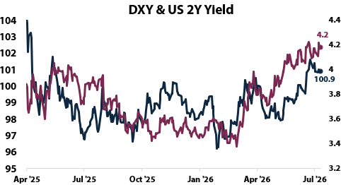
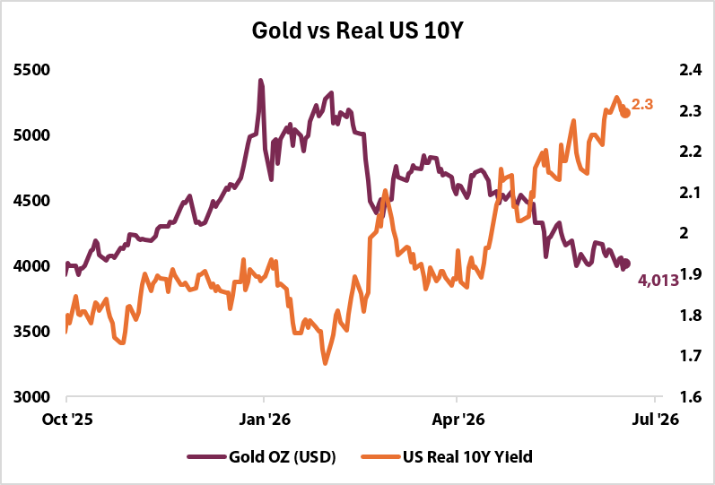 | 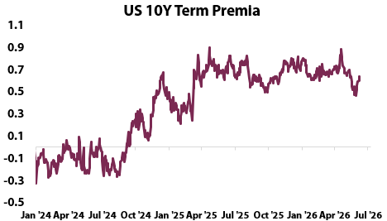
Implication for the theme  The house view of gradual diversification remains intact, but the pace moved lower this week. Gold retains structural official-sector support, while near-term pricing remains vulnerable to real yields; the softer dollar is an offset, not yet evidence of reserve-flight behaviour. | Watch next week  - Treasury verification of May TIC country holdings and the 20-year auction on 23 July.  - Gold's response if oil remains above $80 and US yields stay near recent highs.  - USD/JPY around 162 and any confirmed Japanese intervention before the 30-31 July BoJ meeting.

Theme 3 — Energy & the Energy Transition
(As of 2026_07_17)
Status:
Escalating ▸ A record-priced PJM capacity auction still missed its reliability requirement and FERC ordered mandatory standards for computational loads, while Hormuz disruption lifted oil and Asian LNG; scarcity is now visible in both the physical grid and traded energy prices.
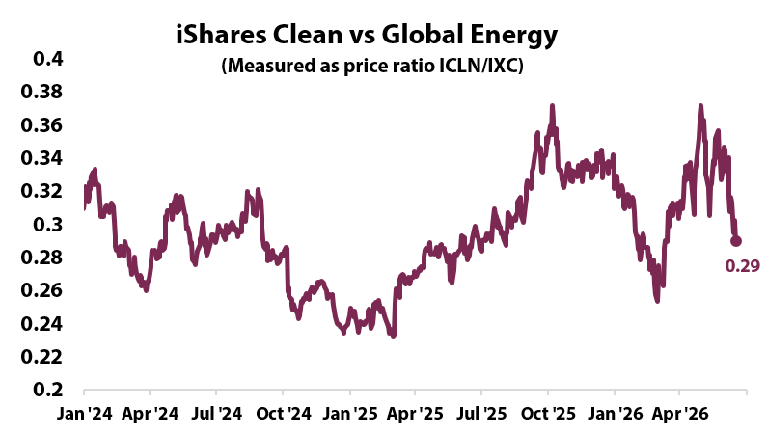 | What changed this week  - Commercial Hormuz traffic fell sharply as the US naval blockade moved into enforcement and regional attacks expanded. WTI rose to about $80 and Brent traded around $86, while Asian spot LNG reached roughly $20.20/MMBtu, its highest since late March. European gas also strengthened, while US Henry Hub remained near a two-month low on domestic supply and maintenance conditions.  - PJM's 2028 capacity auction matched the prior $16.4B record but still fell 6.8 GW short of the reliability margin. The outcome shows that paying more for capacity is not yet producing enough firm supply where large loads are arriving.  - FERC ordered the North American Electric Reliability Corporation to develop mandatory reliability standards for data centres and other computational loads by 31 December. The order moves large-load integration from a planning discussion into a formal reliability obligation.  - Mitsubishi closed a $7.5B acquisition of Haynesville gas assets producing about 2.1 Bcf per day, explicitly linking US gas, Asian LNG security and AI power demand. Copper fell to about $6.19 per pound on filing day, showing that near-term growth and risk-off forces can still overpower the structural electrification demand signal.
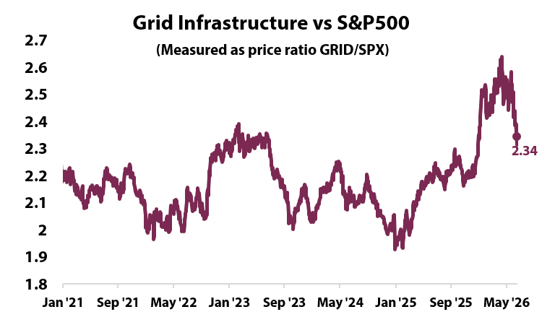
Key Development of the Week:
The grid paid a record bill and still came up short. That converts the electricity thesis from a forecast into an operating constraint: generation, transmission and demand management must arrive together or more spending will not produce reliable capacity.
Implication for the theme  Grid equipment, firm generation, gas infrastructure, storage and large-load management remain the exposures most directly linked to the constraint. The growth support from investment is inflationary in the near term, while weaker copper and equity risk appetite are the offsets to the longer-cycle demand story. | Watch next week  - FERC and NERC implementation details for computational-load reliability standards.  - Hormuz vessel counts, Asian LNG prices and any emergency OPEC+ response.  - PJM follow-up on the 6.8 GW reliability shortfall and heat-related grid alerts.

Theme 4 — Artificial Intelligence
(As of 2026_07_17)
Status:
Held ▸ TSMC raised 2026 capex to $60B-$64B and SK Hynix completed a $26.5B Nasdaq listing, but the SOX approached a 20% correction and AI financing demand weakened; the buildout remains large, while the market is repricing power, policy and monetisation risk.
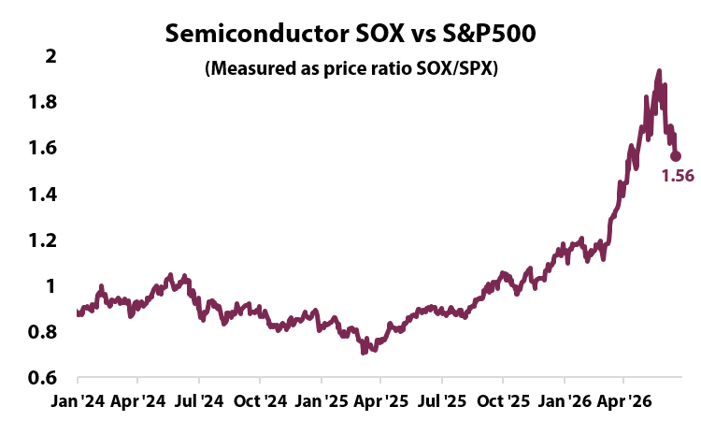 | What changed this week  - SK Hynix raised $26.5B in the largest US listing by a foreign company and closed its first session 12.8% above the offer price. The signal then reversed: its Seoul shares fell 15.4% on Monday, rebounded, and sold off again after the Bank of Korea's surprise hike. The listing confirmed financing demand, but the subsequent volatility showed how dependent the trade remains on liquidity and positioning.  - TSMC reported $40.2B of second-quarter revenue, 67.7% gross margin and 66% of sales from high-performance computing. It raised 2026 capex guidance to $60B-$64B from $52B, yet its shares fell as investors focused on margin dilution and the scale of future spending.  - The broader tape deteriorated. The SOX fell 4.3% on 16 July and moved close to a 20% decline from its June high. Alphabet lost roughly $225B of market value on reported Gemini delays and talent departures, while IBM remained near its lows after a preliminary earnings warning. Strong results no longer lifted the group uniformly.  - The physical and financial constraints tightened together. Microsoft reported an $80B Azure backlog constrained by unavailable power, while AI-bond cover ratios fell from about five times in February to two times in July. DRAM pricing remained firm and high-bandwidth memory stayed effectively sold out, so demand has not disappeared; the cost of satisfying it has risen.
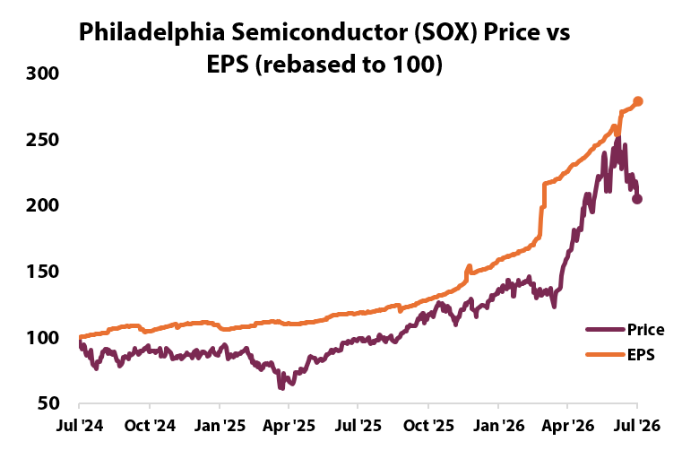
Key Development of the Week:

South Korea's KOSPI fell roughly 6% this week as investors took profits in AI-related semiconductor stocks, with SK Hynix down 12% and Samsung down 9%, though the Bank of Korea upgraded its growth outlook on continued strength in the chip sector. The primary concern around the AI trade remains whether valuations will keep up as multiples get stretched. Slight profit taking and renewed oil price concerns led to a revaluation across the AI sector this week, expected to continue through the coming weeks.

Implication for the theme  The buildout still supports compute, memory, grid and data-centre infrastructure, but return dispersion should widen between scarce enablers and capital-intensive adopters. AI capex supports growth and selected inflation channels, while higher financing costs and weaker software monetisation are the offsets that can pressure broad technology valuations. | Watch next week  - IBM's full second-quarter earnings call on 22 July.  - South Korean semiconductor trading after the 20 July reopening and whether the SOX confirms a 20% correction.  - Hyperscaler capex guidance, AI-bond reception and any update on Alphabet's Gemini timetable.

Theme 5 — Geopolitics & Trade
(As of 2026_07_17)
Status:
Escalating ▸ US-Iran fighting expanded through a sixth consecutive strike night, Hormuz enforcement tightened and Russia-Ukraine remained active; oil, LNG and fertilizer rebuilt the inflationary transmission channel while risk assets weakened.
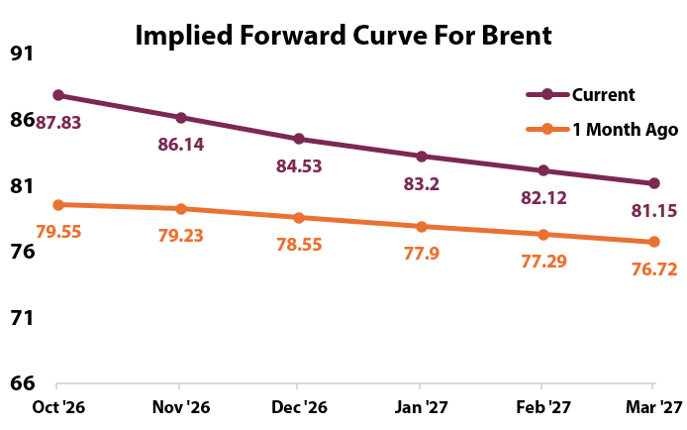 | What changed this week  - US-Iran fighting moved from a failed ceasefire back into a sustained supply shock. The US conducted six consecutive nights of strikes, the naval blockade disabled a tanker near Kharg Island and Iran broadened retaliation across several Gulf states. No replacement diplomatic framework followed Iran's withdrawal from the Islamabad memorandum.  - The market reaction confirmed the escalation. WTI rose more than 11% over the week to around $80, Brent moved into the mid-$80s and Asian LNG reached a four-month high. Gold's decline was a divergence, showing that the conflict traded more cleanly through energy, yields and risk assets than through a traditional safe-haven channel.  - Russia-Ukraine remained active across military and political fronts. Ukraine installed Serhii Koretskyi as prime minister, left key security posts unsettled and continued its campaign against Russian shipping, while Russia launched another barrage against Kyiv. The EU also moved toward a new anti-drone sanctions package.  - Trade fragmentation remained unresolved. The next US-Mexico CUSMA round begins the week of 20 July with Canada outside the bilateral track, while the US Section 122 surcharge is scheduled to expire on 24 July without a confirmed extension. Fertilizer pressure rebuilt at the same time: the World Bank expects its index to rise more than 30% in 2026 and urea by roughly 60%, restoring the food-price channel that had faded in the prior report.
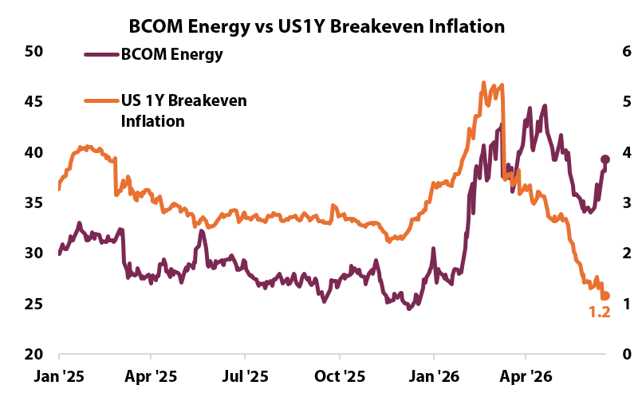
Key Development of the Week:
The key development this week was the collapse of the U.S.-Iran ceasefire, which triggered the most intense fighting since April. After attacks on commercial vessels near the Strait of Hormuz, the U.S. launched multiple rounds of airstrikes against Iranian targets, while Iran responded with missile and drone attacks across the Gulf region. The renewed conflict has threatened traffic through the Strait of Hormuz. Despite the fighting, both sides have indicated a willingness to continue diplomatic talks, though the June peace agreement is effectively no longer in force.
Implication for the theme  The US-Iran and trade legs are inflationary and anti-growth, while continued Russia-Ukraine escalation reinforces defence spending and commodity-security demand. Softer underlying US inflation is the main offset; if Hormuz disruption persists, that offset is likely to fade in the next set of price data. | Watch next week  - Hormuz traffic, any confirmed diplomatic channel and further action around Bab al-Mandeb.  - US-Mexico CUSMA round beginning the week of 20 July and Canada's parallel contacts.  - Section 122 tariff expiry on 24 July and fertilizer benchmarks following the renewed supply disruption.

Theme 6 — Domestic Investing Pressures
(As of 2026_07_17)
Status:
Escalating ▸ Canada added major defence manufacturing contracts as CUSMA uncertainty persisted; domestic deployment is moving from institutional design toward specific projects, even as the BoC's weaker growth outlook raises the quality threshold.
What changed this week  - Canada's domestic deployment pipeline became more concrete. The government announced a $2B partnership with General Dynamics Land Systems-Canada for 190 additional armoured vehicles and 6,000 jobs over eight years. The agreement gives the domestic-investment theme a named manufacturer, delivery schedule and employment channel.  - Defence procurement broadened the industrial-policy channel. Canada finalised an approximately C$24B submarine programme with Germany's TKMS and continued work on Arctic communications and potential participation in the UK-Japan-Italy fighter programme. The mix is not purely domestic, but procurement conditions increasingly centre on Canadian production, skills and supply-chain capacity.  - The macro backdrop became less supportive. The BoC cut 2026 growth to 0.7%, although June employment rose 18,000, unemployment fell to 6.5% and the May merchandise trade surplus widened to $4.2B. A firmer Canadian dollar and a higher TSX on decision day provided modest market confirmation, but oil rather than domestic policy was an important driver.  - The Gordie Howe Bridge is scheduled to open on 27 July, with Canada and the US sharing net toll revenue only after construction debt is repaid. Ontario's wildfire emergency also intensified, creating a near-term need for federal support, rebuilding and resilient transport and utility infrastructure. | 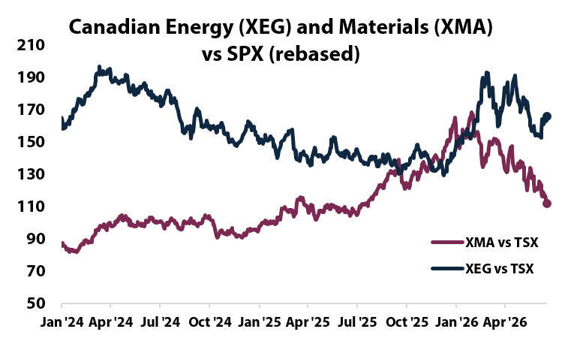  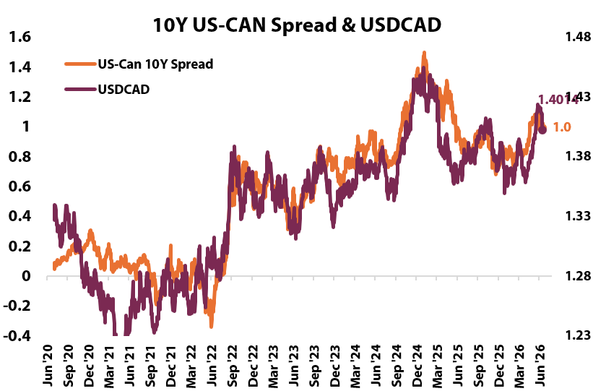
Key Development of the Week:
Domestic investment is moving from funds to contracts. The important shift is not another headline allocation; it is the appearance of named assets, manufacturers and delivery schedules against which employment, productivity and cost can be measured.

Implication for the theme  Defence and critical-minerals deployment support domestic activity and reduce some external supply-chain exposure. The BoC's lower growth forecast means these projects can matter more at the margin, but oil-driven inflation and weak productivity raise the cost of misallocation; execution quality remains the decisive investment test. | Watch next week  - Canada CPI on 20 July and any effect on the BoC's conditional tightening bias.  - CUSMA negotiations beginning the week of 20 July and the Section 122 tariff expiry on 24 July.  - Confirmation of GCAP observer status and federal support for Ontario wildfire recovery.

Light Scoring and Developments
(As of 2026_07_17)
Theme | Light | Supports (more of the theme) | Against (less of the theme) | Net read
Fiscal Expansion & Deregulation | Held | US $95B framework, four confirmed deregulatory actions, Canada $2B armoured-vehicle partnership; +3.0 | NDAA cloture failure, framework below larger funding asks, defence-equity weakness; -2.5 | +0.5. Large pipeline, mixed execution and tape.
Currency Debasement | Deescalating | DXY near a one-month low, continued central-bank gold purchases; +2.0 | Dollar reserve share rose, strong indirect Treasury demand, gold fell during the war shock, China holdings rebounded; -5.0 | -3.0. Less debasement this week.
Energy & the Energy Transition | Escalating | PJM reliability shortfall, FERC computational-load standards, oil and LNG surge, Mitsubishi gas acquisition; +5.0 | Copper weakened and US gas remained soft; -1.0 | +4.0. Physical scarcity outweighed cyclical offsets.
Artificial Intelligence | Held | TSMC capex increase, SK Hynix listing, firm memory prices, Nvidia physical-AI buildout; +5.0 | SOX near correction, Bank of Korea shock, Alphabet and IBM weakness, lower bond cover ratios; -4.0 | +1.0, capped at Held by the tape veto.
Geopolitics & Trade | Escalating | Six US strike nights, Hormuz enforcement, Russia-Ukraine activity, fertilizer pressure, unresolved CUSMA; +7.0 | No durable diplomatic opening; 0.0 | +7.0. Escalation confirmed by oil, LNG and risk assets.
Domestic Investing Pressures | Escalating | C$24B submarine programme, $2B armoured-vehicle partnership, Gordie Howe Bridge opening and CUSMA pressure; +5.0 | No new Canada Strong Fund deployment and weaker BoC growth outlook; -1.0 | +4.0. Specific domestic contracts moved the theme forward.

Theme Light History
(As of 2026_07_17)
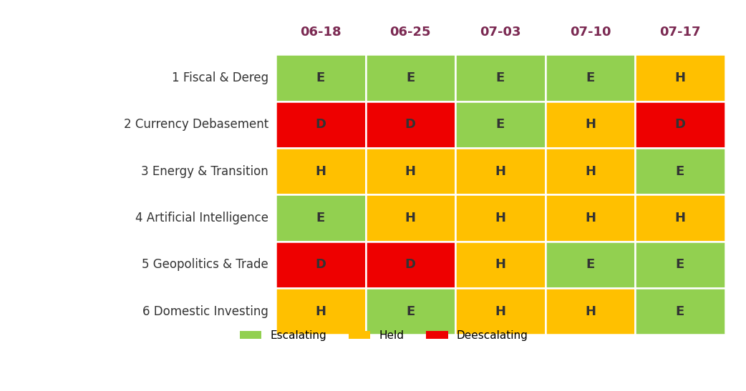
Each cell is that week's light: green Escalating (more of the theme), amber Held (mixed or null), red Deescalating (less). 3-light system since 2 July 2026.
Lights Guide Appendix
Each theme carries a coloured light showing the direction of the theme this week, not whether it is good or bad for the portfolio.
Green (Escalating) means more of the theme: the trend is reinforcing and the signals are getting stronger. Amber (Held) means mixed or null developments, no material change. Red (Deescalating) means less of the theme: the outlook is fading.
What more and less mean is theme-specific. Fiscal: more spending and deregulation. Currency Debasement: weaker dollar confidence. Energy: more transition and electrification. AI: more buildout. Geopolitics and Trade: more conflict and worse trade. Domestic: more domestic or protectionist policy.
The Status Dashboard light is the theme-level read. The Key Risks register tracks each named risk separately.
References
Only sources cited this week, deduplicated, grouped by section. Each item states its tier. Retrieved 17 July 2026.
Executive Summary — Weekly Direction & Key Developments
  - (Tier 1) U.S. Bureau of Labor Statistics. Consumer Price Index, June 2026. 14 July 2026. https://www.bls.gov/news.release/archives/cpi_07142026.htm. Retrieved 17 July 2026.
  - (Tier 1) U.S. Bureau of Labor Statistics. Producer Price Index, June 2026. 15 July 2026. https://www.bls.gov/news.release/archives/ppi_07152026.htm. Retrieved 17 July 2026.
  - (Tier 1) Bank of Canada. Interest Rate Announcement and Monetary Policy Report. 15 July 2026. https://www.bankofcanada.ca/2026/07/fad-press-release-2026-07-15/. Retrieved 17 July 2026.
  - (Tier 1) U.S. Central Command. U.S. Forces Complete New Strikes on Iranian Military Targets. July 2026. https://www.centcom.mil/MEDIA/PUBLIC-RELEASES/Article/4544409/us-forces-complete-new-strikes-on-iranian-military-targets/. Retrieved 17 July 2026.
  - (Tier 1) Taiwan Semiconductor Manufacturing Company. Second Quarter 2026 Results. 16 July 2026. https://investor.tsmc.com/english/quarterly-results/2026/q2. Retrieved 17 July 2026.
Theme 1 — Fiscal Expansion & Deregulation
  - (Tier 1) U.S. Treasury. Monthly Treasury Statement, June 2026. 13 July 2026. https://fiscaldata.treasury.gov/static-data/published-reports/mts/MonthlyTreasuryStatement_202606.pdf. Retrieved 17 July 2026.
  - (Tier 1) House Budget Committee. Committee Markup and Defence Funding Framework. 16 July 2026. https://budget.house.gov/press-release/chairman-arrington-delivers-opening-remarks-at-committee-markup-of-one-big-beautiful-bill-act. Retrieved 17 July 2026.
  - (Tier 1) Commodity Futures Trading Commission. CFTC Stays CME 24/7 WTI Contract. 9 July 2026. https://www.cftc.gov/PressRoom/PressReleases/9265-26. Retrieved 17 July 2026.
  - (Tier 1) Federal Deposit Insurance Corporation. Proposal to Revise Deposit Insurance Assessments. 25 June 2026. https://www.fdic.gov/news/press-releases/2026/fdic-board-approves-proposal-revise-deposit-insurance-assessment. Retrieved 17 July 2026.
  - (Tier 2) Committee for a Responsible Federal Budget. Treasury Confirms FY2026 Deficit Pace. July 2026. https://www.crfb.org/press-releases/treasury-confirms-14-trillion-fy-2026-deficit-so-far-higher-2025. Retrieved 17 July 2026.
Monetary Policy Tracker
  - (Tier 1) Federal Reserve. Semiannual Monetary Policy Report Testimony. 14 July 2026. https://www.federalreserve.gov/newsevents/testimony/warsh20260714a.htm. Retrieved 17 July 2026.
  - (Tier 1) Federal Reserve. Beige Book, July 2026. 15 July 2026. https://www.federalreserve.gov/monetarypolicy/beigebook202607.htm. Retrieved 17 July 2026.
  - (Tier 1) Federal Reserve. Governor Cook Speech. 15 July 2026. https://www.federalreserve.gov/newsevents/speech/cook20260715a.htm. Retrieved 17 July 2026.
  - (Tier 1) Bank of Canada. Monetary Policy Report, July 2026. 15 July 2026. https://www.bankofcanada.ca/publications/mpr/mpr-2026-07-15/. Retrieved 17 July 2026.
  - (Tier 2) CNBC. Bank of Korea Interest Rate Decision and Market Reaction. 16 July 2026. https://www.cnbc.com/2026/07/16/bok-interest-rate-monetary-policy-markets-kospi-skhynix.html. Retrieved 17 July 2026.
Theme 2 — Currency Debasement
  - (Tier 1) International Monetary Fund. Currency Composition of Official Foreign Exchange Reserves, Q1 2026. 1 July 2026. https://data.imf.org/en/dashboards/cofer%20dashboard. Retrieved 17 July 2026.
  - (Tier 1) World Gold Council. Central Bank Gold Statistics. July 2026. https://www.gold.org/goldhub/gold-focus/2026/07/central-bank-gold-statistics-central-banks-remain-committed-gold. Retrieved 17 July 2026.
  - (Tier 1) U.S. Treasury. Quarterly Refunding and Auction Data. July 2026. https://home.treasury.gov/policy-issues/financing-the-government/quarterly-refunding. Retrieved 17 July 2026.
  - (Tier 2) CNBC. Dollar Near a One-Month Low as Inflation Cools. 16 July 2026. https://www.cnbc.com/2026/07/16/dollar-near-one-month-low-as-cooling-inflation-curbs-fed-hike-bets.html. Retrieved 17 July 2026.
Theme 3 — Energy & the Energy Transition
  - (Tier 1) Federal Energy Regulatory Commission. FERC Action on Reliability Safeguards for Computational Loads. 16 July 2026. https://www.ferc.gov/news-events/news/ferc-action-new-reliability-safeguards-american-power-grid. Retrieved 17 July 2026.
  - (Tier 1) U.S. Central Command. U.S. Forces Disable Non-Compliant Vessel in Arabian Gulf. 15 July 2026. https://www.centcom.mil/MEDIA/PUBLIC-RELEASES/Article/4546626/us-forces-disable-non-compliant-vessel-in-arabian-gulf/. Retrieved 17 July 2026.
  - (Tier 2) Bloomberg. Asian Gas Prices Rise to Highest Since March. 16 July 2026. https://www.bloomberg.com/news/articles/2026-07-16/asian-gas-prices-rise-to-highest-since-march-on-mideast-tensions. Retrieved 17 July 2026.
  - (Tier 2) Fortune. Mitsubishi Closes Haynesville Gas Acquisition. 14 July 2026. https://fortune.com/2026/07/14/mitsubishi-takes-over-7billion-gas-fields-aethon-japanese-push-lng-ai/. Retrieved 17 July 2026.
Theme 4 — Artificial Intelligence
  - (Tier 1) Taiwan Semiconductor Manufacturing Company. Second Quarter 2026 Results. 16 July 2026. https://investor.tsmc.com/english/quarterly-results/2026/q2. Retrieved 17 July 2026.
  - (Tier 2) CNBC. SK Hynix Nasdaq Debut. 10 July 2026. https://www.cnbc.com/2026/07/10/sk-hynix-skhy-stock-nasdaq.html. Retrieved 17 July 2026.
  - (Tier 2) Bloomberg. Chip Stock Selloff Deepens in Asia. 17 July 2026. https://www.bloomberg.com/news/articles/2026-07-17/chip-stock-selloff-deepens-in-asia-as-tsmc-fails-to-impress. Retrieved 17 July 2026.
  - (Tier 2) CNBC. Alphabet Falls on Gemini Delay and Talent Departures. 16 July 2026. https://www.cnbc.com/2026/07/16/alphabet-stock-gemini-3-5-pro-ai.html. Retrieved 17 July 2026.
Theme 5 — Geopolitics & Trade
  - (Tier 1) U.S. Central Command. Iran Strike and Maritime Releases. July 2026. https://www.centcom.mil/MEDIA/PUBLIC-RELEASES/Article/4544409/us-forces-complete-new-strikes-on-iranian-military-targets/. Retrieved 17 July 2026.
  - (Tier 1) Government of Canada. Statement Following the Trilateral CUSMA Joint Review. July 2026. https://www.canada.ca/en/global-affairs/news/2026/07/statement-by-minister-leblanc-following-trilateral-cusma-joint-review-meeting.html. Retrieved 17 July 2026.
  - (Tier 2) White & Case. USMCA 2026 Joint Review and Annual Review Path. July 2026. https://www.whitecase.com/insight-alert/usmca-2026-joint-review-united-states-declines-extend-agreement-triggering-annual. Retrieved 17 July 2026.
  - (Tier 1) World Bank. Fertilizer Prices and Hormuz Disruption. July 2026. https://blogs.worldbank.org/en/opendata/fertilizer-prices-surge-as-strait-of-hormuz-disruptions-tighten-. Retrieved 17 July 2026.
  - (Tier 2) Kyiv Independent. Ukrainian Parliament Appoints Koretskyi Cabinet. 16 July 2026. https://kyivindependent.com/ukrainian-parliament-appoints-koretskyis-cabinet/. Retrieved 17 July 2026.
Theme 6 — Domestic Investing Pressures
  - (Tier 1) Prime Minister of Canada. Partnership with General Dynamics Land Systems-Canada. 16 July 2026. https://www.pm.gc.ca/en/news/news-releases/2026/07/16/prime-minister-carney-announces-landmark-partnership-general-dynamics. Retrieved 17 July 2026.
  - (Tier 1) Government of Canada. Gordie Howe International Bridge Opening. 15 July 2026. https://www.canada.ca/en/housing-infrastructure-communities/news/2026/07/the-gordie-howe-international-bridge-will-open-on-july-27th-strengthening-trade-connectivity-and-economic-development.html. Retrieved 17 July 2026.
  - (Tier 1) Bank of Canada. Opening Statement, July 2026 Monetary Policy Report. 15 July 2026. https://www.bankofcanada.ca/2026/07/opening-statement-2026-07-15/. Retrieved 17 July 2026.
  - (Tier 2) CBC News. Ontario Wildfire Emergency and Namaygoosisagagun First Nation. 17 July 2026. https://www.cbc.ca/news/canada/thunder-bay/namaygoosisagagun-first-nation-wildfire-9.7272350. Retrieved 17 July 2026.

