Difference on test

We can see in all the test that the most efficient way to run our processor is with the -f command witch allways finish our process in lees cycles

Split register(left) vs Only forwarding(right)

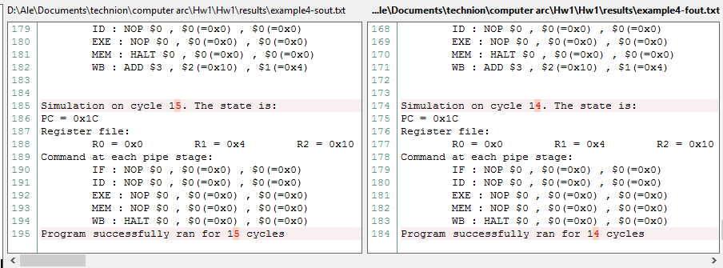

Without Forwarding (left) vs forwarding( Right)

