Neural networks – Moses Mbabaali - 20th April 2021
This last assignment was based on neural networks. The tasks involved included among others acquisition of the data, implementation of the neural network and also implementation of an autoenconder.
Task 1.
This task was straight forward and the handwritten digits were successfully acquired.
Task 2.
This task required one to train a classification neural network, I employed the Keras python library which uses the tensorflow back-end for the task at hand. I used several variations when I was building the network. The first variation was a simple sequential model. This model had only one layer with 100 units. After training the with 60 epochs the Test accuracy was 91.4% and Test loss 30%. The loss function used was ‘categorical_crossentropy’ because the classification problem was categorical in nature having 10 classes of digits to classify.
Sequential model
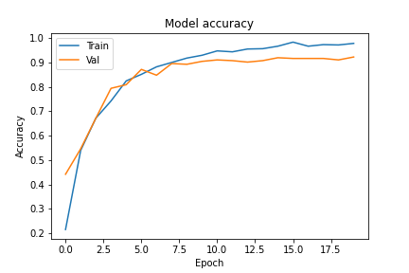

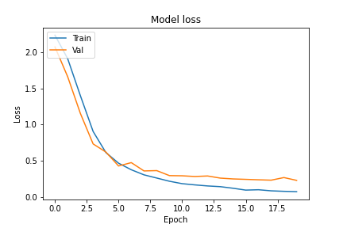

Layered sequential model
In this case the model had several layers but still remained sequential. The first layer had 128 units, then the second one had 64 units, then 32 and 16. The ADAM optimizer was used and ‘categorical-crossentropy’ was used for the loss, 60 iterations were used in the training. In this variation the training came down to having the test accuracy of 87% and loss of 42%. Though this was pretty complicated compared to the simple one it did not do as well.

Often the validation accuracy is often lower than the testing accuracy because the model at that point has seen all the data via training so it has almost a perfect score.

Convolutional Neural Network.
The next model that I used was the convolutional neural network. The CNN always does very well with images. So that is why I ended up employing it. The architecture of the model was 16 units, 32 units, 256 units for the dense layer and finally 10 output neurons. The optimizer was Nadam because its much more stable and the loss was handled by categorical-crosentropy, a drop out of 0.25 was used as well. The epochs in this case were 20 with a batch size of 128. After training the test accuracy came down to 95% and loss was 0.18%.

Graphically the model accuracy and loss can be visualized as above, the trend is similar. As the training accuracy improves and goes to near perfect the validation is slightly lower because training accuracy means that the data has already been memorized by the model during training hence the accuracy is going to be perfect, which is not the case with validation.

Task 3
This task required for one to use a neural network autoencoder on 2 classes. The encoding dimension in this case was 900 units. The input shape was 256 and for each of the layers the relu activation function was used. The optimizer was adam and loss was binary_crossentropy . In this case the epochs used were 50 with a batch size of 256.
The classes that were filtered from the data-set are 3 and 4.

