Fuzzy Systems Design – Moses Mbabaali – April 19 2021
In this report I am going to report the work done in relation to the the tasks performed for the Fuzzy Systems Design challenges using the Matlab fuzzy toolbox. The first part will focus on the Tip calculator, then the air conditioner and finally mental design.
1 a) Tip Calculator.
The first task involved designing of a Tip calculator given 2 inputs that is the quality of food and service, then the calculator would output the amount of tip based on the 2 initial variables. If the service is bad and the food is bad then the tip would be pretty low on the other hand high quality food and service would yield a higher tip. This assignment required a reproduction of the the works done in the tutorial, I responded accordingly.
When designing Fuzzy Systems one needs the inputs and the outputs and this will closely be followed by the membership functions, rules and finally these will give us the final product of a fully functional fuzzy logic system.
In my design of the system first I used the FIS for Matlab which is graphical. The FIS is very open in terms of the number of inputs and outputs, it has no limit . From the FIS I defined the inputs as food and service, then output as tip. For each of the the inputs membership functions were defined, service used the gaussian membership with 3 membership functions representing poor, good and excellent. With a range between [0 to 10]. The parameters for the poor membership function, are standard deviation 1.5 and mean value 0 respectively. The second membership function is defined as good with values 1.5 for the SD and 5 for the mean. Then the last membership function is named excellent and has the standard deviation as 1.5 with the mean value of 10. The the input food the trapezoidal membership was used with 3 functions repenting rancid, medium and delicious for the food tastes. Rancid had values [0 0 1 3], medium has values [3 4 6 7] and delicious has values [7 8 10 10]. The overall range was is between 0 to 10.
Then for the tip which is the output the values or the range were between 0 and 32 with the trimf membership function having 4 of them representing Nothing, Cheap, Average and Generous. The parameters for each of them are [0 4 8] for nothing, [8 12 16] for cheap, [16 20 24] for average and [24 28 32] for generous. After the membership functions were created then the rules were made basing on the fact that each rule for the inputs is connected with either an “and” or an “or” then to the output.

1 b) The fuzzy system graphic.
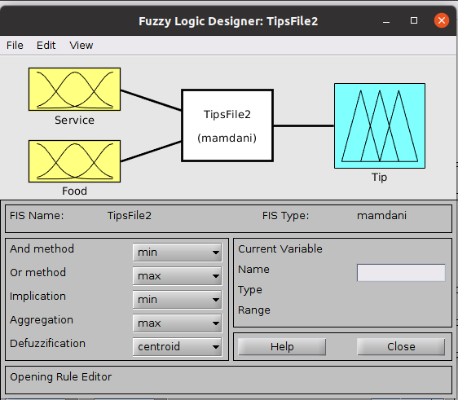

As described above the graphic shows the tip problem fuzzy system with the 2 inputs Service and Food then output being Tip.
1 c) The Service Membership function.
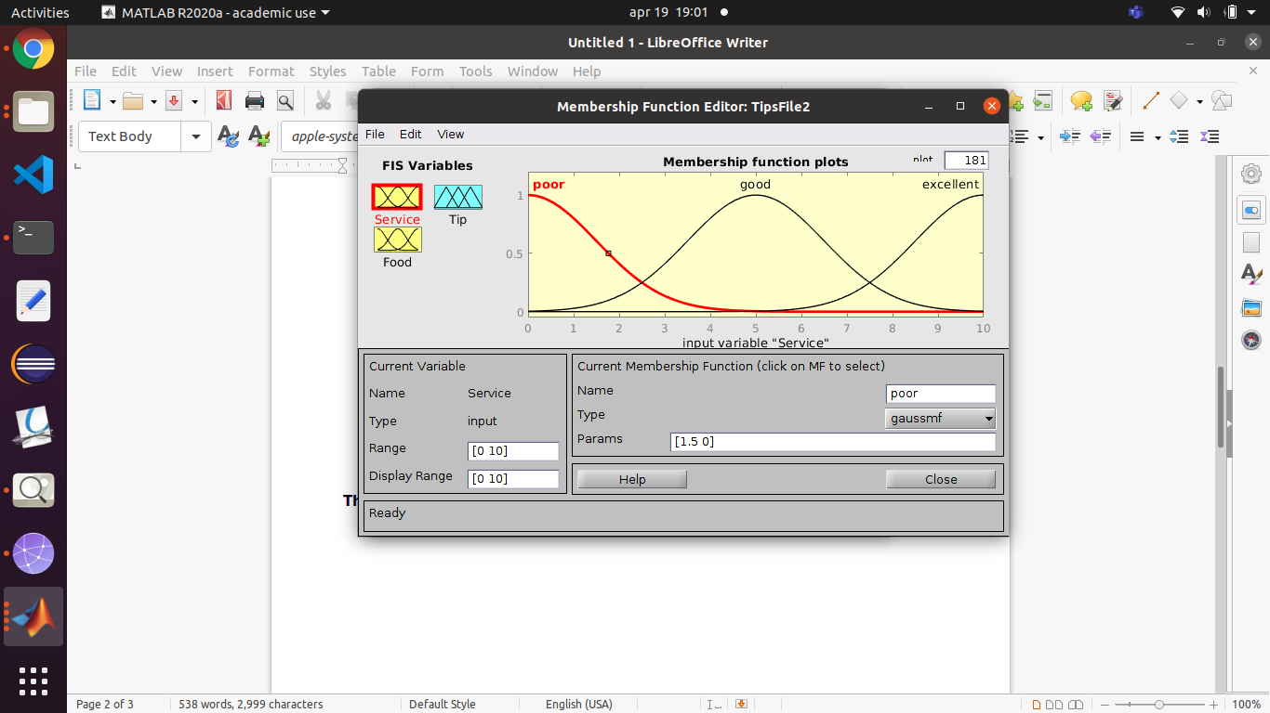

On the other hand the graphic above shows the membership function for the service input, having 3 copies of the function representing poor, good and excellent.

1 d) Membership function for food.
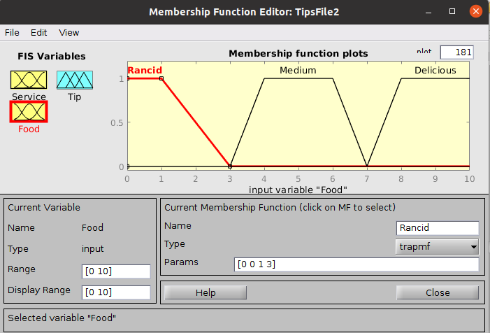

This graphic represents membership function plots for the food input variable. This includes Rancid, Medium and Delicious. The individual parameters are described above.
1 f) Membership function for tip
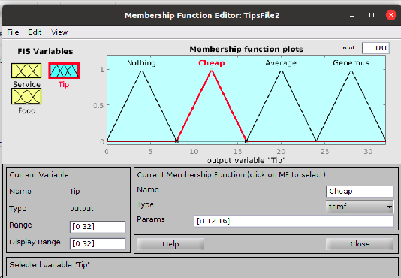

Then for the output the membership function as described was trapezoid with 3 copies representing Nothing, Cheap, Average and Generous.

1 g) The rules.
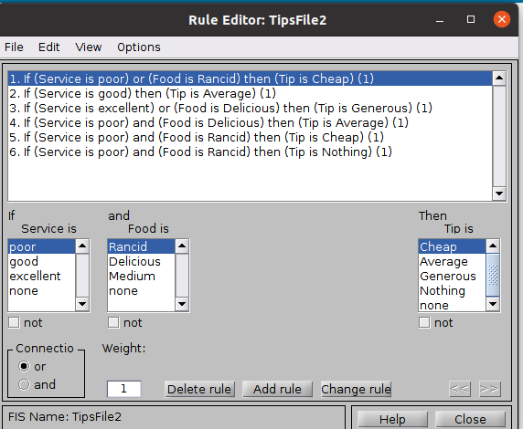

The rules that were used in the system with modifications on my side are showed above.
1 f) Rule viewer.
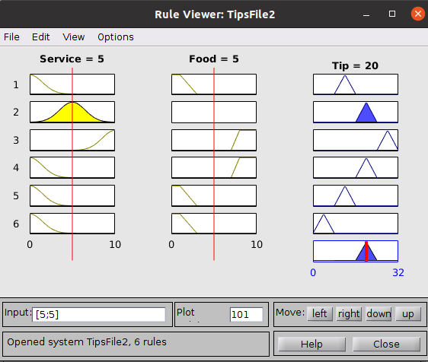

Finally the whole system was put together in terms of rules, each row represents a rule. Visualizing the rules comes down to six in total. The red line for each of the variables represent an amount and if varied then we get the respective tip amount and this is the defuzzified value. So, for the service of 5 and and food of 5 we get the tip of 20.

1 g) The surface plot.
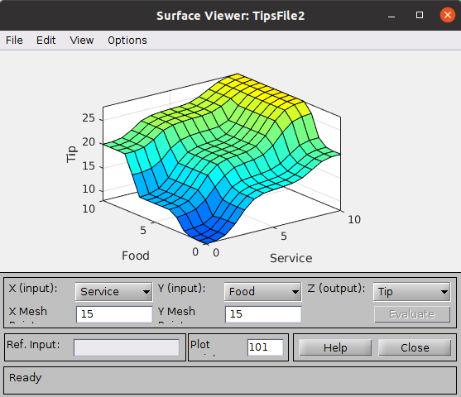

From the surface plot we can view the system representing the same data but in a different way. The surface plot brings in the three variables that is Tip, Food and Service and they are visualized together. The rules are pretty much represented as they were represented verbally. And indeed as Zadeh said fuzzy logic is computing with words. If food is poor and service is also poor then there is no tip but as the service improves and the food quality then tip also appreciates.
2) Air Conditioning System.
A similar approach was employed when working on the second problem. The inputs in this case were temperature and humidity these two will determine the speed of the motor. A few more rules were added on top of the original that were provided. Below is the Fuzzy design.
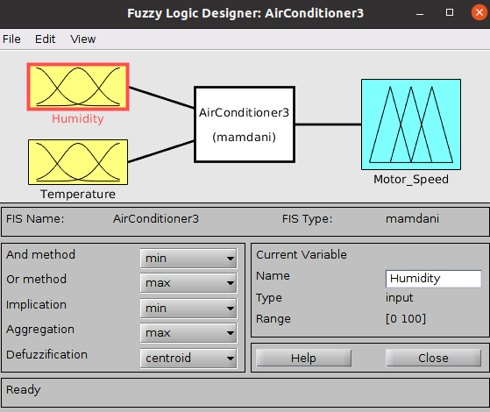

The system was based on the rules below.
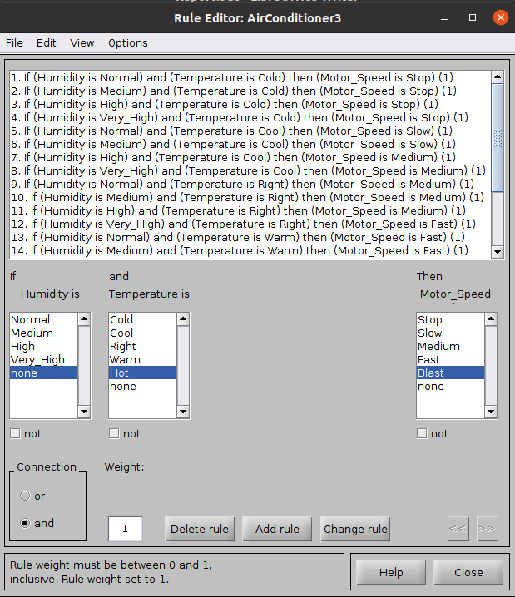

2 a) Humidity membership function.
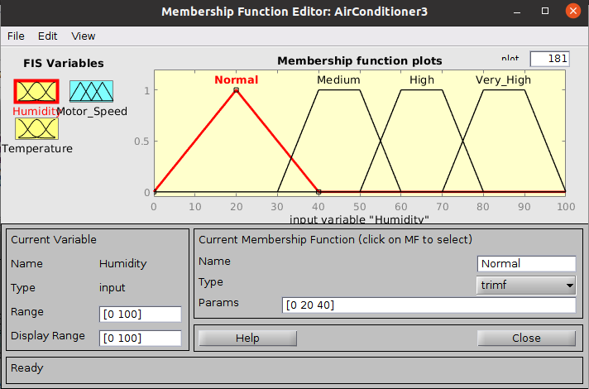

The trimf membership function was used in this case with a range of 0 to 100 having having 2 pairs of the trimf. The first function is the Normal with the parameter range of [0 20 40], then Medium with a parameter range of [30 40 50 60] then the High with [50 60 70 80] and finally Very High [70 80 90 100].
2 b) Temperature membership function.
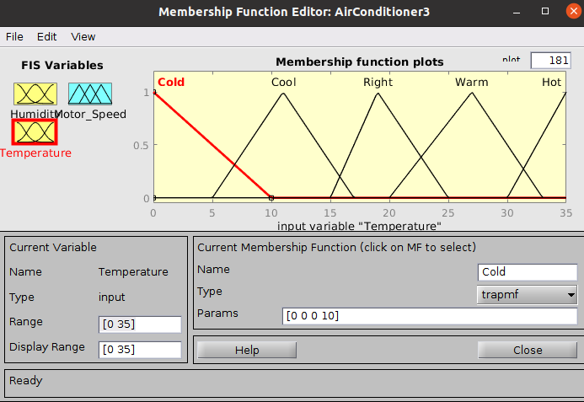

In this case the the trapmf membership function was used with the range of 0 to 35. There are 5 functions that are used for this input. They hold Cold, Cool, Right, Warm and Hot. Cold has a range of [0 0 0 10] , Cool [5 11 11 17], Right [15 19 19 25], Warm [20 27 27 33] and finally Hot [30 35 35 35].
2 c) Motor Speed membership function.
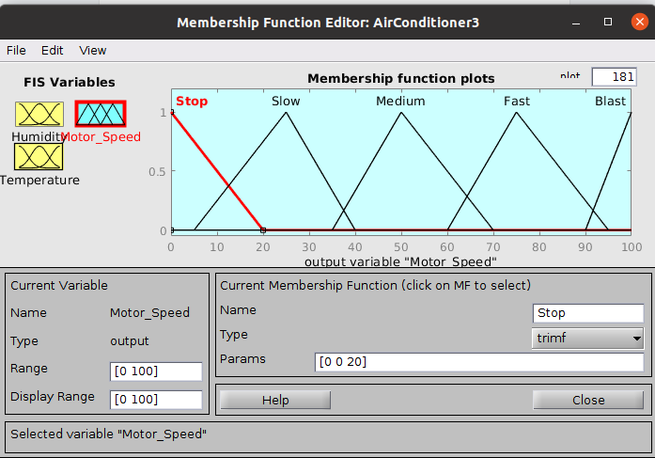

For the motor speed I used the trimf with 5 membership functions representing Stop, Slow, Medium, Fast and Blast. The overall range is between 0 and 100. With Stop having parameter range of [0 0 20], then Slow [5 25 40], Medium [35 50 70], Fast [60 75 95], Blast [90 100 100] repectively.
2d) Testing the System.
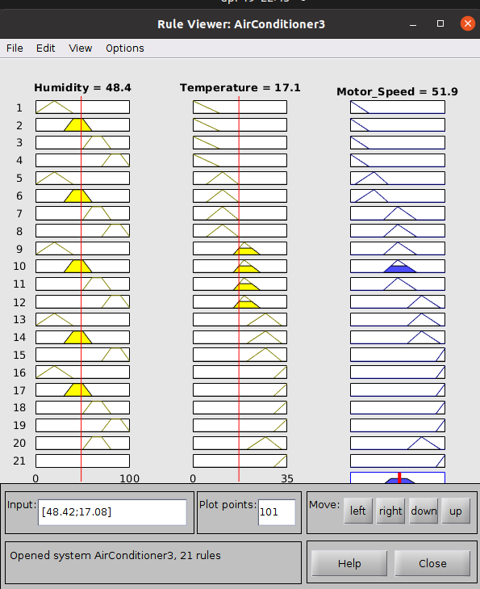
From the rule viewer we can test the system. So with a humidity of 48.4 and a temperature of 17.1 we can have a Motor_Speed of 51.9. By shifting the red lines for either the temperature or humidity the motor speed will adjust accordingly. As explained above each row represents a rule. The system can further be visualized with a surface plot below.

2e) Surface plot for the air conditioner.
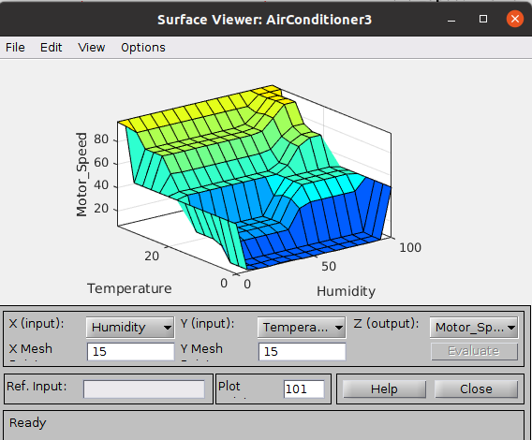
From the plot we can tell that as the humidity is high and the temperature is high the motor speed is at its highest. And also from the general view of the plot the motor responds relatively to both humidity and temperature. The speed is determined by both the two factors. When the humidity is low and the temperature is the same then the Motor speed is 0.

3 Mental State Modeling and driving to flow.
In this part of the assignment similar techniques as above were employed. Having a rule base, defining the inputs and outputs and the the membership functions to employ. In this case the inputs included skill and challenge, then the output was mental state.
3 a) The system.
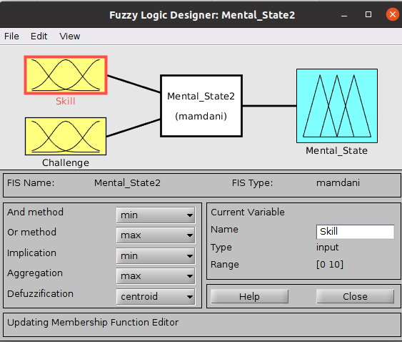
As shown from the graphic there are 2 inputs that is Skill and Challenge, with the output of Mental State. Similarly membership functions were employed for the skill and challenge inputs and for the mental state output.

3 b) The Skill membership function.
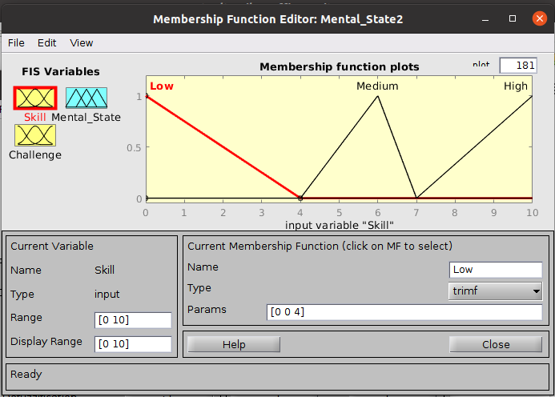
Trimf was used in this case having 3 membership functions representing Low, Medium and High. The overall range for the skill function is between 0 and 10. Low on the other hand represents a parameter set of [0 0 4] and then medium got [4 6 7] and finally high [7 10 10].

3 c) Challenge membership function.
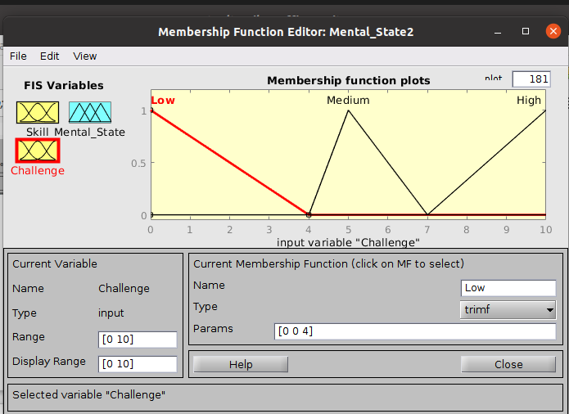
With the input of challenge, the trimf membership function was used. The overall range was between 0 and 10. While the individual functions representing Low got [0 0 4], then Medium [4 5 7] and High [7 10 10] respectively.

3 d) Mental state membership function.
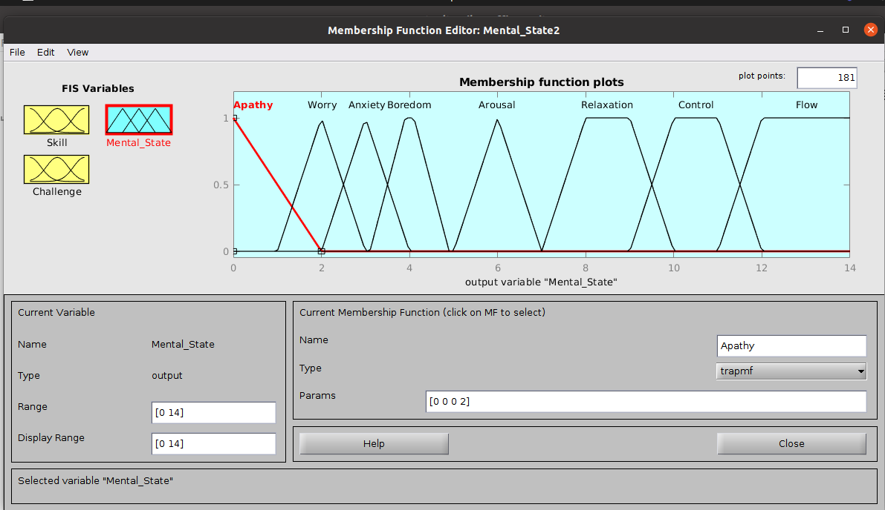
The output in this case is the mental state with several functions representing Apathy, Worry, Anxiety, Boredom, Arousal, Relaxation, Control and Flow. The respective ranges for each of the functions is [0 0 0 2], [1 2 2 3], [2 3 3 4], [3.1 3.9 4.1 4.9], [5 6 6 7], [7 8 9 10], [9 10 11 12] and [11 12 14 14] respectively.

3 e) The rules.
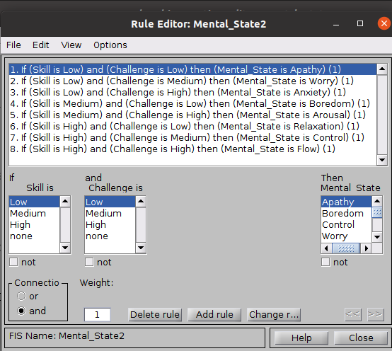
The rules on the left were the basis of the whole system. The two inputs as observed are Skill and Challenge connected with “and” then the output.

3f) Testing the system.
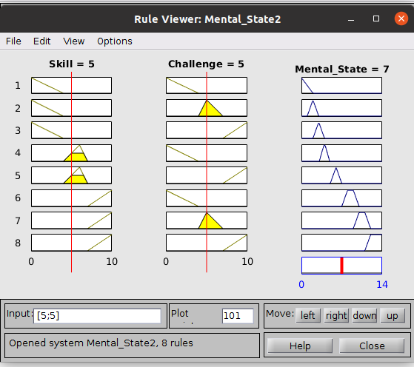
As shown earlier we can now simulate the mental state based on on our fuzzy system. When skill is 5 and Challenge is 5 then mental state is 7. Adjusting the red lines will give us different values for the mental state.

3 g ) The surface chart.
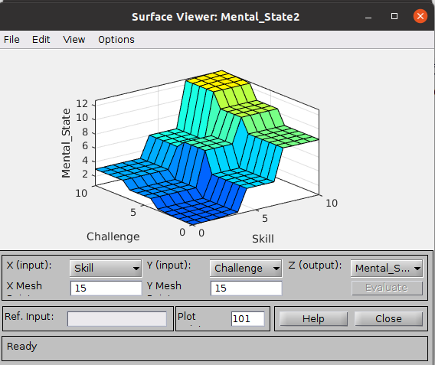
When skill is low and challenge is low then mental state is dormant. Likewise when all challenge is high and skill is high Mental state is pretty vigorous.

In conclusion the exercise was very rewarding and a good learning experience. This whole fuzzy system building taught me how to implement complex systems using fuzzy logic. In fact many much more powerful systems have been implemented with fuzzy logic like the the Sendai Subway system in Japan so, this is a worthwhile technique that is well respected in Engineering.

