WHITFIELD & CRANE LLP

DECLARATION IN SUPPORT OF
EX PARTE ASSET FREEZE

FINANCIAL TRANSACTION FORENSICS / CASE RECORD
COURT | CASE NUMBER
U.S. District Court for the Southern District of New York | #WC-2026-FX7717
DOCUMENT TYPE | DATE
Sworn Affidavit / Declaration | 当天日期
APPLICANT / VICTIM | TARGET INSTITUTION
客户姓名 | Wise Payments Limited

SWORN STATEMENTS
I, 客户姓名, the victim in this matter, declare under penalty of perjury that the following is true and correct:
1. I am the direct victim of a highly organized transnational cyber fraud syndicate.
2. Following the incident, the legal representatives at Whitfield & Crane LLP and their investigative team conducted a forensic trace of my funds.

3. According to the "Funds Tracking Report" (#WC-2026-FX7717), my initial transferred funds were subjected to 167 laundering transfers utilizing offshore shell companies, fictitious trade accounts, and cryptocurrency mixers.
4. The trace definitively shows that the illicit funds have crossed international borders and are currently parked at the London, UK-based Wise platform. The account is under the name Toby A Blackburn, card ending in #8842.
5. I respectfully implore the Court to immediately issue an emergency ex parte asset freeze order. Without immediate ex parte intervention, these funds are highly likely to be transferred again, causing irreparable and permanent financial harm.

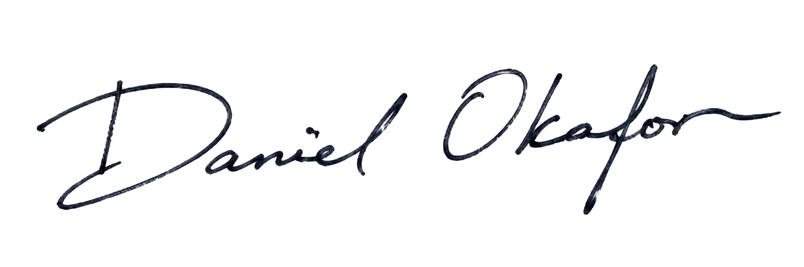  Counsel Signature: | Client Signature:
Name: | Name:
当天日期 | 当天日期

