WHITFIELD & CRANE LLP

UNDERLYING ASSET
INVESTIGATION & EVIDENCE DOSSIER

FINANCIAL TRANSACTION FORENSICS / CASE RECORD
CLIENT NAME | CASE NUMBER
客户姓名 | #WC-2026-FX7717
TOTAL REPORTED LOSS | TRANSACTION EVENTS
$客户损失金额 | 167
TRACE VALUE | FINAL TRACE REGION
$客户其中一笔转账金额 | London, United Kingdom

01. BACKGROUND & PURPOSE
Commissioned by the client, our asset tracing team conducted an in-depth, bottom-layer trace of the diverted funds originating from a cyber fraud scheme. The investigation aims to penetrate the obfuscation routing to identify the final physical and digital destination of the assets.

02. FUNDS MOVEMENT ROUTE
Based on blockchain and fiat penetration tracing, the client's defrauded funds underwent a highly complex laundering process post-transfer:
• High-Frequency Routing: Funds were rapidly transferred 167 times within a short timeframe.
• Obfuscation Network: The perpetrators cross-utilized offshore shell company corporate accounts and fictitious international trade settlement flows.
• Crypto Mixing: Certain segments of the routing chain utilized cryptocurrency mixers (Crypto Mixers) to sever the fiat tracing links.

03. FINAL ASSET DESTINATION
METRIC | VALUE
Destination Platform | Wise (formerly TransferWise)
Recipient Name | Toby A Blackburn
Associated Card Reference | 4756 **** **** 8842 / Ending in #8842

04. INVESTIGATION CONCLUSION
This account exhibits classic characteristics of money laundering and illicit funds receipt. Given that the assets have crossed borders into the UK jurisdiction, we recommend the immediate initiation of mutual legal assistance protocols and regulatory freeze procedures.

Counsel Signature:  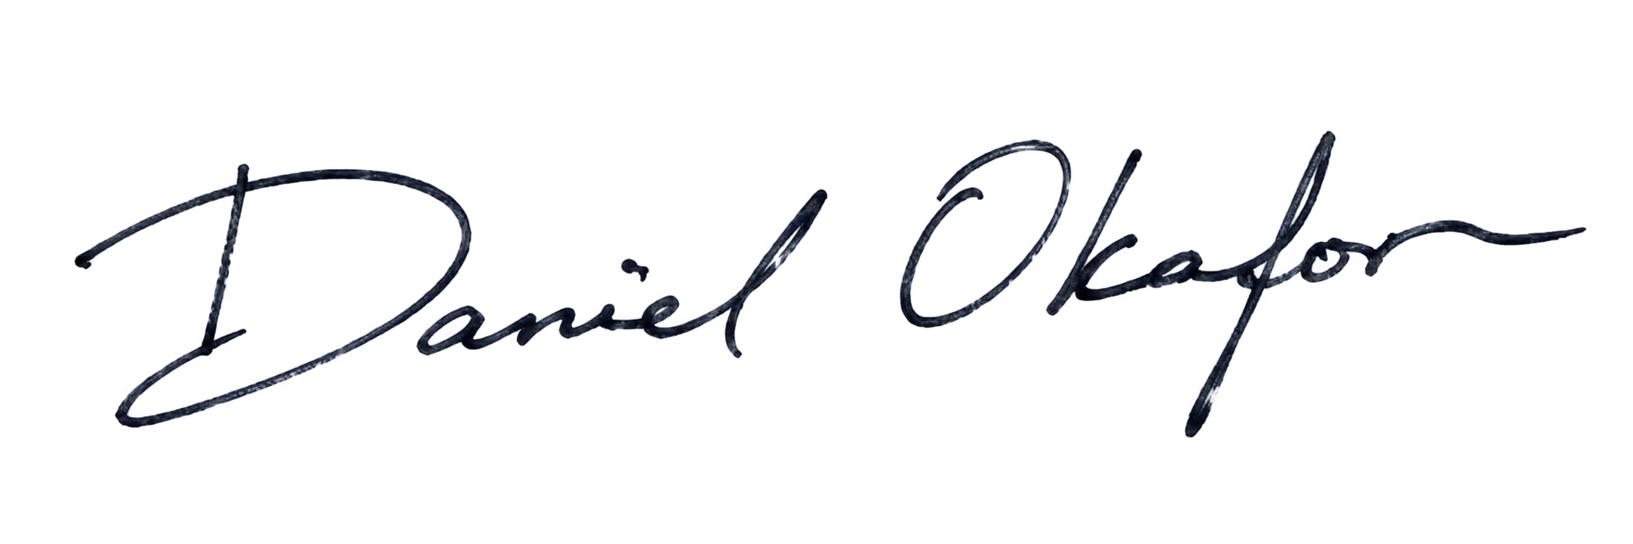 |   Judge Signature:
Name: | Name:
当天日期 | 当天日期

