WHITFIELD & CRANE LLP

MUTUAL LEGAL ASSISTANCE
REQUEST (MLAT)

FINANCIAL TRANSACTION FORENSICS / CASE RECORD
TO: CENTRAL AUTHORITY | CASE NUMBER
UK Home Office | #WC-2026-FX7717
FROM: ISSUING COURT | DATE
U.S. District Court for the Southern District of New York | October 12, 2026
TARGET INSTITUTION | TARGET ACCOUNT
Wise Payments Limited | Toby A Blackburn (#8842)

01. OVERVIEW OF REQUEST

Pursuant to the Treaty Between the Government of the United States of America and the Government of the United Kingdom of Great Britain and Northern Ireland on Mutual Legal Assistance in Criminal Matters, the United States hereby requests the UK Central Authority to take emergency asset preservation measures regarding proceeds of a severe transnational cyber fraud and money laundering case located within UK jurisdiction.

02. CASE BACKGROUND & LAUNDERING TYPOLOGY
The criminal network involved laundered the funds through a complex obfuscation process involving 167 transfers, offshore shell entities, and crypto mixers. The US investigation has successfully penetrated this veil.

03. FREEZE DIRECTIVE TO BE EXECUTED
The illicit funds are currently locked within a UK-based financial institution. We request the UK authorities to immediately issue a binding freeze order to the following institution:
TARGET FIELD | DETAILS
Institution | Wise Payments Limited
Account Name | Toby A Blackburn
Card Info | Ending in #8842

04. DECLARATION OF URGENCY
Without immediate action, the suspects are highly likely to dissipate the illicit funds currently held in this account. We appreciate your prompt assistance.

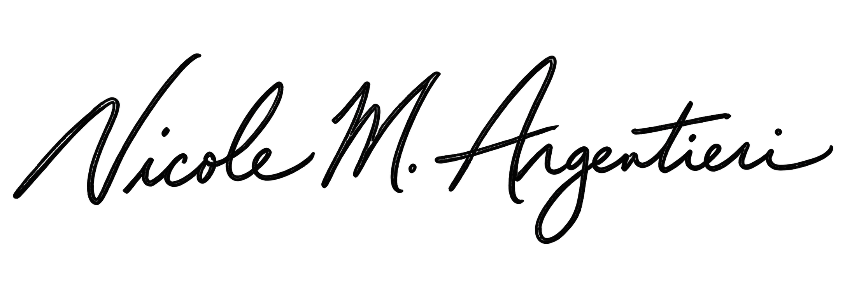  U.S. Department of Justice (DOJ) Official Signature: | 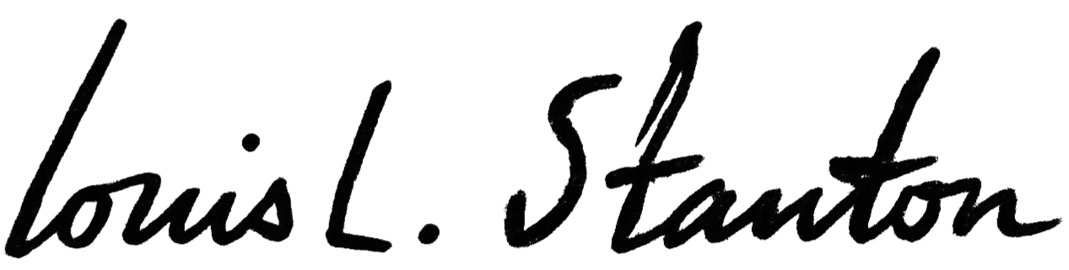  Judge Signature:
Name: | Name:
当天日期 | 当天日期

