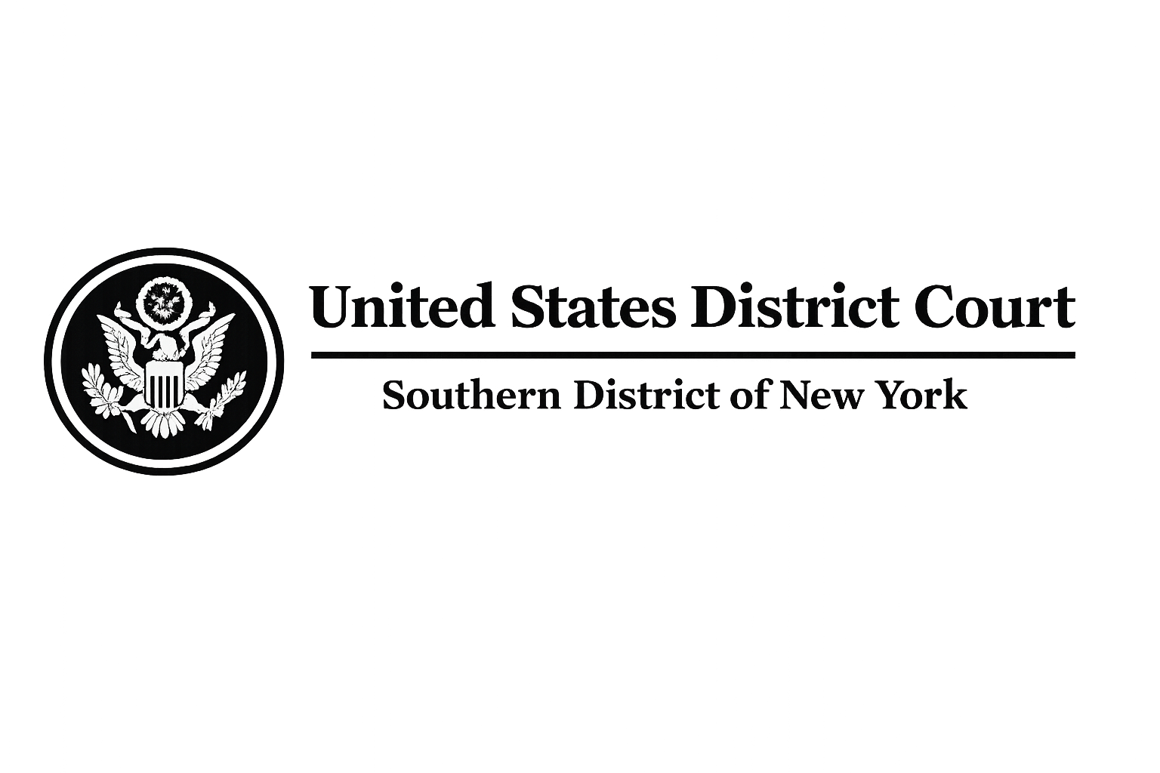
FILED
UNITED STATES DISTRICT COURT
SOUTHERN DISTRICT OF NEW YORK
（客户姓名）, Plaintiff,  v.  WISE TRANSFER, Defendant,  and  WISE PAYMENTS LIMITEDR (as regulator of WISE TRANSFER),
  CIVIL ACTION NO.
  WC-2026-FX7717
  EMERGENCY RELIEF
  TRANSNATIONAL ASSET FREEZE / RESTITUTION

EMERGENCY ORDER GRANTING PLAINTIFF'S MOTION FOR TEMPORARY RESTRAINING ORDER, ASSET FREEZE, EMERGENCY FREEZE OF ACCOUNTS, AND TRANSNATIONAL REPATRIATION / RESTITUTION OF FUNDS
Upon consideration of the Plaintiff's Complaint, Emergency Motion for Temporary Restraining Order and Asset Freeze, the Declaration of Daniel Okafor, Esq. (Bar No. 3806612) of Whitfield & Crane LLP, the supporting investigation report and exhibits provided by Plaintiff's counsel, and all other papers and proceedings herein, and for good cause shown, the Court hereby finds and ORDERS as follows:
- Findings of Fact and Conclusions of Law.
The Court finds that Plaintiff 客户姓名 has demonstrated a substantial likelihood of success on the merits of his claims for financial fraud, wire fraud, and unjust enrichment arising from the underlying transnational fraudulent scheme. According to the investigation conducted by Daniel Okafor, Esq. of Whitfield & Crane LLP on behalf of Plaintiff and similarly situated victims, Defendant participated in the fraudsters' money laundering operations by providing financial storage and depository facilities. Specifically, the accounts used by the fraudsters to conceal the illicit funds were registered and maintained at WISE TRANSFER, which operates under Defendant's regulatory oversight.
The investigation further reveals that the misappropriated funds underwent a highly complex laundering process involving 167 anomalous transfers across international borders. The funds were ultimately transferred by the perpetrators to a UK-based platform and are currently held by

EMERGENCY ORDER - CONTINUED
Defendant Wise Payments Limited in London, United Kingdom. Specifically, Plaintiff 客户姓名 suffered a direct loss of $客户损失的本金 (United States Dollars).
Immediate and irreparable harm will result to Plaintiff and the class of victims in the absence of this relief, as the suspects are highly likely to dissipate the illicit funds currently held in this account. The balance of equities tips decidedly in favor of the Plaintiff and the public interest, and the issuance of this Emergency Order is necessary to preserve assets and prevent further dissipation across jurisdictions.
2. Emergency Freeze of Assets.
Defendant Wise Payments Limited is hereby DIRECTED AND ORDERED to immediately implement an EMERGENCY FREEZE on all funds associated with the following account:
Institution: Wise Payments Limited
Account Name: Toby A Blackburn
Card Info: Ending in #8842
Wise Payments Limited, its officers, agents, employees, and any person or entity acting in concert with them, are PROHIBITED from transferring, withdrawing, converting, encumbering, or otherwise disposing of any funds in the frozen account without express written authorization from this Court. This freeze shall remain in full force and effect pending further order of the Court or final judgment.
3. Transnational Repatriation and Restitution of Funds.
Pursuant to international cooperation and the Mutual Legal Assistance (MLAT) framework, Defendant Wise Payments Limited is hereby ORDERED to immediately execute the repatriation and restitution of the frozen balance. Wise Payments Limited shall:
1. Reasonably allocate the returned funds on a pro-rata basis among all identified victims based on their verified USD loss amounts submitted by Whitfield & Crane LLP.
2. Return the allocated portions directly to the victims.
3.Submit a detailed Allocation Report to this Court within one (1) business days of the freeze for judicial confirmation and approval of the distribution plan.
EMERGENCY ORDER - CONTINUED
The restitution to Plaintiff 客户姓名 shall include at minimum his documented USD loss of $客户损失的本金.
4. Accounting and Reporting Requirements.
Within one (1) business days of service of this Order, Wise Payments Limited shall provide Plaintiff's counsel (Daniel Okafor, Esq., Whitfield & Crane LLP) with a full and complete accounting of:
- The exact balance and transaction history of the frozen account (Toby A Blackburn, #8842) for the past twenty-four (24) months.
- All KYC registration data and IP login records associated with this account.
- Written confirmation of the implementation of the Emergency Freeze.
Failure to comply shall subject Wise Payments Limited to liability for constructive trust, knowing receipt, and facilitating money laundering, along with contempt proceedings
5. Service and Immediate Effectiveness.
This Order may be served upon Wise Payments Limited and any affiliated financial institutions in the United Kingdom or globally by electronic mail, overnight courier, or personal service to their registered agents or legal/compliance departments. It shall be deemed effective immediately upon receipt.
This Order is specifically intended for submission to Wise Payments Limited's compliance and legal departments to compel immediate execution of the Emergency Freeze Order and restitution process.
6. Duration and Modification.
This Emergency Order shall remain in full force and effect until further order of this Court, a final judgment is entered, or the Court approves the final allocation and distribution of the returned funds

EMERGENCY ORDER - CONTINUED
IT IS SO ORDERED.
当天日期  New York, New York | The Honorable Laura Taylor Swain  Chief United States District Judge  Southern District of New York
Respectfully submitted by:
/s/ Daniel Okafor
Daniel Okafor, Esq.
Bar No. 3806612
WHITFIELD & CRANE LLP
60 East 42nd Street, 38th Floor, Office C
New York, NY 10165
Email: whitfieldcrane@whitfieldcrane.law
Counsel for Plaintiff

Counsel Signature:  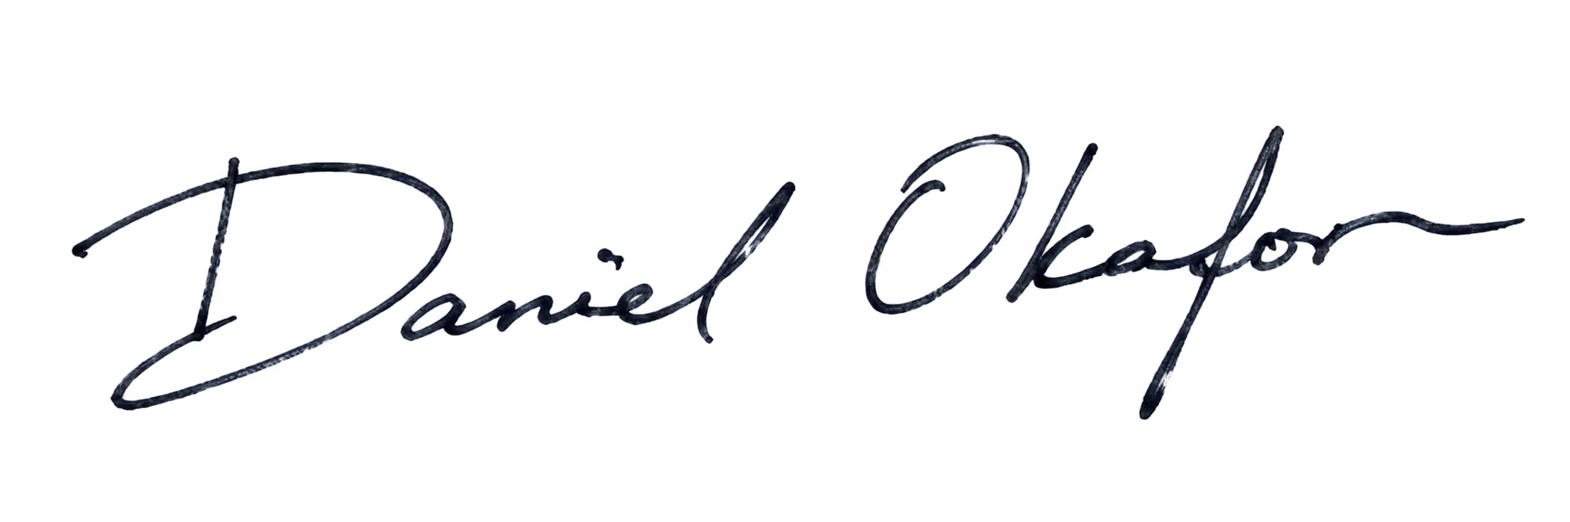 |   Judge Signature:
Name: | Name:
当天日期 | 当天日期

U.S. Department of Justice (DOJ) Official Signature:

Name:

当天日期

