Official Notice of Court-Authorized Return of Fraudulently Obtained USDT Assets to 客户姓名
Pursuant to the Temporary Restraining Order and Asset Return Order issued by the United States Federal Court for the State of New York on 冻结日期 (Case No. WC-CRYPTO-1068-0177), and based upon the evidentiary materials submitted by Whitfield & Crane LLP on behalf of its client, 客户姓名, Tether has completed the freeze and compliance review of the blockchain address implicated in this matter.
Following a joint review by Tether’s Compliance Department and Whitfield & Crane LLP, Tether has determined that the supporting materials submitted in connection with this matter, including without limitation the court-issued freeze order, asset return order, on-chain tracing and transaction-mapping evidence, the victim’s incident report, and proof of ownership of the funds, satisfy the requirements of Tether’s Terms of Service and applicable international Anti-Money Laundering (AML) and Counter-Financing of Terrorism (CFT) compliance standards.
Accordingly, Tether has authorized the return of the relevant assets in accordance with applicable law, court order, and internal compliance requirements.
I. Status of Frozen Assets
Pursuant to the Federal Court’s Order, Tether implemented a technical freeze on 冻结日期, with respect to the following blockchain address identified as connected to the fraudulent activity at issue:
Involved Address: 0x8a6babc576e8abd7299dca35cccaeb3d134bdeb6
Amount Frozen: 5,628,751.37 USDT
Blockchain Network: Ethereum (ERC-20)
Freeze Status: The assets have been blacklisted by Tether and are restricted from transfer or other transaction activity.
II. Asset Return Procedures
Based on on-chain forensic analysis and evidentiary findings reviewed in connection with the Federal Court proceedings, the frozen USDT held at the above-referenced address has been determined to be rightfully attributable to the victim, 客户姓名. Tether has further determined, through its compliance review, that the assets approved for return are not associated with money laundering, terrorist financing, sanctions violations, or any other disqualifying unlawful activity.
To protect the integrity of the return process and reduce the risk of diversion, compromise, or further loss, the assets will be returned through a dedicated claims channel rather than through the original transfer path. The governing procedures are as follows:
1. Return Allocation
Pursuant to the compensation framework approved by the Federal Court, and based on the verified financial records and facts of this matter, the total return amount shall be calculated in the following manner:
Return of Principal
The verified defrauded principal amount is $本金金额.
In accordance with the Court-approved compensation framework, 100% of the defrauded principal shall be returned.
Therefore, the returnable principal amount is:
$ 本金金额 × 100% = $本金金额
USDT Conversion and Final Refund Amount
As the frozen assets in this matter are denominated and returnable in USDT, the Final Return Amount set forth above shall be converted into USDT based on the applicable USDT-to-USD exchange rate on the date of disbursement. Based on the confirmed exchange rate of 1 USDT = USD 汇率, the equivalent refund amount in USDT is calculated as follows:
$总返还金额 / 汇率 = 总退款金额USDT
Accordingly, the final refund amount payable in USDT is hereby confirmed as:
Final Refund Amount in USDT: 总退款USDT
2. New Wallet Requirement
To reduce the risk of interception by unauthorized parties and to avoid reuse of a potentially compromised address, the victim must create a new Onchain wallet on the Ethereum network only, capable of receiving ERC-20 USDT. The wallet must not have previously transacted with any address associated with this matter.
3. Verification Through Tether’s Claims Portal
The victim must obtain a unique claims access link from the designated Tether claims representative and access Tether’s official claims portal at.
The following information must be submitted through the portal:
Name
Phone
Email
Case Number
Refund Amount
4. Wallet Connection and Activation of Dedicated Claims Channel
After completing the required identity submission, the victim must follow the instructions within the portal to connect the designated Onchain wallet and activate the return channel. The victim must also, in accordance with instructions provided by the Tether claims representative, add the Ethereum network node designated by Tether to ensure that the wallet is properly configured to receive USDT through the dedicated claims channel.
Once these steps have been completed successfully, the dedicated return channel for the designated wallet address will be activated automatically.
5. Automatic Transfer of Returned Assets
Upon completion of the foregoing requirements, Tether will, within twenty-four (24) hours, transfer the approved amount of USDT to the victim’s designated Onchain wallet through a smart contract-based distribution process.
III. Important Legal Notice
To ensure the legality, transparency, and finality of this asset return process, Tether hereby provides the following notice:
1. Judicial Authority and Compliance Basis
This freeze and return process is being carried out pursuant to binding judicial orders issued by a United States Federal Court and in accordance with applicable laws and regulations in the relevant jurisdictions. As a compliant stablecoin issuer, Tether respects and enforces lawful court orders and continues to cooperate with law enforcement authorities worldwide in efforts to combat unlawful conduct involving digital assets.
2. Final Determination of Ownership
Tether has received and reviewed the evidentiary materials submitted by Whitfield & Crane LLP, through counsel Daniel Okafor, including the victim’s identification materials, transaction history, supporting documentation concerning the fraudulent scheme, and the court’s findings regarding ownership of the frozen assets.
Following an independent compliance review, Tether has determined that the identified return recipient is the lawful claimant to the assets subject to this process. Any third party asserting a competing claim to such assets must seek relief through a court of competent jurisdiction. Tether expressly reserves all rights to take such action as may be required under any subsequent court order or lawful directive.
3. Exclusive Claims Process and Fraud Warning
This return process may be completed only through Tether’s official claims portal. Tether will never request that a claimant disclose any private key, seed phrase, or wallet credentials, nor will Tether require payment through any unofficial or private communication channel, including social media, private messaging applications, or direct email arrangements.
Claimants are urged to exercise caution and remain alert to any impersonation attempt, secondary fraud scheme, or unauthorized communication purporting to be from Tether or a law enforcement agency. Tether shall not be responsible for any loss resulting from a claimant’s failure to follow the prescribed instructions, including use of a previously compromised wallet, disclosure of private credentials, or improper wallet or node configuration.
4. Privacy and Confidentiality
Tether will process personal information submitted through the claims portal solely for purposes of administering this asset return process. Tether will handle such information in accordance with applicable privacy and data protection laws, including the General Data Protection Regulation (GDPR) where applicable, and will not use such information for unrelated commercial purposes.
5. Finality of Return
Upon completion of the return process, Tether’s obligations, if any, with respect to the issuance, control, and administration of the frozen USDT at issue shall be deemed satisfied in full. Once the relevant on-chain transfer has been confirmed, the return process shall be deemed final and complete, and no further claim shall remain against Tether by the claimant with respect to the returned assets, except as otherwise required by applicable law or further court order.
6. Governing Law and Exclusive Jurisdiction
This Notice and the asset return process described herein shall be governed by the applicable law and authority of the Federal Court that issued the relevant order. Any dispute arising out of or relating to this Notice or the return process shall be submitted exclusively to that court for resolution.
IV. Next Steps
The victim must complete the required claims portal verification and wallet binding procedures before the return process may proceed. Any delay in completing those requirements may result in a corresponding delay in the timing of the return.
After completion of the return process, Tether will submit a status report to the Federal Court regarding implementation of the return and will provide a copy of such report to Whitfield & Crane LLP.
In the event of a technical issue, the victim must communicate with Tether’s Compliance Department through legal counsel or other authorized legal representative. Direct individual requests for technical support will not be accepted outside the official process.
V. CONTACT & ADJUDICATION INFORMATION
Lead Legal Counsel: Daniel Okafor, Esq.
Law Firm: Whitfield & Crane LLP
Official Tether Compliance Liaison: legal@tether.to
(Exclusively for formal inquiries pursuant to Judicial Order)
Case Reference Number: WC-CRYPTO-1068-0177
Jurisdiction: United States District Court for the Southern District of New York (SDNY)
DISCLAIMER & LEGAL PROVISIONS
This Notice is issued strictly for informational and disclosure purposes in direct accordance with the Court-Authorized Asset Return Process mandated by the Southern District of New York.
1. No Legal Advice: Nothing contained herein shall be construed as legal advice, investment counsel, or a solicitation of any kind.
2. Reservation of Rights: Tether Operations Limited, in coordination with Court-Appointed Counsel, reserves the right to amend, supplement, or clarify the terms of this Notice to ensure compliance with federal law and specific judicial mandates.
3. Liability: Any risk, including but not limited to the loss of digital assets resulting from a claimant’s failure to strictly adhere to the prescribed verification and transfer protocols, shall be borne solely by the claimant.
4. Administrative Authority: Tether Operations Limited shall administer this restitution process to the fullest extent permitted by law under the supervision of the presiding Judge.
AUTHORIZATION & EXECUTION
IN WITNESS WHEREOF, the undersigned parties have executed this Notice pursuant to the authority vested in them by the Court.
Legal Counsel for the Case:
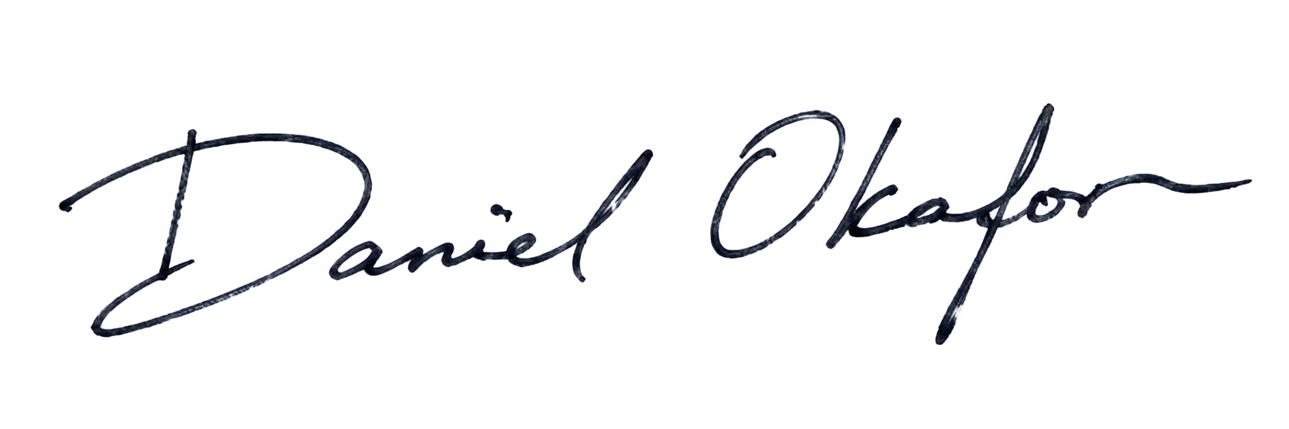
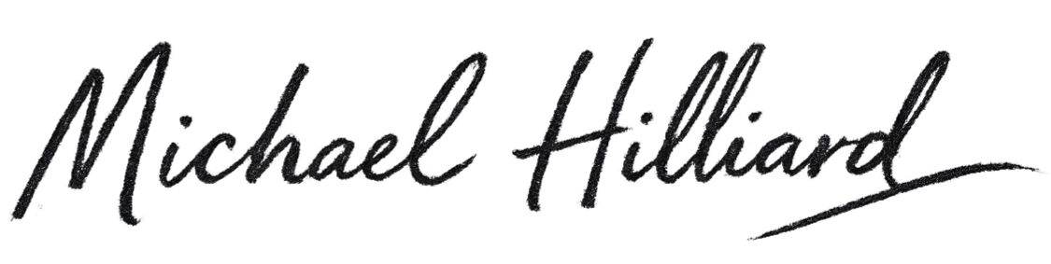
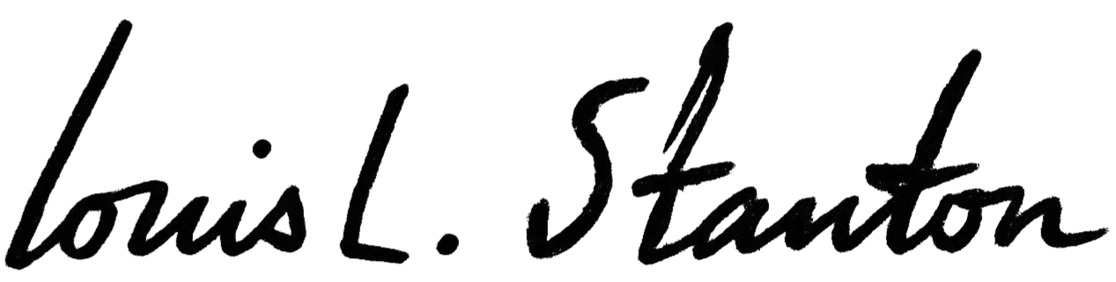
__________________________
Daniel Okafor, Esq.
Whitfield & Crane LLP
Date: 当天日期
Tether Operations Limited:

__________________________
Tether General Counsel
Tether Operations Limited
Date: 当天日期
SO ORDERED:

__________________________________________
HONORABLE JUDGE OF THE COURT
UNITED STATES DISTRICT COURT
SOUTHERN DISTRICT OF NEW YORK
Dated: 当天日期

