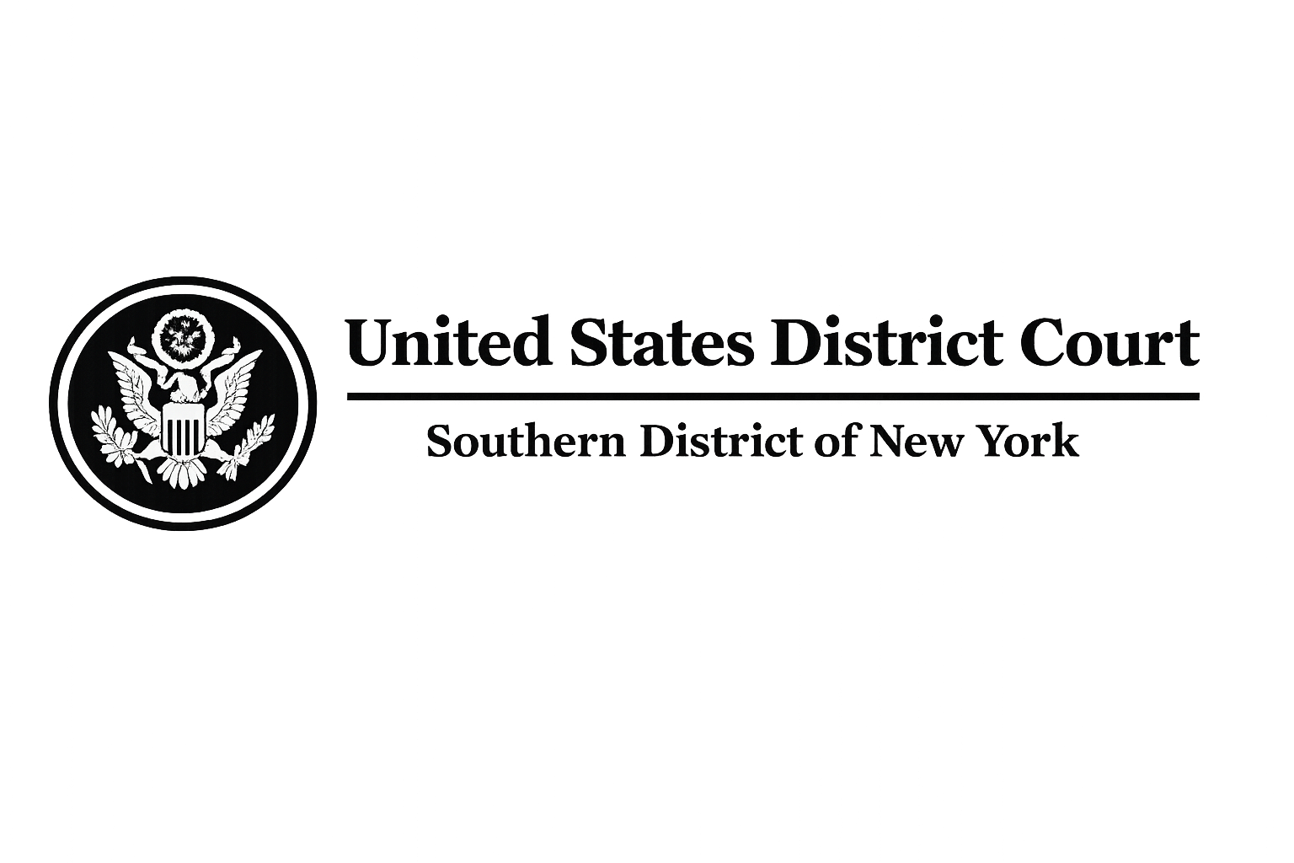
FILED
UNITED STATES DISTRICT COURT
SOUTHERN DISTRICT OF NEW YORK
RICARDO CLEMENTS（客户姓名）, Plaintiff,  v.  CHAINFORCE, Defendant,  and  TETHER LIMITED (as non-party issuer of USDT),  BITGET (as non-party custodial wallet provider),  Third-Party Respondents.
  CIVIL ACTION NO.
  WC-CRYPTO-1068-0177
  EMERGENCY RELIEF
  ASSET FREEZE / RESTITUTION

EMERGENCY ORDER GRANTING PLAINTIFF'S MOTION FOR TEMPORARY RESTRAINING ORDER, ASSET FREEZE, EMERGENCY FREEZE OF USDT TOKENS, AND REPATRIATION / RESTITUTION OF FUNDS
Upon consideration of the Plaintiff's Complaint, Emergency Motion for Temporary Restraining Order and Asset Freeze, the Declaration of Daniel Okafor, Esq. (Bar No. 3806612) of Whitfield & Crane LLP, the supporting investigation report and exhibits provided by Plaintiff's counsel, and all other papers and proceedings herein, and for good cause shown, the Court hereby finds and ORDERS as follows:
1. Findings of Fact and Conclusions of Law.
The Court finds that Plaintiff 客户姓名 has demonstrated a substantial likelihood of success on the merits of his claims for financial fraud, wire fraud, and unjust enrichment arising from the underlying fraudulent scheme. According to the investigation conducted by Daniel Okafor, Esq. of Whitfield & Crane LLP on behalf of Plaintiff and similarly situated victims, Plaintiff was fraudulently induced to transfer or deposit funds as part of the fraudulent activity.

The investigation further reveals that the misappropriated funds were ultimately transferred by the perpetrators to a Bitget custodial wallet and converted into USDT tokens. Specifically, Plaintiff 客户姓名 suffered a direct loss of $客户损失的本金 (United States Dollars). The total amount traceable to the fraudulent scheme and currently held in the Bitget custodial wallet is 5,628,751.37 USDT.

EMERGENCY ORDER - CONTINUED
The investigation confirms that this address contains funds belonging to multiple victims in addition to Mr. 客户姓名. Immediate and irreparable harm will result to Plaintiff and the class of victims in the absence of this relief. The balance of equities tips decidedly in favor of the Plaintiff and the public interest, and the issuance of this Emergency Order is necessary to preserve assets and prevent further dissipation.
2. Emergency Freeze of USDT Assets.
Non-party Tether Limited, as the sole issuer and administrator of USDT tokens, together with Bitget as the custodial service provider, are hereby DIRECTED AND ORDERED to immediately implement an EMERGENCY FREEZE on all USDT tokens associated with the following Bitget custodial wallet address: 0x8a6babc576e8abd7299dca35cccaeb3d134bdeb6. The total frozen amount shall be 5,628,751.37 USDT.
Tether Limited and Bitget, their officers, agents, employees, and any person or entity acting in concert with them, are PROHIBITED from transferring, withdrawing, converting, encumbering, or otherwise disposing of any USDT in the Frozen Address without express written authorization from this Court. This freeze shall remain in full force and effect pending further order of the Court or final judgment.
3. Repatriation and Restitution of Funds.
Tether Limited is hereby ORDERED to immediately execute the repatriation and restitution of the entire frozen balance of 5,628,751.37 USDT. Because the Whitfield & Crane LLP investigation confirms that the Frozen Address contains funds traceable to multiple victims (including but not limited to Plaintiff 客户姓名), Tether Limited shall:
1. Reasonably allocate the returned funds on a pro-rata basis among all identified victims based on their verified USD loss amounts submitted by Whitfield & Crane LLP.
2. Return the allocated portions directly to the victims in USDT, with the amount of USDT to be refunded determined by converting the victims’ USD-denominated loss into its USDT equivalent using the prevailing USDT-to-USD exchange rate in effect on the date of refund.

EMERGENCY ORDER - CONTINUED
3. Submit a detailed Allocation Report to this Court within one (1) business days of the freeze for judicial confirmation and approval of the distribution plan.
The restitution to Plaintiff 客户姓名 shall include at minimum his documented USD loss of $客户损失的本金.
4. Accounting and Reporting Requirements.
Within one (1) business days of service of this Order, Tether Limited and Bitget shall provide Plaintiff's counsel (Daniel Okafor, Esq., Whitfield & Crane LLP) with a full and complete accounting of:
1. The exact balance and transaction history of the Frozen Address for the past twenty-four (24) months.
2. All blockchain records confirming the USDT tokens are under Tether's control.
3. Written confirmation of the implementation of the Emergency Freeze.
Failure to comply shall subject Tether Limited and Bitget to contempt proceedings.
5. Service and Immediate Effectiveness.
This Order may be served upon Tether Limited, Bitget, and any affiliated financial institutions by electronic mail, overnight courier, or personal service to their registered agents or legal departments. It shall be deemed effective immediately upon receipt.
EMERGENCY ORDER - FINAL PAGE
This Order is specifically intended for submission to Tether Limited's compliance and legal departments to compel immediate execution of the Emergency Freeze Order and restitution process.
6. Duration and Modification.
This Emergency Order shall remain in full force and effect until further order of this Court, a final judgment is entered, or the Court approves the final allocation and distribution of the returned funds.
IT IS SO ORDERED.
冻结日期  New York, New York | The Honorable Laura Taylor Swain  Chief United States District Judge  Southern District of New York
Respectfully submitted by:
/s/ Daniel Okafor
Daniel Okafor, Esq.
Bar No. 3806612
WHITFIELD & CRANE LLP
60 East 42nd Street, 38th Floor, Office C
New York, NY 10165
Email: whitfieldcranellp@gmail.com
Counsel for Plaintiff

Counsel Signature:  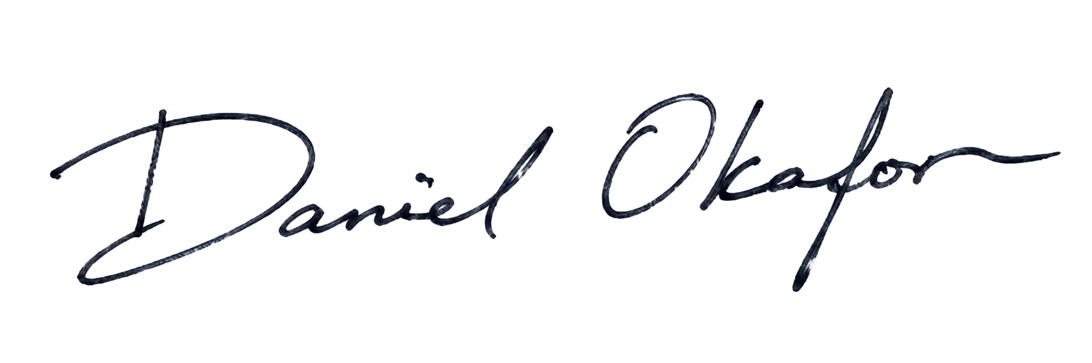 | 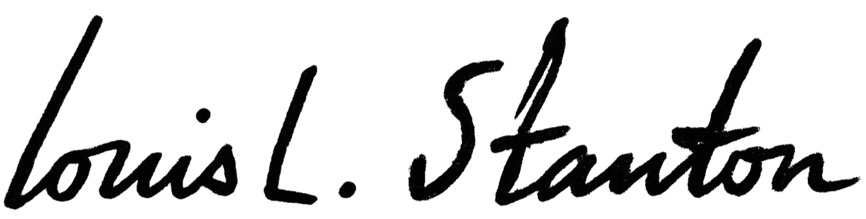  Judge Signature:
Name: | Name:
冻结日期 | 冻结日期

