TETHER OPERATIONS LIMITED
Global Legal Compliance & Victim Assistance Asset Recovery Department
SPECIAL VICTIM ASSISTANCE ASSET RECOVERY & HARDSHIP RELIEF PROGRAM
Claimant Verification, KYC Hardship Exception & OnChain Settlement Agreement
Ref. No.: TETHER-HARP/2026-US-8091 | Jurisdiction: United States Compliance / FinCEN
Effective Date: 生效日期 | Status: Special Hardship Assistance Exception

1. Executive Summary & Regulatory Framework
Tether Operations Limited ("Tether"), in accordance with international consumer financial protection standards, the Bank Secrecy Act (BSA), applicable FinCEN guidance concerning digital asset remediation, and federal victim assistance and hardship-relief policies, hereby establishes the Special Victim Assistance Asset Recovery & Hardship Relief Program (the "Program"). This Agreement sets forth the terms under which affected victims may seek expedited recovery of frozen, seized, or misplaced digital assets through automated on-chain disbursement directly to the victim's designated On-Chain Web3 Wallet.
2. KYC Hardship Exception & Reduced Wallet Verification Deposit (50% Relief)
Under standard anti-money laundering (AML) and Know Your Customer (KYC) compliance procedures (31 C.F.R. § 1022.210), claimants seeking asset recovery are ordinarily required to complete institutional identity verification and provide a standard compliance security deposit of 减免前金额 USDT to verify wallet control and prevent fraudulent claims.
Under Tether's Victim Assistance and Hardship Relief Policy and Special Exception Authority, Tether has approved a 减免百分比% hardship reduction for qualifying victims. The claimant is required to deposit only 减免后金额 USDT (减免剩余百分比% of the standard requirement) to the designated on-chain verification address to complete cryptographic proof of wallet control and initiate the automated smart-contract disbursement.

3. On-Chain Disbursement & 1% Victim Assistance Fund Allocation
Upon successful cryptographic verification of wallet control, the full amount of the victim's eligible recovered assets, together with the 减免后金额 USDT verification deposit, will be scheduled for automated final settlement.
SPECIAL DEDUCTION & PROGRAM FUNDING PROVISION (1% FUND CONTRIBUTION):
In accordance with Section 4(b) of the Program Charter, a non-refundable 1% contribution will be automatically withheld from the total refund amount at the time of final settlement. This 1% allocation will be deposited directly into the Global Victim Assistance Fund to support ongoing legal assistance, fraud prevention, and emergency aid for victims experiencing severe financial hardship. The remaining 99% of the total funds (including 99% of the 减免后金额 USDT verification deposit) will be disbursed directly to the victim's verified On-Chain Wallet.
4. Comparative Verification & Settlement Summary
Compliance Category | Standard Institutional Procedure | Hardship Assistance Program
KYC & Wallet-Control Verification Deposit | 减免前金额 USDT  (100% Full Requirement) | 减免后金额 USDT  (50% Hardship Exception)
Final Refund Distribution Terms | 100% Refund  (Subject to standard legal audit) | 99% Refund to On-Chain Wallet /  1% Retained for Victim Assistance Fund

5. Claimant Acknowledgment & Authorization
By signing below, the Claimant certifies under penalty of perjury under the laws of the United States of America that they are the lawful owner of the registered victim account, fully accept the 1% victim assistance fund contribution, and authorize Tether Operations Limited to complete the final refund settlement to the designated On-Chain Wallet address.
Claimant Full Legal Name:
客户姓名
Claimant Contact Email / Phone:
邮箱或电话
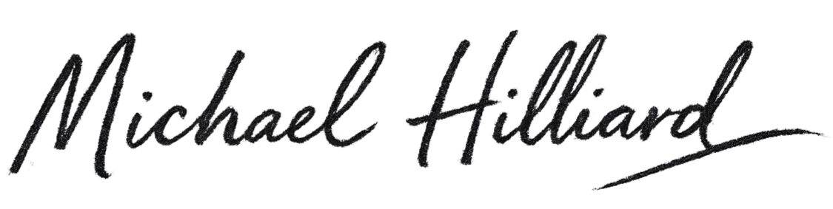
Tether Authorized Compliance Officer:

Date (MM/DD/YYYY): 日/ 月 / 年

