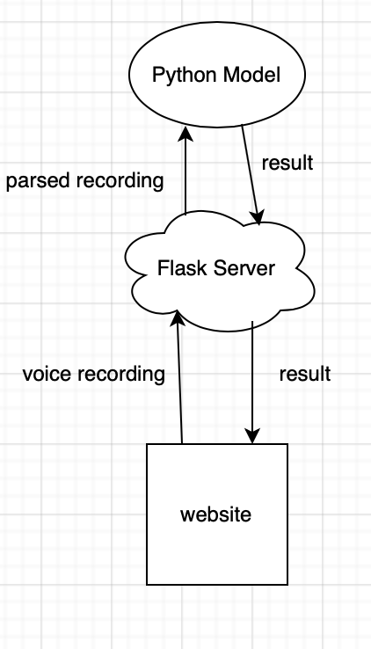

<https://restfulapi.net>

Front end:

* html/css/js

Backend:

* Heroku

AI:

* Tensorflow
* PyTorch

Backend

* *from* flask *import* Flask
* app = Flask(__name__)
* def get_res(file):
* *return* True
* @app.route('/post/audio', methods=['GET','POST'])
* def get_audio():
* *if* request.method == 'POST':
* file = request.files['messageFile']
* *return* get_res(file)
* @app.route('/', methods=['GET'])
* def main():
* *return* "Hello World!"
* *if* __name__ == '__main__':
* app.run()