August Employee and Client Analysis Report: August 17, 2023

Introduction
This report provides a comprehensive analysis of the data for August 17, 2023. The analysis focuses on various aspects including function-specific time allocation, client-specific analysis, and employee-specific insights.

Contents:
The following columns were our key focus during this analysis.
1. The "Function" column contains six unique activity codes: 'PREP', 'QC/REASSEMBLE', 'SCAN/QC', 'DATA MGT', 'SCAN', and 'COURIER'.
2. The "Staff" column contains six unique staff names: 'Barber', 'Hankerson', 'Tinsley', 'Watkins', 'Renneker', 'Walker'.
3. The "Client" column contains 5 unique client names: 'LION PROTECT', 'CCHMC', 'AK STEEL ', 'INTERNAL', 'COURIER'.
4. The "Time (minutes)" column has an object data type for all functions, which indicates that there might be non-numeric values present in this column.

The visualizations and insights are compiled as follows:

Average Time Taken per Activity Code (Function)
This section visualizes the average time taken for different activity codes (functions) on the given date.
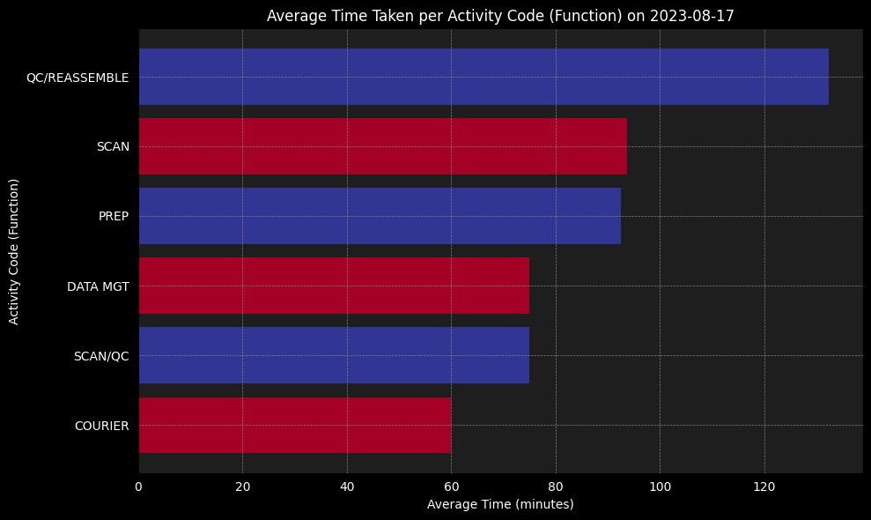

Summary:
This horizontal bar chart visualizes the average time taken for different activity codes (functions).

Insights:
We can identify which functions take the longest and shortest time on average. This information can guide process optimization and task allocation.

QC/REASSEMBLE: take the most time on average, with about 130 minutes per task.

SCAN: Scanning tasks take around 90 minutes on average.

PREP: Prep tasks take around 90 minutes on average.

SCAN/QC: Scan and qc tasks take around 75 minutes on average.

DATA MGT: Data management tasks take around 75 minutes on average.

COURIER: Courier tasks take the least time, with around 60 minutes on average.

Client-Specific Analysis
This part represents the time taken by each employee for different clients, using a stacked bar chart.
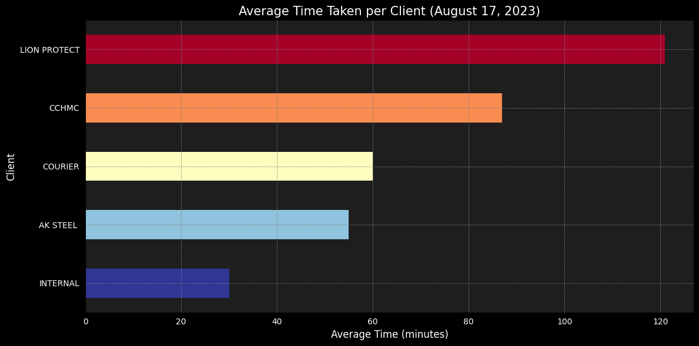

LION PROTECT: lion protect tasks take the most time on average, with about 120 minutes on this client.

CHILD SERVICES: tasks for this client takes around 85 minutes on average.

COURIER: tasks takes around 60 minutes on average.

AKSTEEL: This client takes around 50 minutes on average.

INTERNAL: This client takes the least time, with around 30 minutes on average.

Staff-Specific Analysis
This section shows the time taken for different clients by each employee using a stacked bar chart.
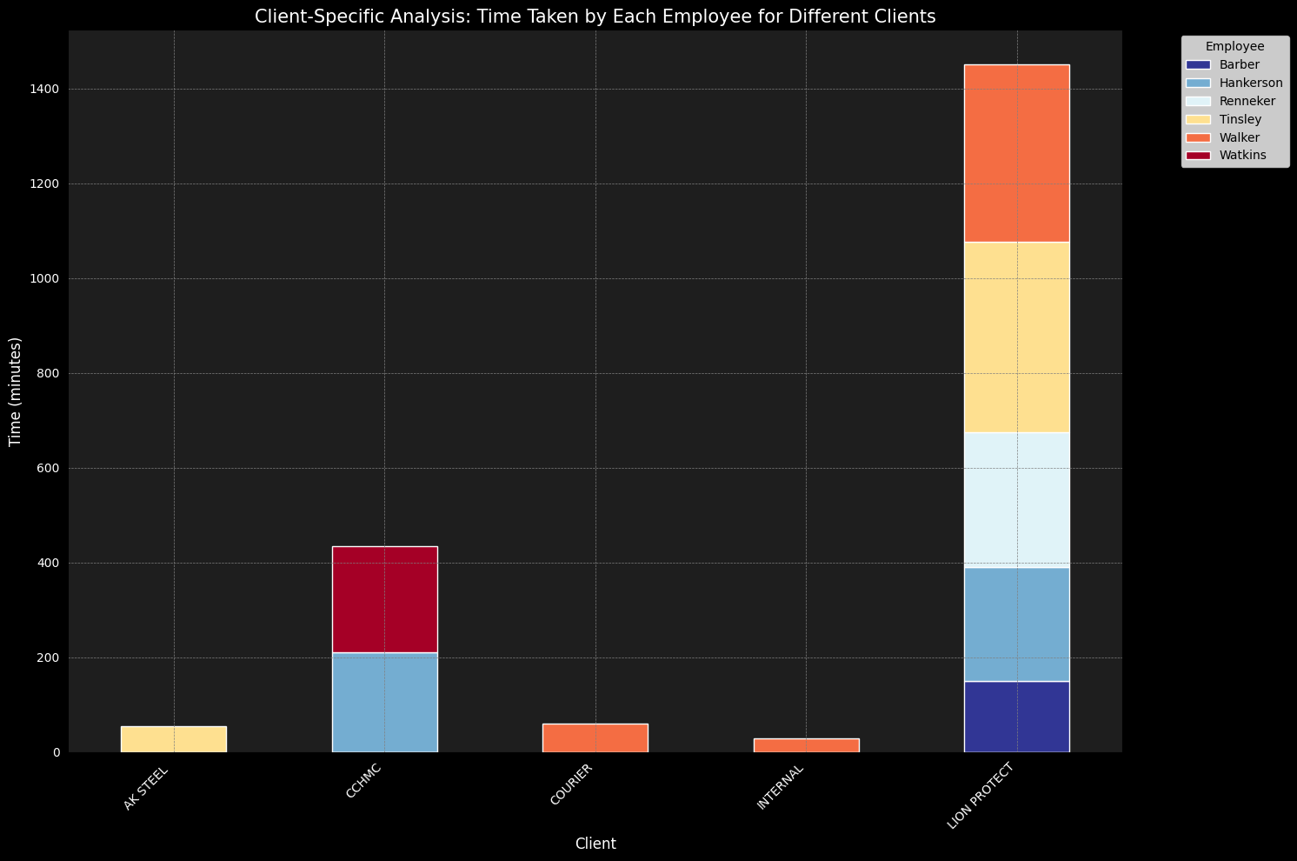

Summary: A stacked bar chart representing the time taken by each employee for different clients.

Insights:
The distribution of time across different clients by each employee is clearly visible. This can help in understanding employee specialization or preferences in handling specific clients.

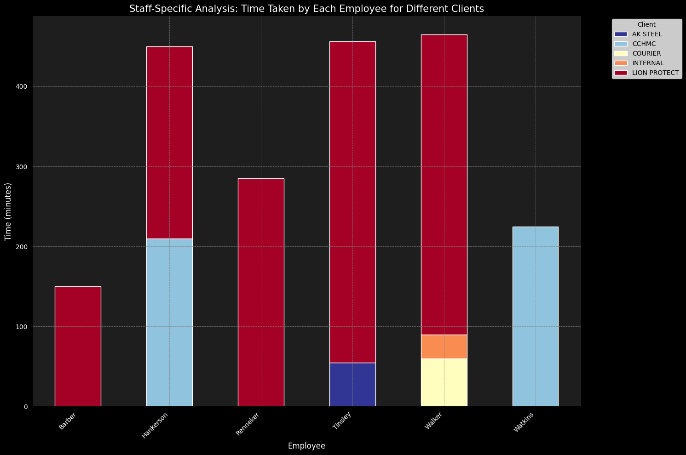

Similar to the previous chart but transposed, showing the time taken for different clients by each employee.

Insights:
This chart provides an alternative perspective on how each staff member allocates their time among different clients, enabling targeted training or reassignment.

Summary of the Client-Specific Analysis and Staff-Specific Analysis Chart
The stacked bar chart we generated illustrates the distribution of time taken by each staff member across different clients. Here's what we can infer from the chart:

Time Distribution: Some employees have a significant spread of time across different clients, indicating a diverse workload. Others focus more on specific clients, possibly reflecting specialization or project assignment.

High Time Consumption Clients: Certain clients may consistently take more time across various staff members. This pattern might imply that tasks related to these clients are more complex or that there are communication challenges that extend the time needed to complete tasks.

Staff Specialization: The chart reveals that some staff members predominantly work with certain clients. This could be strategic, based on the employee's expertise, or it might highlight an uneven distribution of workload.

Potential Efficiency Insights: Comparing the time taken across employees for the same client might expose differences in efficiency or approach. These variations could be leveraged to optimize processes and workload distribution.

Function-Specific Analysis for Each Employee
This part illustrates the distribution of tasks across different functions for each employee using a stacked bar chart.
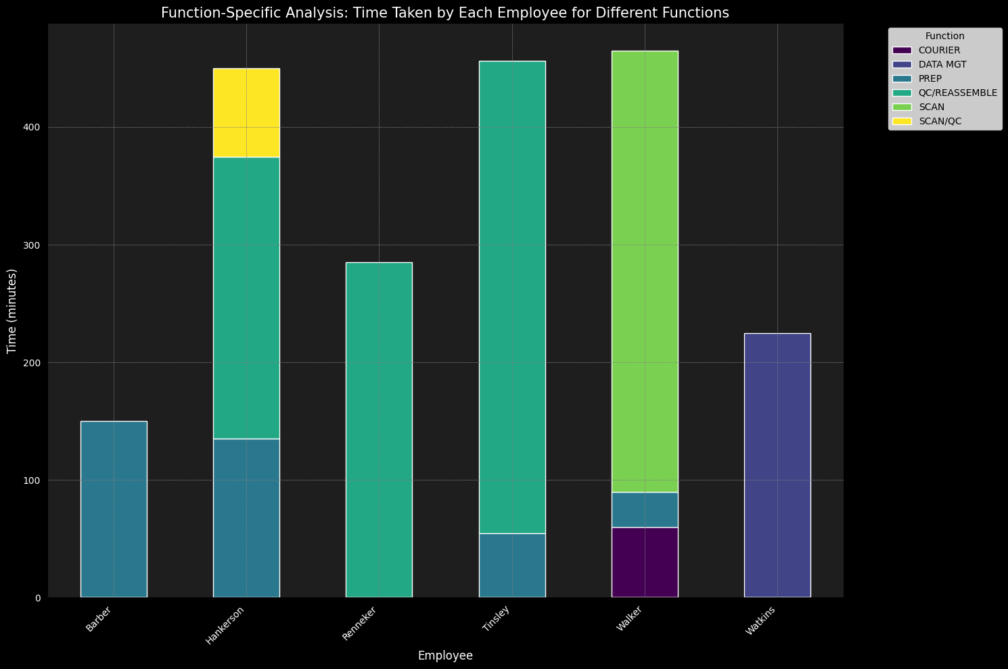

Summary:

Diverse Task Distribution: We can see that the employees have engaged in various functions, and the distribution varies from person to person.
Dominant Functions: Some functions appear more prominently across employees, possibly indicating common or critical tasks.
Employee Specialization: Certain employees might have spent more time on specific functions, possibly reflecting their area of expertise or assigned responsibilities.

Time Allocation Insights: This chart helps in understanding how the time is allocated across different functions for individual employees, enabling better task planning and resource allocation.
The chart provides a comprehensive view of how each employee's work time is distributed across different functions, which can be valuable for managers and team leads in assessing performance, aligning tasks with skills, and optimizing workflows.

Function-Specific Analysis: Time Taken by Each Employee for Different Functions
This section provides a grouped bar chart showing the time taken by each employee for different functions.
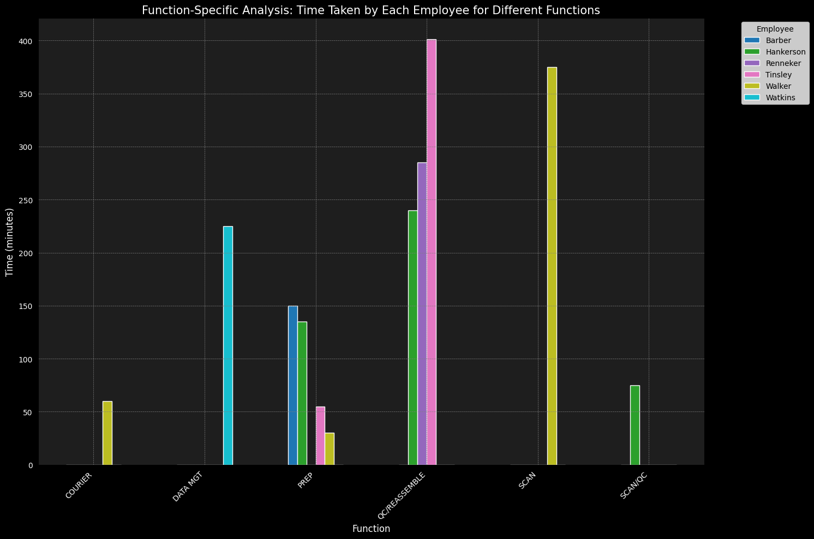
Here is the function-specific analysis plot that shows the distribution of tasks across different functions for every employee:

This chart illustrates the time taken by each employee for different functions. The distribution of colours represents different employees, and the height of the bars indicates the total time spent on each function.

Key Observations:
- Some functions have more even distribution across employees, indicating that multiple employees contribute to these tasks.
- Other functions are dominated by specific employees, suggesting specialization or allocation of certain tasks to particular staff members.
- Employees like "Sheilah" and "Hankerson" have significant contributions across multiple functions, potentially reflecting versatility or higher workload.

Implications: Understanding how tasks are distributed across functions and employees can guide resource allocation, task assignment, and employee training. It can also help in identifying areas where additional support or efficiency improvements are needed.

Function-Specific Analysis: Time Taken for Different Functions for Each Client
This part offers a grouped bar chart illustrating the time taken for different functions for each client.

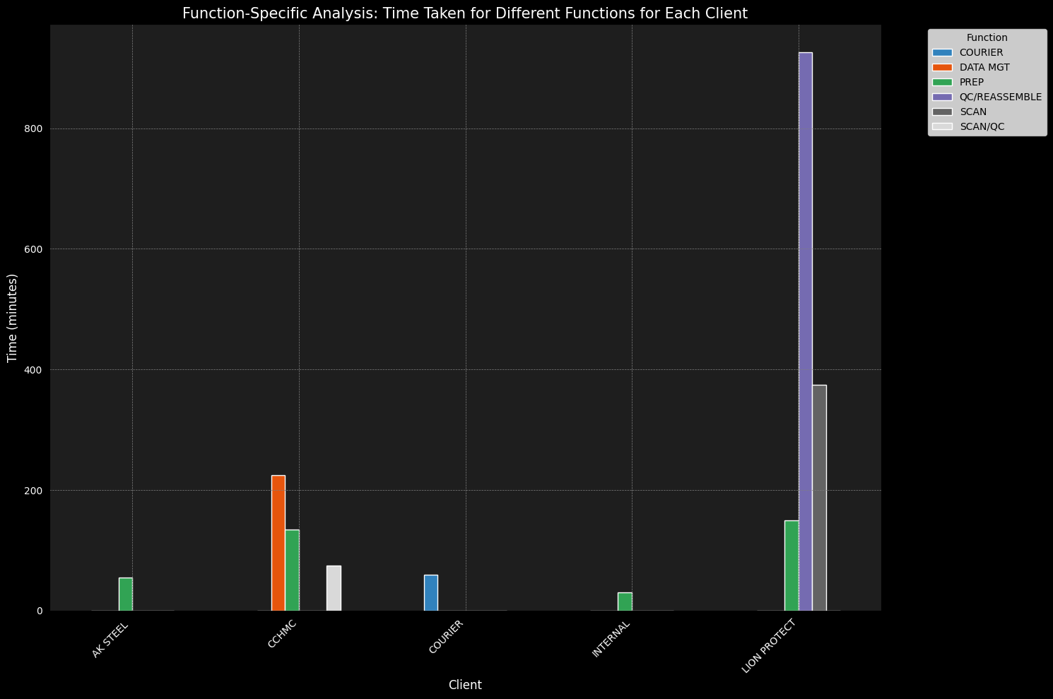 The function-specific analysis for each client has been visualized in the bar plots above. Below are the summaries and insights we can draw from these plots:
Client: AK STEEL
Most of the time is spent on the "Preparation" function, followed by "QC" and "Scanning." Other functions take relatively less time.
Client: CCHMC
The "DATA MGT" function again takes the most time, followed by "PREP" and "QC." There is minimal time spent on "Scanning."
Client: COURIER
The time is mostly spent on COURIER and evenly distributed across "Preparation," "QC," "Scanning," and "Indexing."

Client: INTERNAL
The "Preparation" function dominates the time taken.
Client: LION PROTECT
The "QC/REASSAMBLE" function takes the most time, followed by "SCAN” & ”PREP." There is no time spent on "Scanning" or "QC."
The common theme across all clients is that the "Preparation" function often takes the most time, indicating that it might be the most labour-intensive part of the process

Interpretation:

Variation in Functions: The chart illustrates how different functions are distributed across various clients. Some clients have more time allocated to specific functions, while others have a more balanced distribution.

Client Needs: By analysing the heights of the bars, we can discern the functions that are most time-consuming for individual clients. This information can be valuable for future planning and resource allocation.

Comparison Across Clients: The chart enables a direct comparison of how different clients utilize various functions. This might reveal trends or preferences that could be explored further.

Insights:

Identify Key Functions: Understanding the key functions for each client can lead to more targeted strategies and better client relationships.

Optimize Resource Allocation: By knowing the time required for different functions, resources can be allocated more efficiently.

Enhance Collaboration: Sharing this information with team members can foster collaboration and ensure that everyone is aligned with client needs and expectations.

Employee-Specific Analysis: Time Taken by Each Employee for Different Functions
This section provides a grouped bar chart representing the time taken by each employee for different functions.
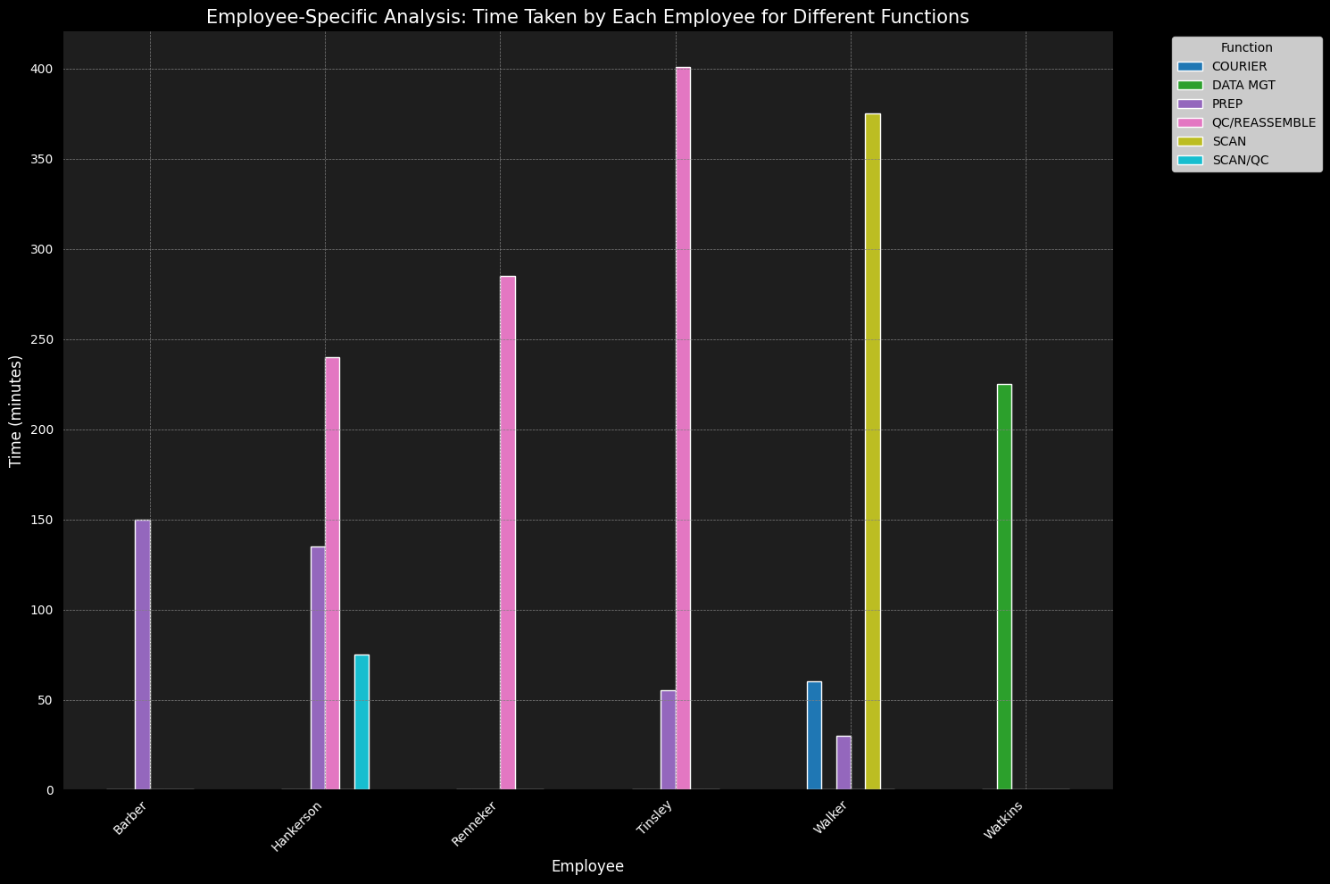
Summary: A grouped bar chart that represents the time taken by each employee for different functions.

Insights:
This provides an employee-centric view of task distribution, revealing possible areas for cross-training or specialization.

Employee Specialization: The chart allows us to see if certain employees are specialized in particular functions. This can be useful for task assignment and team composition.

Balanced Distribution: We can evaluate whether there is a balanced distribution of functions across employees, which might reflect an equitable workload.

Identify Bottlenecks: If an employee is spending a disproportionate amount of time on a specific function, it might indicate a bottleneck or a need for additional training.

Optimize Resource Allocation: Understanding how time is spent across functions for each employee can lead to more effective resource allocation and productivity enhancement.

Enhance Collaboration: The visualization fosters a clear understanding of roles and responsibilities, enabling better collaboration and alignment within the team.

The plot provides a comprehensive view of how different functions are distributed across employees, paving the way for strategic decisions and continuous improvement.

Conclusion
The analysis provides valuable insights into employee efficiency, client preferences, and function distribution. It can guide decision-making in areas like staff training, task allocation, client engagement strategies, and overall process optimization.

Appendices
The appendices include the code blocks used for generating the visualizations in this report. As an HTML file link from the Python Programming Language used.

CLICK BELOW

