Prerequisite
The following list the basic prerequisites for installation of a standalone installation of Backstage. It is mandatory to have basic experience of the terminal commands npm, yarn.
- Access to unix based OS, such as Linux, Windows subsystem for Linux (WSL), MacOS.
- Curl or Wget installation
- Node.js LTS release (for our case, Node.js v18.19.1)
- Docker, yarn, Git installation
- GNU-like build environment available at command line
For a start, pull a stable node.js image:
docker pull node:lts-alpine (Ensure the choice of node image has npx)
mkdir -p backstage-app (you can use suitable name of your choice)
cd backstage-app
Now, from your terminal run:
docker run --rm -p 9000:9000 -it -v ${PWD}/backstage-app:/app -w /app node:lts-alpine sh
On docker container, run the followings:
npx @backstage/create-app@latest
A snippet of the output is below:
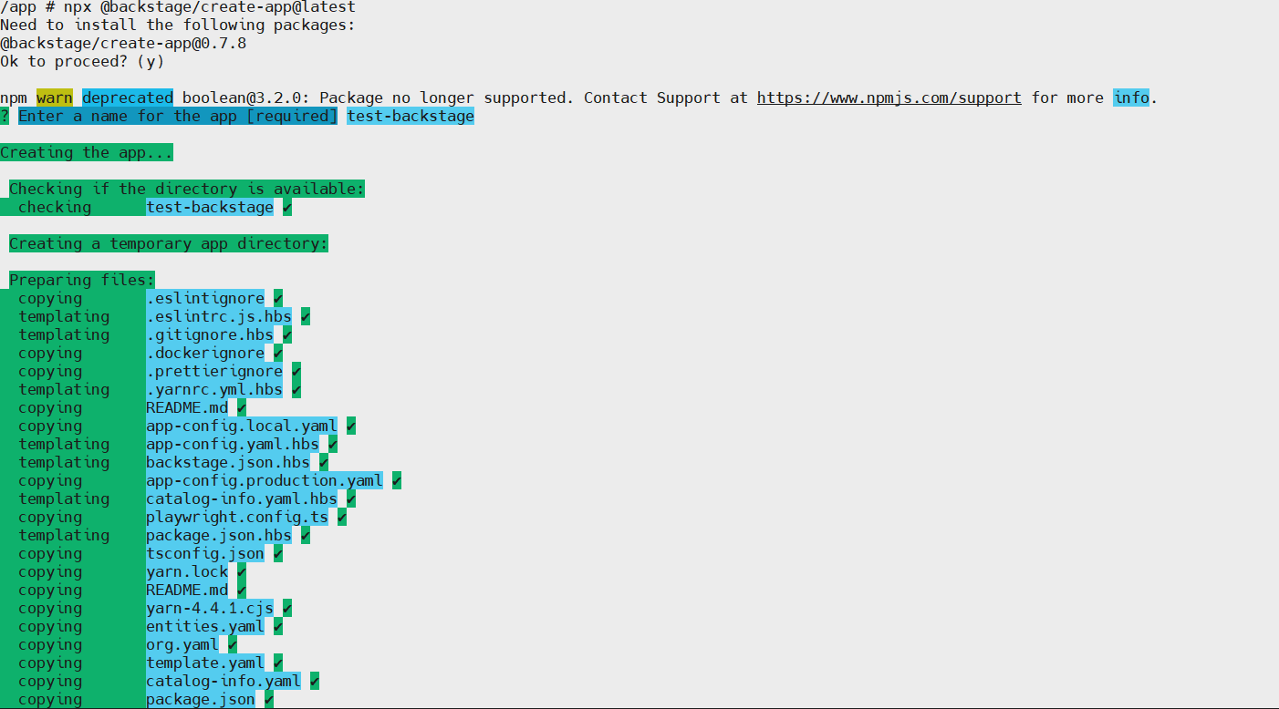
After a successful creation of Backstage, navigate to the project created:
cd test-backstage
To start the backend, run:
yarn start
open a browser of choice and try to access e.g. http://localhost:3000
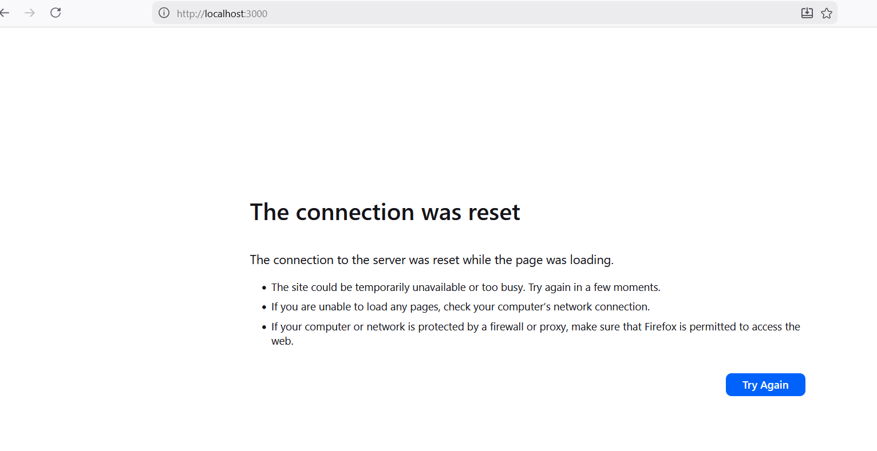
In case you have issue like the above, open a new terminal and verify what the problem is:
Then:
docker exec -it container_id sh
Curl the endpoint to test the connection locally:
curl http:localhost:3000
Note: for the purpose of this, apk package is use: apk add curl
Open app-config.yaml, and add

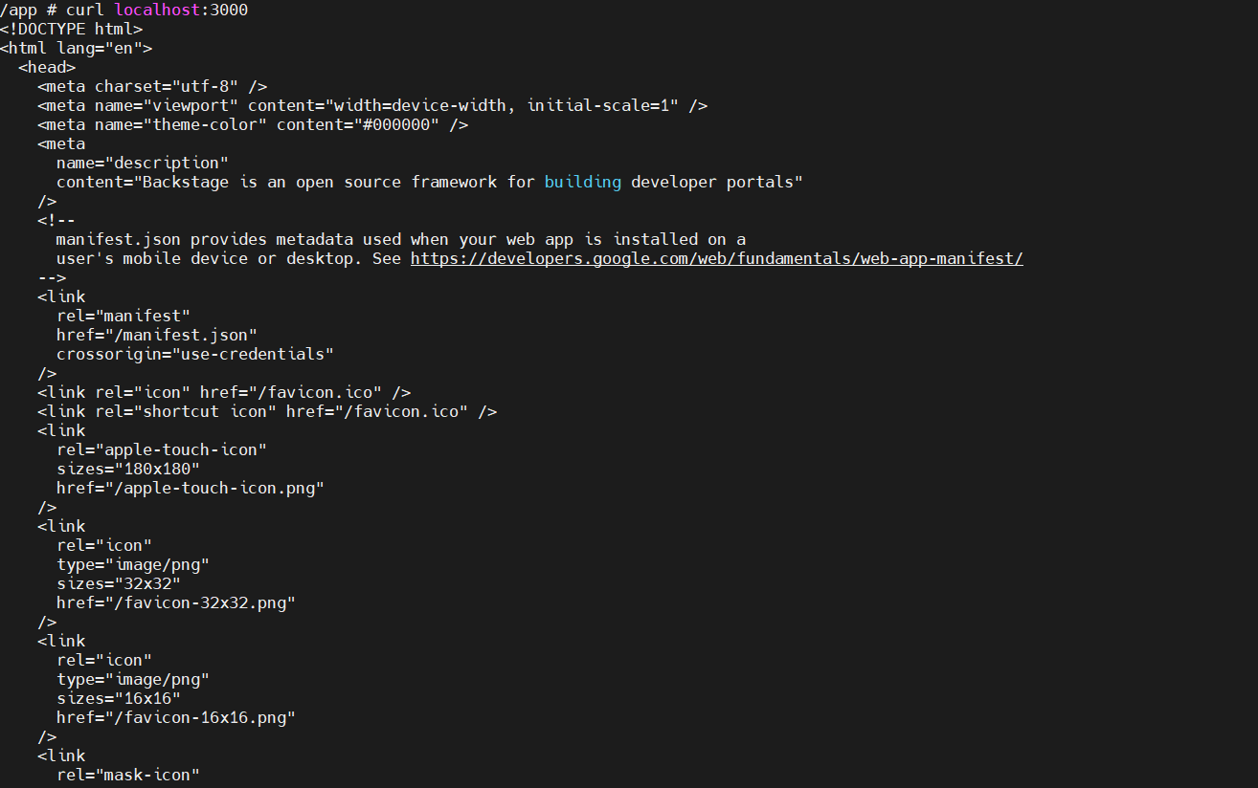

Open app-config, and add
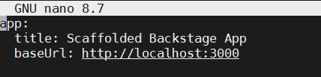
To:
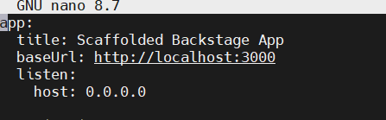
Then:
yarn start

Add snippet here

Configuring Github OAuth
From the documentation, available authentication providers range from Auth0 to VMware cloud. The snippet below highlights the list:
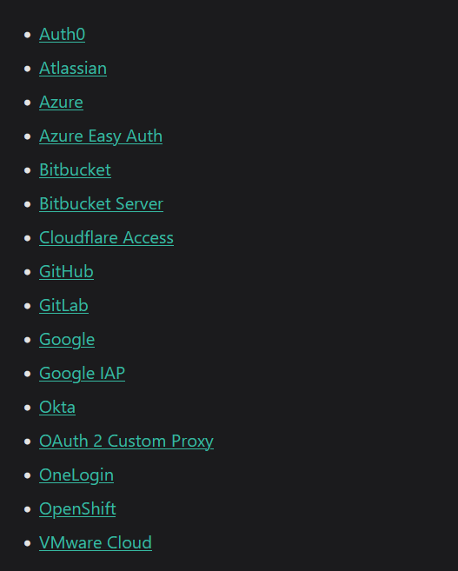
In our case, GitHub was selected. For follow up, go to here for the right configuration.
Login to your GitHub, and find your way to Settings -> Developer settings -> OAuth Apps
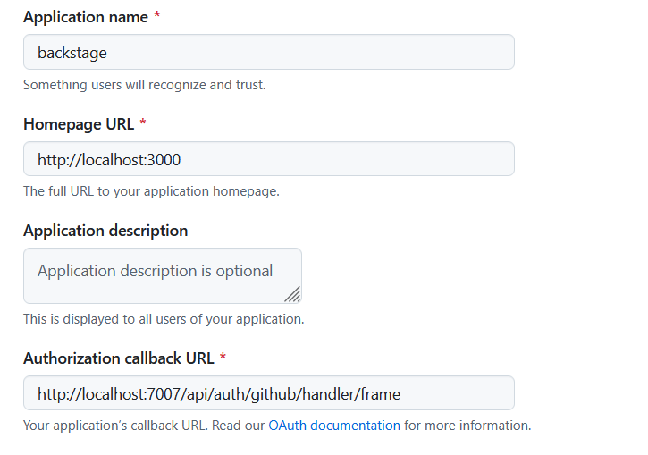
Generate a new client secret and copy and save the keys and client ID in a secure vault.
The generated provider conf iguration can be added to app-config.local.yaml (development environment) as referenced in GitHub as shown in the snippet below:
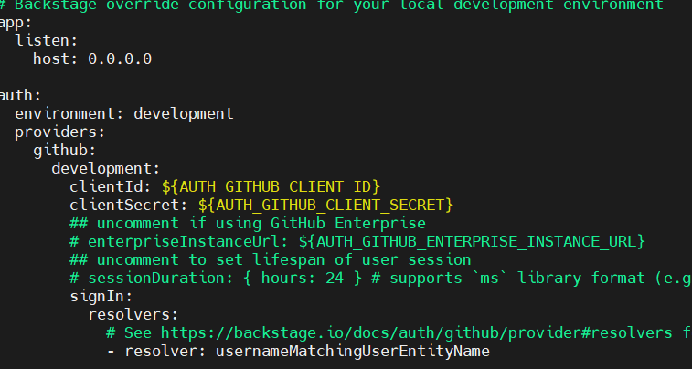
docker run --rm -e AUTH_GITHUB_CLIENT_ID=xxxxxxxxxxxx -e AUTH_GITHUB_CLIENT_SECRET=yyyyyyyyyyyyy -p 3000:3000 -it -p 7007:7007 -v /home/madelere/backstage-app:/app -w /app node:lts-alpine sh
To add Backend installation, go to the root from Backstage then run:
yarn --cwd packages/backend add @backstage/plugin-auth-backend-module-github-provider
Then add the lines below to packages/backend/src/index.ts:
backend.add(import('@backstage/plugin-auth-backend'));
backend.add(import('@backstage/plugin-auth-backend-module-github-provider'));
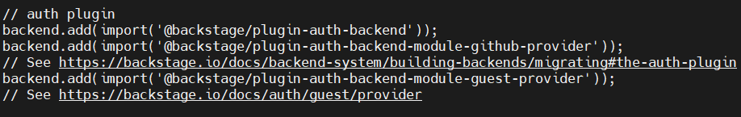
For full guidelines, goto: https://backstage.io/docs/auth/github/provider
To do same for frontend, follow the guideline on here:
https://backstage.io/docs/auth/#sign-in-configuration
To add activate resolver, we are going to create a whitelist of users that can access into our backstage. Start with a simple search “backstage GitHub” and navigate to here: https://github.com/backstage/backstage/tree/master/packages
Look for catalogs-model -> examples – acmes
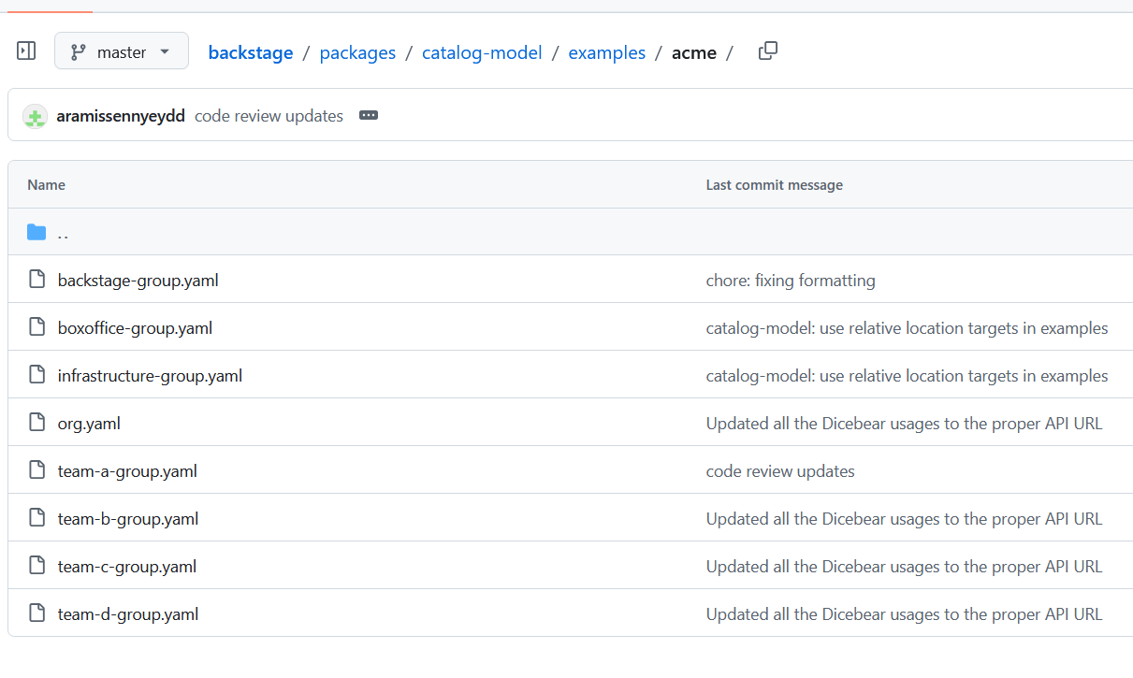
For instance, open team-a-group.yaml and copy the section for Users.
Make a new directory, example:
mkdir -p catalog/entities
cd catalog/entities
vi users.yaml
then add the copied section to the file, the name section should be the username of your GitHub account, and save the file.
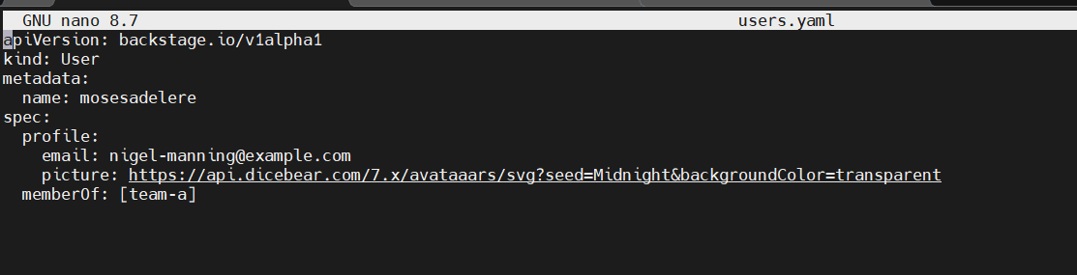

Add the catalog to app-config.local.yaml. copy the catalog manifest from app-config.yaml and add it in app-config.local.yaml just as shown in the snippet below, and update the target with absolute path to the catalogue/entities/users.yaml.
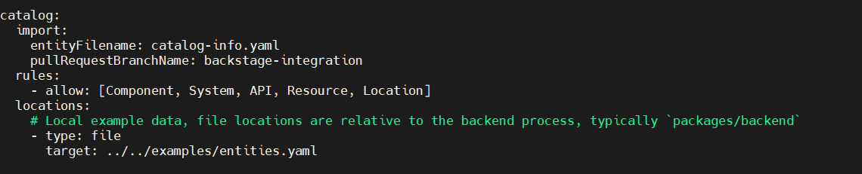
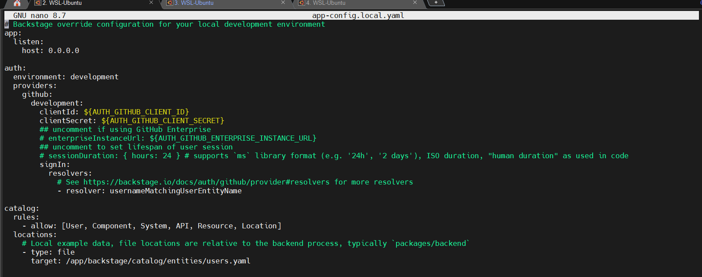

To test what has been done, start the server:
Yarn start
Then open a browser and enter http://localhost:3000. At the prompt of the page shown below, login with your GitHub credentials.
