pertemuan6.R
Moses
2026-10-05
#Tipe Data
#Numeric
print("Numeric")
## [1] "Numeric"
a <- 10
class(a)
## [1] "numeric"
print("integer")
## [1] "integer"
b <- 1000L
class(b)
## [1] "integer"
print("character")
## [1] "character"
c <- "nama saya adalah moses"
class(c)
## [1] "character"
print("complex")
## [1] "complex"
d <- 9i + 3
class(d)
## [1] "complex"
print("boolean")
## [1] "boolean"
e <- TRUE
class(e)
## [1] "logical"
#struktur data
buah <- c("pisang", "pear", "jeruk")
buah #vector
## [1] "pisang" "pear" "jeruk"
list_buah <- list("durian", "mangga",10,20)
list_buah #data list
## [[1]]
## [1] "durian"
##
## [[2]]
## [1] "mangga"
##
## [[3]]
## [1] 10
##
## [[4]]
## [1] 20
matrix_angka <- matrix(c(1,2,3,4,5,6),nrow=3, ncol=2)
matrix_angka
## [,1] [,2]
## [1,] 1 4
## [2,] 2 5
## [3,] 3 6
#data frame(df)
statistik_game_RPG <- data.frame(
stat = c("power","mana","exp"),
marksman = c(100,24,50),
fighter = c(80,40,70)
)
statistik_game_RPG
## stat marksman fighter
## 1 power 100 80
## 2 mana 24 40
## 3 exp 50 70
#vector numeric
angka <- c(1,2,3)
angka
## [1] 1 2 3
urutan <- 1:20
urutan
## [1] 1 2 3 4 5 6 7 8 9 10 11 12 13 14 15 16 17 18 19 20
urutan_desimal <- 1.5:6.5
urutan_desimal
## [1] 1.5 2.5 3.5 4.5 5.5 6.5
urutan_desimal<- 1.5:6.3
urutan_desimal #angka terakhir tidak masuk
## [1] 1.5 2.5 3.5 4.5 5.5
#panjang vektor
length(urutan_desimal)
## [1] 5
length(buah)
## [1] 3
#mengurutkan vektor
fruits <- c("banana", "apple", "mango", "lemon")
sort(fruits)
## [1] "apple" "banana" "lemon" "mango"
#mengakses vektor
fruits[1]
## [1] "banana"
fruits[-1]
## [1] "apple" "mango" "lemon"
#mengganti item
fruits[1] <- "pear"
fruits
## [1] "pear" "apple" "mango" "lemon"
#data frame
statistik_game_RPG
## stat marksman fighter
## 1 power 100 80
## 2 mana 24 40
## 3 exp 50 70
summary(statistik_game_RPG)
## stat marksman fighter
## Length :3 Min. : 24 Min. :40.00
## N.unique :3 1st Qu.: 37 1st Qu.:55.00
## N.blank :0 Median : 50 Median :70.00
## Min.nchar:3 Mean : 58 Mean :63.33
## Max.nchar:5 3rd Qu.: 75 3rd Qu.:75.00
## Max. :100 Max. :80.00
#mengakses data frame
statistik_game_RPG[1]
## stat
## 1 power
## 2 mana
## 3 exp
statistik_game_RPG$marksman
## [1] 100 24 50
#menambahkan baris baru di df
statistik_game_RPG
## stat marksman fighter
## 1 power 100 80
## 2 mana 24 40
## 3 exp 50 70
statistik_game_RPG <- rbind(statistik_game_RPG, c("gold",70,50))
statistik_game_RPG
## stat marksman fighter
## 1 power 100 80
## 2 mana 24 40
## 3 exp 50 70
## 4 gold 70 50
ML <- statistik_game_RPG
ML
## stat marksman fighter
## 1 power 100 80
## 2 mana 24 40
## 3 exp 50 70
## 4 gold 70 50
#menambahkan kolom di df
ML <- cbind(ML, assasin = c(100,24,50,60))
ML
## stat marksman fighter assasin
## 1 power 100 80 100
## 2 mana 24 40 24
## 3 exp 50 70 50
## 4 gold 70 50 60
#menghapus baris dan kolom di df
ML_hapusbariskolom <- ML[-c(1), -c(1)]
ML_hapusbariskolom
## marksman fighter assasin
## 2 24 40 24
## 3 50 70 50
## 4 70 50 60
#Mencari dimensi
dim(ML)
## [1] 4 4
dim(ML_hapusbariskolom)
## [1] 3 3
#melihat data frame
View(ML)
View(ML_hapusbariskolom)
#menggabungkan dua df
data_frame1 <- data.frame(
senjata <- c("M4","AK47","Uzi"),
skin <- c("dragon","alok","jb"),
damage <- c(100,200,150)
)
data_frame2 <- data.frame(
senjata <- c("glock","shotgun","riffle"),
skin <- c("neymar","jokowi","AAA"),
damage <- c(400,100,250)
)
#FF <- rbind(data_frame1, data_frame2)
#View(FF)
##grafik
#plot
plot(1,3)
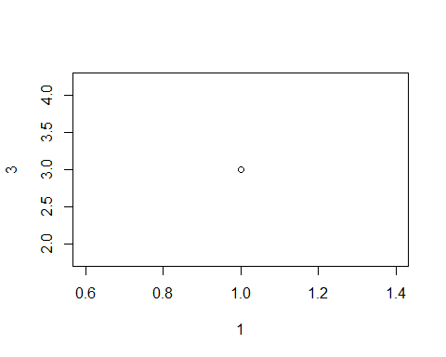
plot(c(1,8),c(7,9))
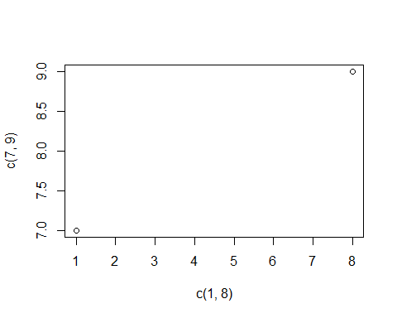
x <- c(1,2,3,4,10)
y <- c(6,7,8,9,10)
plot(x,y)
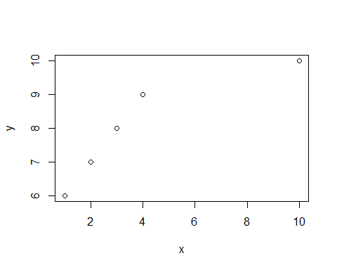
plot(3:10)#urutan
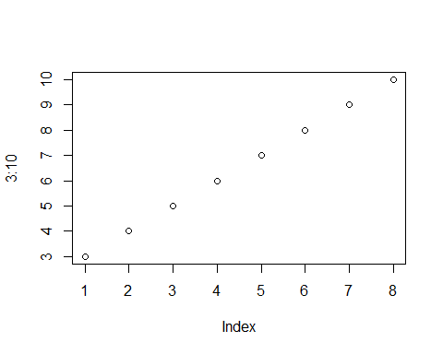
plot(3:10, type = "l")
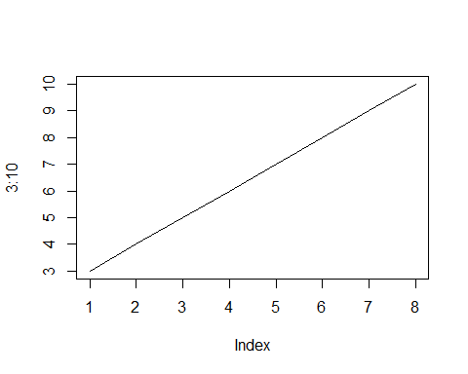
plot(3:10, main = "grafik lurus", xlab = "ini adalah sumbu X", ylab = "sumbu Y", type = "l", col = "red")
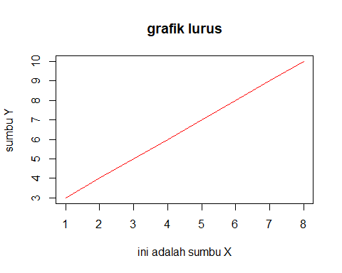
plot(1:10)
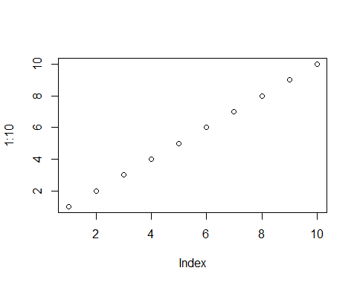
plot(1:10, pch = 11)
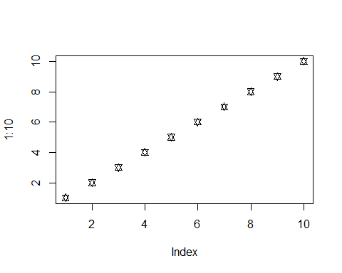
plot(1:10, pch = 11, type = "l")
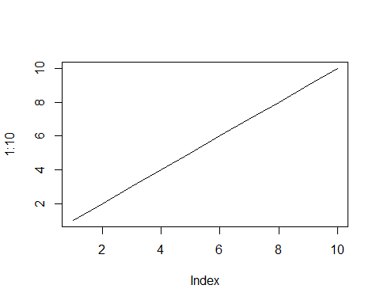
plot(1:10, pch = 11, type = "l", lwd = 5)
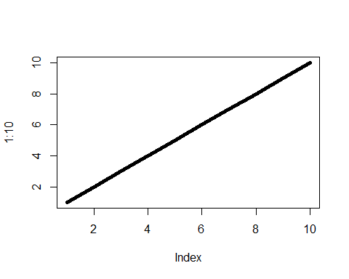
x <- c(1,2,3,4,10)
y <- c(6,7,8,9,10)
plot(x, type = "l", col = "blue")
lines(y, type = "l", col = "green")
