ARIZONA HEART DISEASES TREATMENT COST STRATEGIES
MIS-690 Capstone Project Thesis
Submitted to Grand Canyon University
Graduate Faculty of the Colangelo College of Business
in Partial Fulfillment of the
Requirements for the Degree of
Master of Science
Business Analytics
by
Gershon Apeteh
Moses Cyabukombe
Phoenix, AZ
7/20/2022

Approved by:

Professor Date
Abstract

This project was undertaken to research factors that affect the cost of heart disease treatment in Arizona. By exploring and collecting different data sources such as Arizona Department of Health Services, Centers for Disease Control and Prevention, and Agency for Healthcare Research and Quality (AHRQ), to model linear regression and K-means clustering, to help the State of Arizona on factors that affect the cost of heart disease treatment to strategically minimize cost, save lives and better allocate resources. Factors considered in the research includes, number of patients, Length of stay, gender, age, facility cost, professional fees, medication, and laboratory cost. Analytic algorithms used in finding solutions to the business problems include linear regression and K-means. Analytical tools such as Tableau and Power Bi were utilized to visualize the result for better understanding. The model results show that professional fee and length of stay are the top main cost drivers. Although more research is needed to decrease the cost of heart disease treatment, findings suggest a need for the government to subsidize the cost of diagnosis, professional fee and medication cost, and more advanced facilities for the various hospitals in Arizona. A larger dataset for future models pertaining to this field is highly recommended to find definite solutions to problems.

Keywords: Heart diseases cost , Prescriptive analysis, Machine learning, Linear regression model, K-means cluster.
Table of Contents
List of Tables 5
List of Figures 6
Business Problem Identification 8
Background 8
Factors affecting the Problem 8
Stakeholders 9
Business Problem 9
Business Problem Statement 10
Analytics Assumptions 10
Analytics Problem Statement 13
Data Understanding, Acquisition, And Preprocessing 13
Data Understanding 13
Description of Data 14
Exploration of Data 16
Verify Data Quality 16
Conclusion 17
Data Diagnostics and Descriptive Summary 17
Data Preparation 17
Selecting and Verifying Data 17
Extracting the Data 20
Formatting Data 21
Simpson’s Paradox 23
Descriptive Analytics 23
Conclusion 28
Methodology Approach and Model Building 29
Model Building and Evaluation 29
Modeling Technique and Test Design Selection 30
K-means Clustering model 30
Linear regression model. 33
Conclusion 39
Model Evaluation 40
Evaluation Process Justification 40
Linear regression model evaluation 41
Model Validation 45
Conclusion 49
External Model Verification and Calibration 50
External Validation 50
Literature Review 51
Calibration 52
Future Recommendations 53
Model Deployment and Model Life Cycle 53
Model Deployment 53
Deployment Cost 56
Schedule, Training, and Risk 58
Benefits 58
Recommendations 60
Recommendations for practice. 60
Recommendations for future research. 61
Conclusions 61
References 63
Appendix A: Data Set 68

List of Tables
Table 1: Number of Deaths for The Leading Causes of Mortality By Year, Arizona,2009-2019..14
Table 2: List of Heart Diseases and Factors that Affect Cost of Treatment…………………..14
Table 3: Selecting and Verifying Data …………………………………………………………….17
Table 4: Extracting the Data……………………………………….………………………...……...19
Table 5: Formatting the Data…………………………………………………………….…………21
Table 6: Clustering data table…………………………………………………………….………..34
Table 7: Microsoft Azure Cost Estimate…………………………………………….……………57
Table 8: Model Deployment Operational Costs ……………………………….……………….58

List of Figures
Figure 1: Leading cause of death…………………………………………………………………….24
Figure 2: Median staffing salaries at the hospitals………………………………………………..25
Figure 3: Number of males and females admitted for heart disease…………………………….25
Figure 4: Total Charges of Professional,Lab, and Medication cost………………………………..26
Figure 5: Age and Length of stay………………………………………………………………….....26
Figure 6: Heart Diseases and Age Admission………………………………………………………27
Figure 7:The Severity of Heart Disease and Length of Stay At the Hospital…………………….27
Figure 8: Dashboard representing all the data collected ………………………………………….28
Figure 9: K-Means Cluster Plot……………………………………………………………………….31
Figure 10: Optimal Number of Clusters …………………………………………………………..…32
Figure 11: Number of clusters vs. gap statistic………………………………………………………32
Figure 12: qq plot for each variable …………………………………………………………………36
Figure 13 Histogram for each variable ………………………………………………..……………37
Figure 14: plot of all variables …………………………………………………………………….…38
Figure 15: Correlation Coefficients Between the Variables ……………………………………...39
Figure 16: Linear regression model output with all variables …………………………………..40
Figure 17: Linear regression model with significant variables ………………………………….40
Figure 18: linear regression with highly correlated variables from correlation matrix .……..41
Figure 19: evaluation results for the linear regression model…………………………………….45
Figure 20: linear plot for the significant variables……………………………. ………………….45
Figure 21 Cluster silhouette Plot……………………………….. ………………………………….46
Figure 22 -Silhouette plot showing number of clusters, sizes and widths…………………….47
Figure 23: Silhouette coefficient of observations ………………………………………………….49
Figure 24: 80% train dataset output model ………………………………………………………….52
Figure 25 : Prediction outcome with the validation techniques ………………………………….52
Figure 26: Statistics for k-means clustering …………………… …………………………………….53
Figure 27: Model Deployment Operational Costs…………………………………………………..57
Figure 28: Gantt Chart for Training schedule……………………………………………………….60

Business Problem Identification

Background
Within the United States there are several commodities that do affect the cost of living. One known to be expensive by the United States is health care. Health care is essential when it comes to the quality of life. With great health care it helps in preventing diseases, prevention of death and improving the quality of life (U.S. Department of Health and Human Services, n.d). This project will dive deeper into the cost of heart disease treatment, factors that contribute to the cost, and the effects that cost has on health care more specifically within the state of Arizona. Our goal is to focus on the heart disease which is causing the death of most patients in Arizona, and find strategies to improve heart disease treatment in the area by minimizing cost and allocating resources appropriately. In order to do so, we collected data from reliable sources such as Mayo Clinic organization, Banner Health, Centers for Disease Control and Prevention, Arizona Department of Health Services, GoodRx and other organizations throughout Arizona in order to visualize the problem within health care. Ever since health care spending increased five decades ago. On a per capita basis, it came from a person spending $353 in 1970 to $12,531 in 2020 (Kurani, 2022). This affected hospital patients all over the nation including sick patients in Arizona.

Factors affecting the Problem
By encountering this sharp increase in cost of heart disease treatment, there are some factors that may have influenced and led to this happening. According to JAMA Network “Factors Associated with Increases in US Health Care Spending, 1996-2013” growing population and age are associated with inpatient spending(Dielman et al, 2017). For example, there is an increase in purchased prescriptions requiring more demand from manufacturers for medication, lab costs, and equipment costs. The other factor that affects this problem is viewed in professional fees and late diagnosis. According to zip recruiter, health care doctors in Arizona have a median salary of $183,316. This salary is unmeasurable when compared to median wages in Arizona. This therefore causes the cost of healthcare to be higher in order to meet the salaries of doctors in Arizona.
Another factor affecting the cost is length of stay at the hospital due to the intensity of diseases when associated with increase in cost. According to “Chronic Disease in the United States: A Worsening Health and Economic Crisis” by Tara, Chronic diseases have been getting worse and are expected to keep getting worse overtime. Therefore, the prevalence and cost in the United States to treat these diseases increases as well (Tara et al, 2020). With treatment being expensive, intensity of diseases increasing, and professional fees becoming high, is affecting the heart disease death rate within hospitals.

Stakeholders
In order to have more understanding of why cost is affecting heart disease treatment in Arizona, there are potential stakeholders that can be interviewed. Most of them are within the healthcare system. For example, Doctors and founders of clinics, pharmaceutical companies can be interviewed as well. Other stakeholders that are included are the insurance companies involved at various hospitals and the patients themselves the hospitals hold on a daily basis.

Business Problem
The business problem is stated in a way one can use the data collected from reliable sources and apply analytical tools and techniques to understand the trend of heart disease, factors affecting the cost, mortality rate etc.
We collected the data from several areas including; the Mayo Clinic organization, Banner Health Centers for Disease Control and Prevention, Arizona Department of health services and other organizations that will visualize the problem. Utilizing the data collected and applying analytics, will potentially help us to understand which factors highly affect treatment cost, offer early diagnosis and improve health care overall by minimizing cost to the patients that are dying due to these diseases and better allocate resources.

Business Problem Statement
The business problem we are seeking to resolve by applying analytics is to assist Arizona on factors that do affect the cost of heart disease treatment to strategically minimize cost, save lives and better allocate resources.

Analytics Assumptions
The Health Care sector plays a fundamental role in society. As we live our lives, unfortunates happen—we get sick and must seek healthcare to get better. However, it is not free in most cases and comes with a cost. We can say that health care is remarkably close to basic human needs such as food, water, and shelter since it could affect the opportunity to pursue life goals in general and prevent any premature loss of life. The focus of this project is on the State of Arizona, one of the fastest growing states in the US with about 7.2 million people because more people are moving out here due to business growth. The median household income in Arizona is about $67, 000. Phoenix alone has a median income of $60,914 with people 25 years plus with a bachelor’s degree or higher and 15.8% of people under 65 years without health insurance between 2016 and 2020 (United States Census Bureau, 2020).
According to the Arizona Department of Health Services (n.d.), valley fever, Covid-19 influenza, Hepatitis, tuberculosis, foodborne and waterborne diseases are the most common diseases in Arizona. However, heart disease is the top killing disease in Arizona (Centers for Disease Control and Prevention, 2022). The People who live in Arizona often go to the hospitals including Mayo Clinic, Banner Health, Kaiser Permanente, Dignity Health, Banner Health, and Cleveland Clinic with these diseases for treatment. It will be beneficial for Arizona to pay more attention to heart diseases and make health care affordable and accessible.
Some people often do not have access to healthcare services because they do not have insurance or in the worst case do not live close to where they can see a provider for treatment (U.S. Department of Health and Human Services, n.d). This is usually observed in underserved areas in Arizona where they do not have hospitals in their cities or where healthcare providers do not often want to work due to the living conditions. Paying more attention to heart disease, which is the top killing disease, will help in early diagnosis, treatment, proper allocation of hospital resources to manage other epidemics or pandemic, and decrease the burden on healthcare providers. A typical example is Covid-19 pandemic when most of the health care workers were burnt out during the peak of the virus. Making healthcare accessible would help reduce health professionals' burnout and prevent spread of disease especially during the pandemic in low-income areas (Hamid, Abid, Amir, et al., 2020). By knowing which factors affect the cost of treatment the hospitals are able to reduce resource waste i.e., where to invest less or more in terms of resources such as healthcare professionals, equipment etc.
We would use advanced analytical techniques to assist the Arizona health services identify cost, strategize, and create criteria for offering low-cost health care heart diseases. The data we would use would focus on Arizona that could show necessary information such as professional fees, medication costs, and number of deaths caused by heart diseases over time as well as population behavior patterns, so that Arizona can strategize to offer affordable and accessible healthcare for heart disease treatment. We would use correlation matrix to see the relationship between the variables. According to Corporate Finance Institute (2022), correlation matrix is a great tool that is used to show a summary of correlations between variables and visual patterns in the data. For instance, we would know the relationship between professional fee, and other variables in the data for Arizona which contribute to the cost of disease treatment. The next step is to build the model to solve the problem using algorithms such as K-Means and Linear Regression and use tableau or Power Bi for a better visualization
K-means will play significant roles in helping to classify and cluster input variables to reveal the relationship among the variables such as medication costs, age, gender, length of stay, to help Arizona on which factors/variables to pay attention to. By using the K-means, we would be able to cluster the heart diseases with their charges and the rest of the variables such as number of patients, medication costs, lab cost, professional fee, length of stay, age, and gender to see distinction among the clusters and see how variables contribute to cost(charges) of treatment. Also, the Linear Regression model will assist in discovering which variables are significant cost drivers and how they relate to the other variables such as age, gender, length of stay etc. In research from IBM (n.d), Linear regression is a useful tool that can predict the outcome of a response variable based on value of independent variables

Analytics Problem Statement
By using advanced analytical techniques including linear regression, and K-means, and tools such as Tableau, Power BI etc., we will be able to make effective use of statistical data to help Arizona focus on factors affecting cost of heart diseases treatment to provide affordable and quality healthcare while reducing cost and allocating resources appropriately.

Data Understanding, Acquisition, And Preprocessing

Data Understanding
There are several ways data can be collected to be understood. The different ways include conducting an interview either with individuals or a group, the use of observations, the use of written or visual analysis and several others (P.Gill et al, 2008). According to “Methods of Data Collection in Qualitative Research” by Gill, within healthcare the most common means of collecting data research is having a focus group. For this project the focus is on the cost of heart disease treatment in the state of Arizona. Therefore, having this focus led to a fair amount of research within Arizona. This research consisted of the factors that affect the cost of heart disease treatment. Some identified variables for this project include medication costs, lab costs, professional fee, number of patients. age, gender and facility cost. We collected data from various observations from online resources and compiled them in order to meet our goal of solving the problem statement
Our first dataset covers the past 10 years of top killing diseases in Arizona including the number of heart diseases from 2009 to 2019. The second dataset has information about factors/variables that affect the cost of heart disease treatment such as Professional fee, medication, lab cost, length of stay at the hospital, age, and gender admitted at the hospital in Arizona. The resources we used to collect our data includes the Arizona department of health services, Centers for Disease Control and Prevention, Agency for Healthcare Research and Quality (AHRQ), GoodRx etc. By using analytical tools to run the data we will be able to have a better idea of possible solutions to our business problem.

Description of Data
The data we collected are both discrete and continuous. It involves the dataset for the top killing diseases including heart diseases in Arizona from 2009 to 2019, as shown in table 1. The rest of the dataset includes charges, which is our dependent variable. Charges are the total cost charged to patients for heart disease treatment. Our independent variables in the dataset includes Number of patients, which is the count of number of patient treated of heart diseases, Length of Stay: The number of days patients spend at the hospital for treatment, Facility fee: Amount charged by the hospital for the facility and the equipment used for treatment; Gender: number of male and female patients treated for the specific heart disease. The other independent variables are Professional fee: amount charged by the physicians/health worker for treating patients, Medication cost, which is cost of medication used to treat the disease; and Lab cost, which is charges incurred for various lab tests for diagnosis and treatment of the disease.

Table 1: Number of Deaths for The Leading Causes of Mortality By Year, Arizona 2009-2019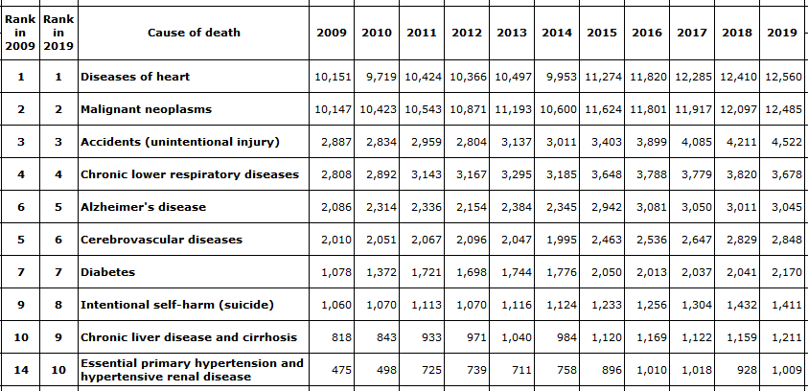

Table 2: List of Heart Diseases and Factors that Affect Cost of Treatment

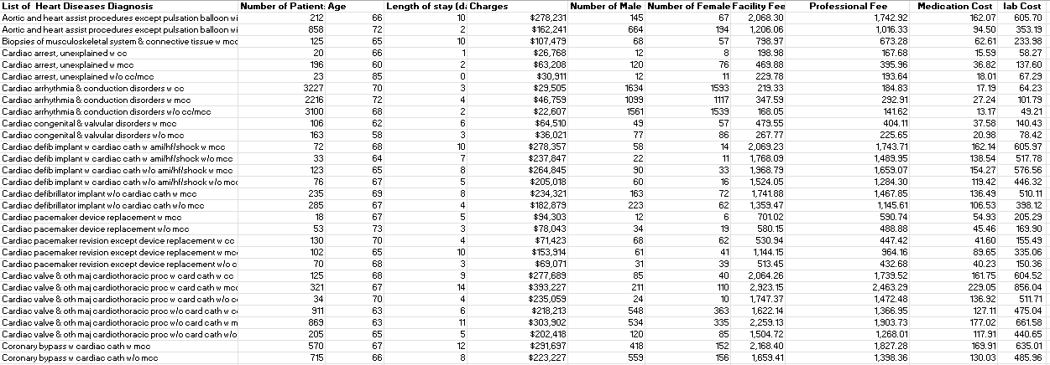

Exploration of Data
Our project focuses on heart disease, which is the number one killing disease in Arizona. We explored the number of deaths caused by the disease over a 10 year period from 2010 to 2019. We came across a list of different categories of diseases in the data we collected from Agency for Healthcare Research and Quality (AHRQ) through ADHHS and filtered to get the list of heart diseases since that is our focus. The total number of deaths increased from 10,151 to 12,560 between 2010 and 2019. Male and female between the ages of 65-85 were admitted to hospital and died of heart diseases in 2019 in Arizona. Males are more likely to be admitted to the hospital for heart disease treatment compared to females. Patients admitted between the age of 65 and 85 with severe heart diseases spent an average of 6 days at the hospital, which affects how much they pay for treatment. Professional fee, medication, facility, and lab costs are the crucial factors that affect the cost of heart disease treatment with an average Professional fee of $20,167. We came across that the number of years of experience affects the professional fees and each of the lab activities taken for each of the heart diseases diagnosed were similar and fall into similar categories. The more severe the disease the higher the medication cost.

Verify Data Quality
We retrieved our data from credible sources such as Mayo Clinic organization , Centers for Disease Control and Prevention, Arizona Department of health services, American Heart Association, and Agency for Healthcare Research and Quality. We believe that the data has been checked and verified before publicizing them, since most of them came from government or the company websites.

Conclusion
The data provides 10 years of records of the death caused by heart diseases. It is very critical for the healthcare providers, the government, and the public since it brings attention to how serious it is. The statistical information will help educate people, especially the vulnerable age groups, to take their health seriously, go in for early diagnosis and treatment; and for hospitals and the government to allocate resources appropriately. Our data gives statistical information on age, possible length of stay, and possible facility, medication, and lab cost, which help hospitals and the state to properly allocate resources and where it is needed to reduce cost.

Data Diagnostics and Descriptive Summary

Data Preparation
Data preparation is a crucial step taken before building a model since the data set used has a significant impact on the model. We have to make sure we have all the necessary variables present in the data to build a model that solves our business problem. To get the most from the data preparation process stage, it is critical that data is thoroughly cleaned, formatted, and modified into something more comprehensible to stakeholders (Chen, 2020). We collected our data from multiple sources which are reliable, but because having clean data will make it easy to build our model and run our analysis, we formatted and got rid of the data we do not need. We cleaned and formatted the data by considering the possible model we have in mind.

Selecting and Verifying Data
The task as an analyst is to look for the data that will help to visualize how our independent variables such as medication cost, professional fees, different costs within the healthcare system and many others are affecting the cost of heart disease treatment. This data has brought challenges and difficulty to be obtained since healthcare systems have some information that is not allowed to be accessed to the public. According to “Privacy protections to encourage use of health-relevant digital data in a learning health system” the new federal law prioritizes privacy protection of health data in order to avoid unethical or harmful uses of the data (McGraw & Mandl, 2021). This has made it a challenge, however, through knowing ways of narrowing the scope area and using different references that allowed us to get public health data. We were able to obtain averages of the independent variables data that were collected. Another way we used to address this challenge is by comparing data with other hospitals outside Arizona but within the United states. This is in order to help us be able to make good assumptions on treatment of heart diseases within Arizona compared to other states.
After we selected all the data, we verified through peer reviewing each other's data that was collected and received feedback. We also were able to perform analysis through the process of data preparation which helped us verify and see missing data that we would need. And lastly in order to check accuracy and inconsistencies, we checked our sources of reference the data was collected from if they are ethical as shown in the table 3 below.
Table 3: Selecting and Verifying Data
 | Type of data | Website
1 | Inpatient diseases database  Hospital  Diagnosis  Age  Cost | http://www.hcup-us.ahrq.gov/
2 | Drug prices  Medication  Cost of medication | https://www.goodrx.com/anticoagulants
3 | List of diseases and number of death  Period  Disease type  Number of death | https://pub.azdhs.gov/health-stats/menu/info/trend/index.php?pg=deaths
4 | Staffing salaries  Career  Salary  Education requirement | https://college.mayo.edu/academics/explore-health-care-careers/careers-a-z/
5 | Laboratory cost  Lab description  cost | https://www.healthtestingcenters.com/blood-testing/arizona/phoenix/  https://www.cardiovascularbusiness.com/topics/cardiac-imaging/ccta-lowers-invasive-testing-costs-suspected-cad  https://www.bankrate.com/personal-finance/how-much-does-an-mri-cost/#:~:text=In%20general%2C%20MRIs%20range%20in,detect%20and%20diagnose%20neurological%20conditions.  https://jamanetwork.com/journals/jama/article-abstract/366293#:~:text=The%20average%20cost%20of%20coronary,laboratory%20charges%2C%20and%20professional%20fees.  https://www.newchoicehealth.com/places/arizona/phoenix/ct-scan/ct-angiography-chest#:~:text=CT%20Angiography%20%2D%20Chest%20Cost%20Report%20in%20Phoenix%2C%20AZ%20Summary,in%20the%20Phoenix%2C%20AZ%20area.  https://www.newchoicehealth.com/places/arizona/phoenix/echo/heart-ekg-transthoracic-echocardiogram

Extracting the Data
The next step we took once we verified the data was to extract the data needed for our analysis from several websites including government and state websites such as CDC, Arizona Department of health services, Healthcare Cost and Utilization Project, and hospitals in Arizona. Since it was hard getting all data at one place, we extracted data from different sites and combined them. Below are the various techniques and methodologies we used to retrieve the data.
Table 4: Extracting the Data

No. | Attribute Description | Extraction Process
 | Healthcare workers Salary. | https://college.mayo.edu/academics/explore-health-care-careers/careers-a-z/  · Copy and paste the data from the hospital website into Excel (job tile, salary, years of experience) and format it
 | Medication cost  Heart disease medication list  Medication prices | https://www.heart.org/en/health-topics/heart-attack/treatment-of-a-heart-attack/cardiac-medications  https://www.goodrx.com/  Copy and paste the data from the hospital website into Excel (medication names and format it to get the names of medications  Next,go to goodrx and do a category search for medication prices  Copy and paste the data from the goodrx website into Excel (medication prices and format it  Create a column for medication and prices
3 | List of Heart diseases.  Discharge cost  Age  Length of stay | https://www.hcup-us.ahrq.gov/overview.jsp  Search the Arizona State statistics from HCUP State Databases  Download the excel file and format it

Formatting Data
Once we are done extracting the data from various websites, the next step taken is to format our data to become standardized across the variables since data came in different formats and had some missing data. After matching the medication names with the costs for each, we also filtered the heart disease names to get the other variables such as total cost, age, and length of stay associated with them among other disease categories. Doing this helped us to get the data in the correct format for our analysis. The table below describes the original raw format and the format it was converted into make it easy for analysis
Table 5: Formatting Data
No | Attribute Distribution | Original data | Formatted Data
1 | Healthcare workers salary | Data contains health workers information (Career,Work type, Median salary, Higher education required) | Changed column names and deleted work type which we did not need
2 | Medication cost  Name  Price | Data contains categories of medications | Changed to sub categories to have singles to make it easy to search and match prices
3 | List of Heart diseases and costs  Discharge cost  Age  Length of stay  Gender | Actual data contains rank, groups of diseases, discharge cost, length of stay, age, gender etc | Filtered to get the heart disease lists and their associated variables in the dataset  Calculated the weight by dividing charge for each heart disease but sum of charge  Applied the weight to professional, medication, and lab cost to get the weighted average

Cleaning and Integrating Data
In order for us to be able to use our data through simulation, analysis and be able to visualize it, we had to clean it. According to “A Review on Data Cleansing Methods for Big Data” this process mainly consists of identifying errors in our data and identifying incomplete or inaccurate data (Ridzuan et al, 2019). Through this process we were able to find inconsistency in the laboratory cost data and the medication data. These data were missing some cost. This required us to do some data integration which is combining data through different resources (Lenzerini, 2002). Therefore, we researched other sources in order to help us fill in the missing values and also be able to compare the data. Within our analysis we made sure the data is in the right format with the way it is sorted in order to still see the trend within our dataset.

Simpson’s Paradox
To prevent the Simpson’s paradox, we aggregated the data together. For example, we gathered the list of various heart medications and found their corresponding costs to match them. We did the same for lab costs but categorized them based on the various tests required to diagnose a particular heart disease. According to Koehrsen (2018), one of the best ways to prevent Simpson’s paradox is to separate or categorize data into groups or aggregate them together.

Descriptive Analytics
In order to perform an analysis to obtain our goal of solving the business problem. We need data that will describe and represent our problem through methods of visualization by different graphics and measures of variability. The demographics of our analysis will be within Arizona state. The first data set that we analyzed was to tell us the most killing disease among all diseases in order to narrow our focus. As shown in Figure 1, the figure shows the leading causes of death over the time period of 2009 to 2019.
Figure 1: Leading cause of death
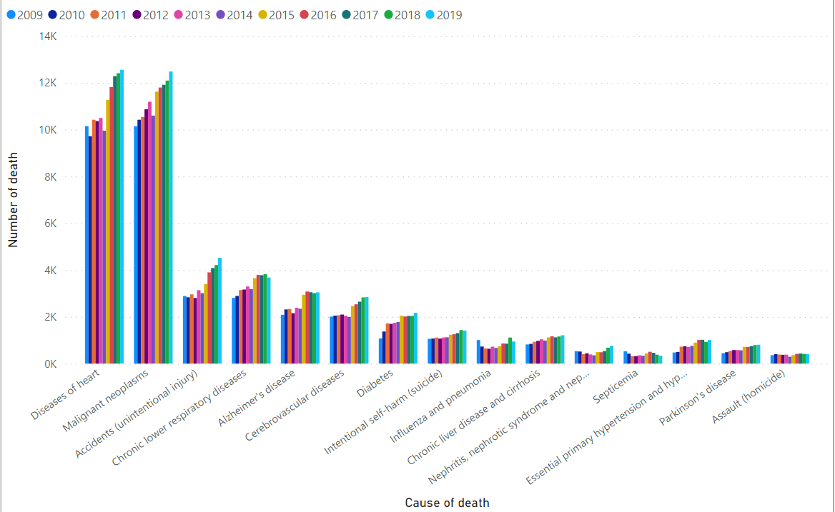
This figure above includes different diseases and the number of deaths caused by each disease over the 10 year period. With this dataset we were able to explore more into heart diseases and what the cost of different heart diseases is composed of.

Figure 2: Median staffing salaries at the hospitals
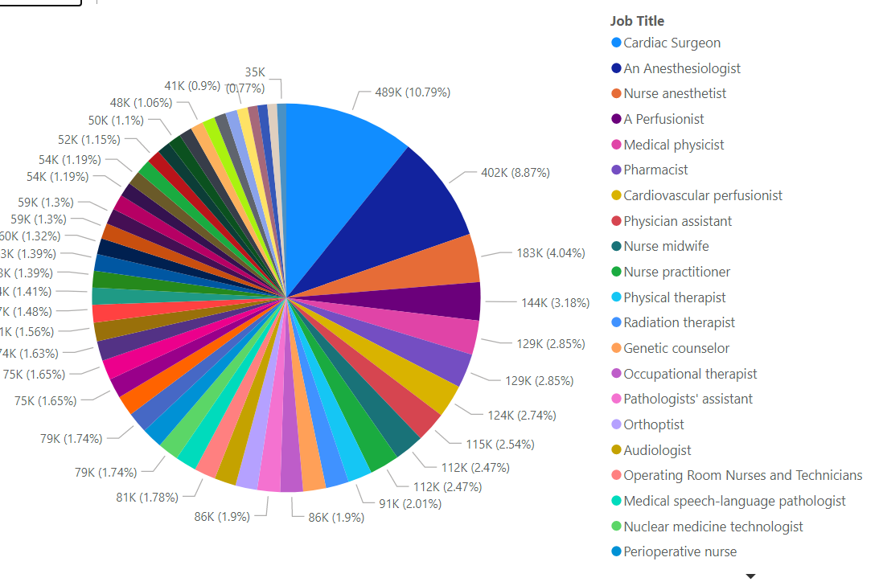

Looking into treatment of diseases we were able to collect a dataset of healthcare staff and their salaries as shown in figure 2 above. This dataset will represent how the professional fee affects the cost of treating heart diseases.
Figure 3: Number of males and females admitted for heart disease
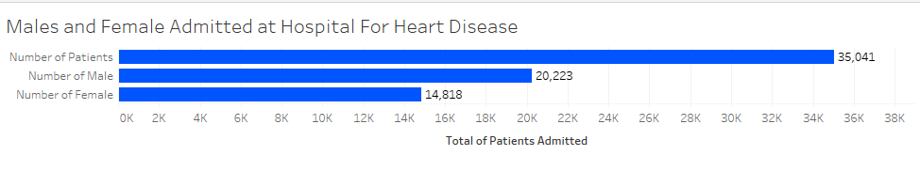
Figure 3 gives us a more understanding of which gender is more likely to experience heart disease. Which will help us in our model to know which variable in our gender is more likely to affect the cost of treatment.

Figure 4: Total Charges of Professional, Lab, and Medication cost
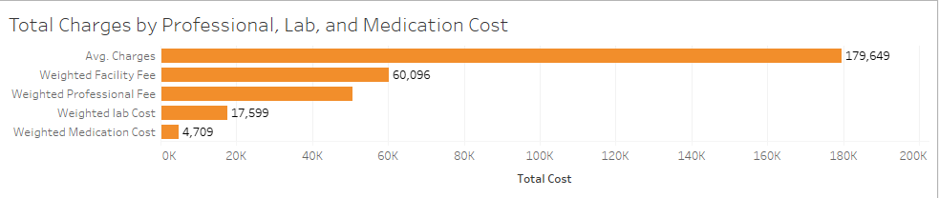
The dataset in figure 4 represents average cost of heart disease treatment (charges) and cost drivers. Combining this dataset will help us be able to visualize where cost can be minimized within the patients treatments.

Figure 5: Age and Length of stay
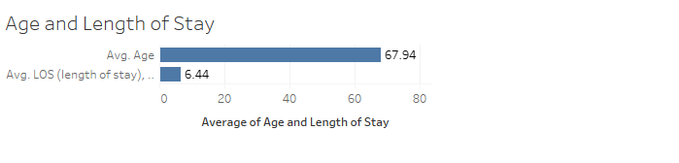
From the above bar chart, we can see the average age of admitted patients with heart diseases versus their length of stay. The chart tells us that the average admitted age is 67.94 and the average length of stay is 6.44 days within the hospital.

Figure 6: Heart Diseases and Age Admission
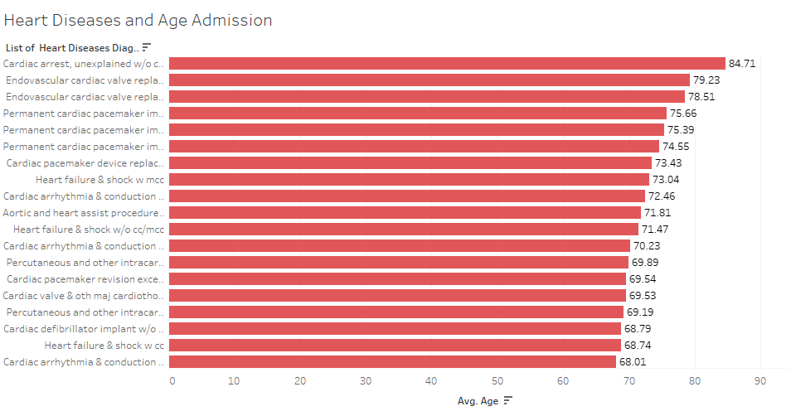
Our data in the figure 6 above shows that patients between the age of 65 and 85 are more likely to be admitted to the hospital for heart diseases from heart failure to cardiac arrest.

Figure 7:The Severity of Heart Disease and Length of Stay At the Hospital
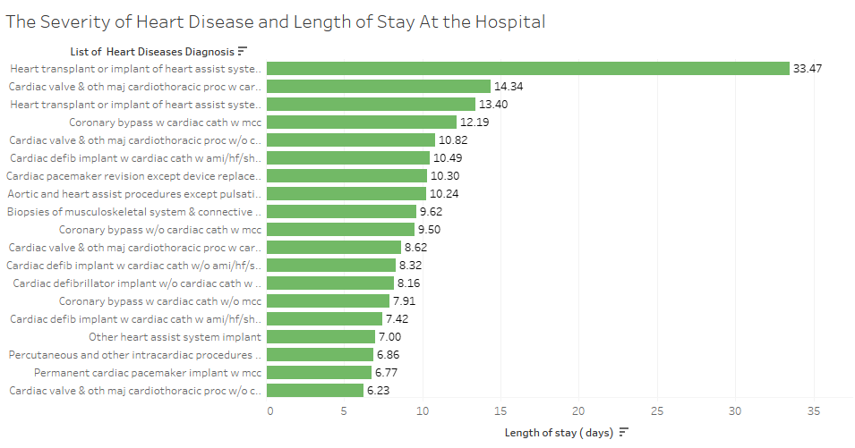
Figure 7 shows that the severity of heart diseases contributes to length of stay at the hospital. Aortic and heart assist and heart transplant or implant procedures require patients to stay at the hospital between 10 to 33 days.

Figure 8: Dashboard representing all the data collected
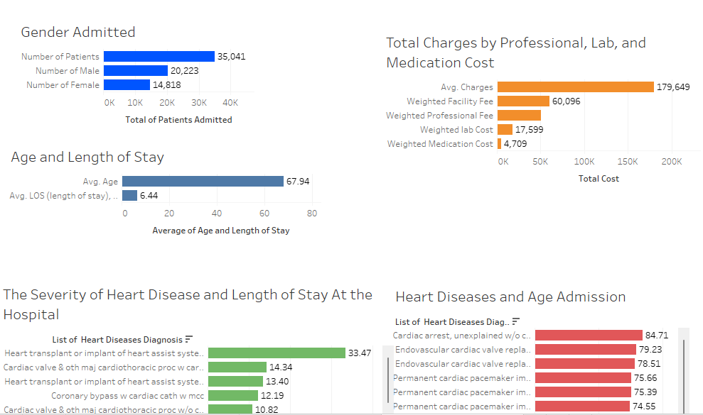

Conclusion
Heart disease has been the top leading cause of deaths in Arizona between 2009 and 2019. From the data we collected from the Arizona Department of Human and Health Services (ADHHS) , the number of deaths increased from 10,151 to 12,560, which is about a 19% increase over the 10 year period. To solve our business problem of minimizing cost and proper allocation of resources, we considered professional fees which is a factor that contributes to the cost of heart disease treatment. Our data analysis shows that Cardiac surgeons are the top paid healthcare workers among the team that treat heart diseases, with a median salary of $489, 000. On average, Cardiologists who treat severe heart diseases make between $279,000 and $370,000. Based on the 35041 patients sick of heart diseases in our data, 20223 and 14818 males and females were admitted respectively. This shows that about 58% of the patients are males and about 42% females. Males stand a higher chance of being admitted to the hospitals in Arizona than the females.
On average the total cost of heart disease treatment is about $180,000 depending on the severity of the disease. Healthcare worker, facility, medication and lab costs constitute the largest part of the cost of treatment. Per our data, the average age admitted to hospitals for heart diseases in Arizona is about 68 years. People between the age of 65 and 85 are at higher risk of being admitted with severe heart diseases ranging from heart failure to cardiac arrest. In the data we collected from Agency for Healthcare Research and Quality (AHRQ) through ADHHS, 9356 patients were admitted for heart failure. The age and the severity of the diseases affect the length of stay at the hospital for treatment. Patients with Aortic and heart assist procedures and heart transplant or implant procedures spend between 10 to 33 days at the hospital.

Methodology Approach and Model Building

Model Building and Evaluation
Using analytical tools to solve problems at hand is very critical to businesses. After data preparation and diagnosis, the next important step is building the model. According to Kszczanowicz & Milosz (2021), models play a role in improving the efficiency of companies, however, success depends on the approach chosen. The business problem we are solving requires us to understand how our independent variables contribute to the cost of heart disease treatment. To solve our business problem, we used variables such as the number of patients, Length of Stay, Facility fee, number of male and female patients, professional fee, medication, and lab cost to apply our K-means clustering and linear regression.

Modeling Technique and Test Design Selection
We used K-means clustering and linear regression to solve our business problem, i.e., help Arizona on factors that affect the cost of heart disease treatment to strategically minimize cost, save lives and better allocate resources. We applied K-means to partition our observations into clusters/groups to find the nearest mean and used linear regression to predict and give us the relationship of the value of our dependent variable (charges) based on the value of the independent variables such as the number of patients, Length of Stay, Facility fee, number of male patients, number of female patients, professional fee, medication and lab cost.

K-means Clustering model
K-means algorithm partition dataset into distinct non-overlapping clusters such that every data point belongs to only one specific group. According to Dabbura (2020), the sum of the squared distance between the data points for a cluster and its centroid assigned by K-means should be at a minimum. We applied K-means to partition our observations into clusters/groups to normalize our data to create a list of heart diseases high number of patients with low charges, medium number of patients with medium charges, professional, medication, lab cost, and medium length of stay; and low number of patients with high charges, charges, professional, medication, lab cost, and medium length of stay. The next step we took was to identify the optimal number of clusters from our dataset and look into other clustering techniques like the gap statistics to assess our error rate and approximate the correct number of clusters, the k values. Based on the three methods, elbow, Silhouette, and gap statistics, we found that three clusters were the optimal number of clusters that best analyze our results as seen in figure 9, 10, and 11 below. In table 6, we can see that the averages of the variables are computed with a low number of patients in cluster 3, which contains 337 patients. Cluster 3 has an average 8.16 length of stay, $2,020.40 facility fee, $1,702.56 professional fee, $158.31 medication cost, $591.67 lab cost, and overall charges of $271,787.29 which is higher than both cluster 1 and 2. Cluster 2 has 2,819 patients with an average 3.11 length of stay(days), $248.12 facility fee,$209.08 professional fee, $19.44 medication cost, $72.66 lab cost, and total charge of $33,377.11, which is less than both cluster 1 and 3. Moreover, Cluster 1 has an average 393.9 patients with a total charge of $97,255.99, which is greater than cluster 2. We believe cluster 2 with high number of patients, less length of stay, less charge is the best choice based on this information provided in table 6.

Figure 9: K-Means Cluster Plot
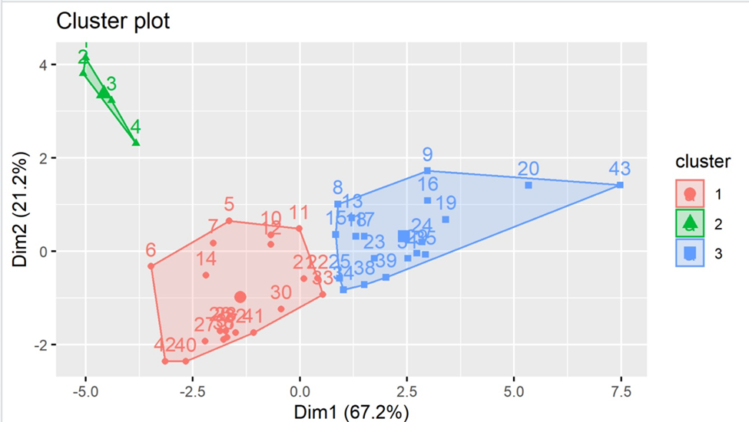

Figure 10: Optimal Number of Clusters- Elbow Method
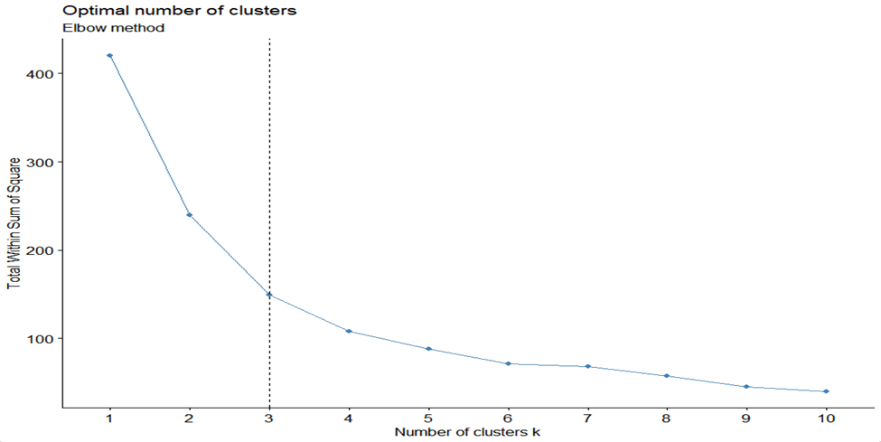
Figure 11: Number of clusters vs. gap statistic
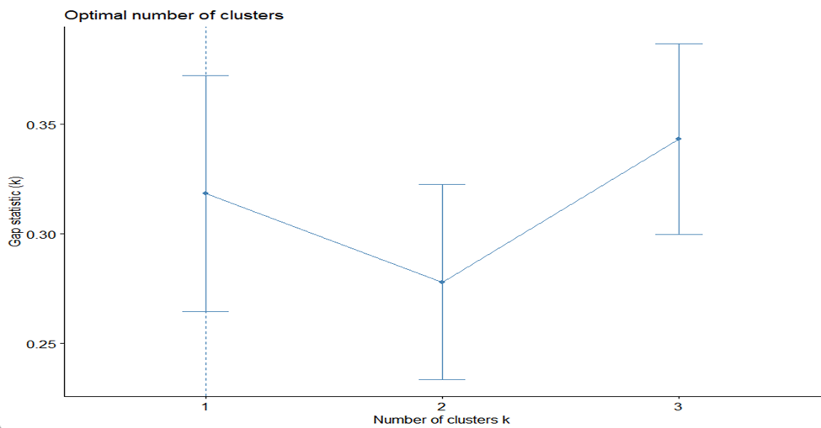

Figure 11: Optimal Number of Clusters- Silhouette method
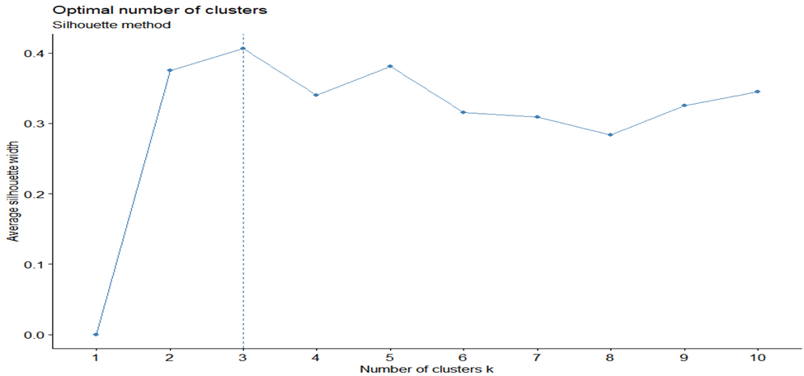

Table 6: Clustering Data Table

Linear regression model
Linear regression is another model we utilized, apart from the K-means Clustering, was a model that would help us in finding the relationship each variable had with the cost of treatment. The goal was to visualize which of the variables are statistically significant and also see the effect the independent variables have on our dependent variable, which in this case are our charges for the heart treatment data. Since we are trying to minimize the cost of treatment, the variables that will have a much higher coefficient value and are significantly significant on the charges(predictor) will be closely monitored. And the values with negative coefficients will be removed from the regression since they do not give us any relationship between the variables to the cost of treatment.
In order to run the linear regression model, we had first plot the variables to see if they are linear through a normal qq plot and also check their histograms as shown in figure 12 & 13. This is in order for the variables not to affect the model performance. We also plotted each of the independent variables against the treatment of cost as shown in Figure 14 in order to visualize their behavior against the cost of treatment(charges). A correlation matrix was also created to see the whole relationship between variables. However, after the first attempt of correlation matrix, we removed some of the variables because they were showing multicollinearity. The use of circle correlation on the plot was used in figure 15a and b to show a representation of relationship. The bigger circles, the more the variables are correlated with each other. After this we were able to have all the variables ready for the linear regression model to be run. The regression we ran is shown in figure 16. The professional fee coefficient was much higher than any other predictor variable coefficient to the treatment of cost. This means the professional fee plays a huge role in the increase of cost for treatment.

Figure 12: qq plot for each variable
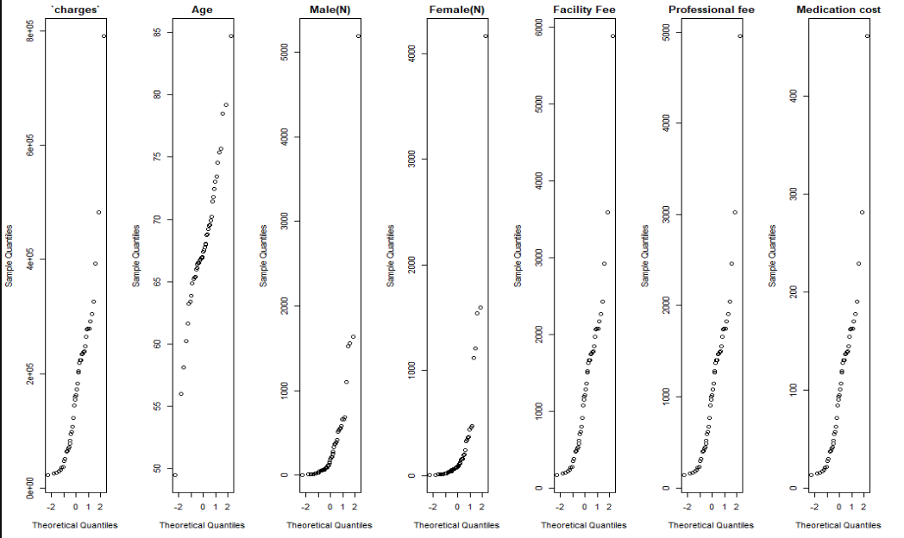
This representation of the models in the qq plot helps us know how the variables are going to affect the model performance. In case some variables are not able to be run in the regression model due to their scale. We will be able to determine how to normalize them

Figure 13: Histogram for each variable
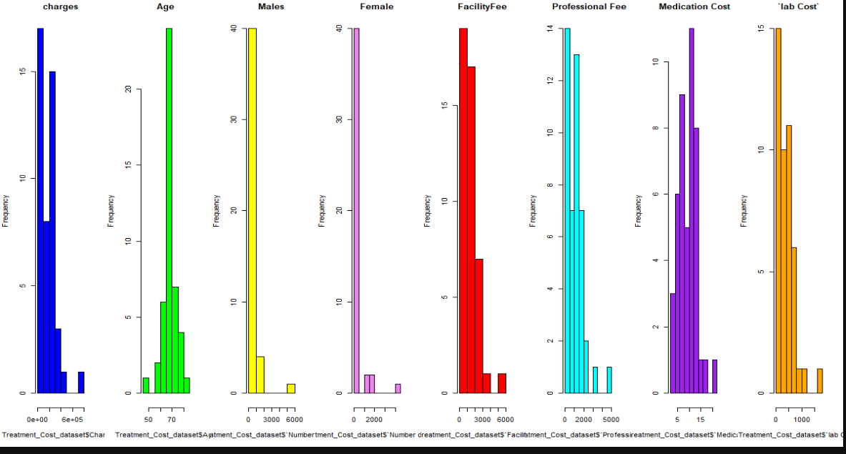
This representation will help us visualize what kind of distribution the variables are having in order to give us a better understanding of the way our regression model is performing.
Figure 14: plot of all variables
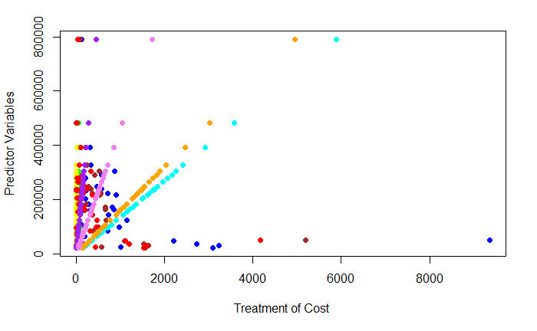
Figure 15a: correlation coefficients between the variables
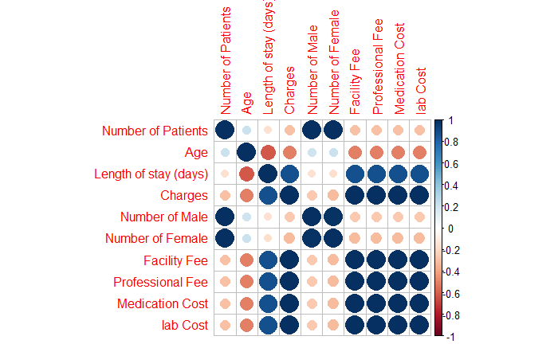
Figure 15b: correlation coefficients between the variables without correlated variables
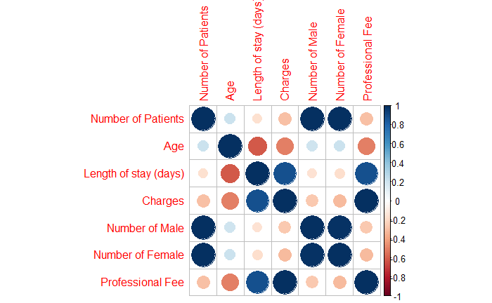
In the figure above the correlation matrix was used in order to visualize the relationship of all the variables. The bigger the circle and the dark blue it gets the more the variables are correlated. As shown in figure 15 the boxed area shows the correlations of all the variables to the charges(treatment cost). The variables that are shown to be more correlated are Length of stay, Facility fee, professional fee, Medication cost, and the lab cost.

Figure 16: Linear regression model output with all variables
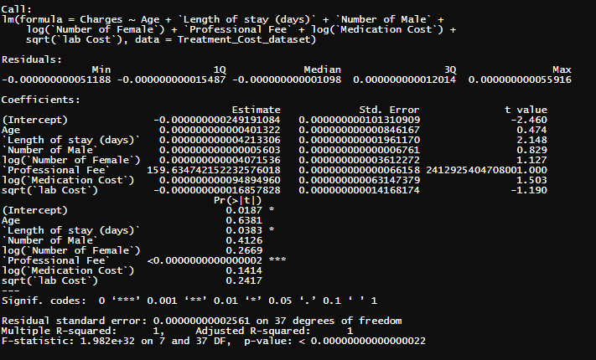
Figure 17: Linear regression model with significant variables 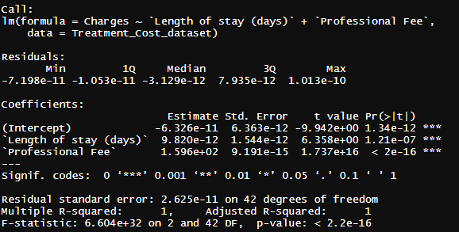
Figure 18: linear regression with highly correlated variables from correlation matrix
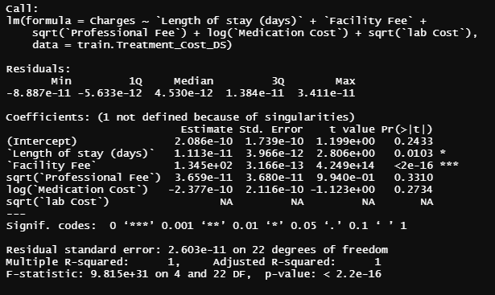

Conclusion
After clustering our model using K-Means and applying all the three methods, three methods, elbow, Silhouette, and gap statistics, we found that three clusters were the optimal number of clusters. After knowing which cluster with the optimal results for the cost of treatment, we also looked into the relationship of the variables to the cost of treatment which resulted in looking more into the professional fee, Length stay and medication cost because their coefficient highly increases the response value(cost of treatment) . Also by looking at their p -values the Professional fee and the length of stay are significantly significant.

Model Evaluation

Evaluation Process Justification
Evaluation is an important part of the model building process. According to Krishna (2021), evaluating the model helps to assess its efficacy in the initial phase and aid in monitoring. When we evaluate the model we get a good idea about the performance, as well as the strengths and weaknesses. We are able to see whether the model will do what is intended to do or not. We used Elbow and Silhouette methods to evaluate our K-means model by looking at Within clusters sum of squares (WSS), which measure the compactness of the clusters and Average.withins, which calculate the average distance within clusters. According to Pathak (2020), one of the best and most popular classification performance evaluation metrics is Silhouette coefficient because it shows whether data points are put in the right clusters or not. For the Silhouette method, we used Clus.avg.silwidths to calculate the width to get an estimate of the average distance between clusters. This gives us a better idea if the heart diseases we clustered belong to the correct group with the charges or not. As shown in figure 22, cluster 3 has 19 diseases with an average of 0.39. Cluster 2, which is the least cluster with only 4 list of heart diseases, has an average of 0.72 score. Overall, the average Silhouette coefficient or score is 0.41, which is a good indication that the diseases are assigned to the correct cluster with their charges. The silhouette score falls within the range of -1 and 1. Any score closer to 1 shows that cluster is well segregated (Bhardwaj 2021).
The evaluation techniques we used for the linear regression model, to help us find how good the linear regression model is performing were; R squared, Mean squared error, and Mean absolute error. The R squared will give us how good the model is fitting, giving us a percentage strength of the relationship between the fitted model and the dependent variables(Frost, 2018) . The use of this evaluation method is the most important in regression than MSE/SSE/RMSE (DataVedas, 2018). The next evaluation we used is by checking the Mean Squared Error(MSE). This will help us visualize how close the regression line is to the set of points of our independent variables hence giving us the amount of error if the residuals are far from the fitted line. The last evaluation for the regression model we used was the Mean absolute error, which sums up all the errors we have in our regression. This will give us the accuracy of how the model fitting

Linear regression model evaluation
As mentioned, this model will help us visualize the relationship each independent variable has with the cost of treatment. With this model created, the evaluation process helped us understand the performance of the model and determine if we can achieve our goal to be able to present our solutions to our business problem. As shown in figure 19 the R squared and the adjusted R both give a value of one. This R squared was obtained to be fitting due to the independent variables that were removed for not being statistically significant with the treatment cost(charges). The variables we used in our linear regression model have a P-value less than 0.05. This left out the two variables, Length of stay and the Professional Fee . With the Mean Squared Error(MSE) method as shown in the same figure 19, the model results came out to be 6.431e-22. This value of error is significantly low indicating the regression line that was built is really close to the set of points. Making the two independent variables, the length of stay and professional fee highly correlated with the cost of treatment. However, due to calculated averages of these variables this might fail to provide us with information showing the patterns that were predicted correctly. This is why several evaluation models are run in case one fails to understand the model. The last evaluation metric we used for the linear regression model was the Mean Absolute error(MAE). The outcome of the MAE was 0.02033674. This value is close to zero indicating our accuracy for this model had a small error and the model is better fit.
Figure 19: evaluation results for the linear regression model
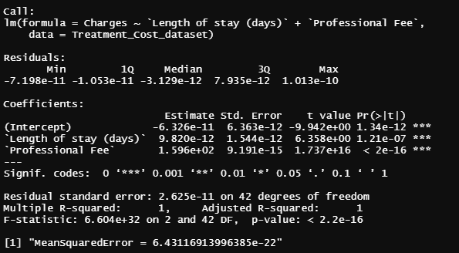

Figure 20: linear plot for the significant variables
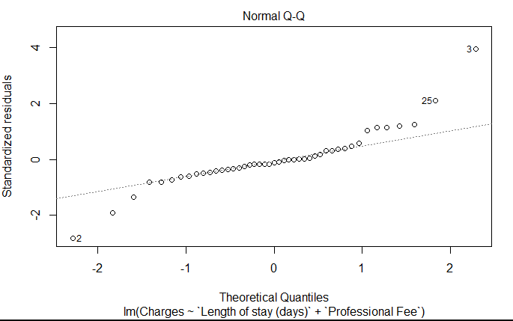
Figure 21 Cluster silhouette Plot
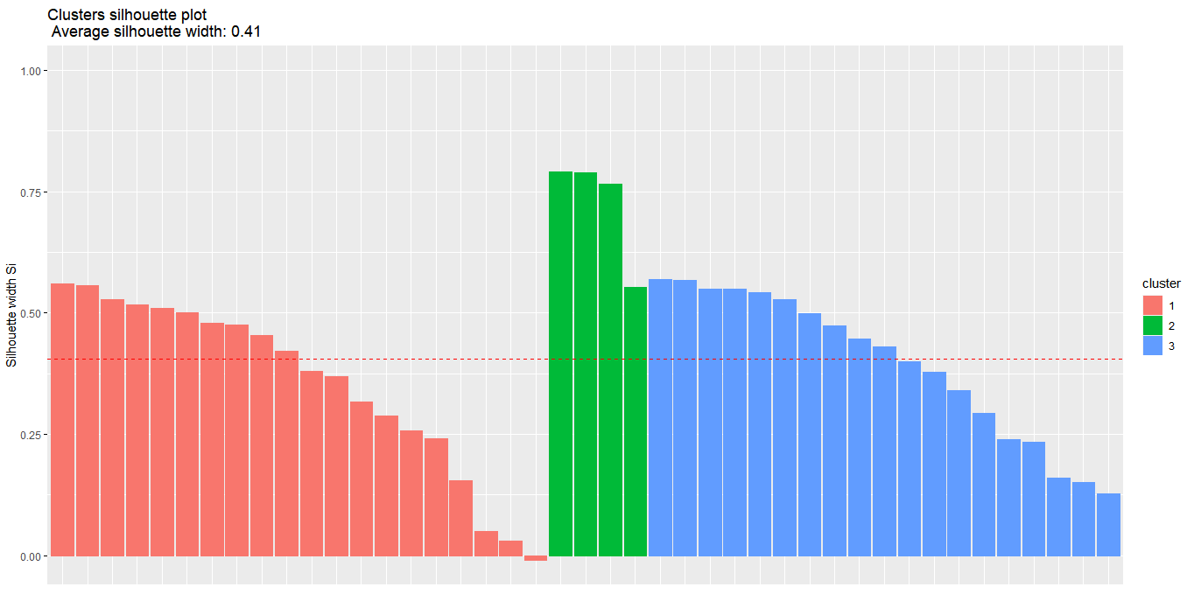

Figure 22 -Silhouette plot showing number of clusters, sizes and widths
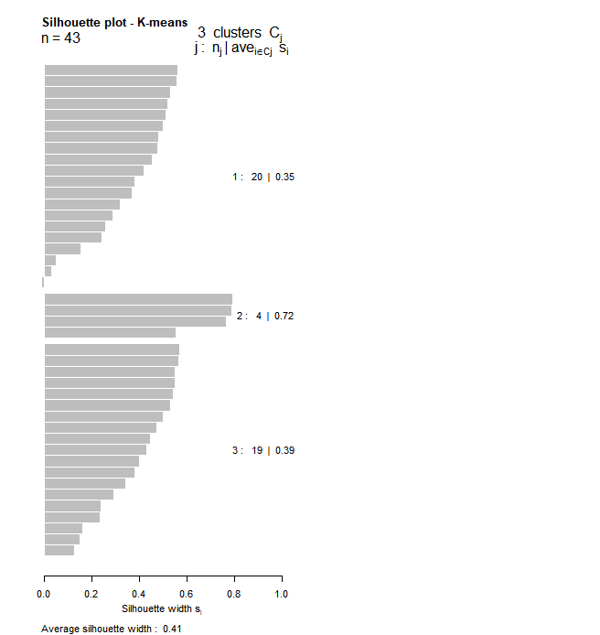

Figure 23: Silhouette coefficient of observations
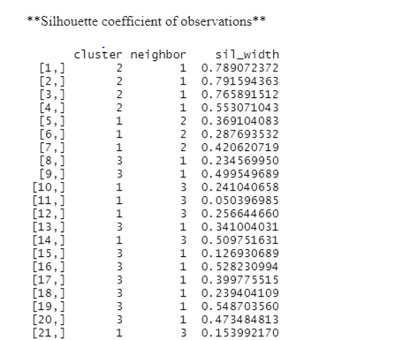

Model Validation
After model building the next important step is validation. Model validation involves various processes taken to ensure that the model achieves its intended purpose. According to Ramzai(2021), the key purpose of model validation is to check the accuracy and performance of the model. This can be done by using internal or external validation techniques depending on the data and problems to be solved. Validation is very crucial in model development processes because if the model is not validated, it might not work well when applied to any unseen data. When that happens it can lead to a poor outcome. For our K-means model, we used silhouette method by looking at silhouette coefficient since it verifies whether the diseases with their charges are in the correct clusters or not. We ran Silhouette summary statistics and plot to visualize the result as shown in figure 21. The overall Silhouette coefficient for our cluster is 0.41 which verifies that the diseases with their charges belong to the correct clusters.

For the regression validation, we split the data into two sets. We used 80% of data for the training set and 20% for testing. This is in order to be able to compare the two data sets. We used 80% of the data which is the train data set to build the model. The results are shown in figure 24. Then we did a prediction to compute the R-squared, RMSE and the MAE. When we partitioned the data for the validation process, the Length of stay variable was no longer statistically significant and its coefficient was negative. This means that the Length of stay variable no longer has an impact on the increase of the cost of treatment.
The validation techniques we used are given in the outcome shown in figure 25. The R squared shown for the predicted is 0.999, leaving a very small room for error. The model for the test set is shown to be fitting well. For the RMSE, will give us how dispersed the residuals are from each other. The outcome for the RMSE came out to be 0.027860862 which is a small deviation between the residuals indicating an absolute fit of the model. The observed data set is pretty close to the predicted. Another validation metric we used for the partitioned linear regression model was the Mean Absolute Error(MAE). Its outcome for the validation came out to be 0.024701974 which also shows the accuracy of the predicted model to be a better fit.
Figure 24: 80% train dataset output model
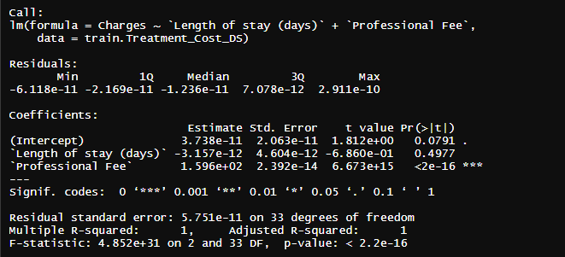
Figure 25 : Prediction outcome with the validation techniques
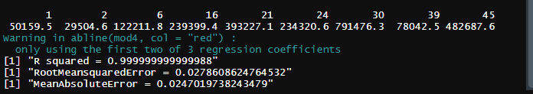
Figure 26: Statistics for k-means clustering
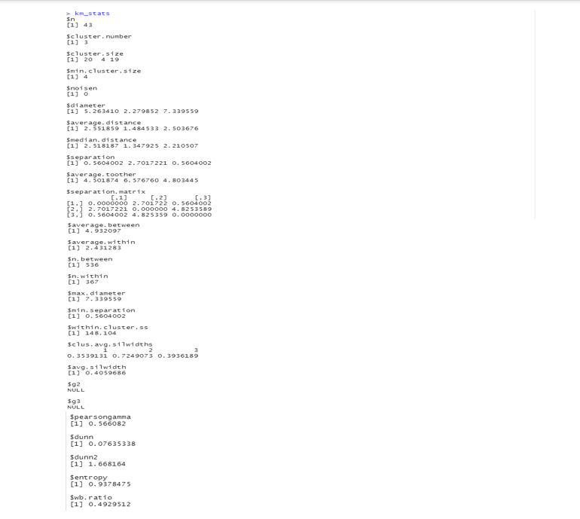

Conclusion
We used both Elbow and Silhouette methods to evaluate the model. We checked Within clusters sum of squares (WSS) plot for the Elbow method which helps to choose the optimal cluster for the diseases and their charges. For the Silhouette method, we used the Silhouette coefficient to evaluate and validate the model. As explained above, we got 0.41 for the Silhouette coefficient, which shows that the diseases with their charges belong to the correct clusters. For the evaluation for the linear regression model, we used the R squared, MSE and the MAE. We ran the model on the whole dataset after removing the variables that are not statistically significant to the cost of treatment. The two variables that remained were highly affecting the cost of treatment . These variables are shown to be the Length of Stay and the Professional fee. We ran these two variables within the linear regression model, allowing us to run our evaluation techniques on them. All the evaluations that we applied to the model were shown to be a better fit for the model with significantly low values of error. Indicating that the linear regression model built is a good model.
After the evaluation process for the linear regression model, we analyzed the same model by validation processes. In this case we partitioned our dataset into a training and testing set. We built the model on the training set and the outcome came out to be the professional fee being the only statistically significant variable to the treatment cost. Then we predicted it with the test data set. The results yielded an R2 value of 0.99,a small RMSE and MAE showing a good performance of the linear regression model.

External Model Verification and Calibration

External Validation
External validation is an important step in the model process to solving business problems. It gives us a better idea on how our model will perform and helps to double check to see if we have to revise our model or not. According to Ho et al.(2020), external validation is the process of using independent datasets to validate the performance of the model. The independent dataset is the data the model has not seen before. With our models, we were able to do internal validations using the Silhouette coefficient for the k-means model and used Root-Mean-Square Error (RMSE), R-squared, and Mean Absolute Error (MAE) to evaluate and validate the regression model. We split the data into training and testing; 80% for the training and 20% for testing.
Our Silhouette coefficient was 0.41 which verified that the heart diseases we clustered with their charges are in the correct cluster. The metrics we used to validate the regression model also came out with a good result, but we could not do an external validation for our models due to the fewer observations in our dataset. We are better off having a large dataset to be able to partition them into training and testing to validate the model.
Moreover, the data we collected were original so it is difficult to get an external dataset to validate the model. There is no historical record of the same raw data as the data that we collected. We collected our data from different sources and put them together. However, the internal validations we did, gave us a good idea of how the model performs as discussed above.

Literature Review
In doing research in validation of regression models, The article by Technimetrics “Validation of Regression Models: Methods and Examples” goes over different methods used in the validation process(Snee,1977). Some of the methods mentioned involve data splitting. For the regression model that we built we split our model into training and testing and were able to get model predictions and compared them to our train data. However, this was not as successful, since the amount of dataset that was available was not large enough to consider data splitting. According to the rule of thumb data is considered to be split when N >= 2p + 25 to allow enough degree of freedom for error(Snee,1977). The dataset we put together only had forty five observations which is not enough data..
The article also goes over correlation matrix to measure the collective effect among the independent variables on variance (Snee,1977). This supports the method we used for correlation matrix in order to view the relationship of the variables within each other and how they are correlated. In order to eliminate some of the variables that may be affecting the model as shown in figure 15. Based on our results of the correlation matrix the professional fee, Length of stay, medication and lab cost were found to be highly correlated with the treatment cost. After we did our regression model the only variables that were left to be statistically significant were the length of stay and the Professional fee. Professional fee had higher coefficient of the residual to the cost of treatment and it was consistent through our model results. In research from Kumar et a l ( 2022), healthcare workers, Length of stay, medication, and Laboratory cost are some of the cost drivers of cardiovascular diseases treatment. The healthcare workers fee appeared to be the highest among other cost drivers, which is consistent with our result. A further review of the article shows that severe heart disease like congenital heart diseases have higher cost of treatment. This is also consistent with the disease with their charges we clustered.
For our K-means model we used the Silhouette coefficient as a validation method. The Silhouette coefficient result we got is consistent with other literature such as using Silhouette Analysis to evaluate the performance of machine learning with applications to clustering by Shutaywi and Kachouie. They used the Silhouette coefficient/ score to assess the performance of their kernel clustering models. According to Shutaywi and Kachouie (2021), if the Silhouette value is greater i.e positive, there is high likelihood that the elements clustered are in the right group. This is consistent with the Silhouette coefficient that came out to be 0.41, which shows that the diseases we clustered with charges are in the correct group.

Calibration
After models are built, it is very important to review and check performance to see how best it can solve the business problem. Model calibration provides more insight into any uncertainties about the model (Blachowski, 2021). When building our k-means model, we used different methods such as Elbow, Silhouette, and Gap statistics to find the optimal number of the cluster that best analyzes our results. Based on the results from the methods, we chose 3 to be the optimal number for our clusters. We found the optimal number of clusters by trying with a number of k’s and chose the optimal cluster to build the model. To see the performance of the model, we used the Silhouette coefficient to validate the model, which came out to be that the diseases with their charges were in the correct clusters. This helps to see how each variable in the clusters affects the charges for each disease treated in each cluster. For our regression, after testing for multicollinearity and the results, we built different models by removing the variable such as lab cost, gender, and age from the model and reran it. The lab cost, gender, and age are the variables we thought do not drive the cost of heart disease treatment (charges), which is our dependent variable. We then revised the models and compared the results using metrics such as Root-Mean-Square Error (RMSE), R-squared, and Mean Absolute Error (MAE) to evaluate and validate the regression model.

Future Recommendations
The dataset that we used to run the two models; K means and the linear regression went through a great deal of data collection and research to be put together. Even though we were able to get enough variables that were important in the case of the heart treatment cost, the data set did not have enough observations. This led to not having enough insight to our business problem and trend analysis. This also made it hard to split our data into training and testing in order to do the cross validation. Therefore, we recommend a larger dataset for the future business model. The dataset that we used also does not help with external validation because we put the data together from different resources making it an original dataset. Therefore, selecting a dataset that has historical data would be a good recommendation because it would enable the dataset to undergo external validation. Further recommendations would involve exploring more into other methods to adjust variables as needed or create more models in order to visualize and get more insight and trend analysis.

Model Deployment and Model Life Cycle

Model Deployment
Model deployment is the process that involves integrating a model into an existing production environment where inputs return an output for decision making (Shin, 2020). Model deployment costs are the costs that are incurred to deploy the model. According to Coop (2021), model deployment can cost $60K over the first few five years. The deployment planning affects all groups involved such as Data scientists, support team, and the leadership of the organization.
In research from Coop (2021), Bare-bones and MLOps are two approaches for deploying and maintaining a machine learning model. The Bare-bones approach does not scale over and misses crucial features the first days. This means the performance of the model will degrade over time. It costs $$60,750 over five years to support the functions of the Bare-bones system (Coop, 2021). This includes executing scripts to pull data , copying models to cloud machines , and personnel labor. The second approach, Machine learning operations (MLOps), has extra discipline to the development and deployment of ML models by defining processes to make ML development more reliable and productive. The MLOps approach costs $94,500 over the first five years. This includes yearly load balancer machine costs, continuous integration and deployment to pull models from register and continuous analytic data updates, and labor costs. Below is the breakdown of the cost comparison for both approaches.

Figure 27: Model Deployment Operational Costs
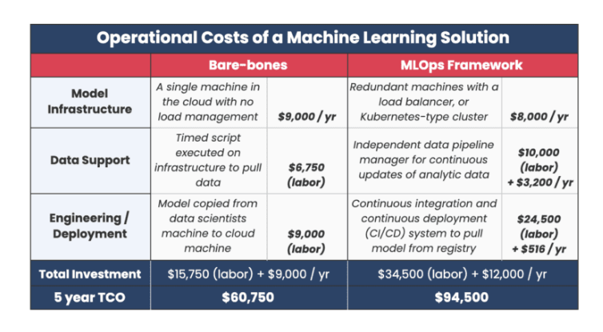

Table 7: Microsoft Azure Cost Estimate
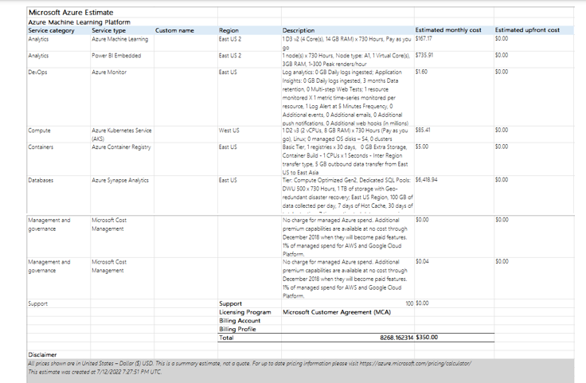

Deployment Cost
We used Microsoft Azure website to get another cost estimate as shown in table 8. This cost estimate tool provided storage and hardware costs with a total of $350 per month. Based on these two cost estimate models, we estimated our deployment cost as depicted below in table 2. Our total estimated deployment cost for the first year is $37,200

Table 8: Model Deployment Operational Costs
Number | Items Needed- Description | Duration | Cost | Subtotal | Comments
1 | Virtual Machine (Cloud) | 12 Months | $350 | $4,200 | RAM: 32 GB  Storage: 1 TB
2 | Data Subscription  - Heart Disease data  - Treatment cost data | 12 Months | $0 | $0 | Derive data from health websites which compiles data  https://www.ahrq.gov/data/infographics/heart-disease.html
3 | Initial Setup  Personnel involved: Business User, Data Scientist, Data Analyst, DevOps Engineer | 1 Month | $9,000 | $9,000 | - Setup of the Virtual (cloud) Machine  - Setup the Machine Learning Environment ( using R language)  - Next, import the Model onto the Virtual Machine  - Import the data needed  - Create the Model execution scripts  - Execute the model  - Review the model  - Modify to improve the performance of the model if needed
4 | Quarterly follow-up Setup | 12 Months | $2,000 | $24,000 | - Create quarterly data Import script to be executed  - Review the model every quarter
Total |  |  |  | $37,200 | Total Cost for the first year

Schedule, Training, and Risk
Since the model will be available to other users and systems, having training is essential for a successful deployment of the model. The timeline scope for this training can be done within 8 weeks. The Gantt chart below gives a visual of the proposed task training and their start and end date for deploying our model. This was built in Microsoft SharePoint. Since we are predicting to be done with this project on July 20th the training would start immediately for the users to be trained on the deployment model that was created. The early stages involve ways data was collected and extracted. This will involve the way the data resets periodically. Once this is done training on how the deployment model is using the regression and k-means would be next. Then following with steps of the way it is operated and an overview of the way the whole model.
Figure 28:Gantt Chart for Training schedule
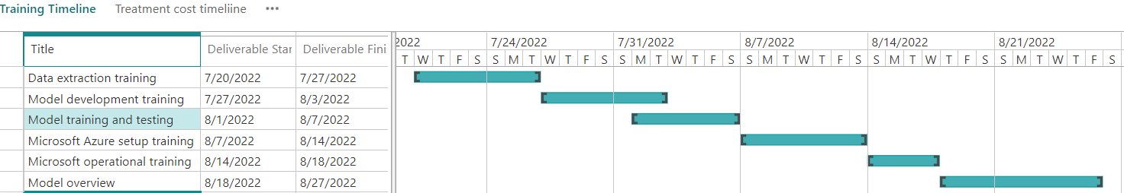

Benefits
We created two main models,linear regression and the K-means model. We used the K means to categorize 3 clusters giving us the diseases that are severe to the heart respectively to cost, length of stay, and facilities. The linear regression would run the variables that affect the cost of treatment(charges) and give us which variable is more significant to the cost of treatment(charges). The way we developed the two models in our deployment model will provide a viable model that can be reused on a repetitive basis as long as the dataset is continuously being updated. The dataset value will change overtime and this can be done by resetting it periodically with new data information. With our suggested recommendation for our model put to place, we are hoping for a trend that will show a visualization of which variables are affecting the cost of treatment over time and which disease severely affects the heart.
A cost-Benefit Analysis becomes useful and important in terms of considering and determining the value of intangibles and benefits of systems(Weller, 2016). The models that we built in our deployment model, their main goal is to find ways we can minimize the cost of heart treatment in the state of Arizona. In order to make some decisions that would help in lowering this cost of treatment, cost benefit analysis needs to be put to place as the foundation of helping decisions to be made with our model solutions and recommendations(Weller,2016). The regression model is composed of the variables that are contributing to this cost of treatment(Charges). This model can provide insight overtime to the state of Arizona, as well as show trends of which variables are statistically significant to the cost of treatment. And our second model(K-means cluster) would help categorize over time, which heart diseases are severe with their respective cost, length of stay, and facilities much needed to be able to allocate resources appropriately. Based on the outcome and trend of the diseases, the model will help health services educate people on the risks and go in for early diagnosis for treatment to save lives.

Recommendations

Recommendations for practice.
A practice of providing recommendations for the project is considered to be essential for clarifying or examining specific technical recommendations that were given (World Health Organization,2011). This can be difficult to deal with, but fruitful for the project. Before building our models both for the K-means and the Linear regressions, we went through a great deal of data collections and research in order to be able to run these models. The dataset we collected did not have enough observation to consider data splitting for validation in order to ensure accuracy. A recommendation for practice is by using a larger dataset in order to have different points of view and improve data quality and quantity, in order to ensure accuracy of our results from the models. The results for our linear regression model came out to show that the professional fee is statistically significant with the cost for treatment(charges). This means the professional fee plays a huge role in the increase of cost for treatment for heart diseases.
Some recommendations for this cost driving factor is by building government-funded clinics for people who do not qualify to afford these hospital charges because of their income level, especially in the rural areas. Implement doctors that are willing to volunteer at these clinics for less pay. Another implementation is having donations that go towards these clinics that treat heart diseases to cover facility, medication cost etc. Knowing that there are more people dying of heart diseases than any other disease, these recommendations would help save lives and better allocate resources for the state of Arizona.

Recommendations for future research.
There is a need for plenty of research in order to run these recommendations successfully.
For example, the government can create new task forces or strengthen existing ones with more experts that focus on heart disease treatment. We recommend more research into any underlying diseases that develop into heart disease and/or make it more complicated and offer educational resources to the people. Funding colleges to do more research to find the best way to diagnose and treat heart diseases. This could include giving scholarships to students in the medical field interested in heart disease causes, prevention, and treatment. Further research on how age, background, and income level affect the cost of heart disease would be very important.
Another key research needed to be done is finding ways the government can subside diagnosis, lab, and medication costs based on income levels of people.

Conclusions
The study went through health care within the state of Arizona, specifically the cost of treating different heart diseases. Our objective is to be able to assist the state of Arizona on factors that affect the cost of heart disease treatment and strategically minimize its cost leading to saving more lives and better allocate resources. We were able to do this through exploring the dataset that we collected, and put together from different reliable sources and applying analytical tools and techniques in order to understand the trend these factors are having to the cost of treating heart diseases in the state of Arizona. While using the analytical tools we were able to run a linear regression model and the K-means clustering model. Through our linear regression model results we found that professional fee to be the most driving factor for the cost of treatment. The K-means helped to cluster the disease to know which ones are severe with their total cost of treatment and the cost drivers such as Professional fee, number of patients, length of stay, facility cost etc. This will help the healthcare services to know how to better allocate resources such as healthcare professionals and facilities needed to treat heart disease at various hospitals at a particular time. A recommendation for practice is by using a larger dataset in order to external validation for the models to ensure accuracy and provide an ultimate solution the business problem
Some of the recommendations for practice are building government-funded clinics that would allow qualified patients to go to that are not able to afford the cost and have medical practitioners for treating heart diseases volunteer for the cause. Another recommendation is by having the government subsidize the cost of diagnosis, professional fee and medication cost, and more advanced facilities for the various hospitals in Arizona. This is because heart disease came out to be the top killing disease, therefore the government would give it much attention. This would help in minimizing the cost of heart treatment for those who are not able to afford the treatment and save more lives

References
Arizona Department of Health Services. (n.d.). AZDHS | Epidemiology & Disease Control - Highlighted Infectious Disease for Arizona. Retrieved June 1, 2022, from https://www.azdhs.gov/preparedness/epidemiology-disease-control/infectious-disease-epidemiology/index.php
Bhardwaj, A. (2021, December 14). Silhouette Coefficient - Towards Data Science. Medium. Retrieved July 2, 2022, from https://towardsdatascience.com/silhouette-coefficient-validating-clustering-techniques-e976bb81d10c
Centers for Disease Control and Prevention. (2022, January 21). National Center for Health Statistics. Retrieved June 2, 2022, from https://www.cdc.gov/nchs/pressroom/states/arizona/az.htm
Chaudhary Mukesh (2020). Evaluation of Linear Regression Modelhttps://medium.com/@cmukesh8688/evaluation-of-linear-regression-model-6e8edbb068f
Chen, M. (2020). Oracle . What is Data Preparation and why is it Important?. Retrieved June 23, 2022, from https://blogs.oracle.com/analytics/post/what-is-data-preparation-and-why-is-it-important
Coop, R. (2021, December 9). What is the Cost to Deploy and Maintain a Machine Learning Model? phData. Retrieved July 10, 2022, from https://www.phdata.io/blog/what-is-the-cost-to-deploy-and-maintain-a-machine-learning-model/
Corporate Finance Institute. (2022, May 5). Correlation Matrix. Retrieved June 1, 2022, from https://corporatefinanceinstitute.com/resources/excel/study/correlation-matrix/#:%7E:text=A%20correlation%20matrix%20is%20simply,patterns%20in%20the%20given%20data.
Dabbura, I. (2020, August 10). K-means Clustering: Algorithm, Applications, Evaluation Methods, and Drawbacks. Medium. Retrieved June 29, 2022, from https://towardsdatascience.com/k-means-clustering-algorithm-applications-evaluation-methods-and-drawbacks-aa03e644b48a
DataVedas(2018). Model Evaluation – Regression Models. Retrieved June 20, 2022, from https://www.datavedas.com/model-evaluation-regression-models/
Dieleman, J. L., Squires, E., Bui, A. L., Campbell, M., Chapin, A., Hamavid, H., Horst, C., Li,
digital data in a learning health system. Npj Digital Medicine, 4(1). https://doi.org/10.1038/s41746-020-00362-8
Hamid, H., Abid, Z., Amir, A., Rehman, T. U., Akram, W., & Mehboob, T. (2020). Current burden on healthcare systems in low-and middle-income countries: recommendations for emergency care of COVID-19. Drugs & Therapy Perspectives, 36(10), 466-468.
IBM. (n.d.). About Linear Regression | IBM. Retrieved June 6, 2022, from https://www.ibm.com/topics/linear-regression

Kervizic, J. (n.d.). Overview of Different Approaches to Deploying Machine Learning Models in Production. KDnuggets. Retrieved July 11, 2022, from https://www.kdnuggets.com/2019/06/approaches-deploying-machine-learning-production.html
Krishna, D. (2021, December 27). Model Selection and Evaluation - Towards Data Science. Medium. Retrieved June 7, 2022, from https://towardsdatascience.com/model-selection-and-evaluation-57701ff13c2b
Koehrsen, W. (2018, October 14). Simpson’s Paradox: How to Prove Opposite Arguments with the Same Data. Medium. Retrieved June 30, 2022, from https://towardsdatascience.com/simpsons-paradox-how-to-prove-two-opposite-arguments-using-one-dataset-1c9c917f5ff9
Kszczanowicz, L., & Milosz, D. (2021, September 8). Data modeling – how can it improve your business?- DS Stream. Data Analytics. Retrieved June 30, 2022, from https://dsstream.com/why-is-data-modeling-important-for-your-business/
Kurani Nisha (2022). How has U.S. spending on healthcare changed over time? Retrieved June 6, 2022, from https://www.healthsystemtracker.org/chart-collection/u-s-spending-healthcare-changed-time/
Lenzerini, M. (2002). Data Integration. Proceedings of the Twenty-First ACM SIGMOD-SIGACT-SIGART Symposium on Principles of Database Systems - PODS '02. https://doi.org/10.1145/543613.543644
Lifestyle Prescription(2013). 4 Major Factors Influencing Health Care Costs. Retrieved May 29, 2022, from https://lifestyleprescriptions.org/blog/4-major-factors-influencing-health-care-costs/
Mayo Clinic. (n.d.). Mission, Vision and Value Statements. Mayo Clinic Health System. Retrieved May 30, 2022, from https://www.mayoclinichealthsystem.org/locations/eau-claire/about-us/mission-vision-and-value-statements
McGraw, D., & Mandl, K. D. (2021). Privacy protections to encourage use of health-relevant
on healthcare systems in low- and middle-income countries: recommendations for emergency care of COVID-19. Drugs Ther Perspect 36, 466–468 https://doi.org/10.1007/s40267-020-00766-2
P. Gill, K. Stewart, E. Treasure & B. Chadwick (2018). Methods of data collection in qualitative research: interviews and focus groups. https://www.nature.com/articles/bdj.2008.192#:~:text=There%20are%20a%20variety%20of,interviews%20(individual%20or%20group).&text=However%2C%20the%20most%20common%20methods,are%20interviews%20and%20focus%20groups.
Pathak, M. (2020, November 23). Quick Guide to Evaluation Metrics for Supervised and Unsupervised Machine Learning. Analytics
Vidhya. Retrieved July 3, 2022, from https://www.analyticsvidhya.com/blog/2020/10/quick-guide-to-evaluation-metrics-for-supervised-and-unsupervised-machine-learning/
Ramzai, J. (2021, December 15). Why is model validation so darn important and how is it different from model monitoring. Medium. Retrieved July 2, 2022, from https://towardsdatascience.com/why-is-model-validation-so-darn-important-and-how-is-it-different-from-model-monitoring-61dc7565b0c#:%7E:text=The%20purpose%20of%20model%20validation,which%20we%20already%20have%20actuals.
Ridzuan, F., &amp; Wan Zainon, W. M. (2019). A review on data cleansing methods for Big Data. Procedia Computer Science, 161, 731–738. https://doi.org/10.1016/j.procs.2019.11.177
Sharma, P. (2022, June 15). The Most Comprehensive Guide to K-Means Clustering You’ll Ever Need. Analytics Vidhya. Retrieved June 28, 2022, from https://www.analyticsvidhya.com/blog/2019/08/comprehensive-guide-k-means-clustering/
Shin, T. (2021, December 14). What Does it Mean to Deploy A Machine Learning Model? Medium. Retrieved July 9, 2022, from https://towardsdatascience.com/what-does-it-mean-to-deploy-a-machine-learning-model-dddb983ac416
Tara, O.H, Gillian, S (2020).Chronic Disease in the United States: A Worsening Health and Economic Crisis. https://www.americanactionforum.org/research/chronic-disease-in-the-united-states-a-worsening-health-and-economic-crisis/
Trzęsiok, Michał. (2018). Measuring the Quality of Multivariate Statistical Models. Acta Universitatis Lodziensis. Folia Oeconomica. 6. 10.18778/0208-6018.339.06.
U.S Department of Health and Human Services. (n.d.). Health Care. The Office of Disease Prevention and Health Promotion (ODPHP). Retrieved June 1, 2022, from https://health.gov/healthypeople/objectives-and-data/browse-objectives/health-care#:%7E:text=High%2Dquality%20health%20care%20helps,improve%20health%20and%20well%2Dbeing.
United State Census Bureau. (2020). U.S. Census Bureau QuickFacts: Phoenix city, Arizona. Census Bureau QuickFacts. Retrieved June 1, 2022, from https://www.census.gov/quickfacts/fact/table/phoenixcityarizona/INC110220
Valohai. (n.d.). What is Model Monitoring? Retrieved July 12, 2022, from https://valohai.com/model-monitoring/
Weller, J. (2016, December 8). Cost benefit analysis: An expert guide. Smartsheet. Retrieved July 12, 2022, from https://www.smartsheet.com/expert-guide-cost-benefit-analysis.
World Health Organization. (2011). Prevention and treatment of Hiv and other sexually transmitted infections among men who have sex with other men and transgender people: Recommendations for a public health approach, 2011
Z., Matyasz, T., Reynolds, A., Sadat, N., Schneider, M. T., &amp; Murray, C. J. (2017). Factors associated with increases in US health care spending, 1996-2013. JAMA, 318(17), 1668. https://doi.org/10.1001/jama.2017.15927

Appendix A: Data Set

