GEOPHYSICAL SURVEY REPORT
Groundwater Investigation for Borehole Siting
at Rokel, Western Area

Client: Living Water International
Project: Geophysical Survey
Survey date: 8th December, 2015

Table of Contents
1. Introduction
2. Background and Geology of the Project Area
3. Field Work
3.1 Reconnaissance Survey
3.2 Geophysical Survey
3.2.1 Vertical Electrical Sounding (VES)
4. Data Analysis and Interpretation
Drill-target suitability
Chance of a working borehole
The value of one more measurement
Subsurface maps from the survey
5. Conclusions and Recommendations
6. Limitations and Uncertainty
Annex A. Data Verification Notes

Executive Summary
A geophysical siting survey using 2 vertical electrical sounding points was carried out at Rokel, Western Area. Point A (1) is recommended as the preferred drilling location, to a depth of at least 40 m. The most promising water bearing zone at the preferred point lies from 8 m to at least 40 m. Its base is not resolved: the sounding sees to about 40 m and the conductive ground continues below that, so the thickness is a minimum.
Key findings:
- Preferred drilling point: A (1).
- Target water zone: 8 m to at least 40 m.
- Model fit at the preferred point: ERR 13.3 percent (above target; the layer depths are approximate and the ranking confidence is 0.71).
- Yield and water quality can only be confirmed by test drilling and test pumping.
Decision numbers:
- Drilling depth at A (1): at least 40 m (P10 and P90 of the models that fit, both 40 m); basis: the best fit's interpretation, with the band from the drilling depth of each of 4000 models sampled around it, rounded up to 5 m and cut back to the 40 m the sounding resolves; provisional.
- Chance of a working borehole at A (1): 96 percent (P10 to P90 of the prior carried through the survey's factors, 88 to over 99 percent); basis: the prior from success_prior.csv, held as firmly as 10 boreholes, and the likelihood ratios from success_evidence.yaml; provisional.

1. Introduction
Geological and hydrogeological/geophysical investigations are prerequisites for borehole drilling. Living Water International requested a geophysical investigation to site the borehole position at Rokel in Western Area. The study assessed the possibility of accessing groundwater in the project area, and the details of the investigations are documented in this report.

2. Background and Geology of the Project Area
The site lies on the unit the USGS Geologic Map of Africa maps as Holocene (Qe). Bullom Group (Q, Tb), Miocene to Recent. Sands, clays, clayey sands and lignite over the coastal lowland; alluvium along the drainage. Intergranular, generally the best yields available without deep drilling. Shallow water tables mean the protective cover is thin, so siting must keep clear of latrines and surface drainage. The BGS Africa Groundwater Atlas classes the aquifer here as Unconsolidated intergranular aquifer - moderate to high productivity (tertiary-quaternary unconsolidated sediments). Groundwater potential depends on the thickness of the weathered zone and the degree of fracturing beneath it, which the soundings below resolve.
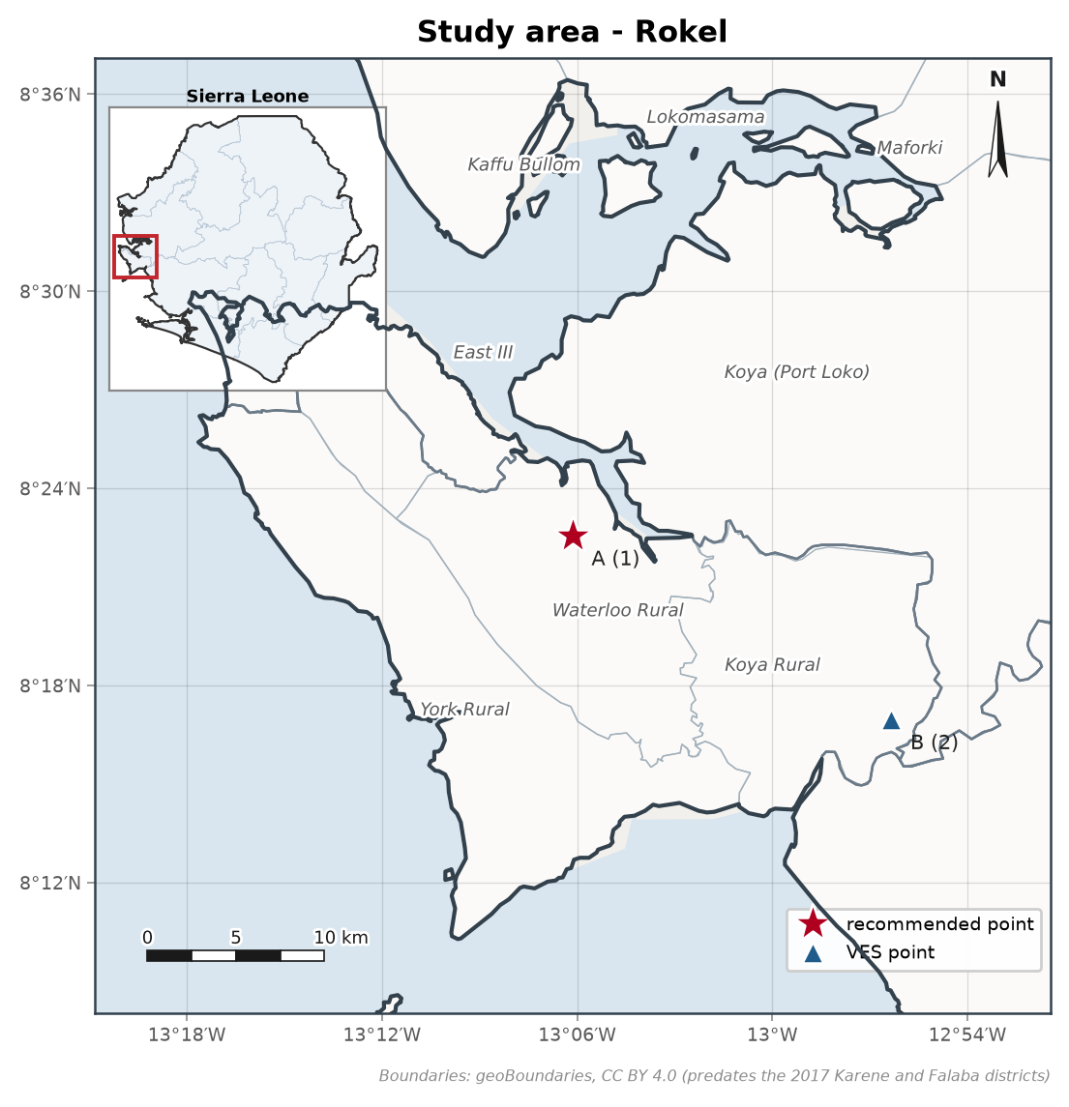
Figure 1. Study area at Rokel, with the survey points and its location in Sierra Leone inset. The star is the recommended drilling point, A (1). The survey points are up to 20.7 km apart, which is unusually far for one site; the positions should be checked against the field notes. Boundaries from geoBoundaries (CC BY 4.0).
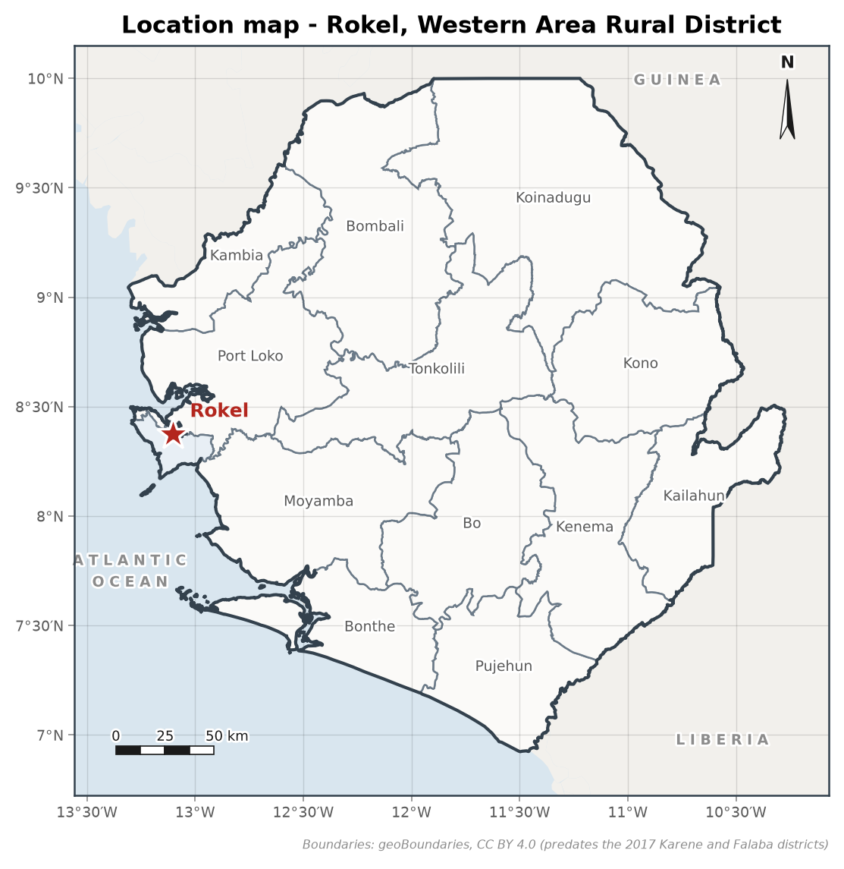
Figure 2. Location of Rokel. Boundaries from geoBoundaries (CC BY 4.0).
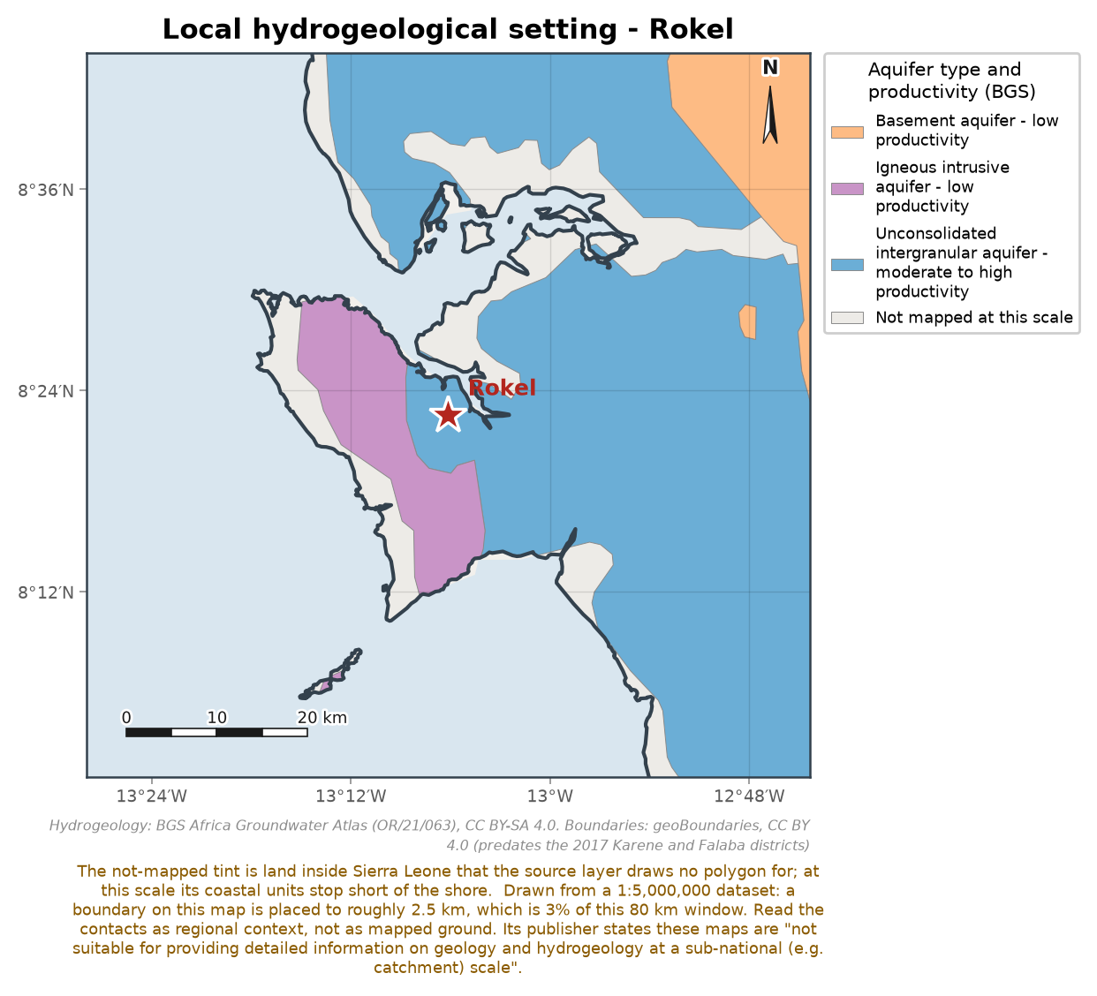
Figure 3. Aquifer type and productivity around the site, from the BGS Africa Groundwater Atlas country map (CC BY-SA 4.0).
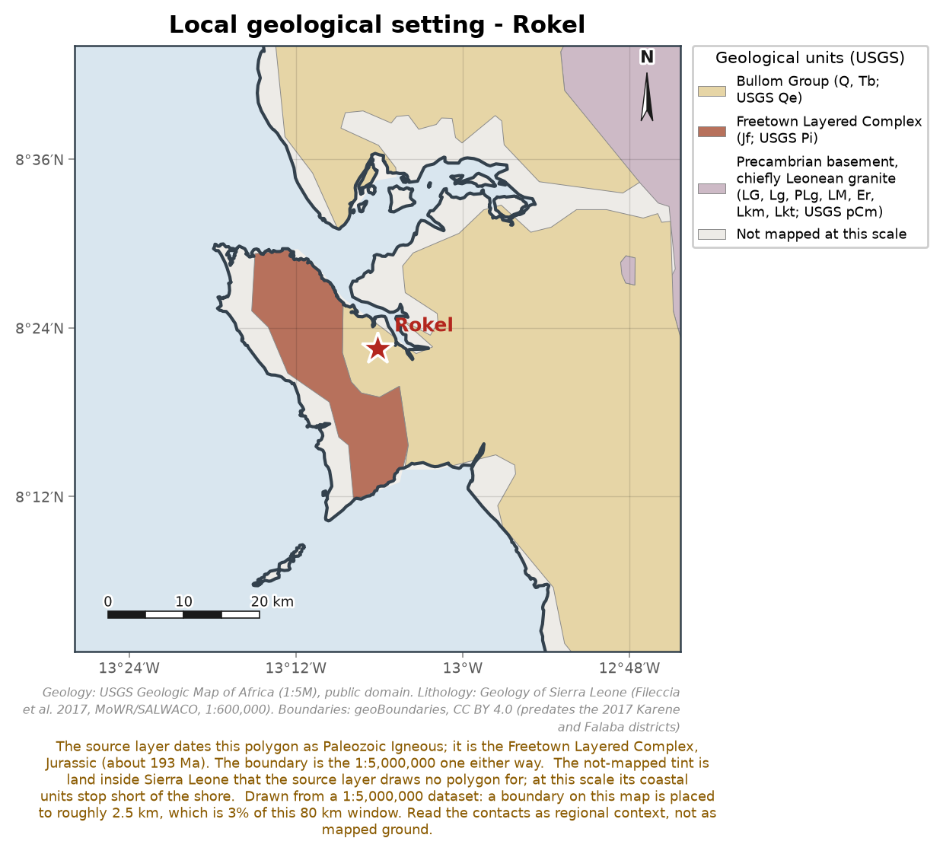
Figure 4. Geological setting around the site, from the USGS Geologic Map of Africa (1:5,000,000). The Geology of Sierra Leone map (Ministry of Water Resources/SALWACO, 2017) gives the detailed local formations.

3. Field Work

3.1 Reconnaissance Survey
No reconnaissance record (date or field observations) was supplied with the sounding data, so none is reported here. The sounding points were taken as recorded on the field sheets, dated 8th December, 2015.
The weathered zone over the bedrock and the fractured rock beneath it are the groundwater prospects in this ground, and the soundings below are interpreted for both.
No elevation model was supplied with this survey, so no topographic map is drawn: the toolkit bundles none and invents none. The elevations the crew recorded at the soundings are the ground levels this report has.
Sounding positions
2 soundings of 2 carry a recorded GPS position, marked on the study area map. How the points were chosen on the ground is not recorded on the field sheets; where a traverse or profiling was run, its notes belong in the reconnaissance record above.

3.2 Geophysical Survey
The geophysical survey consisted of electrical resistivity measurements, specifically vertical electrical sounding (VES) using the Syscal Junior instrument.

3.2.1 Vertical Electrical Sounding (VES)
2 vertical electrical soundings (A (1), B (2)) were recorded with the Schlumberger electrode configuration, to determine the formation resistivities and the depth to bedrock, and whether water bearing fractures or a saturated weathered zone are present at depth and how thick they are. No resistivity profiling record was supplied.

4. Data Analysis and Interpretation
Table 1 presents the Schlumberger array VES data recorded at point A (1), from which the sounding curve of apparent resistivity against half the current electrode spacing (AB/2) in Figure 5 is plotted.
Client | Living Water International | Community | Rokel
Project | Geophysical Survey | Sounding Number | A (1)
District | Western Area | GPS Coordinate East | 708958 m E (UTM zone 28N)
Date | 8th December, 2015 | GPS Coordinate North | 926355 m N
Field Supervisor |  | Elevation | 71 m

Table 1. Schlumberger array VES data at point A (1).
No. | AB/2 (m) | MN (m) | Apparent Resistivity (ohm-m)
1 | 1 | 0.4 | 1,165
2 | 2 | 0.4 | 1,193
3 | 3 | 0.4 | 1,303
4 | 3 | 0.8 | 1,317
5 | 4 | 0.8 | 1,502
6 | 5 | 0.8 | 1,500
7 | 7 | 0.8 | 1,432
8 | 10 | 0.8 | 1,392
9 | 10 | 1.5 | 961
10 | 15 | 1.5 | 715.5
11 | 20 | 1.5 | 732
12 | 30 | 1.5 | 162
13 | 40 | 1.5 | 156.1
14 | 40 | 7.6 | 78.7
15 | 50 | 7.6 | 52.1
16 | 70 | 7.6 | 55.8
17 | 70 | 14 | 53.2
18 | 80 | 14 | 47.9

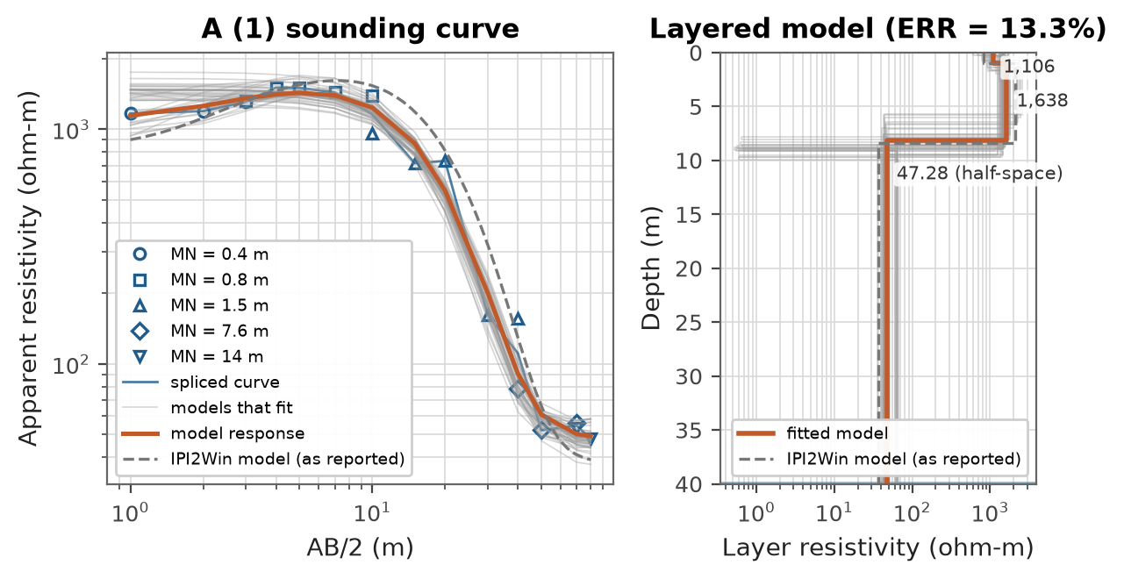
Figure 5. Schlumberger array VES curve and model at point A (1). The dashed line is the IPI2Win model (as reported). The model panel is drawn to the depth of investigation (40 m). The grey fan is 40 of the sampled models that fit. The shaded band on the model is the P10 to P90 of the depth the models that fit would be drilled to, before it is rounded up to the drilling step.
Table 2. Layered earth model at point A (1) (curve type K, ERR = 13.3%). z is the depth to the top of each layer. The (x/ factor) is the linearised 1-sigma uncertainty; a factor near 1 is well resolved and a large factor marks equivalence.
N | rho (ohm-m) | h (m) | z (m)
1 | 1,106 (x/ 1.3) | 1.02 (x/ 3.7) | 0
2 | 1,638 (x/ 1.2) | 7.08 (x/ 1.4) | 1.02
3 | 47.28 (x/ 1.1) | half-space | 8.1

Models tried: 2 layers, 15.4%; 3 layers, 13.3%; 4 layers, 13.1%. Of these none reaches the 10 percent target, and the 3-layer model is kept as the simplest within 15 percent of the best fit; the alternatives are equally admissible readings of the same curve.
The boundary at 1.02 m (x/ 3.7) is poorly resolved: within its uncertainty the model collapses to one with a layer fewer, so the layer count above is a reading of the curve rather than a property of it.
Basement not resolved in over 99 percent of the models that fit, within the 40 m the sounding resolves. Water-bearing weathered zone 31 to 33 m thick (P10 to P90), counted from 3 m down to the 40 m the sounding resolves. Drilling depth from the P90 of the models that fit: at least 40 m, cut back to the 40 m the sounding resolves. Basis: 4000 models of 3 layers sampled by Metropolis-Hastings in 4 chains, started from the best of 9 fits (the inversion's own and 8 from Latin hypercube starting models), with an error of 3 percent on each reading, plus the measured disagreement at the MN overlaps at AB/2 3, 10, 40 and 70 m; the errors were widened 5.1 times, to the misfit the best model reaches. The error model is provisional.
Table 3. The range of models at point A (1): P10, P50 and P90 of the models that fit, from the same sample as the sentences above.
 | P10 | P50 | P90
Water-bearing weathered zone (m) | 30.8 | 31.5 | 33
Resistivity of layer 1 (ohm-m) | 894 | 1,400 | 1,590
Resistivity of layer 2 (ohm-m) | 0.587 | 1,450 | 2,040
Resistivity of layer 3 (ohm-m) | 40.5 | 46.1 | 63.8
Base of layer 1 (m) | 0.315 | 5.25 | 8.9
Base of layer 2 (m) | 6.99 | 8.48 | 9.19

Table 4. IPI2Win model (as reported) at point A (1), reported ERR = 21.5%; on the readings tabled above this toolkit computes ERR = 35.8%.
N | rho (ohm-m) | h (m) | z (m)
1 | 832.1 | 1 | 0
2 | 2,103 | 7.37 | 1
3 | 36.71 | half-space | 8.37

Its reported misfit (21.5 percent) is not reproduced on these readings (35.8 percent): either the readings it was fitted to differ from the transcribed sheet, or the misfit was defined differently. Neither is settled here.
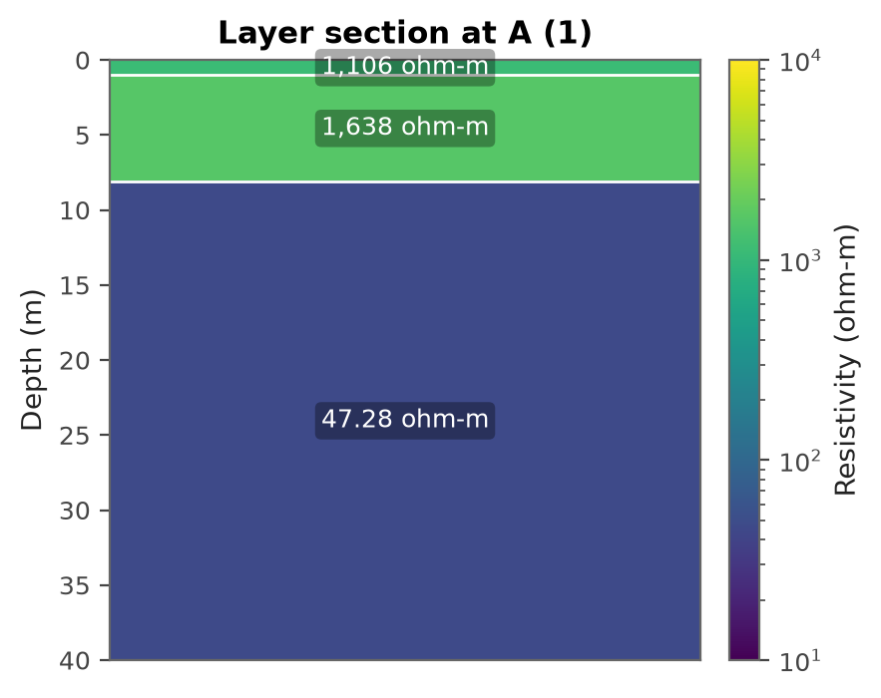
Figure 6. Interpreted one-dimensional layer section at point A (1): the resistivity and thickness of each fitted layer, drawn to the depth of investigation (40 m).
The data at A (1) are fitted with a 3 layer model (type K; a resistive layer between two more conductive layers, often dry laterite or duricrust over a conductive saprolite), though the boundary at 1.02 m is poorly resolved, so the layer count is uncertain. Layer 1 from 0 m to 1.02 m (1.02 m thick) has a resistivity of about 1,106 ohm-m and is interpreted as dry lateritic topsoil / duricrust. Layer 2 from 1.02 m to 8.1 m (7.08 m thick) has a resistivity of about 1,638 ohm-m and is interpreted as compact or dry weathered rock (regolith). Layer 3 below 8.1 m has a resistivity of about 47.28 ohm-m and is interpreted as weathered or fractured zone, potentially water bearing when saturated; its base is not resolved within the depth of investigation. The unusually low resistivity within the interpreted fractured or weathered intervals is indicative of pore electrolyte, possibly groundwater. The possible water zones are 8 m to at least 40 m. The base of the deepest zone is not resolved: the sounding sees to about 40 m, and the conductive ground continues below that. The model reproduces the readings to 13.3 percent (ERR), above the target, so the layer depths are approximate. The Dar-Zarrouk longitudinal conductance of the section is 0.00525 siemens and the transverse resistance is 12,700 ohm m2. The cover overlying the water bearing zone has a longitudinal conductance of 0.00525 siemens, indicating a poor protective capacity against surface contamination.

Table 5 presents the Schlumberger array VES data recorded at point B (2), from which the sounding curve of apparent resistivity against half the current electrode spacing (AB/2) in Figure 7 is plotted.
Client | Living Water International | Community | Rokel
Project | Geophysical Survey | Sounding Number | B (2)
District | Port Loko | GPS Coordinate East | 727012 m E (UTM zone 28N)
Date | 8th December, 2015 | GPS Coordinate North | 916125 m N
Field Supervisor |  | Elevation | 68 m

Table 5. Schlumberger array VES data at point B (2).
No. | AB/2 (m) | MN (m) | Apparent Resistivity (ohm-m)
1 | 1 | 0.4 | 995.7
2 | 2 | 0.4 | 984.2
3 | 3 | 0.4 | 965.4
4 | 3 | 0.8 | 1,081
5 | 4 | 0.8 | 1,298
6 | 5 | 0.8 | 1,366
7 | 7 | 0.8 | 1,209
8 | 10 | 0.8 | 1,307
9 | 10 | 1.5 | 891.8
10 | 15 | 1.5 | 739.6
11 | 20 | 1.5 | 329.1
12 | 30 | 1.5 | 140.1
13 | 40 | 1.5 | 147.9
14 | 40 | 7.6 | 96.3
15 | 50 | 7.6 | 34.1
16 | 70 | 7.6 | 90.3
17 | 70 | 14 | 55.2
18 | 80 | 14 | 51.4

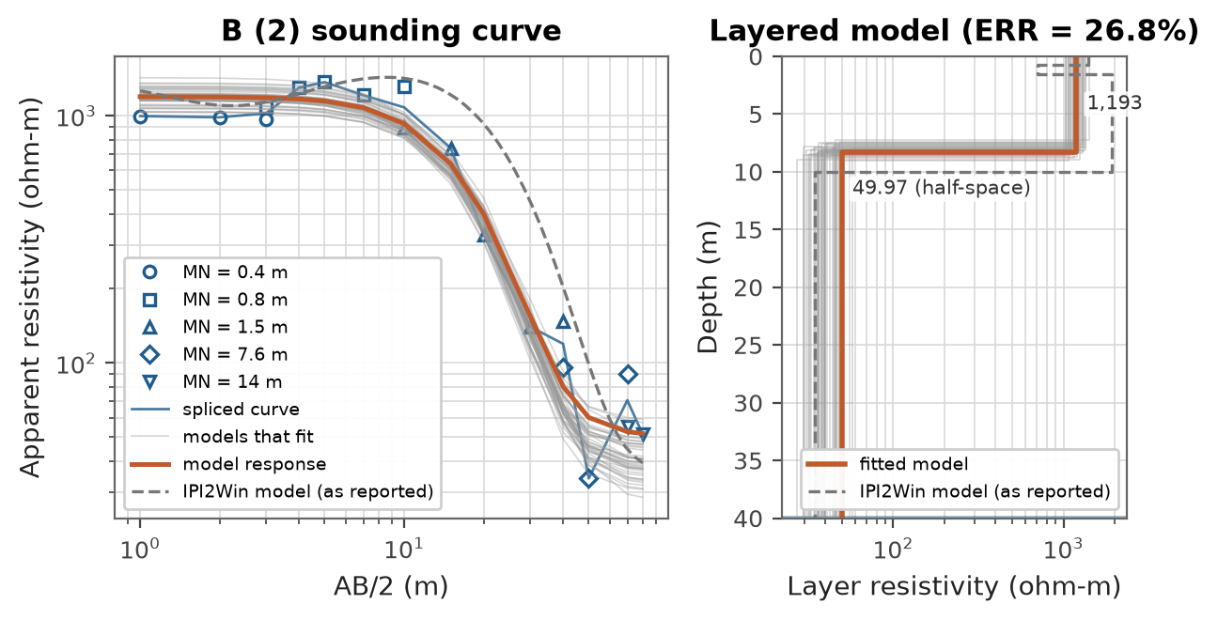
Figure 7. Schlumberger array VES curve and model at point B (2). The dashed line is the IPI2Win model (as reported). The model panel is drawn to the depth of investigation (40 m). The grey fan is 40 of the sampled models that fit. The shaded band on the model is the P10 to P90 of the depth the models that fit would be drilled to, before it is rounded up to the drilling step.
Table 6. Layered earth model at point B (2) (curve type 2-layer descending, ERR = 26.8%). z is the depth to the top of each layer. The (x/ factor) is the linearised 1-sigma uncertainty; a factor near 1 is well resolved and a large factor marks equivalence.
N | rho (ohm-m) | h (m) | z (m)
1 | 1,193 (x/ 1.1) | 8.28 (x/ 1.1) | 0
2 | 49.97 (x/ 1.2) | half-space | 8.28

Models tried: 2 layers, 26.8%; 3 layers, 23.7%; 4 layers, 24.9%. Of these none reaches the 10 percent target, and the 2-layer model is kept as the simplest within 15 percent of the best fit; the alternatives are equally admissible readings of the same curve.
Basement not resolved in 100 percent of the models that fit, within the 40 m the sounding resolves. Water-bearing weathered zone 31 to 33 m thick (P10 to P90), counted from 3 m down to the 40 m the sounding resolves. Drilling depth from the P90 of the models that fit: at least 40 m, cut back to the 40 m the sounding resolves. Basis: 4000 models of 2 layers sampled by Metropolis-Hastings in 4 chains, started from the best of 9 fits (the inversion's own and 8 from Latin hypercube starting models), with an error of 3 percent on each reading, plus the measured disagreement at the MN overlaps at AB/2 3, 10, 40 and 70 m; the errors were widened 7.3 times, to the misfit the best model reaches. The error model is provisional.
Table 7. The range of models at point B (2): P10, P50 and P90 of the models that fit, from the same sample as the sentences above.
 | P10 | P50 | P90
Water-bearing weathered zone (m) | 31.2 | 31.9 | 32.5
Resistivity of layer 1 (ohm-m) | 1,070 | 1,200 | 1,360
Resistivity of layer 2 (ohm-m) | 30.7 | 38.2 | 46.8
Base of layer 1 (m) | 7.46 | 8.07 | 8.83

Table 8. IPI2Win model (as reported) at point B (2), reported ERR = 26.5%; on the readings tabled above this toolkit computes ERR = 96.7%.
N | rho (ohm-m) | h (m) | z (m)
1 | 1,398 | 0.71 | 0
2 | 703 | 0.87 | 0.71
3 | 1,912 | 8.42 | 1.58
4 | 34.71 | half-space | 10

The reference interpretation has 4 layers where this one has 2. Its reported misfit (26.5 percent) is not reproduced on these readings (96.7 percent): either the readings it was fitted to differ from the transcribed sheet, or the misfit was defined differently. Neither is settled here.
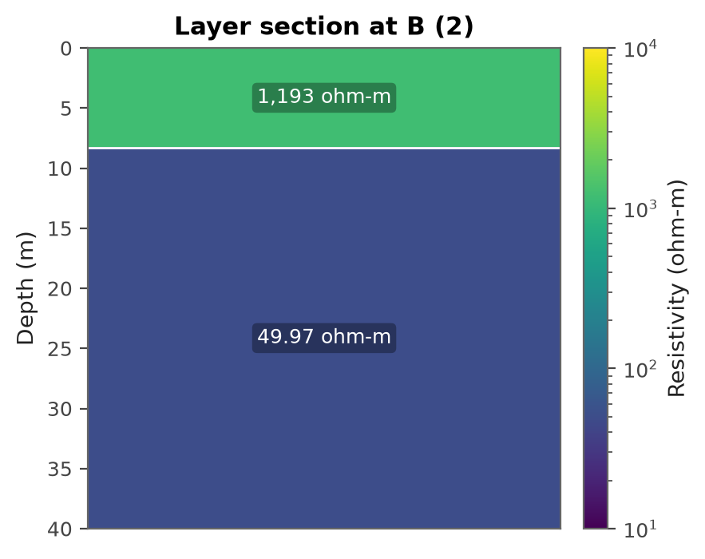
Figure 8. Interpreted one-dimensional layer section at point B (2): the resistivity and thickness of each fitted layer, drawn to the depth of investigation (40 m).
The data at B (2) resolves a 2 layer subsurface (a two layer response with resistivity decreasing at depth, consistent with weathered or fractured, possibly water bearing rock beneath a resistive surface layer). Layer 1 from 0 m to 8.28 m (8.28 m thick) has a resistivity of about 1,193 ohm-m and is interpreted as dry lateritic topsoil / duricrust. Layer 2 below 8.28 m has a resistivity of about 49.97 ohm-m and is interpreted as weathered or fractured zone, potentially water bearing when saturated; its base is not resolved within the depth of investigation. The unusually low resistivity within the interpreted fractured or weathered intervals is indicative of pore electrolyte, possibly groundwater. The possible water zones are 8 m to at least 40 m. The base of the deepest zone is not resolved: the sounding sees to about 40 m, and the conductive ground continues below that. The model reproduces the readings to 26.8 percent (ERR), well above the target: it does not describe the curve closely, and the layer depths are indicative only. The Dar-Zarrouk longitudinal conductance of the section is 0.00694 siemens and the transverse resistance is 9,880 ohm m2. The cover overlying the water bearing zone has a longitudinal conductance of 0.00694 siemens, indicating a poor protective capacity against surface contamination.

Table 9. List of VES points in order of preference for drilling. The resistivities are those of the fitted layers, not the apparent resistivities read in the field. A water zone marked + continues below the depth the sounding resolves, so its base and the drilling depth are minima.
No. | VES Point | Layer | Thickness (m) | Depth (m) | Layer resistivity (ohm-m) | Possible Water Zones (m) | Max Drilling Depth (m) | Ranking
1 | A (1) | 1  2  3 | 1.02  7.08 | 1.02  8.1 | 1,106  1,638  47.28 | 8-40+ | at least 40 m | 1st
2 | B (2) | 1  2 | 8.28 | 8.28 | 1,193  49.97 | 8-40+ | at least 40 m | 2nd

Drill-target suitability
Each surveyed point is given a transparent suitability score from 0 to 100. The score combines the interpreted water-bearing thickness, how well the resistivity of the water zone sits within the productive fractured or weathered window, the overburden profile, and the presence of a fractured zone at the basement contact. The scores rank the points as drilling targets.
Table 10. Drill-target suitability of the surveyed points. Suitability is the geological score; confidence discounts it for a model fit above the target and for a water-bearing zone whose base the sounding never reached; the points are ranked on the weighted figure.
Rank | VES point | Suitability (0 to 100) | Confidence | Weighted | Grade
1 | A (1) | 67.7 | 0.71 | 47.9 | Good
2 | B (2) | 68.2 | 0.42 | 29.0 | Good

Point A (1) ranks first (suitability 68 out of 100, good, confidence 0.71) and is the recommended drilling target. Driven by at least 32 m of interpreted water-bearing thickness, the base of the zone being below the depth the sounding resolves (thick); resistivities near the edge of the productive window. Confidence 0.71: a model fit of 13.3 percent (ERR) and a basement the sounding did not reach discount the score before ranking.

Chance of a working borehole
Beside the suitability score, each point is given the chance that a borehole there yields enough for a handpump through the dry season: a prior for the ground under it, from published yields, multiplied by a factor for each thing the survey found. The table under each point shows how far each factor moved it. Every figure here is provisional. Success means a yield of at least 1 m3/h (0.28 L/s) at the dry-season water level, the handpump design rate in the configuration. Basis: the prior from success_prior.csv and the likelihood ratios from success_evidence.yaml; calibration: the toolkit's provisional default from PLAN.md step 3.3, adopted by no named person and not calibrated against drilled outcomes. The band is the 10th to 90th percentile of a Beta prior with the table's effective sample size, carried through the same factors; the factors themselves are provisional choices. The suitability score is kept beside these odds for comparison.
Point A (1). About 96 percent (between 88 and over 99) that a borehole here yields enough for a handpump through the dry season. Provisional prior. The prior is 97 percent (between 90 and over 99), for the BGS class U-M/H on the USGS unit Qe: BGS Moderate to High productivity, the span 2 to 20 L/s (O Dochartaigh 2021, Tables 3 and 4). No cited source separates the Holocene unit within the class, so the class's yields apply. The yields say nothing of salinity near the coast. Read as the quartiles of a lognormal spread, 2 and 20 L/s put 97 percent of boreholes at or above 0.28 L/s. It is held as firmly as 10 boreholes would hold it, and has not been calibrated against boreholes drilled here.
Table 11. How the survey moved the chance of a working borehole at point A (1). Each factor multiplies the odds; together they multiply the prior odds to the odds the headline gives.
Evidence | What the survey found | Factor on the odds | Chance after (percent)
Prior | the BGS class U-M/H on the USGS unit Qe |  | 97
Depth to basement (P50) | no depth quoted, too few models find basement | 1.00 | 97
Basement resolved | no basement in over 99 percent of the models: not resolved | 0.80 | 96
Water-zone resistivity | 47 ohm-m: clayey | 0.90 | 95
Confidence of the fit | 13.3 percent: poor, the survey evidence weighted 0.6 | 1.14 | 96

Point B (2). About 96 percent (between 89 and over 99) that a borehole here yields enough for a handpump through the dry season. Provisional prior. The prior is 97 percent (between 90 and over 99), for the BGS class U-M/H on the USGS unit Qe: BGS Moderate to High productivity, the span 2 to 20 L/s (O Dochartaigh 2021, Tables 3 and 4). No cited source separates the Holocene unit within the class, so the class's yields apply. The yields say nothing of salinity near the coast. Read as the quartiles of a lognormal spread, 2 and 20 L/s put 97 percent of boreholes at or above 0.28 L/s. It is held as firmly as 10 boreholes would hold it, and has not been calibrated against boreholes drilled here.
Table 12. How the survey moved the chance of a working borehole at point B (2). Each factor multiplies the odds; together they multiply the prior odds to the odds the headline gives.
Evidence | What the survey found | Factor on the odds | Chance after (percent)
Prior | the BGS class U-M/H on the USGS unit Qe |  | 97
Depth to basement (P50) | no depth quoted, too few models find basement | 1.00 | 97
Basement resolved | no basement in 100 percent of the models: not resolved | 0.80 | 96
Water-zone resistivity | 50 ohm-m: clayey | 0.90 | 95
Confidence of the fit | 26.8 percent: unreliable, the survey evidence weighted 0.3 | 1.26 | 96

The value of one more measurement
Before the rig is called, one more sounding beside the first-ranked point, or a profiling line through it, can change where to drill. Each is worth what it is expected to save that decision, over everything it might read: the expected cost of the best choice now, less the expected cost of the best choice once its reading is known. The value of one more measurement is worked out once the cost of a borehole has been estimated, because it depends on what a dry attempt costs.
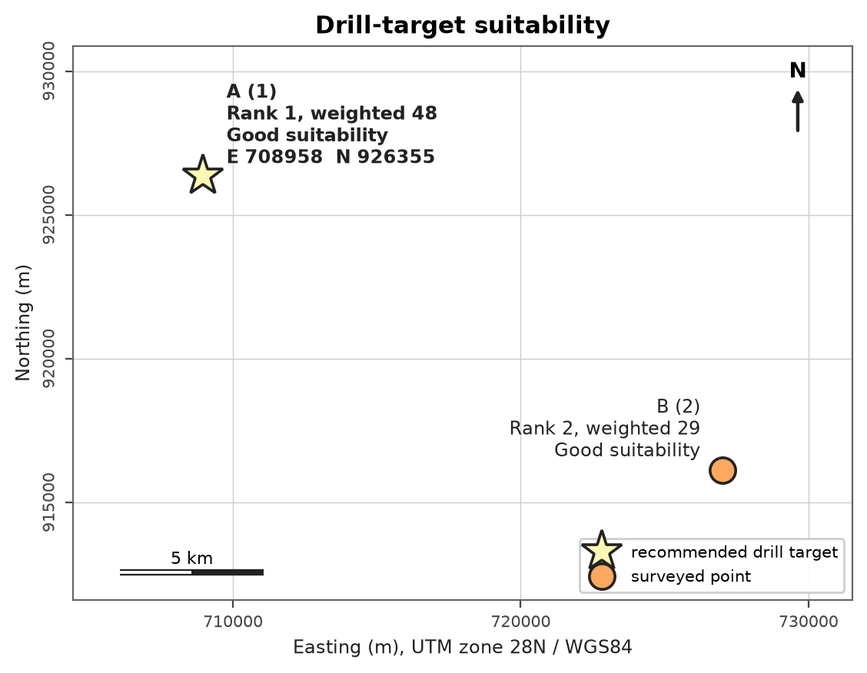
Figure 9. Drill-target suitability of the surveyed points, coloured by the confidence-weighted score; greener is more suitable. Each point is labelled with its rank and weighted score, and, where the map has room, with the grade of its suitability before the confidence discount, as in the table above. The star is the recommended target, A (1), with its grid coordinates.

Subsurface maps from the survey
The maps in this section are drawn from the soundings themselves rather than from a national dataset, so they carry the survey's own resolution.
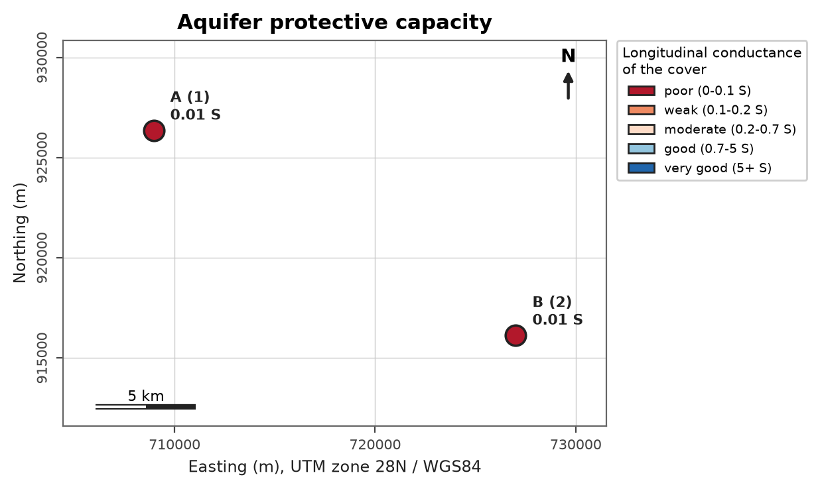
Figure 10. Protective capacity of the cover over the aquifer, from the longitudinal conductance of the overlying layers. It rates how well the ground above the aquifer resists downward contamination; it says nothing about yield. With fewer than three soundings no surface is drawn; each point is coloured by its class.
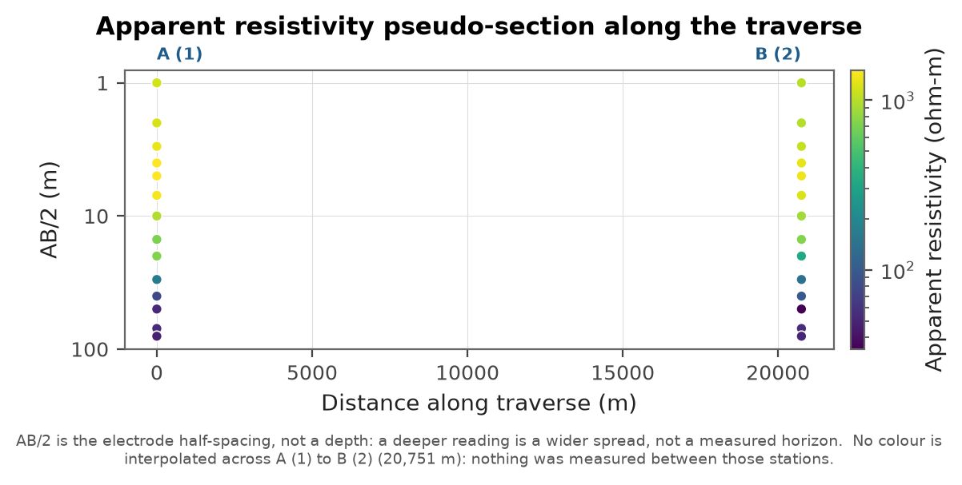
Figure 11. Apparent resistivity along the traverse, as measured. Unlike every other section in this report it involves no inversion: each point is a reading at the station and electrode spacing it was taken with. AB/2 is that spacing, not a depth. Colour is interpolated only between stations within reach of each other.
Not drawn from this survey, and why:
- Ground profile: the levelled stations are 20,751 m apart, about 519 times the 40 m the soundings resolve; a ground line between them would be a straight slope across ground nobody levelled, so none is drawn.
- Depth to bedrock map: a depth to bedrock map needs at least 3 soundings that carry both a position and the value; 0 do. 2 of 2 positioned soundings did not reach basement within the depth they resolve, so they have no depth to bedrock.
- Aquifer thickness map: an aquifer thickness map needs at least 3 soundings that carry both a position and the value; 2 do.
- Bedrock elevation map: a bedrock elevation map needs at least 3 soundings that carry both a position and the value; 0 do. 2 of 2 positioned soundings did not reach basement within the depth they resolve, so they have no bedrock elevation.
- Geoelectric section: the soundings are 20,751 m apart, about 519 times the 40 m they resolve; a section between them would join two measurements with no measurement between, so none is drawn. A section needs stations within a few times the depth of investigation of each other.

5. Conclusions and Recommendations
Conclusions:
- The project area is part of the Freetown Basic Complex lithological formation.
- Groundwater potential (quality and quantity) could be favourable at depth within weathered zones and fractured bedrock.
- The potential water zones at point A (1) are found from 8 m to at least 40 m. The base of the deepest zone lies below the depth the sounding resolves.
- The potential water zones at point B (2) are found from 8 m to at least 40 m. The base of the deepest zone lies below the depth the sounding resolves.
- Point A (1) is selected as the preferred point for drilling according to the results and data analysis.
- It is premature to estimate quantities, which can only be determined during test drilling and test pumping.
- The borehole locations were selected within both national and international borehole siting guidelines.
Recommendations:
- Drilling should be carried out at the selected point A (1) to confirm the existence of groundwater.
- Point B (2) is an optional drilling point.
- The drilling depth should be at least 40 m at point A (1); at least 40 m at point B (2), to cut across the probable water zones. Where the depth is a minimum, the water-bearing zone continues below what the survey resolves: drill on while the formation is water bearing, guided by the strikes and the penetration rate, and stop in fresh rock.
- The borehole must be constructed using correct and standard materials such as standard uPVC screens and plain casings and well sorted gravel pack.
- Both physico-chemical and bacteriological tests should be carried out on water samples from the completed well.

6. Limitations and Uncertainty
- The fitted models reproduce the measured apparent resistivities to within 26.8 percent (ERR); a larger misfit means a less certain model. The target is 10 percent, and A (1), B (2) do not reach it: the layer depths there are indicative, and the ranking discounts them for it.
- Resistivity models are not unique: different layered models can fit the same sounding curve almost equally well (the equivalence and suppression problem), so the interpreted layer depths and thicknesses carry an uncertainty of the order of plus or minus 20 percent.
- A low resistivity layer can represent either a saturated, water bearing zone or a conductive clay; the interpretation is made from the geological context and must be confirmed by drilling.
- A Schlumberger sounding resolves the ground to roughly half its largest AB/2, not to the spacing itself: with AB/2 expanded to 80 m the depth of investigation here is about 40 m, and any structure below it is not resolved. A layer that continues to that depth has no base in these data.
- The survey indicates groundwater potential only. The actual yield and water quality can be confirmed only by test drilling, test pumping and laboratory analysis.

Annex A. Data Verification Notes
The following checks were raised automatically during data processing and should be verified against the field notes.
- [WARNING] district_coordinate_conflict (B (2)): Stated district 'Port Loko' does not contain the coordinates (8.2826 N, 12.9390 W), which fall in Koya Rural chiefdom, Western Area Rural district. Verify against the field notes.
- [WARNING] inconsistent_district: Different district values within one project: 'Western Area' on A (1); 'Port Loko' on B (2). This usually comes from copying the previous sheet.
- [WARNING] points_far_apart: A (1) and B (2) are 20.7 km apart, which is unusually far for one site; check the coordinates.
- [WARNING] segment_overlap_discrepancy (A (1)): At an MN change the two readings at one AB/2 should agree within a few percent; these differ by more than 20 percent: AB/2 10 m: 1392 and 961 ohm-m (ratio 1.45); AB/2 40 m: 156.1 and 78.7 ohm-m (ratio 1.98). That is a field problem (potential-electrode contact, lateral inhomogeneity at the new MN) or a transcription slip, and the inversion merges the pair by geometric mean, so part of the model misfit is made by the splice. Check the sheet before relying on the deep branch.
- [WARNING] segment_overlap_discrepancy (B (2)): At an MN change the two readings at one AB/2 should agree within a few percent; these differ by more than 20 percent: AB/2 10 m: 1307 and 891.8 ohm-m (ratio 1.47); AB/2 40 m: 147.9 and 96.3 ohm-m (ratio 1.54); AB/2 70 m: 90.3 and 55.2 ohm-m (ratio 1.64). That is a field problem (potential-electrode contact, lateral inhomogeneity at the new MN) or a transcription slip, and the inversion merges the pair by geometric mean, so part of the model misfit is made by the splice. Check the sheet before relying on the deep branch.

References
Ministry of Water Resources and SALWACO (2017). Geology of Sierra Leone. Freetown.
United States Geological Survey (1997). Geologic Map of Africa, Open-File Report 97-470A. Public domain, 1:5,000,000.
British Geological Survey. 2019/2021. Africa Groundwater Atlas Country Hydrogeology Maps. Africa Groundwater Atlas (https://www2.bgs.ac.uk/africagroundwateratlas/index.cfm). Licensed CC BY-SA 4.0.
Ó Dochartaigh, B. (2021). User Guide Version 1.2: Africa Groundwater Atlas Country Hydrogeology Maps. British Geological Survey Open Report OR/21/063.
Runfola, D. et al. (2020). geoBoundaries: A global database of political administrative boundaries. PLoS ONE, 15(4). Licensed CC BY 4.0.
Niwas, S. and Singhal, D.C. (1981). Estimation of aquifer transmissivity from Dar-Zarrouk parameters in porous media. Journal of Hydrology, 50, 393-399.
Rural Water Supply Network (2015). Professional Water Well Drilling: A UNICEF Guidance Note. St Gallen: RWSN / UNICEF.

Glossary and Abbreviations
Term | Meaning
VES | Vertical electrical sounding, a resistivity depth survey
AB/2 | Half the current-electrode spacing in a Schlumberger array
ohm-m | Ohm-metre, the unit of electrical resistivity
ERR | Root-mean-square misfit of the fitted layered model (percent)
S (Dar-Zarrouk) | Longitudinal conductance, sum of thickness/resistivity (siemens)
T (Dar-Zarrouk) | Transverse resistance, sum of thickness x resistivity (ohm m2)
SWL | Static water level, the rest water level before pumping
DWL | Dynamic water level, the water level during pumping
T (transmissivity) | Aquifer transmissivity (m2/day)
S (storativity) | Aquifer storage coefficient (dimensionless)
m3/h | Cubic metres per hour, a discharge or yield rate
LSI / RSI | Langelier and Ryznar indices of water corrosivity and scaling
WQI | Water Quality Index, an aggregate 0-based quality score
HI | Health Hazard Index, the sum of chronic hazard quotients
uPVC | Unplasticised polyvinyl chloride, the casing and screen material
GPS / UTM | Satellite positioning and the Universal Transverse Mercator grid
WASH | Water, sanitation and hygiene
RWSN | Rural Water Supply Network
SALWACO | Sierra Leone Water Company
WHO | World Health Organization
SLSB | Sierra Leone Standards Bureau

REPORT SUBMITTED BY:

..............................

Geologist / Field Supervisor

