BOREHOLE DRILLING AND
PUMP TEST REPORT
for Dr. Timbo's Residence

Submitted to: Dr. Timbo
Contractor: WiNGiN Heavy Duty Machines Co. Ltd
Borehole Ref. No.: BH-1
Completion date: 13th May, 2018
Status: Successful

Table of Contents
Right-click and choose Update Field to fill the table of contents.

1. Introduction
Groundwater can be abstracted from the ground in different ways, and the choice of abstraction method depends on the resources available and the local conditions. Borehole drilling was the recommended abstraction method for this project at Dr. Timbo's Residence, and the work was executed as per the specifications. Details of the activities are presented in this report.

2. Methodology
The methodology adopted included reconnaissance, observation of the geological and hydrogeological conditions, assessment of existing boreholes and hand dug wells, drilling, construction, development and test pumping of the borehole.

3. Drilling
The drilling work included the following:
- Mobilisation of the drill rig and all necessary equipment.
- Drilling through all formations for completion of the borehole using the Air rotary (DTH hammer) method.
- Supply and installation of casings (plain and screen).
- Gravel packing of the annulus.
- Development of the borehole by surging with compressed air and airlifting.
- Demobilisation.
Contractor | WiNGiN Heavy Duty Machines Co. Ltd | Client | Dr. Timbo
Location | Dr. Timbo's Residence | Depth of borehole | 70 m
Start date | 11th May, 2018 | Completion date | 13th May, 2018
Drilling method | Air rotary (DTH hammer) | BH status | Successful

4. Borehole Log Data
Table 1. Drilling record and formation log.
Depth (m) | Interval (m) | From | To | Penetration rate (m/min) | Sample description | Diameter
0-5 | 5 | 13:30 | 13:35 | 1 | Reddish brown lateritic topsoil | 6.5"
5-10 | 5 | 13:36 | 13:41 | 1 | Light yellow clayey laterites | 6.5"
10-15 | 5 | 13:55 | 14:10 | 0.33 | Light yellow clayey laterites, wet from 12 m | 6.5"
15-20 | 5 | 14:14 | 14:26 | 0.42 | Clayey saprolite with weathered granite fragments | 6.5"
20-25 | 5 | 14:30 | 14:38 | 0.63 | Saprolite, decreasing clay content | 6.5"
25-30 | 5 | 15:15 | 15:23 | 0.63 | Weathered light colour granite, fractured | 6.5"
30-35 | 5 | 15:25 | 15:34 | 0.56 | Light colour granite, slightly weathered, fractured | 6.5"
35-40 | 5 | 15:38 | 15:48 | 0.5 | Light colour granite, slightly weathered | 6.5"
40-45 | 5 | 15:50 | 16:01 | 0.45 | Light colour granite | 6.5"
45-50 | 5 | 16:03 | 16:13 | 0.5 | Light colour granite, fracture zone 49-52 m | 6.5"
50-55 | 5 | 16:15 | 16:17 |  | Light colour granite | 6.5"
55-60 | 5 | 16:18 | 16:20 |  | Light colour granite, fracture zone 60-62 m | 6.5"
60-65 | 5 | 16:27 | 16:31 |  | Light colour granite | 6.5"
65-70 | 5 | 16:56 | 17:00 |  | Light colour granite, fresh | 6.5"

First water strike: 12 m
Second water strike: 30 m
Grouting: 20 m

5. Borehole Construction
Table 2. Construction summary.
Item | Detail
Total depth | 70 m
Drilled diameter | 6.5"
Casing | 5" uPVC, stick-up 0.5 m
Screens | 14-17 m; 25-35 m; 45-50 m; 55-60 m (slot 0.75 mm)
Gravel pack | 12-70 m
Backfill | 3-12 m
Sanitary seal | 0-3 m cement grout
Static water level | 9.44 m
Water strikes | 12 m, 30 m
Recommended pump intake | 40 m

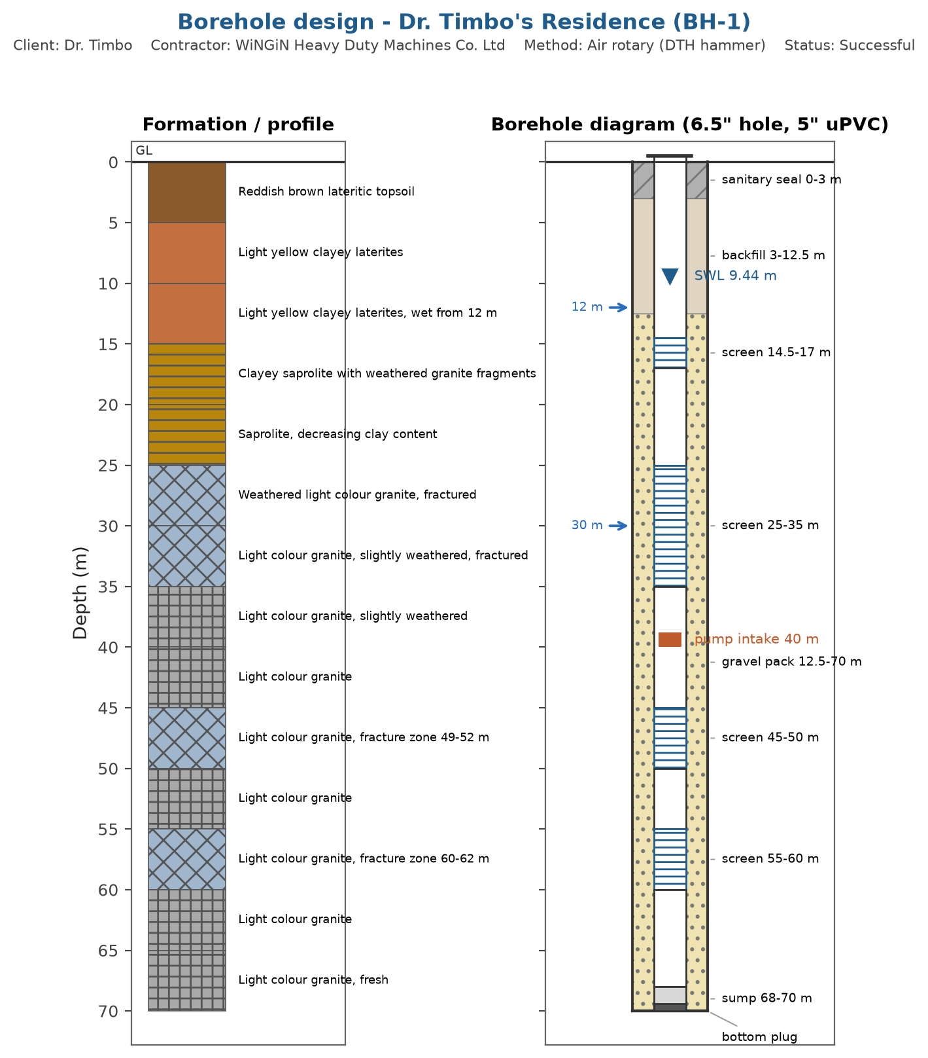
Figure 1. As-built borehole design with lithology and construction columns.
Design basis:
- screens positioned against the water strikes recorded in the drilling log (12 m, 30 m)
- 5 inch uPVC casing in a 6.5 inch hole
- gravel pack (well sorted siliceous gravel, 2-4 mm) from 12 m to the bottom, 2 m above the top screen
- cement sanitary seal from surface to 3 m with concrete apron with drainage channel and soakaway
- screens kept at least 5 m below the static water level

6. Borehole Development Record
The borehole was developed by surging with compressed air and air lifting for a total of two hours.
Table 3. Borehole development by air lifting.
From | To | Estimated yield (m3/h) | Observation
17:00 | 17:17 |  | Muddy water flushed out
17:17 | 17:47 | 2.5 | Cloudy water flushed out
17:48 | 18:00 |  | Clean water flushed out

7. Pumping Test
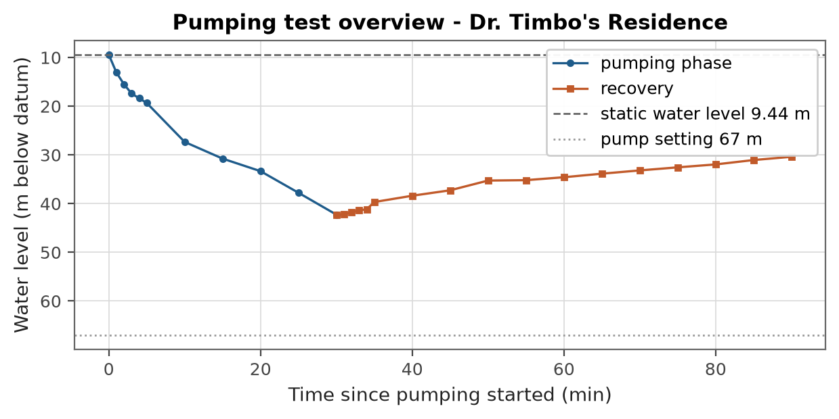
Figure 2. Constant discharge test and recovery record.
Table 4. Pumping test summary.
Item | Value
Test type | constant+recovery
Duration | 30 min
Discharge | 2.93 m3/h
Static water level | 9.44 m
Maximum drawdown | 32.8 m
Transmissivity | 1.4 m2/day
Specific capacity | 0.0893 m3/h per m

8. Borehole Characteristics and Installation
Borehole depth | 70 m | Borehole diameter | 6.5"
Static water level | 9.44 m | Dynamic water level | 42.3 m
Drawdown | 32.8 m | Flow rate | 2,930 L/h
Pump type | Submersible pump | Installation depth | 40 m

9. Water Quality Summary
The water does not meet the health based guideline value(s) for: Manganese. Treatment or an alternative source is required before the water is used for drinking.
Table 5. Parameters above guideline or standard limits.
Parameter | Value | Unit | Limit | Remark
Manganese | 0.12 | mg/L | 0.08 | exceeds the WHO health based guideline (0.08)
pH | 5.9 | pH units | 6.5-8.5 | exceeds the national standard limit (6.5-8.5)
Iron | 0.85 | mg/L | 0.3 | exceeds the national standard limit (0.3)
Total coliforms | 4 | CFU/100 mL | 0 | exceeds the national standard limit (0)

10. Recommendations and Conclusions
- The borehole is successful and sustainable when operated as recommended.
- The recommended abstraction rate is 1.01 m3/h (safety factor 1.5 applied to the long term yield).
- The pump installation depth is 40 m.
- The pump should rest for at least one hour in every pumping cycle and the pumping water level should be checked routinely.
- Water treatment is required before drinking; see the water quality assessment.
REPORT SUBMITTED BY:

..............................
A. N. Manager
Technical Manager
WiNGiN Heavy Duty Machines Co. Ltd

