PROJECT HANDOVER REPORT
Borehole Water Supply
at Dr. Timbo's Residence, Western Area Rural District

Client: Dr. Timbo
Project:
Contractor: WiNGiN Heavy Duty Machines Co. Ltd
Date:

Table of Contents
Right-click and choose Update Field to fill the table of contents.

1. Project Summary
Community | Dr. Timbo's Residence | Chiefdom
District | Western Area Rural | Client | Dr. Timbo
Contractor | WiNGiN Heavy Duty Machines Co. Ltd | Project reference
GPS East |  | GPS North
Latitude / Longitude |  | Elevation

2. Works Completed
- Geophysical siting survey and borehole location selection.
- Drilling of the borehole to 70 m by Air rotary (DTH hammer).
- Construction with 5 inch uPVC casing and screens, gravel pack and sanitary seal.
- Development of the borehole by air lifting until clear.
- Pumping test and yield assessment.
- Water quality sampling and laboratory analysis.
- Wellhead completion with apron and drainage.

3. Borehole Data Sheet
Table 1. Key borehole data.
Item | Value
Borehole reference | BH-1
Total depth | 70 m
Drilling method | Air rotary (DTH hammer)
Water strikes | 12 m, 30 m
Completion date | 13th May, 2018
Status | Successful
Total depth | 70 m
Drilled diameter | 6.5"
Casing | 5" uPVC, stick-up 0.5 m
Screens | 14-17 m; 25-35 m; 45-50 m; 55-60 m (slot 0.75 mm)
Gravel pack | 12-70 m
Backfill | 3-12 m
Sanitary seal | 0-3 m cement grout
Static water level | 9.44 m
Water strikes | 12 m, 30 m
Recommended pump intake | 40 m
Transmissivity | 1.4 m2/day
Safe yield (safety factor 1.5) | 1.01 m3/h
Pump installation depth | 40 m
Pump type | Submersible pump

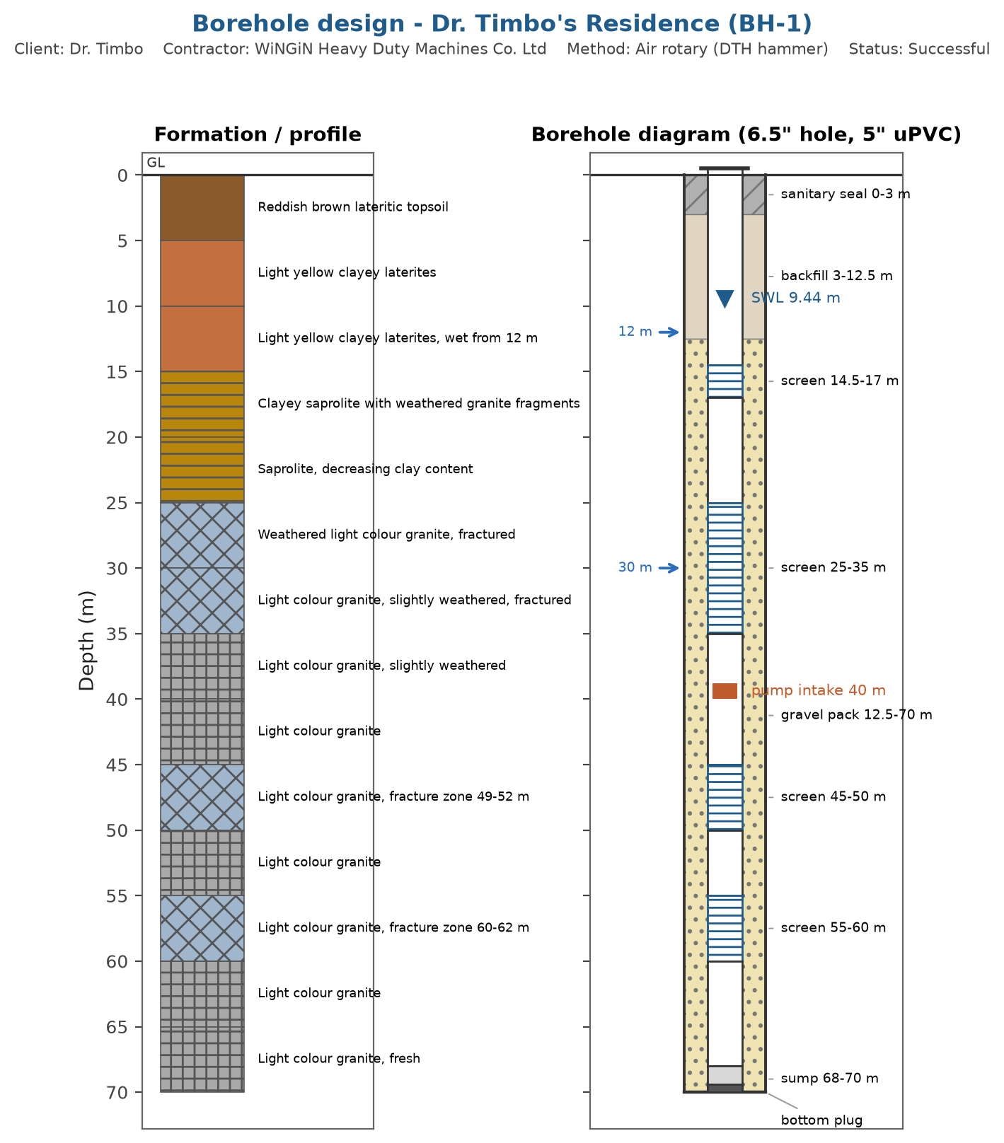
Figure 1. As-built borehole diagram.

4. Water Quality
The water does not meet the health based guideline value(s) for: Manganese. Treatment or an alternative source is required before the water is used for drinking.
Table 2. Parameters above guideline or standard limits.
Parameter | Value | Unit | Remark
Manganese | 0.12 | mg/L | exceeds the WHO health based guideline (0.08)
pH | 5.9 | pH units | exceeds the national standard limit (6.5-8.5)
Iron | 0.85 | mg/L | exceeds the national standard limit (0.3)
Total coliforms | 4 | CFU/100 mL | exceeds the national standard limit (0)

5. Operation and Maintenance Guidance
The lifetime of the borehole depends on routine care. The tasks below follow standard rural water supply practice; the community should keep a logbook of all maintenance, breakdowns and payments.
Daily
- Keep the apron and surroundings clean; no washing or animal watering on the apron.
- Check for leaks, unusual pump noise and discoloured water.
- Keep the drainage channel and soakaway free flowing.
Weekly
- Tighten loose bolts on the pump head and inspect the apron for cracks.
- Record the approximate hours of use or strokes per day.
Monthly
- Measure and record the water level where a dip access exists.
- Collect the agreed user fees and update the cash book.
- Inspect the fence and the sanitary protection zone (no pit latrine, refuse pit or animal pen within 30 m).
Yearly
- Service the pump according to the manufacturer schedule and replace fast wearing parts.
- Repeat the physico-chemical and bacteriological water tests.
- Review the tariff against the cost of spare parts.
Operate the pump at no more than 1.01 m3/h and allow the recommended rest periods. If the water level reaches the pump intake, stop pumping and let the borehole recover.

6. Community / WASH Committee
Table 3. WASH committee members responsible for the water point.
Role | Name | Phone
Chairperson | To be completed
Secretary | To be completed
Treasurer | To be completed
Caretaker | To be completed

7. Recommendations
- Implement the treatment measures in the water quality report before the water is used for drinking.
- Protect the wellhead: keep the 30 m sanitary zone free of latrines, refuse pits and animal pens.
- Keep this report and the borehole data sheet with the committee records; any future contractor will need them.
- Report persistent taste, odour or discolouration to the district water office and arrange a water quality test.

8. Handover Signatures
The works described above are handed over to the client and the community in working condition.

..............................
For the contractor: WiNGiN Heavy Duty Machines Co. Ltd
Date: ........................

..............................
For the client: Dr. Timbo
Date: ........................

..............................
For the community / WASH committee:
Date: ........................

