WATER QUALITY REPORT
Borehole water assessment at Dr. Timbo's Residence, Western Area Rural District

Client: Dr. Timbo
Sample ID: WQ-BH1-01
Borehole: BH-1
Sample date: 20th May, 2018
Laboratory: Example Laboratory, Freetown

1. Sample Details
Community | Dr. Timbo's Residence | Client | Dr. Timbo
Sample ID | WQ-BH1-01 | Borehole Ref. No. | BH-1
Sample date | 20th May, 2018 | Laboratory | Example Laboratory, Freetown
District | Western Area Rural | Project | Borehole completion

Results are compared against the WHO Guidelines for Drinking-water Quality (fourth edition with addenda) and the national standard limits configured for this project. Values reported by the laboratory as below the detection limit are shown as such.

2. Results Against Guideline Values
Table 1 lists every parameter tested. Exceedances are highlighted in the status column.
Table 1. Laboratory results against guideline values.
Parameter | Value | Unit | WHO health | WHO acceptability | National | Status
pH | 5.9 | pH units |  | 6.5-8.5 | 6.5-8.5 | Exceeds national limit
Electrical conductivity | 185 | uS/cm |  |  | 2500 | Complies
TDS | 120 | mg/L |  | 1000 | 1000 | Complies
Turbidity | 3.2 | NTU |  | 5 | 5 | Complies
Temperature | 27.4 | deg C |  |  |  | No guideline value
Total hardness | 58 | mg/L as CaCO3 |  | 500 | 500 | Complies
Alkalinity | 46 | mg/L as CaCO3 |  |  |  | No guideline value
Calcium | 14.2 | mg/L |  |  |  | No guideline value
Magnesium | 5.5 | mg/L |  |  |  | No guideline value
Sodium | 12.6 | mg/L |  | 200 | 200 | Complies
Potassium | 2.1 | mg/L |  |  |  | No guideline value
Bicarbonate | 56 | mg/L |  |  |  | No guideline value
Chloride | 18.4 | mg/L |  | 250 | 250 | Complies
Sulfate | 6.8 | mg/L |  | 250 | 250 | Complies
Nitrate (as NO3) | 8.2 | mg/L | 50 |  | 50 | Complies
Nitrite (as NO2) | < DL | mg/L | 3 |  | 3 | Below detection
Ammonia (as N) | 0.12 | mg/L |  | 1.5 | 1.5 | Complies
Fluoride | 0.22 | mg/L | 1.5 |  | 1.5 | Complies
Iron | 0.85 | mg/L |  | 0.3 | 0.3 | Exceeds national limit
Manganese | 0.12 | mg/L | 0.08 | 0.1 | 0.08 | EXCEEDS HEALTH GUIDELINE
Arsenic | < DL | mg/L | 0.01 |  | 0.01 | Below detection
Lead | < DL | mg/L | 0.01 |  | 0.01 | Below detection
Copper | 0.02 | mg/L | 2 | 1 | 2 | Complies
Zinc | 0.11 | mg/L |  | 3 | 3 | Complies
Chromium (total) | < DL | mg/L | 0.05 |  | 0.05 | Below detection
Cadmium | < DL | mg/L | 0.003 |  | 0.003 | Below detection
E. coli | 0 | CFU/100 mL | 0 |  | 0 | Complies
Total coliforms | 4 | CFU/100 mL |  | 0 | 0 | Exceeds national limit

The water does not meet the health based guideline value(s) for: Manganese. Treatment or an alternative source is required before the water is used for drinking.

3. Ionic Balance Check
Sum of cations 1.8 meq/L, sum of anions 1.72 meq/L, charge balance error +2.1 percent. The analysis balances within the normal 5 percent tolerance.

4. Hydrochemical Facies
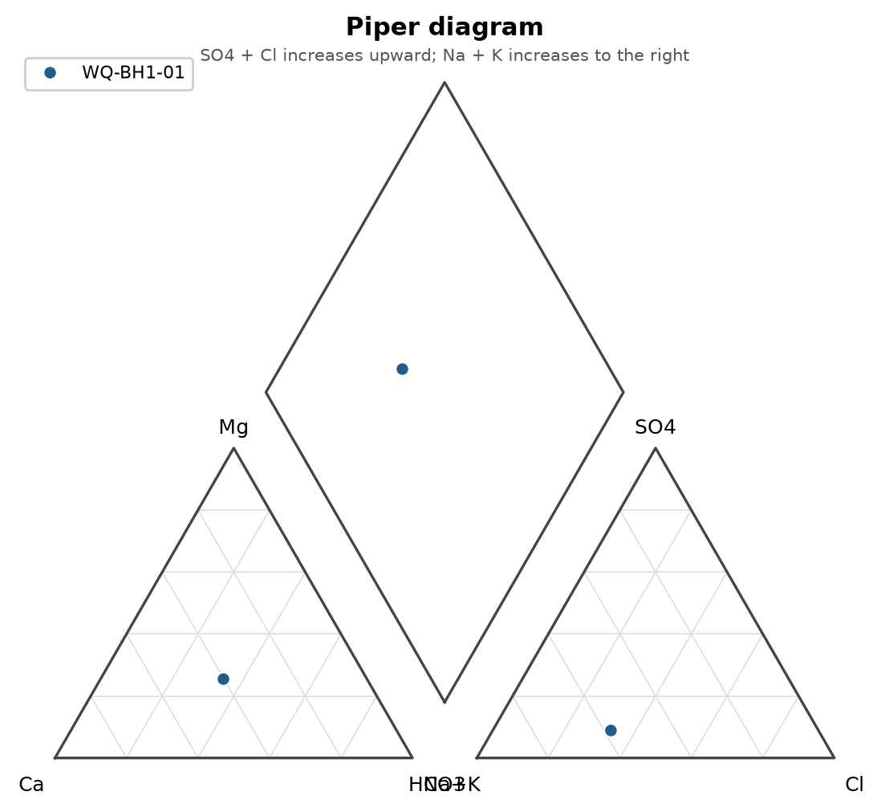
Figure 1. Piper diagram.
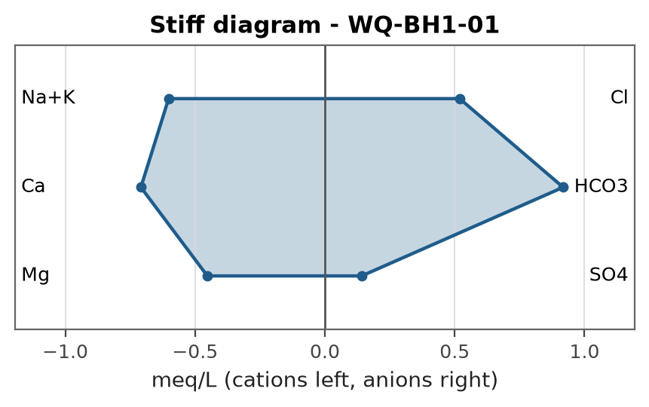
Figure 2. Stiff diagram.

5. Recommendations
- Manganese requires oxidation and filtration (aeration or chlorination followed by filtration); monitor infant exposure in the meantime.
- Low pH water is corrosive to metal fittings; a limestone contactor or careful choice of corrosion resistant materials is advised.
- Iron above the acceptability value causes staining and metallic taste; aeration followed by sand filtration or a simple oxidation filter normally resolves it.
- Coliform detection calls for disinfection of the borehole and pump, a sanitary inspection of the wellhead, and re-sampling.
- Repeat physico-chemical and bacteriological testing at least once a year, and after any flooding or repair work on the wellhead.
REPORT SUBMITTED BY:

..............................
A. N. Analyst
Water Quality Analyst

