PUMPING TEST REPORT
Step With Recovery Test
at Kuntoloh, Port Loko District

Client: ACF
Borehole: KTL-01
Test date: 1st April, 2017
Conducted by: WiNGiN

1. Test Details
Community | Kuntoloh | Client | ACF
Borehole Ref. No. | KTL-01 | Date | 1st April, 2017
Test type | step+recovery | Conducted by | WiNGiN
Depth of borehole | 70 m | Static water level | 19.3 m
Pump setting | 60 m | Length of each step | 60 min

Discharge rates: Step 1: not recorded, Step 2: not recorded, Step 3: not recorded.
The discharge rate was not recorded on the field sheet. The drawdown and recovery curves below remain valid; transmissivity and yield results are pending until the discharge is supplied.

2. Field Data
True drawdown is computed as the measured water level minus the static water level. The drawdown column recorded on the field sheet holds the increment between successive readings and is not used directly. Reading intervals are irregular and are handled as recorded.
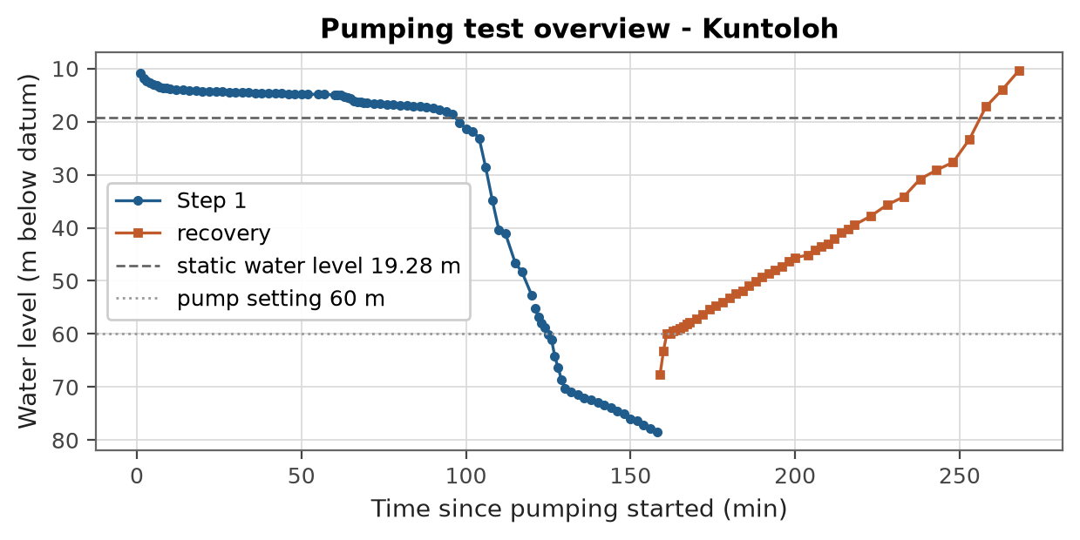
Figure 1. Water level record for the full test including recovery.
The maximum drawdown reached 59.2 m below the static water level.
Data verification notes:
- [WARNING] missing_discharge: Discharge not recorded for step(s) 1, 2, 3. Drawdown and recovery curves are produced, but transmissivity and yield results are pending until discharge values are supplied.
- [WARNING] water_level_above_static: Some pumping water levels are above the stated static water level, giving negative drawdown. Check the static level and the measuring datum on the sheet.
- [WARNING] level_below_borehole: Recorded water level 78.45 m exceeds the stated borehole depth 70 m; check the sheet.
- [WARNING] step_test_pending: Step test analysis pending: discharge per step is missing.

3. Analysis

3.1 Step drawdown analysis
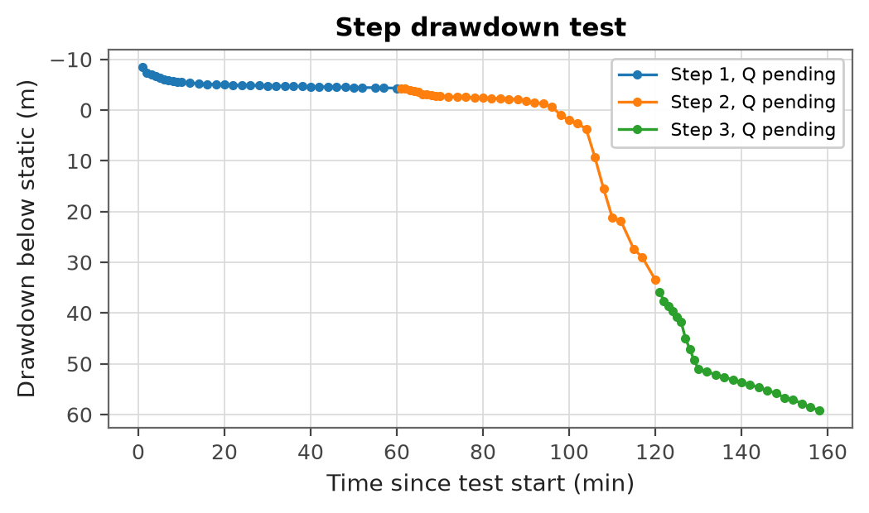
Figure 2. Step drawdown curves (discharge pending).
Hantush-Bierschenk analysis is pending until the discharge of each step is supplied.

4. Results Summary
Transmissivity: pending (discharge not recorded).
Table 1. Yield summary.
Quantity | Value
Specific capacity | pending
Available drawdown | 37.7 m
Usable drawdown | 26.4 m
Long term yield | pending
Recommended safe yield (safety factor 1.5) | pending
Recommended pump installation depth | pending

5. Yield Recommendation
Yield recommendation pending: discharge is missing on the field sheet.
REPORT SUBMITTED BY:

..............................
A. N. Analyst
Hydrogeologist

