GEOPHYSICAL SURVEY REPORT
Groundwater Investigation for Borehole Siting
at Rokel, Western Area

Client: Living Water International
Project: Geophysical Survey
Survey date: 8th December, 2015
Prepared by: A. N. Geologist

Table of Contents
Right-click and choose Update Field to fill the table of contents.

1. Introduction
Geological and hydrogeological/geophysical investigations are prerequisites for borehole drilling. Living Water International requested a geophysical investigation to site the borehole position at Rokel in Western Area. The study assessed the possibility of accessing groundwater in the project area, and the details of the investigations are documented in this report.

2. Background and Geology of the Project Area
The project area lies within the Freetown Basic Complex. The Freetown Complex is a layered gabbroic anorthosite intrusion emplaced against gneisses and schists of the Kasila Group, and it forms part of the Peninsula and Banana Islands. It is thought to have been formed by multiple injections of magma that occurred intermittently. Groundwater potential within the Freetown Basic Complex is found within weathered and fractured zones of these igneous (crystalline) rocks. Groundwater quality and quantity can be high if the borehole is properly located through appropriate hydrogeological and geophysical investigations.

3. Field Work

3.1 Reconnaissance Survey
The aim of the reconnaissance survey was to select suitable points for the geophysical survey. Existing water points, environmental and other physical conditions were also assessed. The field reconnaissance survey was conducted on 8th December, 2015.
Geomorphological survey of the area
The landscape and other physical features of the area were examined, including slopes, drainage lines and streams, since there is normally hydraulic continuity between groundwater and surface water.
Geological and hydrogeological survey to determine the formation of the area and identify possible features
The weathered products overlying the bedrock were assessed as the principal prospect for groundwater, since groundwater occurs mostly in weathered and unconsolidated materials compared with consolidated and crystalline rocks.
Selection of traverse line for the geophysical survey
The traverse line for the resistivity survey was selected on the basis of geomorphologic and geological/hydrogeological features as well as the location of the project area. Points for the vertical electrical soundings were selected considering the available space and the environmental and other physical conditions, and the proposed borehole locations were marked with pegs for identification.

3.2 Geophysical Survey
The geophysical survey consisted of electrical resistivity measurements, specifically vertical electrical sounding (VES) using the Syscal Junior instrument.

3.2.1 Resistivity Profiling
Electrical resistivity profiling is usually carried out along a selected traverse of 50 m to 100 m length at 10 m intervals to determine the lateral variation of subsurface resistivities and delineate anomalous points with groundwater potential. Where the available land extent does not permit profiling, the vertical electrical soundings are carried out at the selected points directly.

3.2.2 Selection of VES Points
2 vertical electrical sounding point(s) were selected based on the available space and the location of the project area, considering geological, hydrogeological and environmental conditions. The points are labelled A (1), B (2) in this report.

3.2.3 Vertical Electrical Sounding (VES)
Vertical electrical soundings were carried out with the aim of determining the formation resistivities and the depth to bedrock, as well as the possibility of finding water bearing fractures or aquifers at depth with their corresponding thicknesses. The Schlumberger electrode configuration and the required procedures were used for the soundings.

4. Data Analysis and Interpretation
Table 1 presents the Schlumberger array VES data recorded at point A (1), from which the sounding curve of apparent resistivity against half the current electrode spacing (AB/2) in Figure 1 is plotted.
Client | Living Water International | Community | Rokel
Project | Geophysical Survey | Sounding Number | A (1)
District | Western Area | GPS Coordinate East | 708,958
Date | 8th December, 2015 | GPS Coordinate North | 926,355
Field Supervisor |  | Elevation | 71 m

Table 1. Schlumberger array VES data at point A (1).
No. | AB/2 (m) | MN (m) | Apparent Resistivity (ohm-m)
1 | 1 | 0.4 | 1,165
2 | 2 | 0.4 | 1,193
3 | 3 | 0.4 | 1,303
4 | 3 | 0.8 | 1,317
5 | 4 | 0.8 | 1,502
6 | 5 | 0.8 | 1,500
7 | 7 | 0.8 | 1,432
8 | 10 | 0.8 | 1,392
9 | 10 | 1.5 | 961
10 | 15 | 1.5 | 715.5
11 | 20 | 1.5 | 732
12 | 30 | 1.5 | 162
13 | 40 | 1.5 | 156.1
14 | 40 | 7.6 | 78.7
15 | 50 | 7.6 | 52.1
16 | 70 | 7.6 | 55.8
17 | 70 | 14 | 53.2
18 | 80 | 14 | 47.9

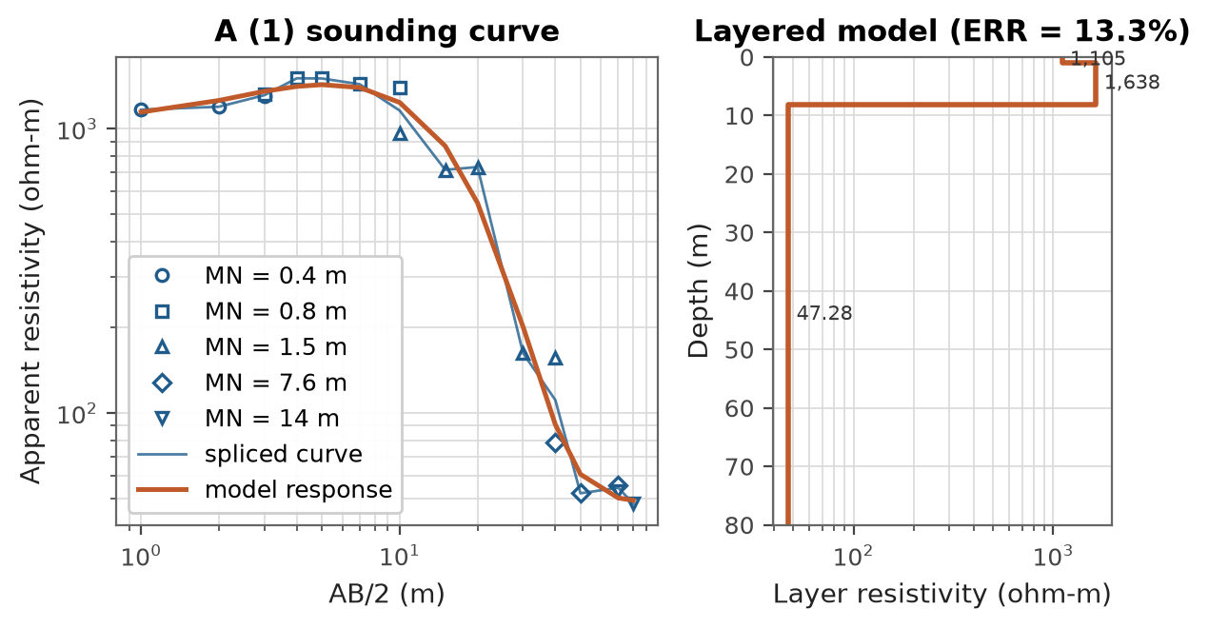
Figure 1. Schlumberger array VES curve and model at point A (1).
Table 2. Layered earth model at point A (1) (curve type K, ERR = 13.3%).
N | rho (ohm-m) | h (m) | z (m)
1 | 1,105 | 1.02 | 0/0
2 | 1,638 | 7.08 | 1.02
3 | 47.28 |  | 8.1

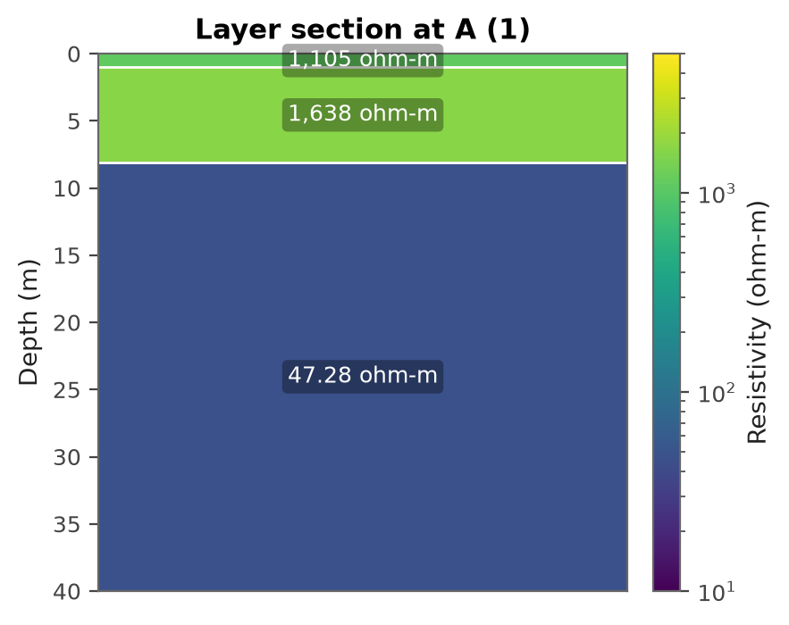
Figure 2. Pseudo-section showing resistivity and layer thicknesses at point A (1).
The data at A (1) resolves a 3 layer subsurface (type K; a resistive layer between two more conductive layers, often dry laterite or duricrust over a conductive saprolite). Layer 1 from 0 m to 1.02 m (1.02 m thick) has a resistivity of about 1,105 ohm-m and is interpreted as dry lateritic topsoil / duricrust. Layer 2 from 1.02 m to 8.1 m (7.08 m thick) has a resistivity of about 1,638 ohm-m and is interpreted as compact or dry weathered rock (regolith). Layer 3 below 8.1 m has a resistivity of about 47.28 ohm-m and is interpreted as fractured bedrock, low resistivity indicative of groundwater in fractures. The unusually low resistivity within the interpreted fractured or weathered intervals is indicative of pore electrolyte, possibly groundwater. The possible water zones are 8 m to 80 m.

Table 3 presents the Schlumberger array VES data recorded at point B (2), from which the sounding curve of apparent resistivity against half the current electrode spacing (AB/2) in Figure 3 is plotted.
Client | Living Water International | Community | Rokel
Project | Geophysical Survey | Sounding Number | B (2)
District | Port Loko | GPS Coordinate East | 727,012
Date | 8th December, 2015 | GPS Coordinate North | 916,125
Field Supervisor |  | Elevation | 68 m

Table 3. Schlumberger array VES data at point B (2).
No. | AB/2 (m) | MN (m) | Apparent Resistivity (ohm-m)
1 | 1 | 0.4 | 995.7
2 | 2 | 0.4 | 984.2
3 | 3 | 0.4 | 965.4
4 | 3 | 0.8 | 1,081
5 | 4 | 0.8 | 1,298
6 | 5 | 0.8 | 1,366
7 | 7 | 0.8 | 1,209
8 | 10 | 0.8 | 1,307
9 | 10 | 1.5 | 891.8
10 | 15 | 1.5 | 739.6
11 | 20 | 1.5 | 329.1
12 | 30 | 1.5 | 140.1
13 | 40 | 1.5 | 147.9
14 | 40 | 7.6 | 96.3
15 | 50 | 7.6 | 34.1
16 | 70 | 7.6 | 90.3
17 | 70 | 14 | 55.2
18 | 80 | 14 | 51.4

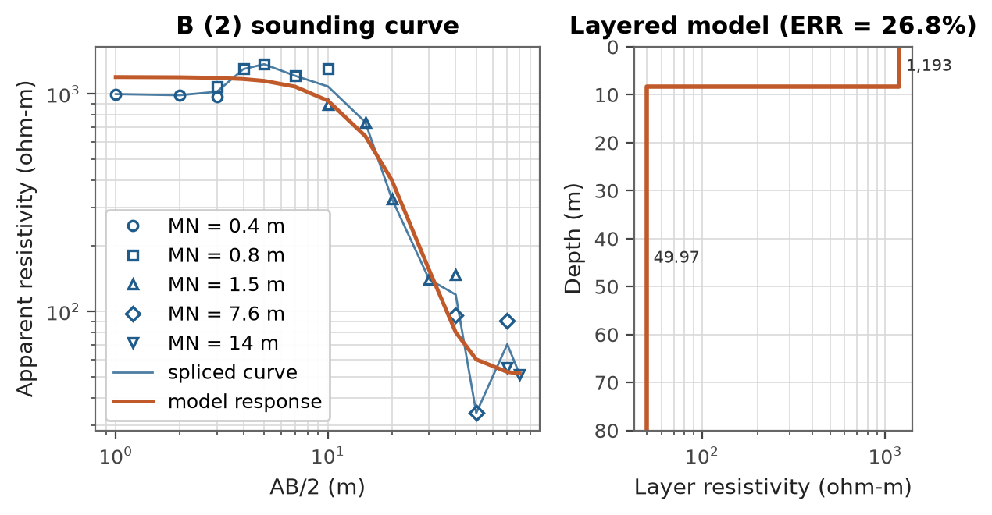
Figure 3. Schlumberger array VES curve and model at point B (2).
Table 4. Layered earth model at point B (2) (curve type 2-layer descending, ERR = 26.8%).
N | rho (ohm-m) | h (m) | z (m)
1 | 1,193 | 8.28 | 0/0
2 | 49.97 |  | 8.28

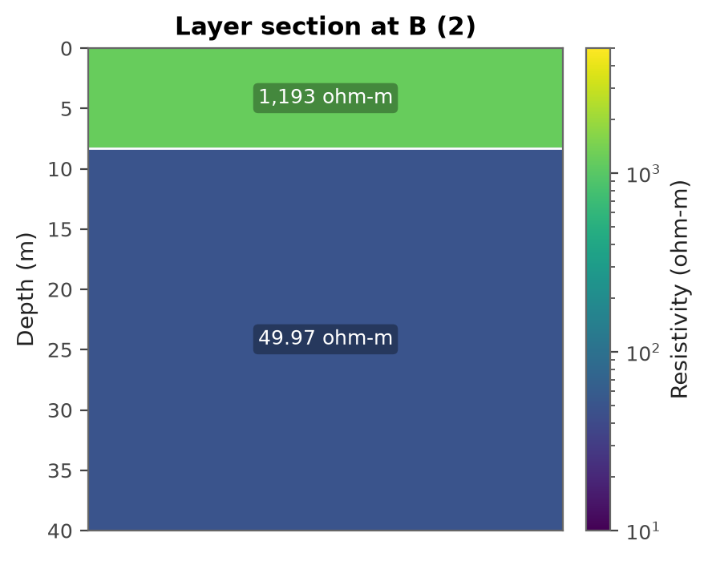
Figure 4. Pseudo-section showing resistivity and layer thicknesses at point B (2).
The data at B (2) resolves a 2 layer subsurface (a two layer response with resistivity decreasing at depth, consistent with weathered or fractured, possibly water bearing rock beneath a resistive surface layer). Layer 1 from 0 m to 8.28 m (8.28 m thick) has a resistivity of about 1,193 ohm-m and is interpreted as dry lateritic topsoil / duricrust. Layer 2 below 8.28 m has a resistivity of about 49.97 ohm-m and is interpreted as fractured bedrock, low resistivity indicative of groundwater in fractures. The unusually low resistivity within the interpreted fractured or weathered intervals is indicative of pore electrolyte, possibly groundwater. The possible water zones are 8 m to 80 m.

Table 5. List of VES points in order of preference for drilling.
No. | VES Point | Layer | Thickness (m) | Depth (m) | Apparent Resistivity (Ohm-m) | Possible Water Zones (m) | Max Drilling Depth (m) | Ranking
1 | A (1) | 1  2  3 | 1.02  7.08 | 1.02  8.1 | 1,105  1,638  47.28 | 8-80 | 80 m | 2nd
2 | B (2) | 1  2 | 8.28 | 8.28 | 1,193  49.97 | 8-80 | 80 m | 1st

5. Conclusions and Recommendations
Conclusions:
- The project area is part of the Freetown Basic Complex lithological formation.
- Groundwater potential (quality and quantity) could be favourable at depth within weathered zones and fractured bedrock.
- The potential water zones at point A (1) are found between 8 m to 80 m.
- The potential water zones at point B (2) are found between 8 m to 80 m.
- Point B (2) is selected as the preferred point for drilling according to the results and data analysis.
- It is premature to estimate quantities, which can only be determined during test drilling and test pumping.
- The borehole locations were selected within both national and international borehole siting guidelines.
Recommendations:
- Drilling should be carried out at the selected point B (2) to confirm the existence of groundwater.
- Point(s) A (1) are optional drilling points.
- The maximum drilling depth should be 80 m at point B (2); 80 m at point A (1), to cut across the probable water zones for sustainable productivity and a high yield of the borehole(s).
- The borehole must be constructed using correct and standard materials such as standard uPVC screens and plain casings and well sorted gravel pack.
- Both physico-chemical and bacteriological tests should be carried out on water samples from the completed well.

Annex A. Data Verification Notes
The following checks were raised automatically during data processing and should be verified against the field notes.
- [WARNING] district_coordinate_conflict (B (2)): Stated district 'Port Loko' does not contain the coordinates (8.2826 N, -12.9390 E). The point falls in Western Area Rural, Moyamba. District extents are approximate; verify against the field notes.
- [WARNING] inconsistent_district: Different district values within one project: 'Western Area' on A (1); 'Port Loko' on B (2). This usually comes from copying the previous sheet.
- [WARNING] points_far_apart: A (1) and B (2) are 20.8 km apart, which is unusually far for one site; check the coordinates.
REPORT SUBMITTED BY:

..............................
A. N. Geologist
Geologist / Field Supervisor
Cell: +232 00 000 000

