WATER QUALITY REPORT
Borehole water assessment at Dr. Timbo's Residence, Western Area Rural District

Client: Dr. Timbo
Sample ID: WQ-BH1-01
Borehole: BH-1
Sample date: 20th May, 2018
Laboratory: Example Laboratory, Freetown

PROVISIONAL - NOT FOR CERTIFICATION
This report rests on incomplete results. The following requirements for certification are outstanding.
- Field data: Readings that were never measured are in this project: dr_timbo_water_quality.xlsx. The values in that file were invented to demonstrate the toolkit, so no result derived from them describes anything that was sampled.
- Site position: No GPS position is recorded on any sheet in this project. A borehole that cannot be found again on the ground cannot be certified, revisited or maintained.

Executive Summary
Laboratory results for the borehole water at Dr. Timbo's Residence were assessed against the WHO Guidelines for Drinking-water Quality and the national/adopted limits. The water does not meet the health based guideline value(s) for Manganese, Total coliforms, so treatment or an alternative source is required before it is used for drinking.
Key findings:
- Health based exceedance(s): Manganese, Total coliforms.
- Treatment or an alternative source is required before drinking.

1. Sample Details
Community | Dr. Timbo's Residence | Client | Dr. Timbo
Sample ID | WQ-BH1-01 | Borehole Ref. No. | BH-1
Sample date | 20th May, 2018 | Laboratory | Example Laboratory, Freetown
District | Western Area Rural | Project | Borehole completion

Results are compared against the WHO Guidelines for Drinking-water Quality (fourth edition with addenda) and the national standard limits configured for this project. Where a confirmed national value is not available, the WHO or regional figure is adopted for that parameter and the status column reads national/adopted limit. Values reported by the laboratory as below the detection limit are shown as such.
The national column in the standards table is provisional: its values are WHO guideline figures carried across, or limits adopted from regional practice, and have not been confirmed against the Sierra Leone Standards Bureau drinking water specification. Confirm the figures before treating a national exceedance as a compliance finding.

1.1 Location and setting
The site is recorded as Dr. Timbo's Residence, Western Area Rural district. No GPS position is recorded for it, so the maps below cover Western Area Rural district rather than the borehole itself and carry no site marker. Record the position on the field sheet and reissue this report: a borehole that cannot be found again on the ground cannot be revisited or maintained.
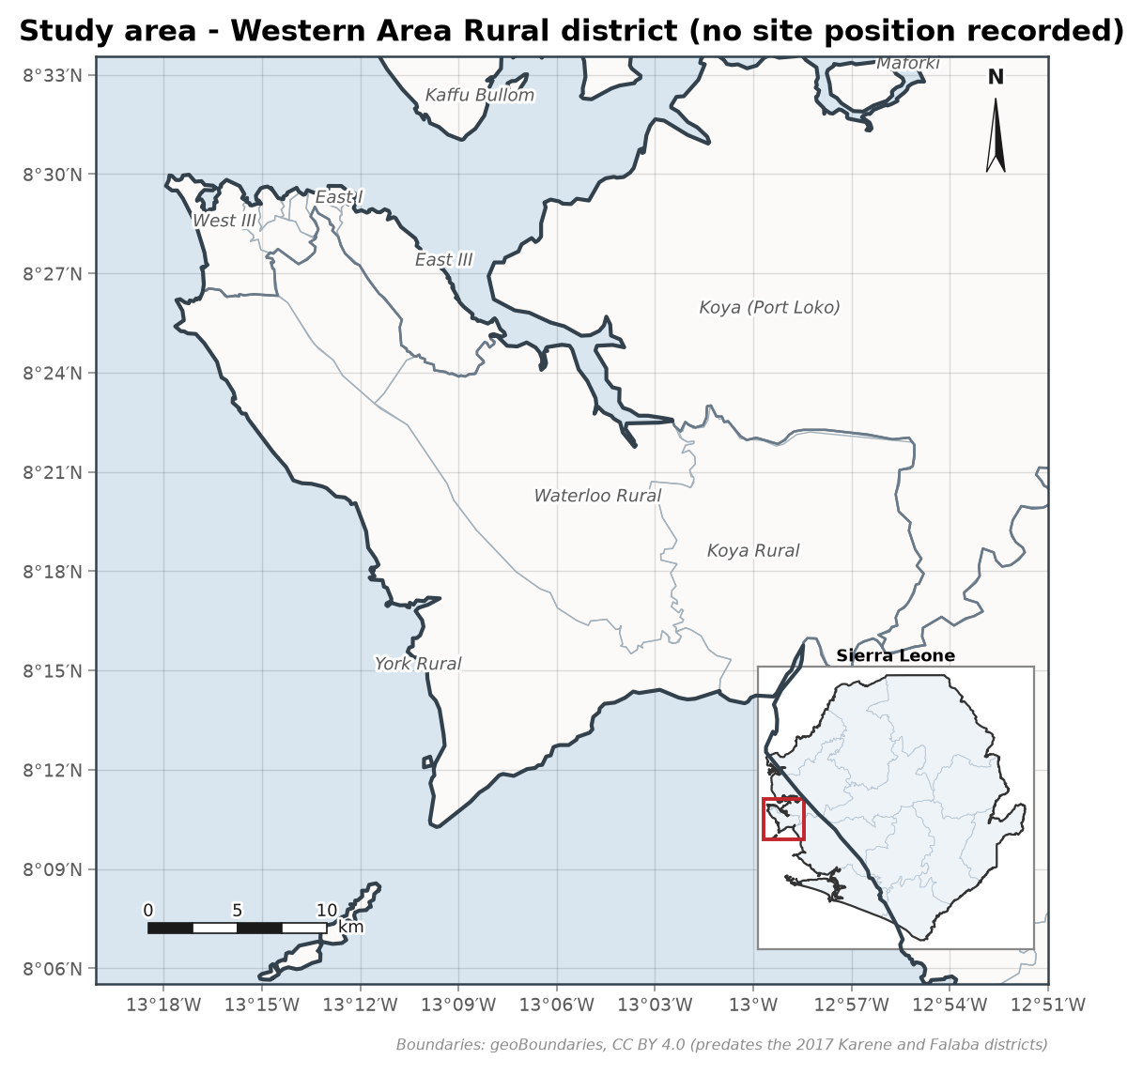
Figure 1. Study area at Western Area Rural district, with its location in Sierra Leone inset. Boundaries from geoBoundaries (CC BY 4.0).
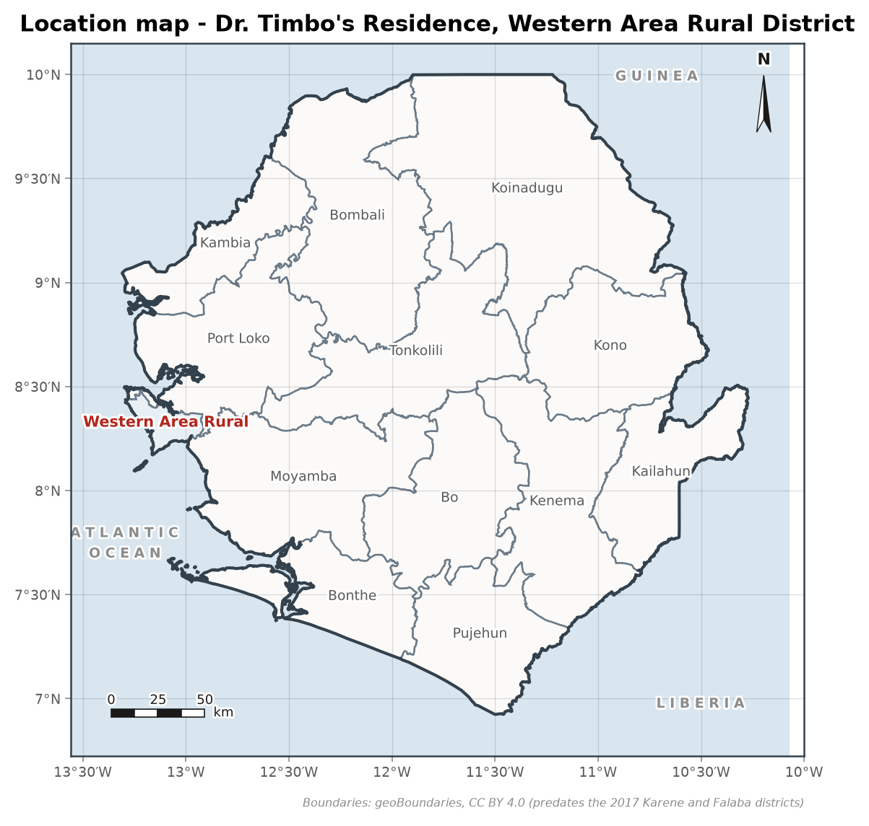
Figure 2. Location of Western Area Rural district. Boundaries from geoBoundaries (CC BY 4.0).

2. Results Against Guideline Values
Table 1 lists every parameter tested. Exceedances are highlighted in the status column.
Table 1. Laboratory results against guideline values.
Parameter | Value | Unit | WHO health | WHO acceptability | National | Status
pH | 5.9 | pH units |  | 6.5-8.5 | 6.5-8.5 | Exceeds acceptability value
Electrical conductivity | 185 | uS/cm |  |  | 2500 | Complies
TDS | 120 | mg/L |  | 1000 | 1000 | Complies
Turbidity | 3.2 | NTU |  | 5 | 5 | Complies
Temperature | 27.4 | deg C |  |  |  | No guideline value
Total hardness | 58 | mg/L as CaCO3 |  | 500 | 500 | Complies
Alkalinity | 46 | mg/L as CaCO3 |  |  |  | No guideline value
Calcium | 14.2 | mg/L |  |  |  | No guideline value
Magnesium | 5.5 | mg/L |  |  |  | No guideline value
Sodium | 12.6 | mg/L |  | 200 | 200 | Complies
Potassium | 2.1 | mg/L |  |  |  | No guideline value
Bicarbonate | 56 | mg/L |  |  |  | No guideline value
Chloride | 18.4 | mg/L |  | 250 | 250 | Complies
Sulfate | 6.8 | mg/L |  | 250 | 250 | Complies
Nitrate (as NO3) | 8.2 | mg/L | 50 |  | 50 | Complies
Nitrite (as NO2) | < DL | mg/L | 3 |  | 3 | Below detection
Ammonia (as N) | 0.12 | mg/L |  | 1.5 | 1.5 | Complies
Fluoride | 0.22 | mg/L | 1.5 |  | 1.5 | Complies
Iron | 0.85 | mg/L |  | 0.3 | 0.3 | Exceeds acceptability value
Manganese | 0.12 | mg/L | 0.08 | 0.1 | 0.08 | EXCEEDS HEALTH GUIDELINE
Arsenic | < DL | mg/L | 0.01 |  | 0.01 | Below detection
Lead | < DL | mg/L | 0.01 |  | 0.01 | Below detection
Copper | 0.02 | mg/L | 2 | 1 | 2 | Complies
Zinc | 0.11 | mg/L |  | 3 | 3 | Complies
Chromium (total) | < DL | mg/L | 0.05 |  | 0.05 | Below detection
Cadmium | < DL | mg/L | 0.003 |  | 0.003 | Below detection
E. coli | 0 | CFU/100 mL | 0 |  | 0 | Complies
Total coliforms | 4 | CFU/100 mL |  | 0 | 0 | EXCEEDS HEALTH GUIDELINE

The water does not meet the health based guideline value(s) for: Manganese, Total coliforms. Treatment or an alternative source is required before the water is used for drinking.
Water Quality Index: 224 (Very poor), over 10 physico-chemical parameters.
Health Hazard Index: 0.19 (Acceptable (Hazard Index below 1)).

3. Ionic Balance Check
Sum of cations 1.8 meq/L, sum of anions 1.72 meq/L, charge balance error +2.1 percent. The analysis balances within the normal 5 percent tolerance.

4. Corrosivity and Materials
The water is chemically aggressive (Ryznar index 11.4, Langelier index -2.7). It will corrode metal fittings, and it can be aggressive even though the pH is within the acceptability range, which is typical of soft basement groundwater.
Table 2. Corrosivity and scaling indices.
Index | Value
Langelier Saturation Index (LSI) | -2.74
Ryznar Stability Index (RSI) | 11.37
Aggressive Index (AI) | 9.11
Larson-Skold ratio | 0.72
Classification | Strongly corrosive

Specify uPVC or stainless steel (grade 304 or 316) for the rising main and pump components, and avoid galvanised iron and mild steel, which corrode rapidly in this water and are a leading cause of premature handpump failure. Inspect the rising main and pump rods for corrosion at each service.

5. Hydrochemical Facies
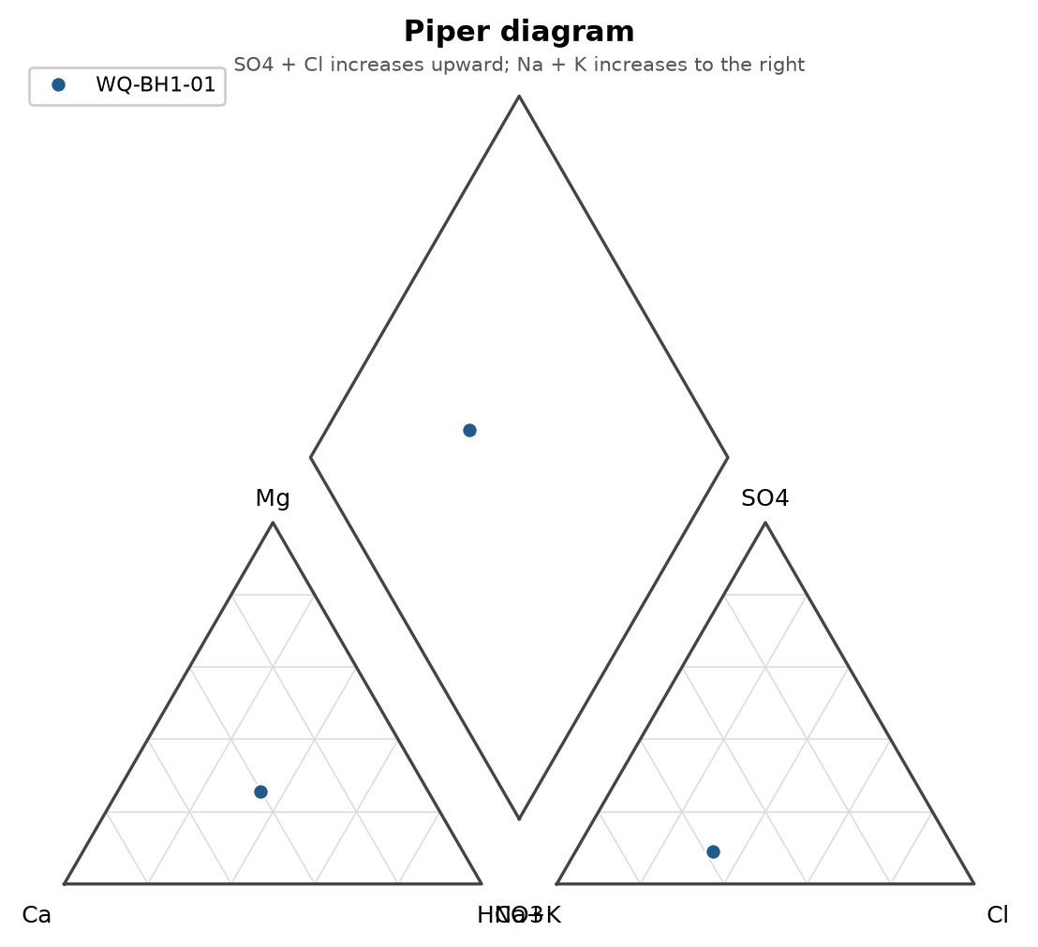
Figure 3. Piper diagram.
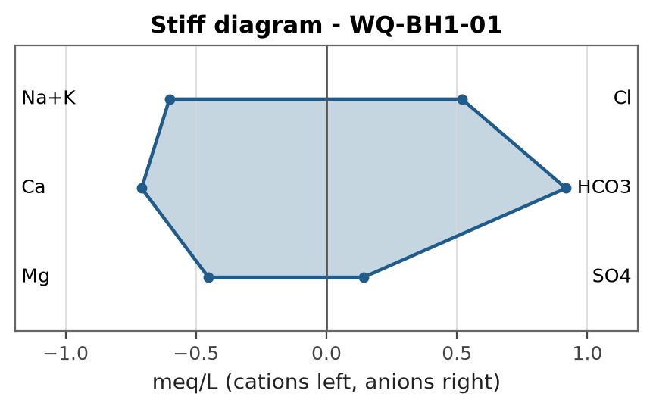
Figure 4. Stiff diagram.

6. Recommendations
- Specify uPVC or stainless steel (grade 304 or 316) for the rising main and pump components, and avoid galvanised iron and mild steel, which corrode rapidly in this water and are a leading cause of premature handpump failure. Inspect the rising main and pump rods for corrosion at each service.
- Manganese requires oxidation and filtration (aeration or chlorination followed by filtration); monitor infant exposure in the meantime.
- Coliform detection calls for disinfection of the borehole and pump, a sanitary inspection of the wellhead, and re-sampling.
- Low pH water is corrosive to metal fittings; a limestone contactor or careful choice of corrosion resistant materials is advised.
- Iron above the acceptability value causes staining and metallic taste; aeration followed by sand filtration or a simple oxidation filter normally resolves it.
- Repeat physico-chemical and bacteriological testing at least once a year, and after any flooding or repair work on the wellhead.

7. Limitations and Uncertainty
- The results describe a single sample at one point in time. Water quality varies with the season, rainfall and the condition of the wellhead, so periodic re-testing is needed to confirm the verdict.
- Parameters reported below the laboratory detection limit are shown as such; a non-detection does not prove complete absence.
- The corrosivity and index calculations use the parameters supplied. Missing pH, calcium or alkalinity limit what can be assessed, and any assumptions made are stated where they are used.

References
World Health Organization (2022). Guidelines for Drinking-water Quality, 4th edition incorporating the first and second addenda. Geneva: World Health Organization.
Sierra Leone Standards Bureau. Sierra Leone Standard for drinking water quality (SLS). Freetown: SLSB.
Langelier, W.F. (1936). The analytical control of anti-corrosion water treatment. Journal of the American Water Works Association, 28, 1500-1521.

Glossary and Abbreviations
Term | Meaning
VES | Vertical electrical sounding, a resistivity depth survey
AB/2 | Half the current-electrode spacing in a Schlumberger array
ohm-m | Ohm-metre, the unit of electrical resistivity
ERR | Root-mean-square misfit of the fitted layered model (percent)
S (Dar-Zarrouk) | Longitudinal conductance, sum of thickness/resistivity (siemens)
T (Dar-Zarrouk) | Transverse resistance, sum of thickness x resistivity (ohm m2)
SWL | Static water level, the rest water level before pumping
DWL | Dynamic water level, the water level during pumping
T (transmissivity) | Aquifer transmissivity (m2/day)
S (storativity) | Aquifer storage coefficient (dimensionless)
m3/h | Cubic metres per hour, a discharge or yield rate
LSI / RSI | Langelier and Ryznar indices of water corrosivity and scaling
WQI | Water Quality Index, an aggregate 0-based quality score
HI | Health Hazard Index, the sum of chronic hazard quotients
uPVC | Unplasticised polyvinyl chloride, the casing and screen material
GPS / UTM | Satellite positioning and the Universal Transverse Mercator grid
WASH | Water, sanitation and hygiene
RWSN | Rural Water Supply Network
SALWACO | Sierra Leone Water Company
WHO | World Health Organization
SLSB | Sierra Leone Standards Bureau

REPORT SUBMITTED BY:

..............................
A. N. Analyst
Water Quality Analyst

