PUMPING TEST REPORT
Step drawdown test with recovery
at Kuntoloh, Port Loko District

Client: ACF
Borehole: KTL-01
Test date: 1st April, 2017
Conducted by: WiNGiN

PROVISIONAL - NOT FOR CERTIFICATION
This report rests on incomplete results. The following requirements for certification are outstanding.
- Site position: No GPS position is recorded on any sheet in this project. A borehole that cannot be found again on the ground cannot be certified, revisited or maintained.
- Pumping test measured: No discharge is recorded for the test, so transmissivity and yield stay pending.
- Yield established: discharge is missing on the field sheet

Executive Summary
This report is provisional and not a certification (outstanding: Site position, Pumping test measured, Yield established). The findings below are those the supplied records support; the cover says what is missing.
A step drawdown test with recovery was carried out on the borehole at Kuntoloh. The recorded water levels are inconsistent with the stated static level, pump setting or borehole depth (see the data verification notes), so the curves are shown as recorded and their drawdowns are not to be relied on; the transmissivity and safe yield are pending because discharge is missing on the field sheet.
Key findings:
- Yield recommendation pending: discharge is missing on the field sheet.

1. Test Details
Community | Kuntoloh | Client | ACF
Borehole Ref. No. | KTL-01 | Date | 1st April, 2017
Test type | step drawdown test with recovery | Conducted by | WiNGiN
Depth of borehole | 70 m | Static water level | 19.3 m
Pump setting during test | 60 m | Pumping duration | 158 min
Length of each step | 60 min

Water levels are depths below the top of the casing, the datum the field sheet records them from; the casing's stick-up above ground is not recorded, so every depth in this report is to that datum.
Discharge rates: Step 1: not recorded, Step 2: not recorded, Step 3: not recorded.
The discharge rate was not recorded on the field sheet. The drawdown and recovery curves below remain valid; transmissivity and yield results are pending until the discharge is supplied.

1.1 Location and setting
The site is recorded as Kuntoloh, Port Loko district. No GPS position is recorded for it, so the maps below cover Port Loko district rather than the borehole itself and carry no site marker. Record the position on the field sheet and reissue this report: a borehole that cannot be found again on the ground cannot be revisited or maintained.
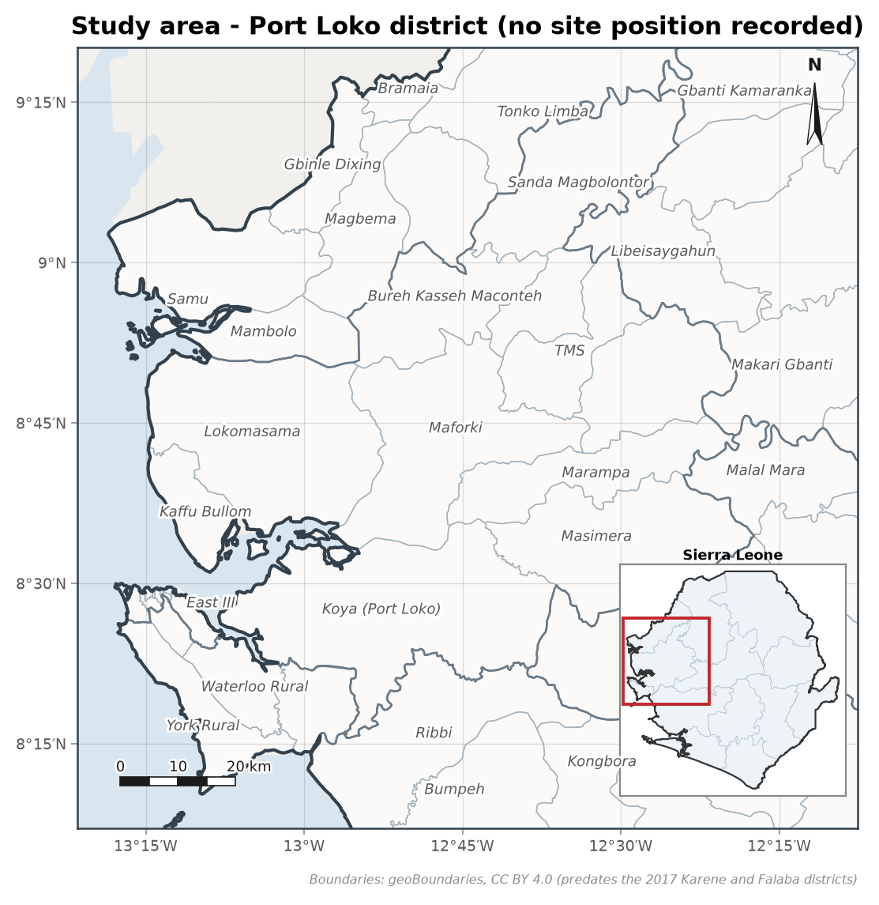
Figure 1. Study area at Port Loko district, with its location in Sierra Leone inset. Boundaries from geoBoundaries (CC BY 4.0).
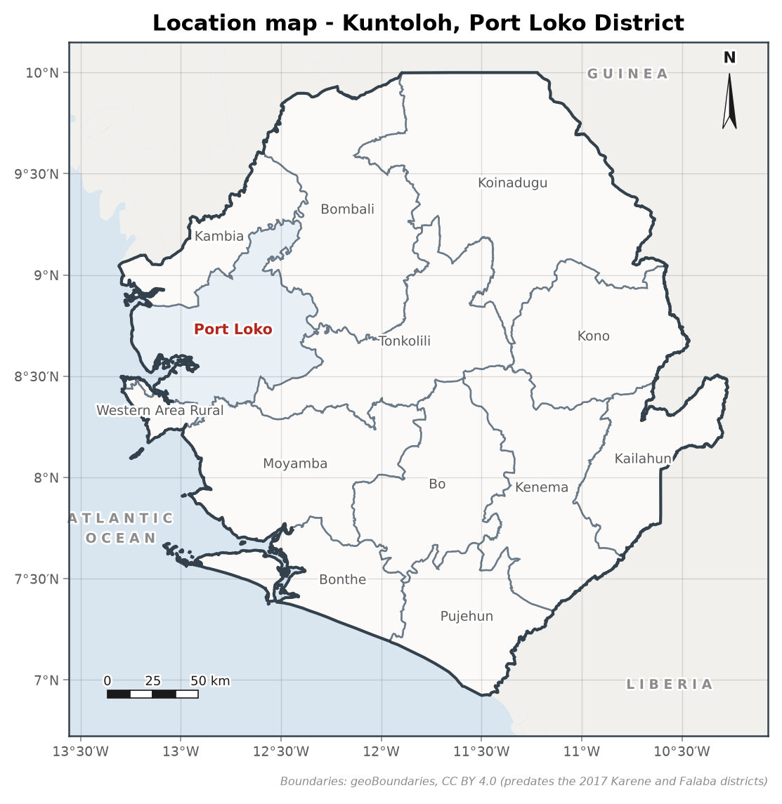
Figure 2. Location of Port Loko district. Boundaries from geoBoundaries (CC BY 4.0).

2. Field Data
True drawdown is computed as the measured water level minus the static water level. The drawdown column recorded on the field sheet holds the increment between successive readings and is not used directly. Reading intervals are irregular and are handled as recorded.
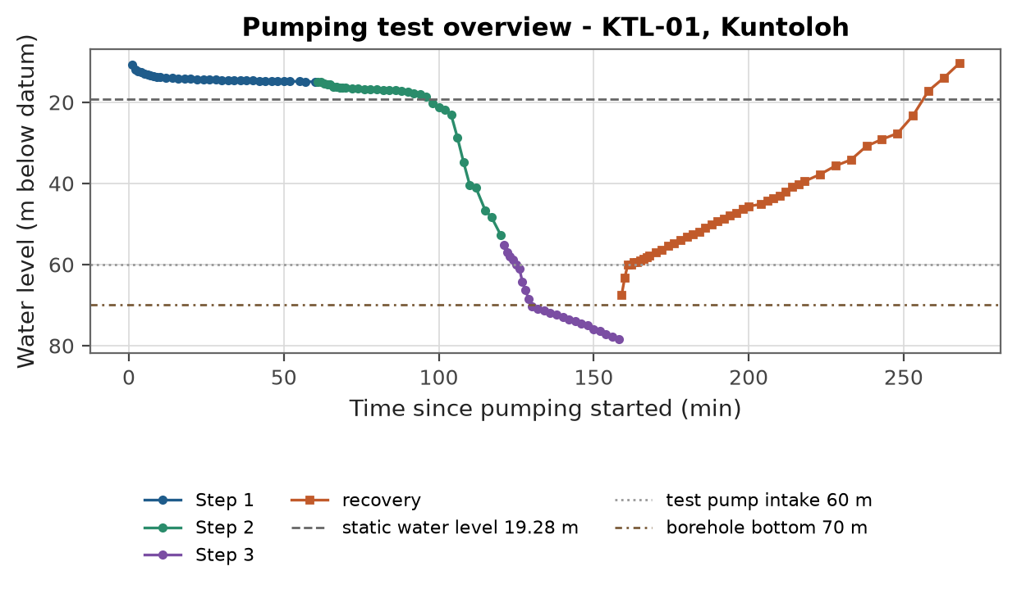
Figure 3. Water level record for the full test including recovery.
The maximum drawdown reached 59.2 m below the static water level, as recorded; the notes below say why the recorded levels cannot all be right.
Data verification notes:
- [WARNING] missing_discharge: Discharge not recorded for step(s) 1, 2, 3. Drawdown and recovery curves are produced, but transmissivity and yield results are pending until discharge values are supplied.
- [WARNING] water_level_above_static: Some pumping and recovery water levels are above the stated static water level, giving negative drawdown. Check the static level and the measuring datum on the sheet.
- [WARNING] level_below_borehole: Recorded water level 78.45 m exceeds the stated borehole depth 70 m; check the sheet.
- [WARNING] level_below_pump: Recorded water level 78.45 m is below the pump intake at 60 m. A pump cannot draw the level below its own intake, so the pump setting, the levels or the datum on the sheet is wrong; the drawdown figures are as recorded and not to be relied on.
- [WARNING] step_test_pending: Step test analysis pending: discharge per step is missing.

3. Analysis
The first step has fewer than five positive drawdowns, so no derivative is drawn.

3.1 Step drawdown analysis
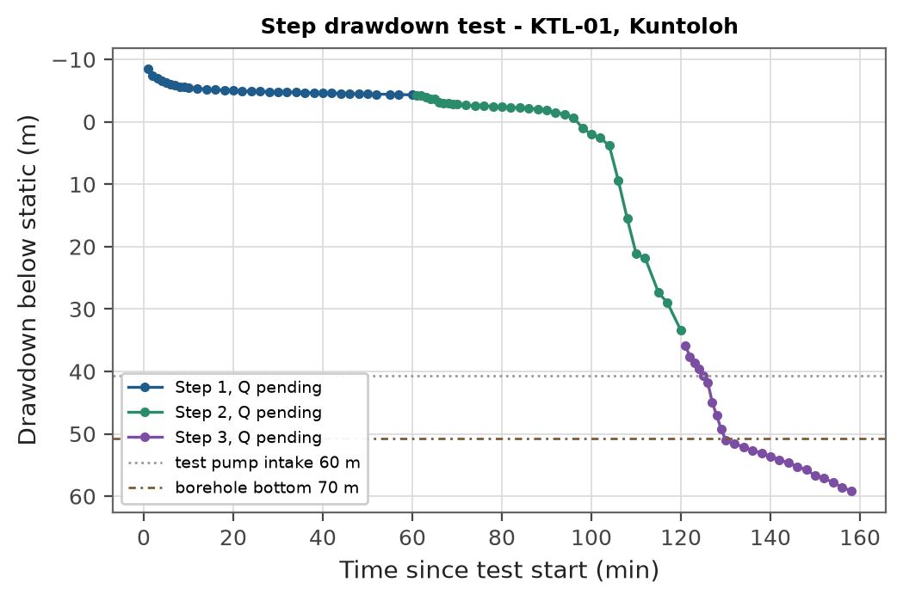
Figure 4. Step drawdown curves (discharge pending).
Hantush-Bierschenk analysis is pending until the discharge of each step is supplied.

4. Results Summary
Transmissivity: pending (discharge not recorded).
Table 1. Yield summary.
Quantity | Value
Transmissivity adopted for the yield | pending
Specific capacity | pending
Available drawdown | 37.7 m
Usable drawdown | 25 m
Long term yield | pending
Recommended safe yield (safety factor 1.5) | pending
Confidence | pending
Recommended pump installation depth | pending
Pump setting during the test | 60 m

5. Yield Recommendation
Yield recommendation pending: discharge is missing on the field sheet.

6. Limitations and Uncertainty
- The analysis assumes a homogeneous, isotropic aquifer of large extent. A barrier or a recharge (stream or coast) boundary, if present, changes the late-time drawdown slope and would bias the transmissivity.
- In a single pumped well the storativity trades off against the effective well radius, so any storativity reported from this test is indicative only.
- The safe yield is projected to the design period from a short test; it should be confirmed by monitoring the pumping water level once the borehole is in service.
- Yield varies with the season. This report gives the yield at the water level measured on the day of the test; no seasonal projection was supplied, so the dry-season and drought-year figures are not given. Two water-level readings a year apart in this borehole would allow that projection.

References
Theis, C.V. (1935). The relation between the lowering of the piezometric surface and the rate and duration of discharge of a well using groundwater storage. Transactions of the American Geophysical Union, 16, 519-524.
Cooper, H.H. and Jacob, C.E. (1946). A generalized graphical method for evaluating formation constants and summarizing well-field history. Transactions of the American Geophysical Union, 27, 526-534.
Hantush, M.S. (1964). Hydraulics of wells. In V.T. Chow (ed.), Advances in Hydroscience, 1, 281-442.
Papadopulos, I.S. and Cooper, H.H. (1967). Drawdown in a well of large diameter. Water Resources Research, 3(1), 241-244.
Stehfest, H. (1970). Algorithm 368: Numerical inversion of Laplace transforms. Communications of the ACM, 13(1), 47-49.
Bourdet, D., Ayoub, J.A. and Pirard, Y.M. (1989). Use of pressure derivative in well-test interpretation. SPE Formation Evaluation, 4(2), 293-302.
Renard, P., Glenz, D. and Mejias, M. (2009). Understanding diagnostic plots for well-test interpretation. Hydrogeology Journal, 17(3), 589-600.
Kuensch, H.R. (1989). The jackknife and the bootstrap for general stationary observations. The Annals of Statistics, 17(3), 1217-1241.
Hall, P., Horowitz, J.L. and Jing, B.-Y. (1995). On blocking rules for the bootstrap with dependent data. Biometrika, 82(3), 561-574.
Rural Water Supply Network (2015). Professional Water Well Drilling: A UNICEF Guidance Note. St Gallen: RWSN / UNICEF.

Glossary and Abbreviations
Term | Meaning
VES | Vertical electrical sounding, a resistivity depth survey
AB/2 | Half the current-electrode spacing in a Schlumberger array
ohm-m | Ohm-metre, the unit of electrical resistivity
ERR | Root-mean-square misfit of the fitted layered model (percent)
S (Dar-Zarrouk) | Longitudinal conductance, sum of thickness/resistivity (siemens)
T (Dar-Zarrouk) | Transverse resistance, sum of thickness x resistivity (ohm m2)
SWL | Static water level, the rest water level before pumping
DWL | Dynamic water level, the water level during pumping
T (transmissivity) | Aquifer transmissivity (m2/day)
S (storativity) | Aquifer storage coefficient (dimensionless)
m3/h | Cubic metres per hour, a discharge or yield rate
LSI / RSI | Langelier and Ryznar indices of water corrosivity and scaling
WQI | Water Quality Index, an aggregate 0-based quality score
HI | Health Hazard Index, the sum of chronic hazard quotients
uPVC | Unplasticised polyvinyl chloride, the casing and screen material
GPS / UTM | Satellite positioning and the Universal Transverse Mercator grid
WASH | Water, sanitation and hygiene
RWSN | Rural Water Supply Network
SALWACO | Sierra Leone Water Company
WHO | World Health Organization
SLSB | Sierra Leone Standards Bureau

REPORT SUBMITTED BY:

..............................
WiNGiN
Hydrogeologist

