BOREHOLE DRILLING AND
PUMP TEST REPORT
for Dr. Timbo's Residence

Submitted to: Dr. Timbo
Contractor: WiNGiN Heavy Duty Machines Co. Ltd
Borehole Ref. No.: BH-1
Completion date: 13th May, 2018
Status as recorded by the driller: Successful

PROVISIONAL - NOT FOR CERTIFICATION
This report rests on incomplete results. The following requirements for certification are outstanding.
- Field data: Readings that were never measured are in this project: dr_timbo_water_quality.xlsx. The values in that file were invented to demonstrate the toolkit, so no result derived from them describes anything that was sampled.
- Site position: No GPS position is recorded on any sheet in this project. A borehole that cannot be found again on the ground cannot be certified, revisited or maintained.
- Yield established: The safe yield of 0.39 m3/h (0.22 to 0.71) is indicative, not established: the test pumped for 30 minutes, below the 240 needed to see late-time behaviour, so the yield is extrapolated 4.2 log cycles of time; the whole test lies inside the 117-minute casing-storage period, so its drawdown is the borehole emptying rather than the aquifer responding; no transmissivity method fitted to standard and the Cooper-Jacob value is adopted as the best available.

Table of Contents
1. Introduction
1.1 Location and setting
2. Methodology
3. Drilling
4. Borehole Log Data
5. Borehole Construction Design
6. Borehole Development Record
7. Pumping Test
8. Borehole Characteristics and Installation
9. Water Quality Summary
10. Recommendations and Conclusions

Executive Summary
This report is provisional and not a certification (outstanding: Field data, Site position, Yield established). The findings below are those the supplied records support; the cover says what is missing.
This report documents the drilling, construction and testing of the borehole at Dr. Timbo's Residence. The borehole was drilled to 70 m by Air rotary (DTH hammer) and is recorded as successful. The recommended safe yield is 0.391 m3/h with the pump intake at 54 m below the top of the casing. The yield is indicative, not established: the test pumped for 30 minutes, below the 240 needed to see late-time behaviour, so the yield is extrapolated 4.2 log cycles of time; the whole test lies inside the 117-minute casing-storage period, so its drawdown is the borehole emptying rather than the aquifer responding; no transmissivity method fitted to standard and the Cooper-Jacob value is adopted as the best available. Confirm it by a longer test or by monitoring the pumping level in service before it is relied on. The water requires treatment before drinking.
Key findings:
- Borehole depth: 70 m, Successful.
- Water safety: treatment required before drinking.
Decision numbers:
- Safe yield: 0.391 m3/h (P10 to P90 of the transmissivity, 0.354 to 0.443 m3/h); basis: a block bootstrap of the Cooper-Jacob residuals, with the yield projected at each end of the transmissivity band it gives and the 2 m dry-season reserve taken; the band is the least the spread can be; provisional.
- Pump intake below the top of the casing: 54 m (the recommendation's setting over a 1 to 4 m dry-season decline, 51 to 52 m); basis: the yield recommendation's setting at the adopted transmissivity, 52 m, which the transmissivity band does not move, set instead in plain casing clear of the screens by the design; provisional.

1. Introduction
Groundwater can be abstracted from the ground in different ways, and the choice of abstraction method depends on the resources available and the local conditions. Borehole drilling was the recommended abstraction method for this project at Dr. Timbo's Residence, and the work was executed as per the specifications. Details of the activities are presented in this report.

1.1 Location and setting
The site is recorded as Dr. Timbo's Residence, Western Area Rural district. No GPS position is recorded for it, so the maps below cover Western Area Rural district rather than the borehole itself and carry no site marker. Record the position on the field sheet and reissue this report: a borehole that cannot be found again on the ground cannot be revisited or maintained.
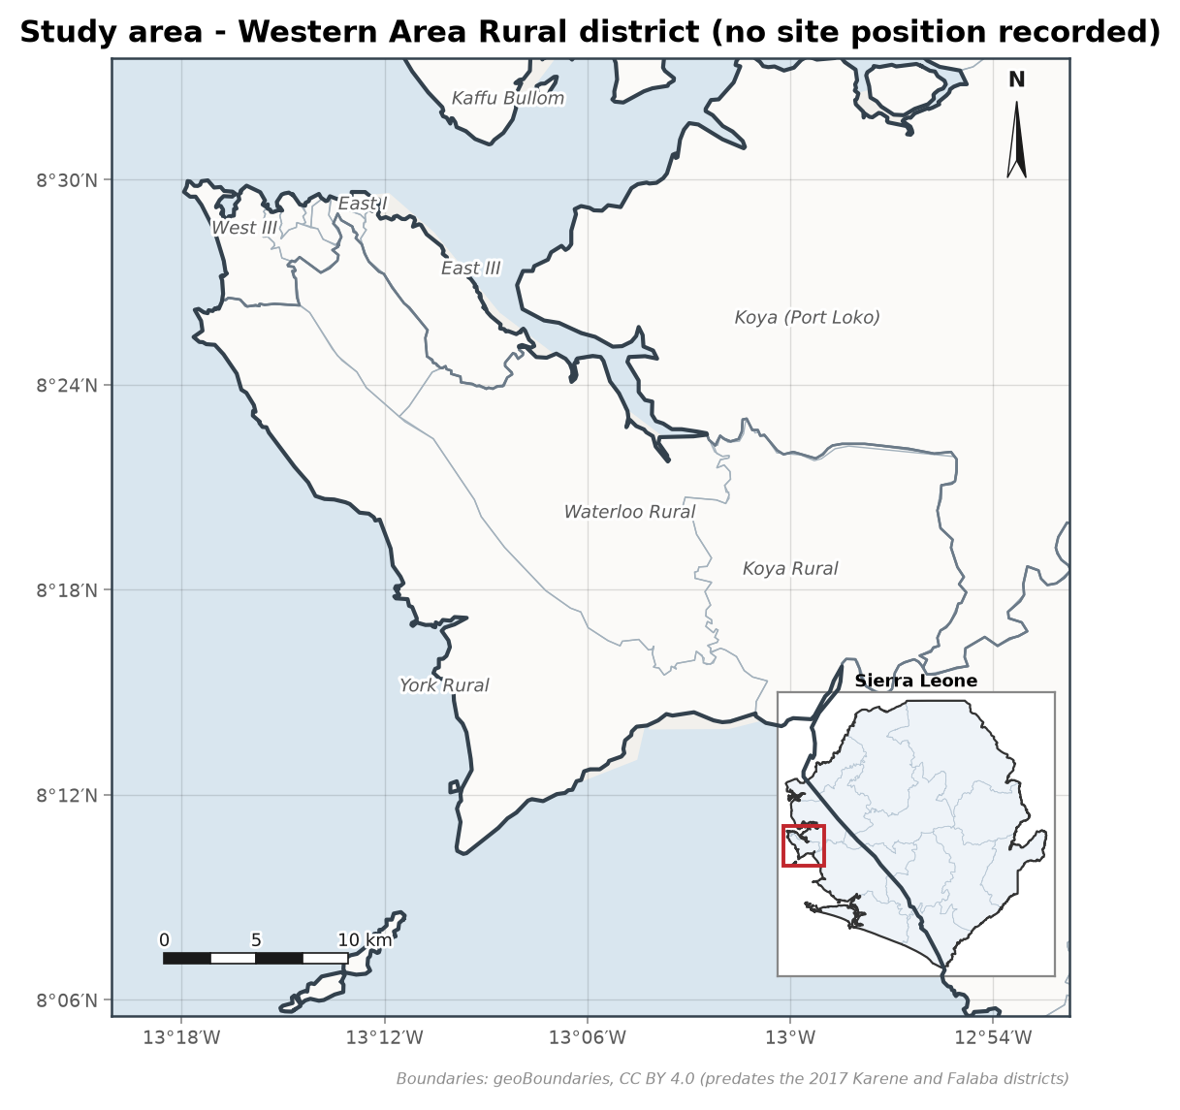
Figure 1. Study area at Western Area Rural district, with its location in Sierra Leone inset. Boundaries from geoBoundaries (CC BY 4.0).
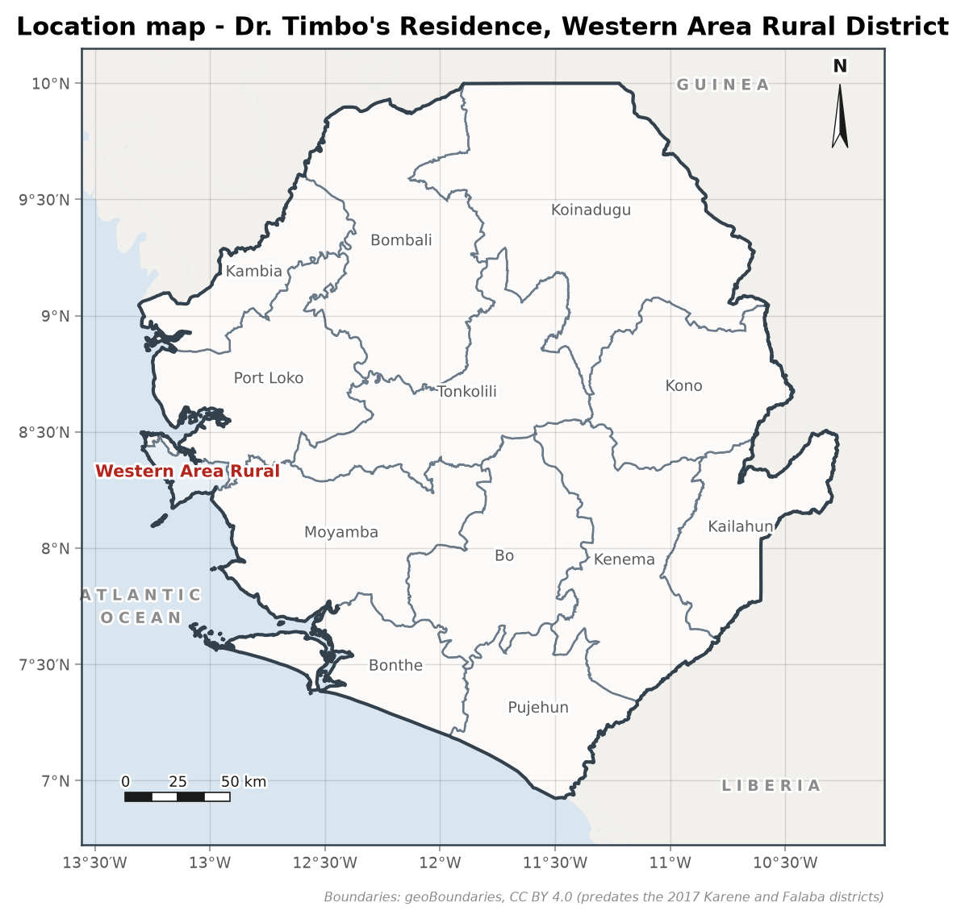
Figure 2. Location of Western Area Rural district. Boundaries from geoBoundaries (CC BY 4.0).

2. Methodology
The methodology adopted included reconnaissance, observation of the geological and hydrogeological conditions, assessment of existing boreholes and hand dug wells, drilling, construction, development and test pumping of the borehole.

3. Drilling
The drilling work included the following:
- Mobilisation of the drill rig and all necessary equipment.
- Drilling through all formations for completion of the borehole using the Air rotary (DTH hammer) method.
- Supply and installation of casings (plain and screen) as designed in section 5; the drilling log records no casing string as installed.
- No gravel pack: the 19 mm annulus is too thin to place one.
- Development of the borehole by surging with compressed air and airlifting.
- Demobilisation.
Contractor | WiNGiN Heavy Duty Machines Co. Ltd | Client | Dr. Timbo
Location | Dr. Timbo's Residence | Depth of borehole | 70 m
Start date | 11th May, 2018 | Completion date | 13th May, 2018
Drilling method | Air rotary (DTH hammer) | BH status | Successful

4. Borehole Log Data
Table 1. Drilling record and formation log.
Depth (m) | Interval (m) | From | To | Penetration rate (m/min) | Sample description | Diameter
0-5 | 5 | 13:30 | 13:35 | 1 | Reddish brown lateritic topsoil | 6.5"
5-10 | 5 | 13:36 | 13:41 | 1 | Light yellow clayey laterites | 6.5"
10-15 | 5 | 13:55 | 14:10 | 0.33 | Light yellow clayey laterites, wet from 12 m | 6.5"
15-20 | 5 | 14:14 | 14:26 | 0.42 | Clayey saprolite with weathered granite fragments | 6.5"
20-25 | 5 | 14:30 | 14:38 | 0.63 | Saprolite, decreasing clay content | 6.5"
25-30 | 5 | 15:15 | 15:23 | 0.63 | Weathered light colour granite, fractured | 6.5"
30-35 | 5 | 15:25 | 15:34 | 0.56 | Light colour granite, slightly weathered, fractured | 6.5"
35-40 | 5 | 15:38 | 15:48 | 0.5 | Light colour granite, slightly weathered | 6.5"
40-45 | 5 | 15:50 | 16:01 | 0.45 | Light colour granite | 6.5"
45-50 | 5 | 16:03 | 16:13 | 0.5 | Light colour granite, fracture zone 49-52 m | 6.5"
50-55 | 5 | 16:15 | 16:17 |  | Light colour granite | 6.5"
55-60 | 5 | 16:18 | 16:20 |  | Light colour granite, fracture zone 60-62 m | 6.5"
60-65 | 5 | 16:27 | 16:31 |  | Light colour granite | 6.5"
65-70 | 5 | 16:56 | 17:00 |  | Light colour granite, fresh | 6.5"

First water strike: 12 m
Second water strike: 30 m
Grouting: 20 m

5. Borehole Construction Design
Construction generated from the drilling log by the design rules. The log records no casing string, so this is a design, not an as-built record.
Table 2. Construction design summary.
Item | Detail
Total depth | 70 m
Drilled diameter | 6.5"
Casing | 5" uPVC, stick-up 0.5 m
Screens | 25-35 m; 48-53 m; 59-63 m (slot 0.75 mm)
Annular fill | 23-70 m: no gravel pack: the 19 mm annulus is too thin to place one
Backfill | 20-23 m
Sanitary seal | 0-20 m cement grout
Static water level | 9.44 m
Water strikes | 12 m, 30 m
Recommended pump intake | 54 m

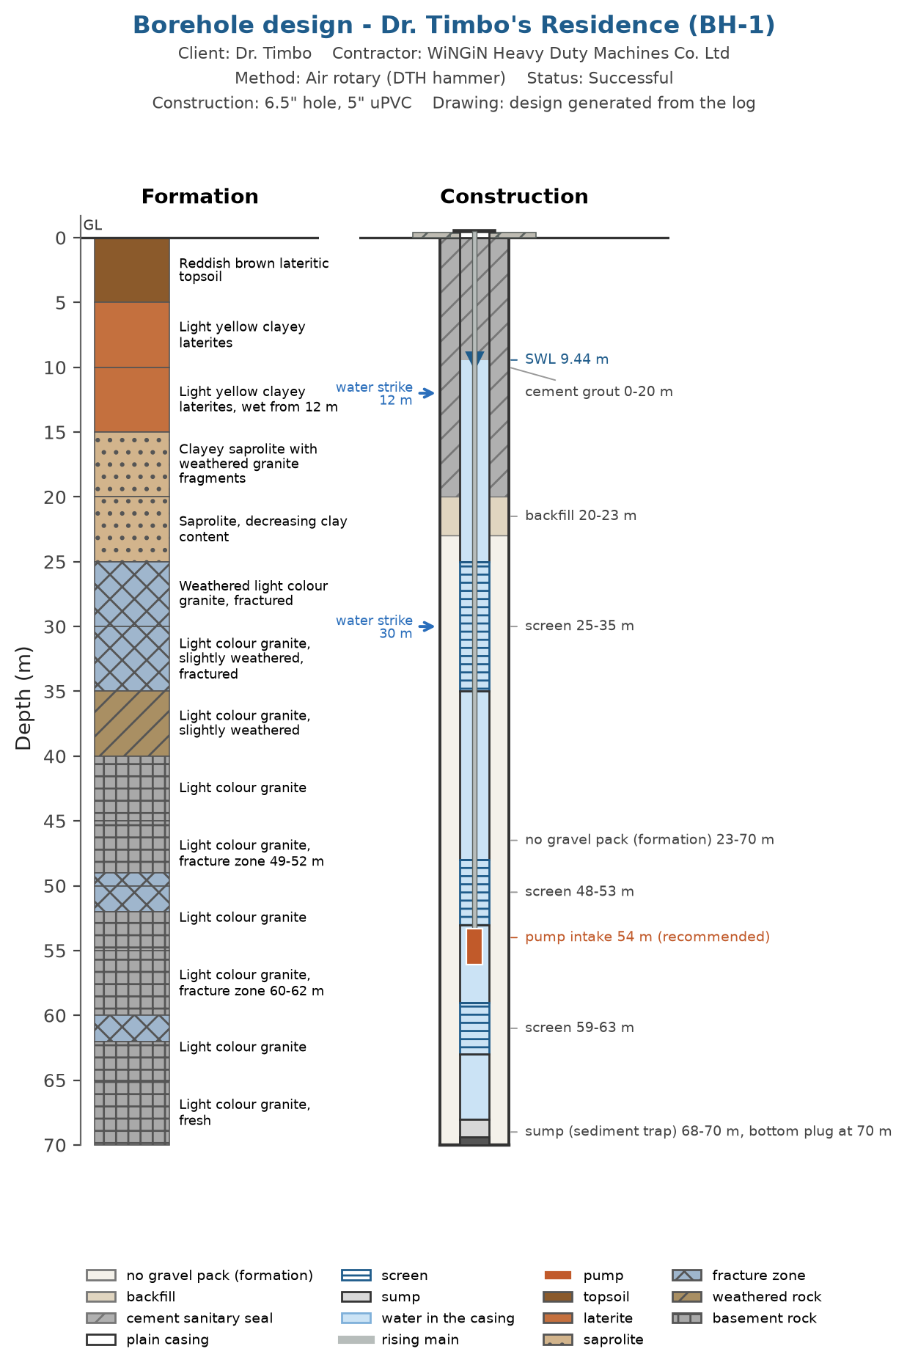
Figure 3. Borehole construction design generated from the drilling log, with lithology and construction columns.
Design basis:
- screens positioned against the water strikes recorded in the drilling log (30 m)
- screens positioned against the fracture zones the log names (49-52 m, 60-62 m), with 1 m of screen either side
- screens positioned against the fractured or water-bearing intervals logged at 25-30 m, 30-35 m
- the 12 m strike is not screened: it is in light yellow clayey laterites, wet from 12 m, a seepage horizon that is cased and grouted off rather than screened and it lies within the 20 m grouted interval
- 5 inch uPVC casing in a 6.5 inch hole as logged
- no gravel pack: the 19 mm annulus between the 5 inch casing and the 6.5 inch hole is too thin to place one, so the annulus below the seal is left to the formation
- cement grout from surface to 20 m as recorded on the drilling log (the rule's minimum is 6 m), with concrete apron with drainage channel and soakaway
- screens kept at least 5 m below the static water level
- pump intake at 54 m, in plain casing 1 m below the 48-53 m screen rather than the 52 m the yield recommendation asked for
Design notes:
- [WARNING] thin_annulus: A 5 inch casing in a 6.5 inch hole leaves 19 mm of annulus per side, under the 50 mm needed to place gravel without bridging (70 mm for a true filter pack), so no gravel pack is drawn or priced and the screen slot must suit the formation; use a larger bit or smaller casing to fit one.

6. Borehole Development Record
The borehole was developed by surging with compressed air and air lifting.
Table 3. Borehole development by air lifting.
From | To | Estimated yield (m3/h) | Observation
17:00 | 17:17 |  | Muddy water flushed out
17:17 | 17:47 | 2.5 | Cloudy water flushed out
17:48 | 18:00 |  | Clean water flushed out

The record covers 1 h 00 min (17:00 to 18:00).

7. Pumping Test
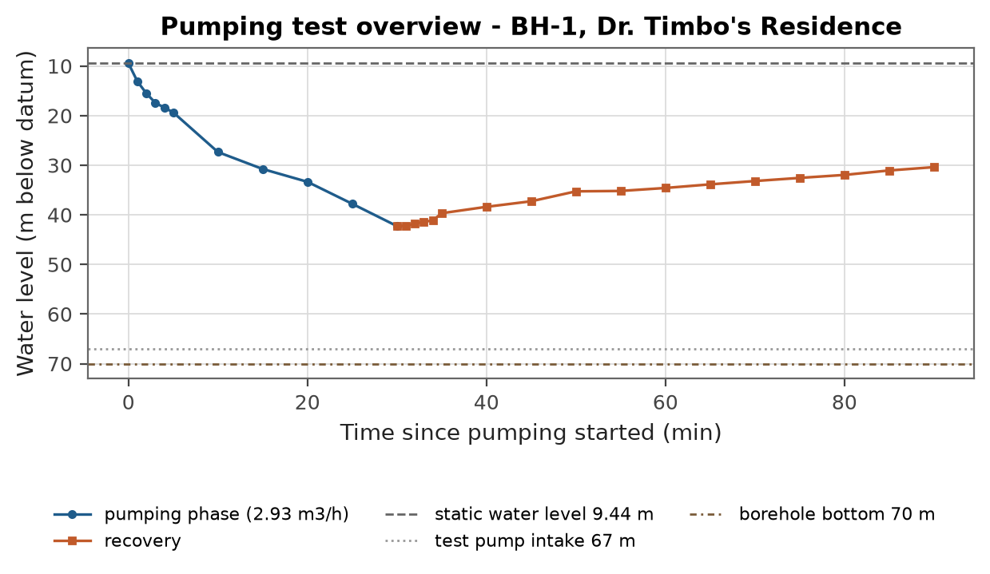
Figure 4. Constant discharge test and recovery record.
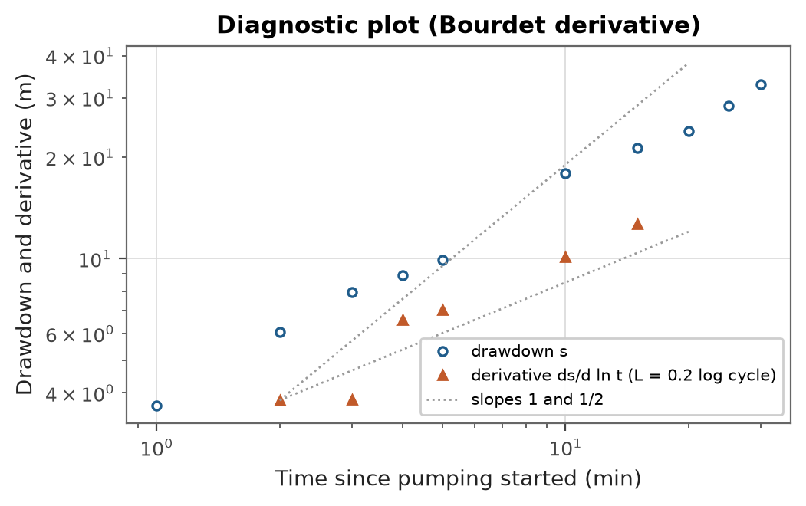
Figure 5. Drawdown and its Bourdet derivative, with the flow regimes the derivative's slope names.
The Bourdet derivative of the first step's drawdown, ds/d ln t with neighbours at least 0.2 of a log cycle apart, is read from the slope of its log-log curve: a unit slope is casing storage, a plateau radial flow, a half slope linear flow along a fracture, and a fall or a rise after the plateau a boundary. On this test no run of three derivative points holds one slope over enough of a log cycle to name a regime.
Table 4. Pumping test summary.
Item | Value
Test type | constant discharge test with recovery
Duration | 30 min
Discharge | 2.93 m3/h
Static water level | 9.44 m
Pump setting during the test | 67 m
Maximum drawdown | 32.8 m
Transmissivity | 0.536 m2/day (Cooper-Jacob)
Specific capacity | 0.089 m3/h per m (2.93 m3/h over 32.8 m of drawdown after 30 minutes)
Safe yield | 0.39 m3/h (0.22 to 0.71)
Yield confidence | indicative: the test pumped for 30 minutes, below the 240 needed to see late-time behaviour, so the yield is extrapolated 4.2 log cycles of time; the whole test lies inside the 117-minute casing-storage period, so its drawdown is the borehole emptying rather than the aquifer responding; no transmissivity method fitted to standard and the Cooper-Jacob value is adopted as the best available

Resampling the Cooper-Jacob residuals in blocks of 2 consecutive readings (400 resamples of 8 readings, a circular block bootstrap) puts the transmissivity between 0.482 and 0.612 m2/day (P10 to P90). The band is narrower than its percentiles name: on synthetic tests with independent 2 cm reading errors a band drawn this way held the true value in 64 to 74 tests in a hundred, not 80, and in 48 when consecutive errors ran together. Read it as the least the spread can be.
With the static level lowered by the 2 m dry-season reserve, as the recommendation is, that band puts the safe yield between 0.354 and 0.443 m3/h.
At the low end of the band the long-term yield is 0.53 m3/h, which still covers the recommended 0.391 m3/h: the safety factor absorbs the spread in the data at the dry-season level.
The pump intake moves between 51 and 52 m below the top of the casing over a dry-season decline of 1 to 4 m. The transmissivity band does not move it: the intake is set by the drawdown available, not by the rate.
The Theis fit's own covariance puts its transmissivity between 0.417 and 0.527 m2/day (nominally P10 to P90; on the same synthetic tests it held the true value in 67 tests in a hundred). That band assumes every reading's error is independent of the next, which the bootstrap does not.

8. Borehole Characteristics and Installation
Borehole depth | 70 m | Borehole diameter | 6.5"
Static water level | 9.44 m | Dynamic water level at the end of the test | 42.3 m
Drawdown | 32.8 m | Test discharge | 2.93 m3/h
Pump type | Submersible pump | Pump setting during the test | 67 m
Recommended pump intake | 54 m below the top of the casing

9. Water Quality Summary
The water does not meet the health based guideline value for: Manganese. Treatment or an alternative source is required before the water is used for drinking.
Table 5. Parameters above guideline or standard limits.
Parameter | Value | Unit | Limit | Remark
Manganese | 0.12 | mg/L | 0.08 | exceeds the WHO health based guideline (0.08)
Total coliforms | 4 | CFU/100 mL | 0 | detected above the national limit (0); an indicator of ingress or inadequate wellhead protection, not of faecal contamination in itself, and WHO sets no health based guideline for it
pH | 5.9 | pH units | 6.5-8.5 | exceeds the national acceptability limit (6.5-8.5), which is provisional; the WHO acceptability value is 6.5-8.5
Iron | 0.85 | mg/L | 0.3 | exceeds the national acceptability limit (0.3), which is provisional; the WHO acceptability value is 0.3

The national column in the standards table is provisional: its values are WHO guideline figures carried across, or limits adopted from regional practice, and have not been confirmed against the Sierra Leone Standards Bureau drinking water specification. Confirm the figures before treating a national exceedance as a compliance finding.

10. Recommendations and Conclusions
- The borehole is recorded as successful. Whether it is sustainable at the recommended rate is indicative, not established: the test pumped for 30 minutes, below the 240 needed to see late-time behaviour, so the yield is extrapolated 4.2 log cycles of time; the whole test lies inside the 117-minute casing-storage period, so its drawdown is the borehole emptying rather than the aquifer responding; no transmissivity method fitted to standard and the Cooper-Jacob value is adopted as the best available. Confirm it by a longer test or by monitoring the pumping level in service.
- The recommended abstraction rate is 0.391 m3/h (safety factor 1.5 applied to the long term yield, indicative).
- The pump intake is set at 54 m below the top of the casing, in plain casing clear of the screens.
- The pump should rest for at least one hour in every pumping cycle and the pumping water level should be checked routinely.
- Water treatment is required before drinking; see the water quality assessment.

References
Rural Water Supply Network (2015). Professional Water Well Drilling: A UNICEF Guidance Note. St Gallen: RWSN / UNICEF.
Rural Water Supply Network (2010). Code of Practice for Cost Effective Boreholes. St Gallen: RWSN.
World Health Organization (2022). Guidelines for Drinking-water Quality, 4th edition incorporating the first and second addenda. Geneva: World Health Organization.
Sierra Leone Standards Bureau. Sierra Leone Standard for drinking water quality (SLS). Freetown: SLSB. Edition and date not verified against the issued specification: the national limits this toolkit applies are provisional (WHO or regional figures carried across) until confirmed against it.

Glossary and Abbreviations
Term | Meaning
VES | Vertical electrical sounding, a resistivity depth survey
AB/2 | Half the current-electrode spacing in a Schlumberger array
ohm-m | Ohm-metre, the unit of electrical resistivity
ERR | Root-mean-square misfit of the fitted layered model (percent)
S (Dar-Zarrouk) | Longitudinal conductance, sum of thickness/resistivity (siemens)
T (Dar-Zarrouk) | Transverse resistance, sum of thickness x resistivity (ohm m2)
SWL | Static water level, the rest water level before pumping
DWL | Dynamic water level, the water level during pumping
T (transmissivity) | Aquifer transmissivity (m2/day)
S (storativity) | Aquifer storage coefficient (dimensionless)
m3/h | Cubic metres per hour, a discharge or yield rate
LSI / RSI | Langelier and Ryznar indices of water corrosivity and scaling
WQI | Water Quality Index, an aggregate 0-based quality score
HI | Health Hazard Index, the sum of chronic hazard quotients
uPVC | Unplasticised polyvinyl chloride, the casing and screen material
GPS / UTM | Satellite positioning and the Universal Transverse Mercator grid
WASH | Water, sanitation and hygiene
RWSN | Rural Water Supply Network
SALWACO | Sierra Leone Water Company
WHO | World Health Organization
SLSB | Sierra Leone Standards Bureau

REPORT SUBMITTED BY:

..............................

Technical Manager
WiNGiN Heavy Duty Machines Co. Ltd

