PROJECT HANDOVER REPORT
Borehole Water Supply
at Dr. Timbo's Residence, Western Area Rural District

Client: Dr. Timbo
Contractor: WiNGiN Heavy Duty Machines Co. Ltd

PROVISIONAL - NOT FOR CERTIFICATION
This report rests on incomplete results. The following requirements for certification are outstanding.
- Field data: Readings that were never measured are in this project: dr_timbo_water_quality.xlsx. The values in that file were invented to demonstrate the toolkit, so no result derived from them describes anything that was sampled.
- Site position: No GPS position is recorded on any sheet in this project. A borehole that cannot be found again on the ground cannot be certified, revisited or maintained.
- Yield established: The safe yield of 0.39 m3/h (0.22 to 0.71) is indicative, not established: the test pumped for 30 minutes, below the 240 needed to see late-time behaviour, so the yield is extrapolated 4.2 log cycles of time; the whole test lies inside the 117-minute casing-storage period, so its drawdown is the borehole emptying rather than the aquifer responding; no transmissivity method fitted to standard and the Cooper-Jacob value is adopted as the best available.

Table of Contents
1. Project Summary
2. Works Completed
3. Borehole Data Sheet
4. Water Quality
5. Operation and Maintenance Guidance
6. Community / WASH Committee
7. Recommendations
8. Handover Signatures

Executive Summary
This report is provisional and not a certification (outstanding: Field data, Site position, Yield established). The findings below are those the supplied records support; the cover says what is missing.
This report hands over the completed borehole water supply at Dr. Timbo's Residence, Western Area Rural District. The borehole was drilled to 70 m and is recorded as successful. The recommended safe yield is 0.391 m3/h. The yield is indicative, not established: the test pumped for 30 minutes, below the 240 needed to see late-time behaviour, so the yield is extrapolated 4.2 log cycles of time; the whole test lies inside the 117-minute casing-storage period, so its drawdown is the borehole emptying rather than the aquifer responding; no transmissivity method fitted to standard and the Cooper-Jacob value is adopted as the best available. Confirm it by a longer test or by monitoring the pumping level in service before it is relied on. The water requires treatment before drinking; see the water quality section.
Key findings:
- Borehole depth: 70 m, Successful.
- Water safety: treatment required before drinking.
- Keep this report with the WASH committee records and maintain the sanitary protection zone around the wellhead.
Decision numbers:
- Safe yield: 0.391 m3/h (P10 to P90 of the transmissivity, 0.354 to 0.443 m3/h); basis: a block bootstrap of the Cooper-Jacob residuals, with the yield projected at each end of the transmissivity band it gives and the 2 m dry-season reserve taken; the band is the least the spread can be; provisional.
- Pump intake below the top of the casing: 54 m (the recommendation's setting over a 1 to 4 m dry-season decline, 51 to 52 m); basis: the yield recommendation's setting at the adopted transmissivity, 52 m, which the transmissivity band does not move, set instead in plain casing clear of the screens by the design; provisional.

1. Project Summary
Community | Dr. Timbo's Residence | Chiefdom
District | Western Area Rural | Client | Dr. Timbo
Contractor | WiNGiN Heavy Duty Machines Co. Ltd | Project reference
GPS East |  | GPS North
Latitude / Longitude |  | Elevation

The site is recorded as Dr. Timbo's Residence, Western Area Rural district. No GPS position is recorded for it, so the maps below cover Western Area Rural district rather than the borehole itself and carry no site marker. Record the position on the field sheet and reissue this report: a borehole that cannot be found again on the ground cannot be revisited or maintained.
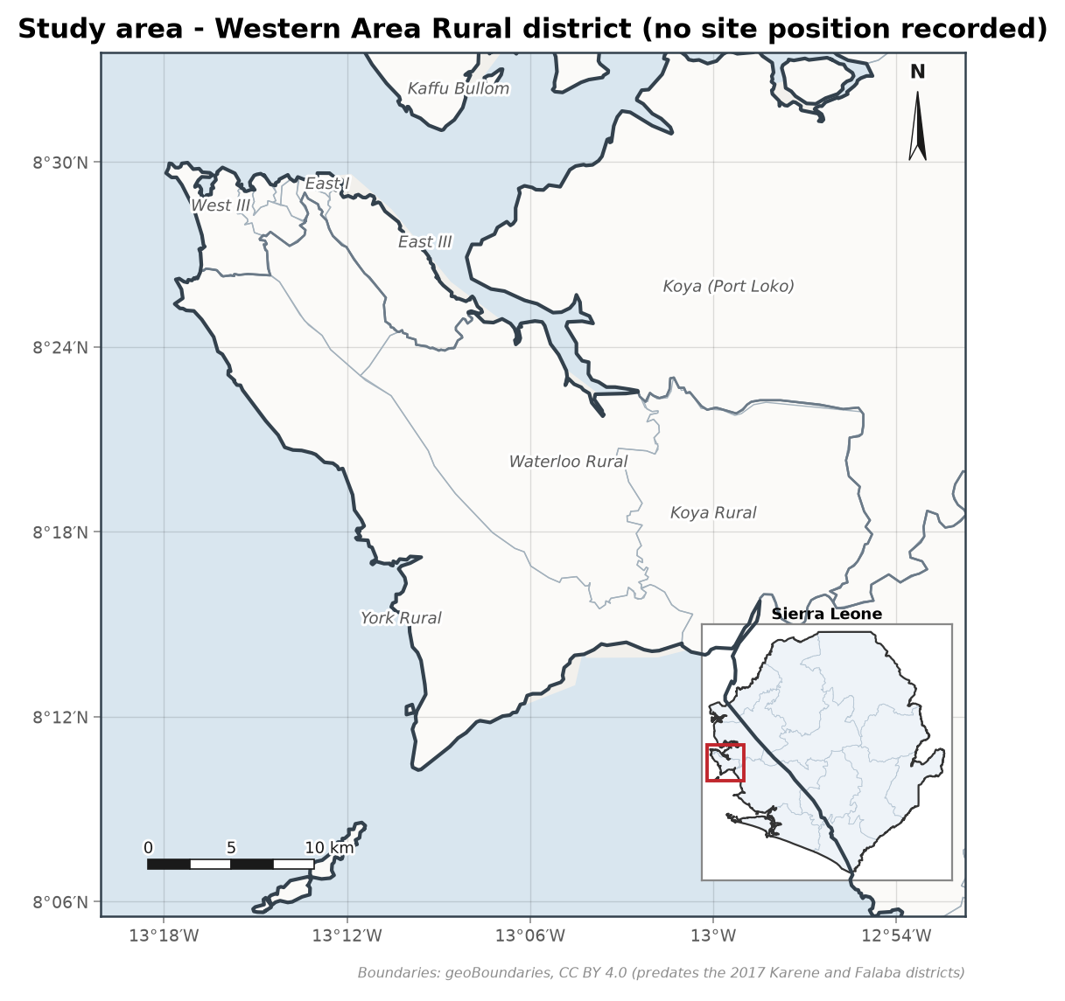
Figure 1. Study area at Western Area Rural district, with its location in Sierra Leone inset. Boundaries from geoBoundaries (CC BY 4.0).
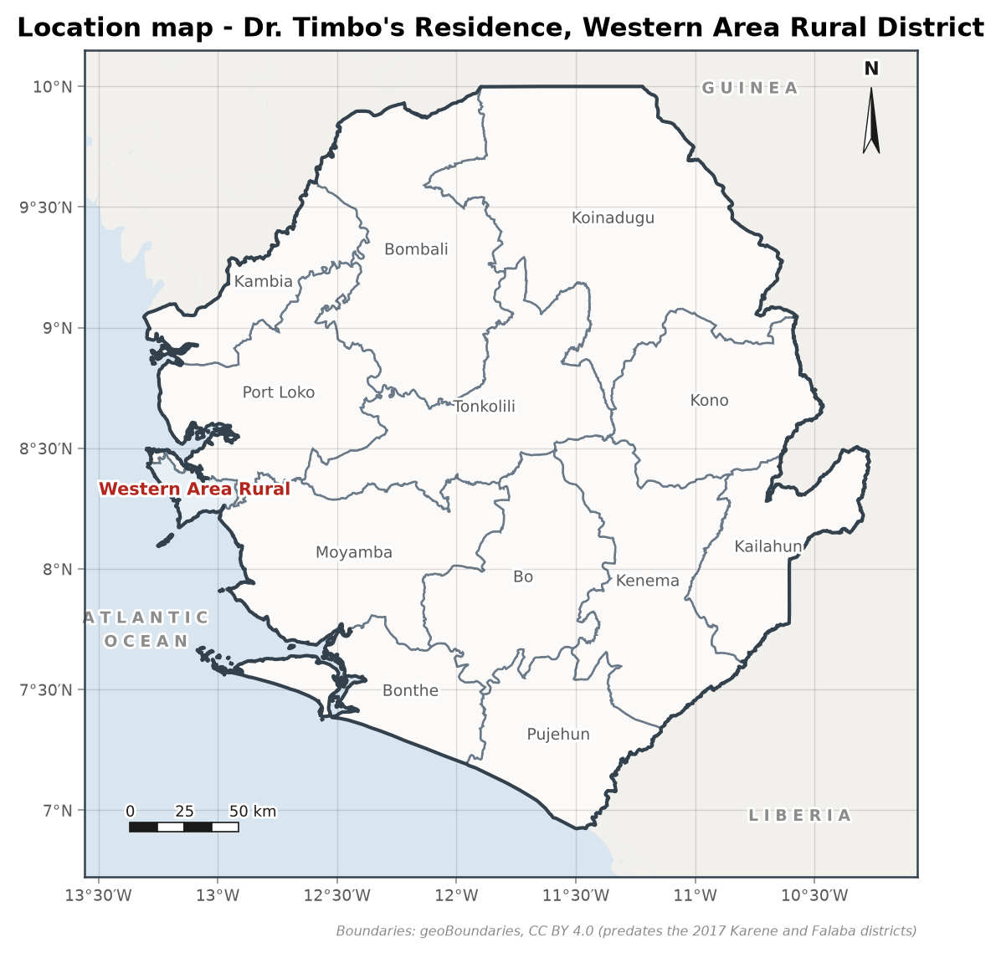
Figure 2. Location of Western Area Rural district. Boundaries from geoBoundaries (CC BY 4.0).

2. Works Completed
- Drilling of the borehole to 70 m by Air rotary (DTH hammer).
- Construction designed with 5 inch uPVC casing, 19 m of screen, no gravel pack (the 19 mm annulus is too thin to place one) and sanitary seal to 20 m; the drilling log records no casing string as installed.
- Development of the borehole by air lifting until clear.
- Pumping test and yield assessment.
- Water quality sampling and laboratory analysis.

3. Borehole Data Sheet
Table 1. Key borehole data.
Item | Value
Borehole reference | BH-1
Total depth | 70 m
Drilling method | Air rotary (DTH hammer)
Water strikes | 12 m, 30 m
Completion date | 13th May, 2018
Status | Successful
Drilled diameter | 6.5"
Casing | 5" uPVC, stick-up 0.5 m
Screens | 25-35 m; 48-53 m; 59-63 m (slot 0.75 mm)
Annular fill | 23-70 m: no gravel pack: the 19 mm annulus is too thin to place one
Backfill | 20-23 m
Sanitary seal | 0-20 m cement grout
Static water level | 9.44 m
Recommended pump intake | 54 m
Transmissivity | 0.536 m2/day
Safe yield (safety factor 1.5) | 0.39 m3/h (0.22 to 0.71) (indicative)
Yield confidence | indicative: the test pumped for 30 minutes, below the 240 needed to see late-time behaviour, so the yield is extrapolated 4.2 log cycles of time; the whole test lies inside the 117-minute casing-storage period, so its drawdown is the borehole emptying rather than the aquifer responding; no transmissivity method fitted to standard and the Cooper-Jacob value is adopted as the best available
Pump intake depth | 54 m below the top of the casing
Pump type | Submersible pump

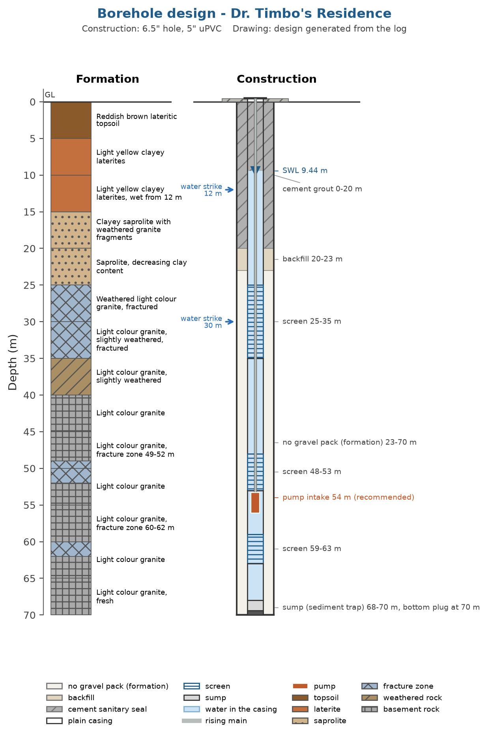
Figure 3. Borehole construction design generated from the drilling log; the log records no casing string, so this is not an as-built record.
Design notes:
- [WARNING] thin_annulus: A 5 inch casing in a 6.5 inch hole leaves 19 mm of annulus per side, under the 50 mm needed to place gravel without bridging (70 mm for a true filter pack), so no gravel pack is drawn or priced and the screen slot must suit the formation; use a larger bit or smaller casing to fit one.

4. Water Quality
The water does not meet the health based guideline value for: Manganese. Treatment or an alternative source is required before the water is used for drinking.
Table 2. Parameters above guideline or standard limits.
Parameter | Value | Unit | Remark
Manganese | 0.12 | mg/L | exceeds the WHO health based guideline (0.08)
Total coliforms | 4 | CFU/100 mL | detected above the national limit (0); an indicator of ingress or inadequate wellhead protection, not of faecal contamination in itself, and WHO sets no health based guideline for it
pH | 5.9 | pH units | exceeds the national acceptability limit (6.5-8.5), which is provisional; the WHO acceptability value is 6.5-8.5
Iron | 0.85 | mg/L | exceeds the national acceptability limit (0.3), which is provisional; the WHO acceptability value is 0.3

The national column in the standards table is provisional: its values are WHO guideline figures carried across, or limits adopted from regional practice, and have not been confirmed against the Sierra Leone Standards Bureau drinking water specification. Confirm the figures before treating a national exceedance as a compliance finding.

5. Operation and Maintenance Guidance
The lifetime of the borehole depends on routine care. The tasks below follow standard rural water supply practice; the community should keep a logbook of all maintenance, breakdowns and payments.
Daily
- Keep the pump house, apron and surroundings clean; no washing or animal watering at the tap stand.
- Check for leaks, unusual pump or motor noise, discoloured water and a falling flow.
- Keep the drainage channel and soakaway free flowing.
Weekly
- Record the hours of pumping and the meter reading, if fitted.
- Check the control box, cables, starter and (for a solar pump) the array for damage, loose connections and shading.
Monthly
- Measure and record the water level where a dip access exists.
- Collect the agreed user fees and update the cash book.
- Inspect the fence and the sanitary protection zone (no pit latrine, refuse pit or animal pen within 30 m).
- Check the running current against the commissioning value.
Yearly
- Service the pump and motor according to the manufacturer schedule; check the rising main and cable for corrosion and wear.
- Repeat the physico-chemical and bacteriological water tests.
- Review the tariff against the cost of spare parts and power.
Operate the pump at no more than 0.391 m3/h and allow the recommended rest periods. If the water level reaches the pump intake, stop pumping and let the borehole recover.

6. Community / WASH Committee
Table 3. WASH committee members responsible for the water point.
Role | Name | Phone
Chairperson | To be completed
Secretary | To be completed
Treasurer | To be completed
Caretaker | To be completed

7. Recommendations
- Specify uPVC or stainless steel (grade 304 or 316) for the rising main and pump components, and avoid galvanised iron and mild steel, which corrode rapidly in this water and are a leading cause of premature pump failure. Inspect the rising main and the wetted metal parts of the pump for corrosion at each service.
- Implement the treatment measures in the water quality report before the water is used for drinking.
- Protect the wellhead: keep the 30 m sanitary zone free of latrines, refuse pits and animal pens.
- Keep this report and the borehole data sheet with the committee records; any future contractor will need them.
- Report persistent taste, odour or discolouration to the district water office and arrange a water quality test.

References
Rural Water Supply Network (2015). Professional Water Well Drilling: A UNICEF Guidance Note. St Gallen: RWSN / UNICEF.
World Health Organization (2022). Guidelines for Drinking-water Quality, 4th edition incorporating the first and second addenda. Geneva: World Health Organization.
Sierra Leone Standards Bureau. Sierra Leone Standard for drinking water quality (SLS). Freetown: SLSB. Edition and date not verified against the issued specification: the national limits this toolkit applies are provisional (WHO or regional figures carried across) until confirmed against it.

Glossary and Abbreviations
Term | Meaning
VES | Vertical electrical sounding, a resistivity depth survey
AB/2 | Half the current-electrode spacing in a Schlumberger array
ohm-m | Ohm-metre, the unit of electrical resistivity
ERR | Root-mean-square misfit of the fitted layered model (percent)
S (Dar-Zarrouk) | Longitudinal conductance, sum of thickness/resistivity (siemens)
T (Dar-Zarrouk) | Transverse resistance, sum of thickness x resistivity (ohm m2)
SWL | Static water level, the rest water level before pumping
DWL | Dynamic water level, the water level during pumping
T (transmissivity) | Aquifer transmissivity (m2/day)
S (storativity) | Aquifer storage coefficient (dimensionless)
m3/h | Cubic metres per hour, a discharge or yield rate
LSI / RSI | Langelier and Ryznar indices of water corrosivity and scaling
WQI | Water Quality Index, an aggregate 0-based quality score
HI | Health Hazard Index, the sum of chronic hazard quotients
uPVC | Unplasticised polyvinyl chloride, the casing and screen material
GPS / UTM | Satellite positioning and the Universal Transverse Mercator grid
WASH | Water, sanitation and hygiene
RWSN | Rural Water Supply Network
SALWACO | Sierra Leone Water Company
WHO | World Health Organization
SLSB | Sierra Leone Standards Bureau

8. Handover Signatures
The works described above are handed over to the client and the community in working condition.

..............................
For the contractor: WiNGiN Heavy Duty Machines Co. Ltd
Date: ........................

..............................
For the client: Dr. Timbo
Date: ........................

..............................
For the community / WASH committee:
Date: ........................

