Aweil Malaria Monitoring, Evaluation & Data Quality System
End-to-End M&E Portfolio Project
Synthetic public-health project demonstrating Monitoring & Evaluation, data management, data quality assurance, analysis, reporting, and data-use skills.

Project Overview
This project simulates the work of an M&E Assistant supporting malaria programming in Aweil, South Sudan.
The project models an end-to-end Monitoring & Evaluation data workflow, from facility-level data collection and submission management through data quality assessment, cleaning, indicator analysis, reporting, and management action.
The simulation is designed around the practical responsibilities commonly expected of an M&E/data management officer working in a public-health programme.
Project Objective
To design and implement a practical M&E system capable of:
- Collecting facility-level programme data
- Monitoring reporting completeness and timeliness
- Applying data validation and quality checks
- Identifying and investigating data-quality problems
- Cleaning and standardizing programme data
- Calculating M&E indicators
- Producing management-oriented analysis
- Developing dashboards and reports
- Documenting data corrections and decisions
- Supporting evidence-based programme action

Important Disclaimer
All data in this repository are synthetic and created exclusively for portfolio and skills-demonstration purposes.
The project does not contain confidential beneficiary information, real patient information, or proprietary programme datasets.
The project is a simulation and should not be interpreted as evidence of employment with any organization or as analysis of real programme data.

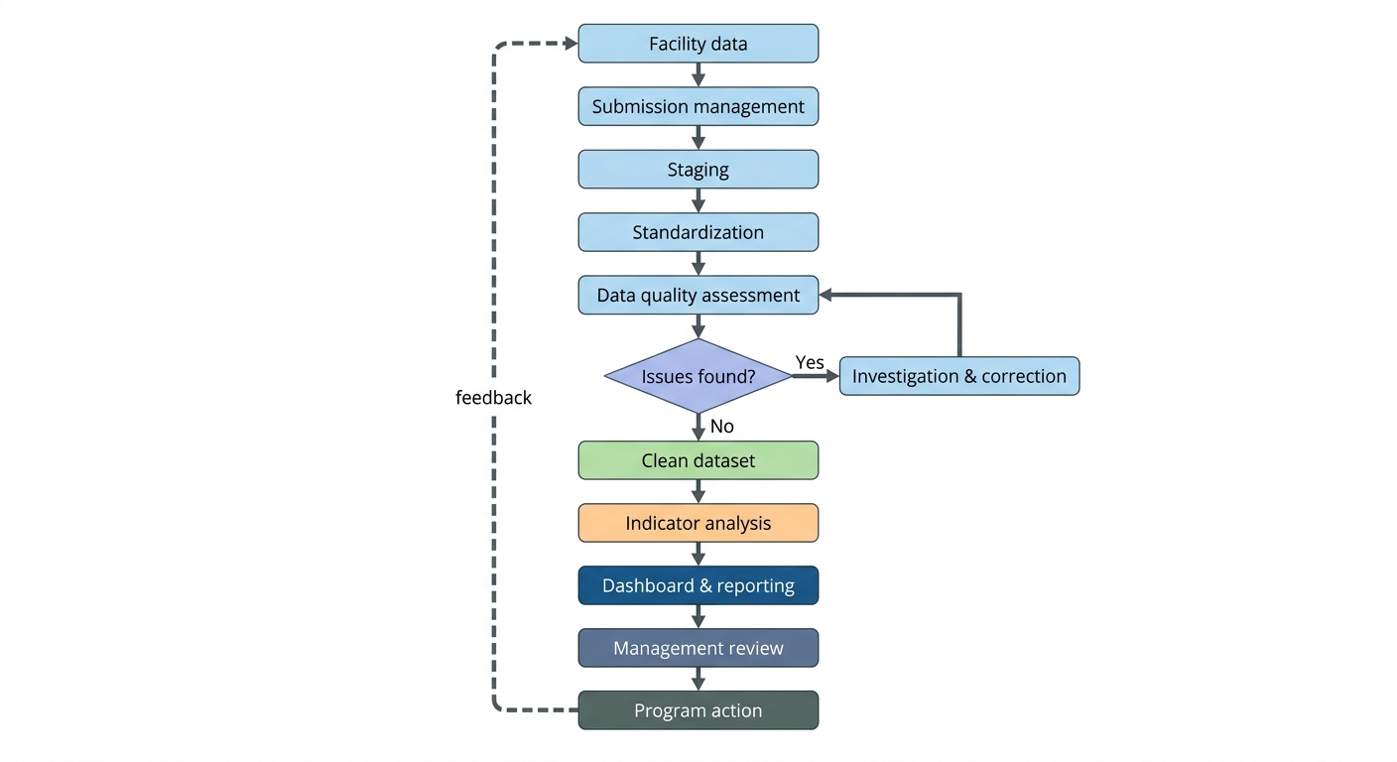
M&E System Architecture

Technical Stack
Area | Tools
Data Collection | Excel, ODK, KoboToolbox / XLSForm
Data Management | Excel, Power Query
Data Quality | Excel, Power Query, validation rules
Analysis | Excel, Power Pivot, Python/Pandas
Database | SQL / PostgreSQL
Visualization | Excel dashboards, Power BI concepts
Reporting | Excel, Markdown, PDF
Application | Streamlit
Health Information Systems | DHIS2
Documentation | Markdown, Git/GitHub

Project Missions
Mission | Focus | Status
01 | Project & M&E System Design | 🟢 Completed
02 | Indicator Framework | 🟢 Completed
03 | Data Collection System | 🟢 Completed
04 | Data Flow & Workflow | 🟢 Completed
05 | Submission Management | 🟢 Completed
06 | Data Quality Assessment | 🟢 Completed
07 | Data Cleaning Pipeline | 🟡 In Progress
08 | DQA Investigation & Change Control | ⚪ Planned
09 | Monthly M&E Analysis | ⚪ Planned
10 | Dashboard | ⚪ Planned
11 | Monthly M&E Report | ⚪ Planned
12 | Management Review | ⚪ Planned
13 | Field Monitoring | ⚪ Planned
14 | ODK/Kobo | ⚪ Planned
15 | SQL M&E Database | ⚪ Planned
16 | Python Automation | ⚪ Planned
17 | DHIS2 | ⚪ Planned
18 | Streamlit M&E Application | ⚪ Planned
19 | Data Governance | ⚪ Planned
20 | Full M&E Assistant Simulation | ⚪ Planned

Key M&E Capabilities Demonstrated

M&E System Design
- Results frameworks
- Indicator definitions
- Data sources
- Reporting responsibilities
- Data-flow design

Data Management
- Facility master data
- Submission tracking
- Data standardization
- Staging and clean datasets
- Data traceability

Data Quality Assurance
- Completeness
- Timeliness
- Validity
- Consistency
- Uniqueness
- Accuracy
- Traceability
- DQA investigation
- Corrective action tracking

Data Analysis
- Indicator calculation
- Coverage and performance analysis
- Trend analysis
- Programme interpretation
- Management-oriented findings

Technical Skills
- Excel
- Power Query
- Power Pivot
- Python/Pandas
- SQL
- ODK/Kobo/XLSForm
- DHIS2
- Streamlit
- Git/GitHub

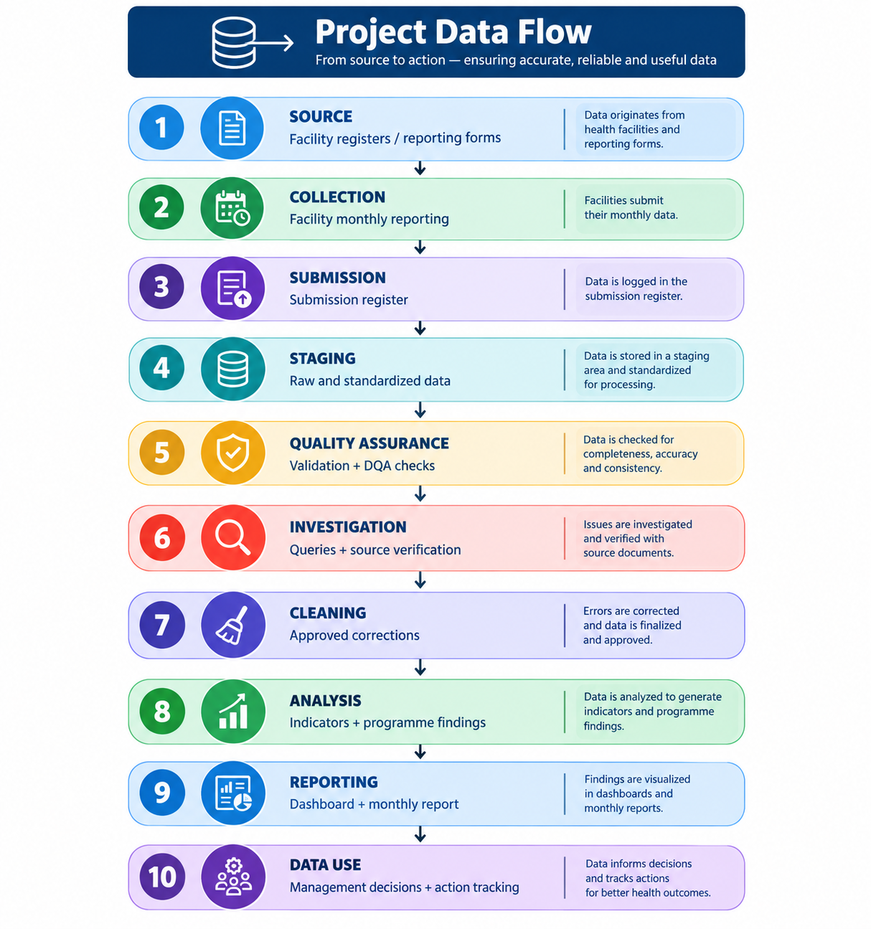

Repository Structure
01_project_design/
Project overview
Results framework
Indicator reference sheet
Assumptions

02_data_collection/
Facility reporting form
Data dictionary
Validation rules

03_data_flow/
Data-flow workflow
Workflow diagram
Data-management SOP

04_submission_management/
Submission tracker
Submission register

05_data_quality/
DQA framework
DQA rules
DQA flags
Investigation log
Change log

06_data_cleaning/
Raw data
Staging data
Clean data
Power Query transformations

07_analysis/
Indicator calculations
Analysis
Findings

08_dashboard/
Dashboard
Screenshots

09_reporting/
Monthly M&E report
Management summary

10_field_monitoring/
Supervision checklist
Field visit report
Action plan

11_odk_kobo/
XLSForms
Forms
Documentation

12_sql/
Database schema
DQA queries
Analysis queries

13_python/
Data cleaning
DQA automation
Analysis

14_dhis2/
DHIS2 implementation documentation

15_streamlit/
M&E application

docs/
Architecture
Data dictionary
Project journal

Current Project Status
The project is being developed mission-by-mission.
Each mission documents:
- The programme problem
- M&E requirements
- Data structure
- Technical implementation
- Data-quality controls
- Investigation and decision-making
- Outputs produced
- Lessons learned

This approach demonstrates not only the ability to manipulate data, but also the ability to design, manage, quality-assure, analyse, document, and use M&E information for programme decision-making.

Portfolio Goal
The final product will demonstrate an end-to-end M&E capability rather than isolated software skills.
