Rate 'N Date Chatroom:
1. Please run/import the attached chartroomdb.sql script on your database, and confirm if the chatroomdb is created on your database.
2. Update the database settings on the config.ini file, the file is on classes folder (see below screenshot)
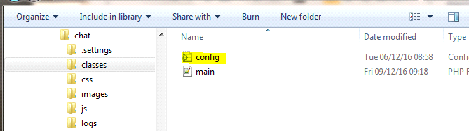

3. I have added the following users for testing
Username: mskay@test.co.za password: Test123
Username: moss@test.co.za password: test
Username: shady@test.co.za password: TEST

