**INTRODUCTION**

The Boost converter is the one of six topologies of DC-DC converters which are widely used in many power electronic appliances and also application circuits, such as battery powering circuit, uninterruptible power supply (UPS) among others.

A boost converter is one of the simplest types of switch mode converter. As the name suggests, it takes an input voltage and boosts or increases it. Its main function is to maintain the output voltage as close as possible to a desired reference voltage.

The biggest advantage boost converters offer is their high efficiency – some of them can even go up to 99% In other words, 99% of the input energy is converted to useful output energy, only 1% is wasted.

This report will take a boost converter circuit, simulated under various load conditions, in order to analyze current and voltage waveforms and the effect of the varying conditions on the overall circuit.

**METHODOLOGY**

**MODELING OF BOOST CONVERTER**

The sketch of the boost converter to be modelled is shown below:

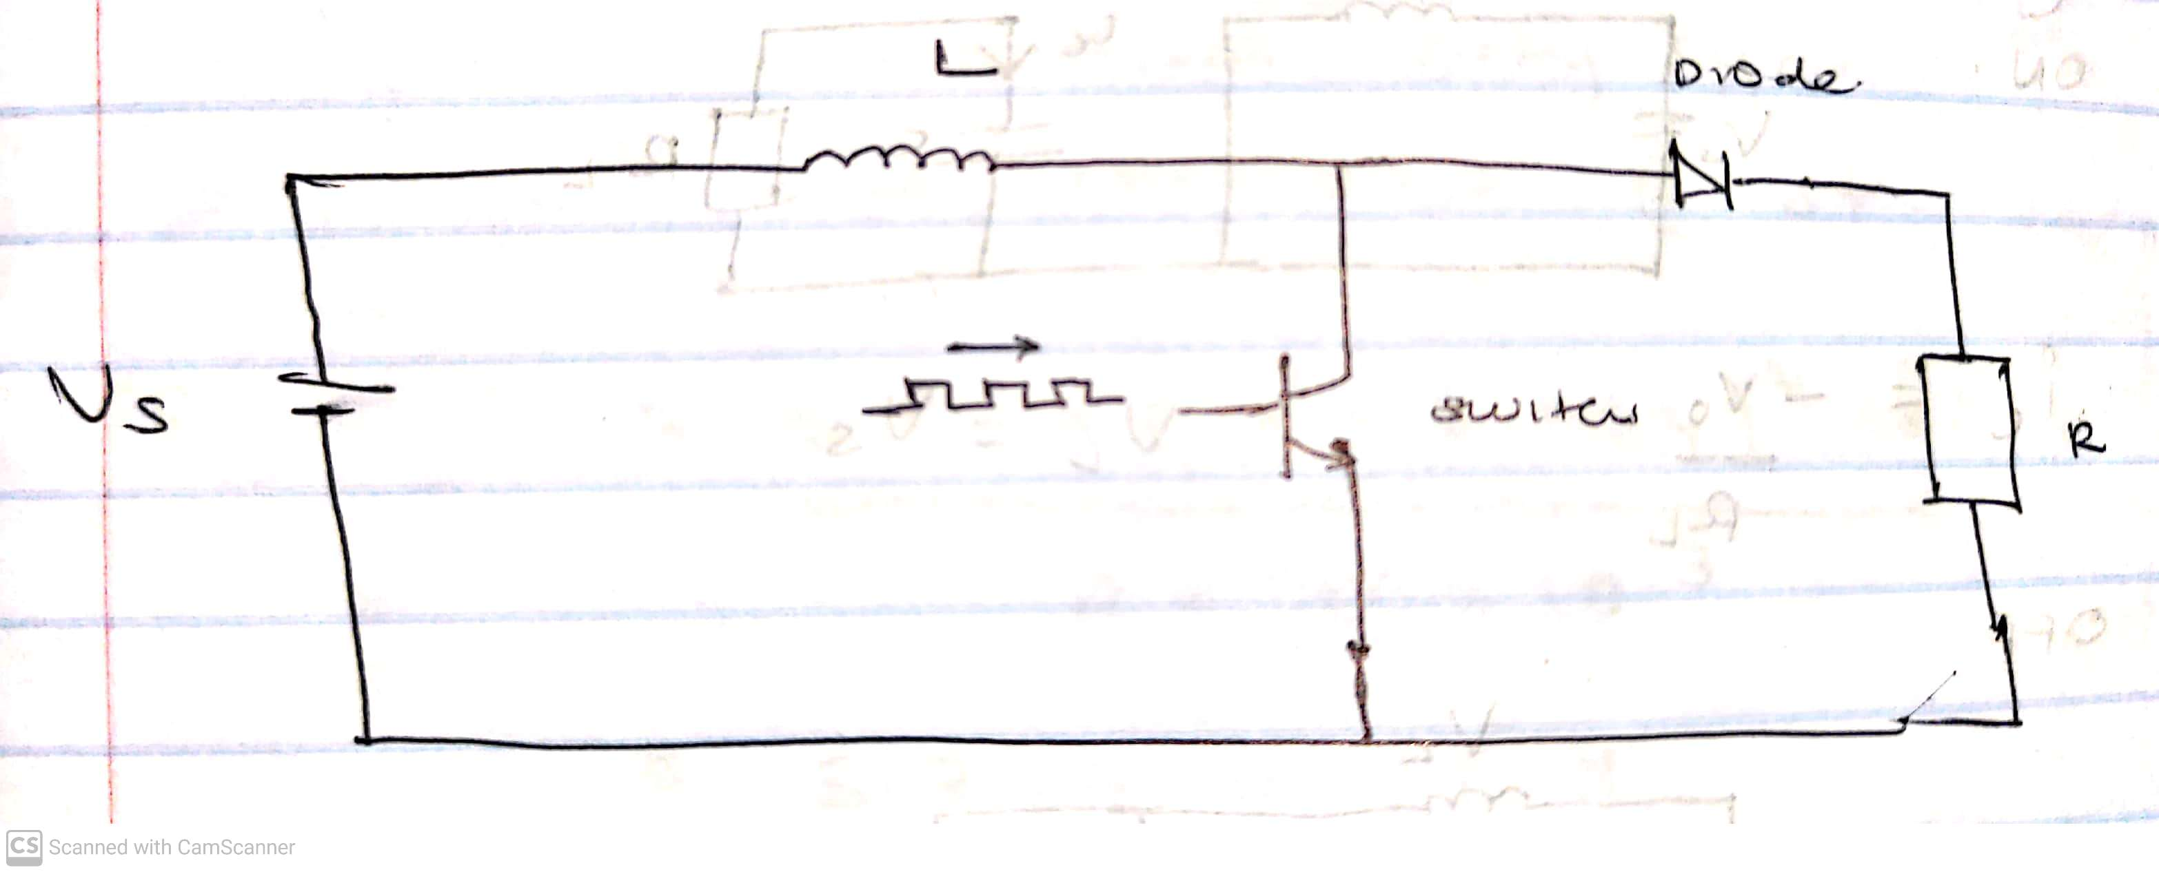

The mode of operation of boost converter is based on two states; ON state and OFF state. ON state is also referred to as charging mode, and OFF state as discharging mode.

**Mode 1, Switch ON $(t=0, t=Ton)$**

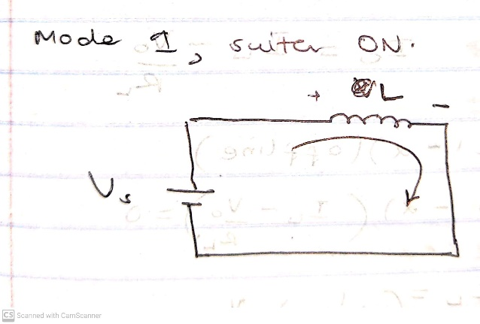

$At t=0, io=Imin$ $t=Ton, io=Imax$ $Imax – Imin =$ $\frac{Vs}{L}Ton………………(1)$

During the charging mode; when the switch is closed, the diode is in reversed-biased condition. All the current is diverted through to the switch through the inductor. The output capacitor stays charged since it can’t discharge through the now back-biased diode. Also, a magnetic field builds up around the inductor. Note the polarity of the voltage applied across the inductor.

**Mode 2, Switch OFF (t=0, t=Toff)**

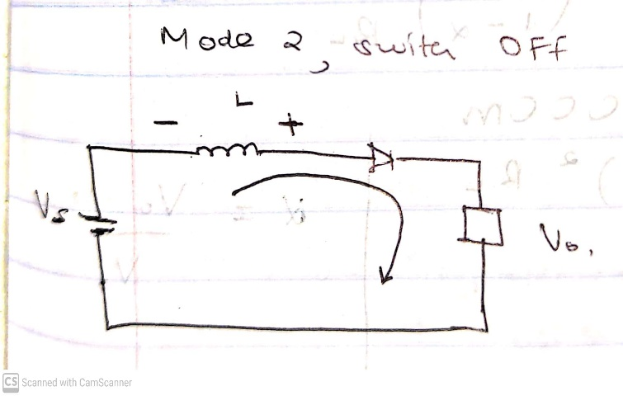

$$At t=0, io=Imax$$

$$At t = Toff, io = Imin$$

$$Imax – Imin = \frac{Vo-Vs}{L} Toff……………(2)$$

The switch is turned off and the current to the inductor is stopped abruptly.

The very nature of an inductor is to maintain smooth current flow; it doesn’t like sudden changes in current. It responds to this by generating a large voltage with the opposite polarity of the voltage originally supplied to it using the energy stored in the magnetic field to maintain that current flow.

Noticing the polarity symbols, the inductor now acts like a voltage source in series with the supply voltage. This means that the anode of the diode is now at a higher voltage than the cathode, recalling that the capacitor was already charged to supply voltage in the beginning. The diode is thus forward biased.

The output capacitor is now charged to a higher voltage than before, which means that a low DC voltage has successfully been stepped up to a higher one!

To obtain expressions for transfer function M(α)=Vo/Vin:

Equating (1) and (2)

$$\frac{Vs}{L}Ton= \frac{Vo-Vs}{L} Toff$$

$$Vs Ton=\left(Vo-Vs\right) Toff$$

$$Recall Ton + Toff = T$$

$$Vs Ton = Vo Toff – Vs Toff$$

$$Vs(Ton + Toff) = VoToff$$

$$VsT = VoToff$$

$Vo = Vs\frac{T}{Toff}$ $Vo=Vs\frac{T}{T-Ton}$ $Vo=Vs \frac{1}{1-Ton/T}$

Recall $∝ = \frac{Ton}{T}$

Thus M (∝) = $\frac{Vo}{Vs}= \frac{1}{1- ∝}$

$$Vo=Vs \frac{1}{1-∝}$$

Calculating Inductor Current:

Using charge rule

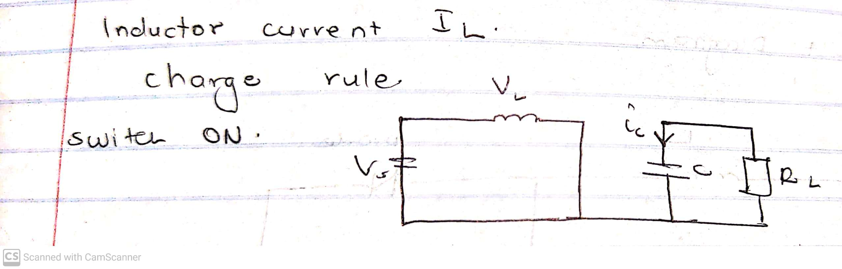

$ic = \frac{-Vo}{R_{L}}$ VL = VS

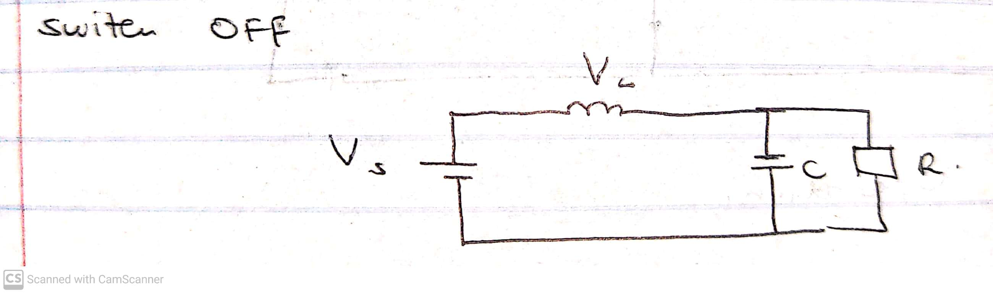

Solving for IL :

To design L and C for ripple requirement:

$$L_{C}= \frac{∝{(1-∝)}^{2}R_{L}}{2f}$$

$$Lc = 10 Lc$$

$Cc = \frac{\left(Vo-Vs\right)Io}{fVo2r_{f}}$

At CCM, the largest inductance desired which occurs at minimum duty cycle (αmin) and maximum load resistance (at Vsmax and Iomin) Vsmax = 42V, Iomin = 0.5A , fsw = 20 KHz

$$∝ = \frac{90-42}{90}= 0.5333$$

V = IRL

RL = = = 180Ω

Lc = $\frac{0.5333(1-0.5333)^{2}180}{2 x 20 x {10}^{3}}$ = 5.227 x 10-4 H

L = 10 Lc = 5.227mH

Rf = 10% = 0.1

Cc = $\frac{\left(90-42\right)0.5}{\left(20 x {10}^{3}\right)x {\left(90\right)}^{2} x (0.1)}$ = 1.481 µF

Switch Rating:

$I_{L}= \frac{1}{1-0.5333} x \frac{90}{180}$ = 1.071A

**Choosing of components**

**Diode**

To select a diode, we need it to have:

* a fast switching speed
* low conduction loss
* low forward voltage drop

The diode should have Small Forward Voltage (Vf) to prevent losses and increase efficiency.

Capacitance between diode should be small. If it is large, switching speed is slowed.

It should also have a small reverse leak current (IR). With high IR, efficiency decreases at light load.

Finally, we need to determine the max. voltage that the diode will have across it in reverse.

To get the minimum ratings:

The voltage will be the difference in potential between two points multiplied by 1.25:

(90-42) x 1.25 = 60V

To get the maximum ratings:

Voltage:

The voltage will be the difference in potential between two points multiplied by 2.5:

(90-42) x 2.5 = 120V

A Schottky diode was selected due to its fast switching speed.

The **UF4003** diode was chosen.

**Choosing Switch (Transistor)**

In choosing a transistor:

* Breakdown voltage should be higher than maximum output voltage of converter.
* Gate capacitance should be low. The lower it is, the easier the driving requirements. (Increases switching speed)
* Rdson should be low.
* Vgsoff should be lower than Vs
* It should have a short **turn-on** delay time.

IRF540N was selected as it fitted all these specifications.

**Choosing Capacitor**

Capacitance limits ripple. The bigger the capacitor the smaller the ripple.

Our calculated capacitance value is 1.481µF.

When selecting a standard capacitor value, we chose a higher value capacitance of 1.5 µF since we don’t want ripple to pass rating.

An aluminum electrolytic capacitor was due to its large capacitance and small size to help reduce the ripple voltage.

**SIMULATION AND ANALYSIS**

The simulations were done using SimPowerSystems toolbox of MATLAB/SIMULINK software.

The sketched model of the DC-DC boost converter was then implemented in Matlab/Simulink and the circuit modelled is shown below:

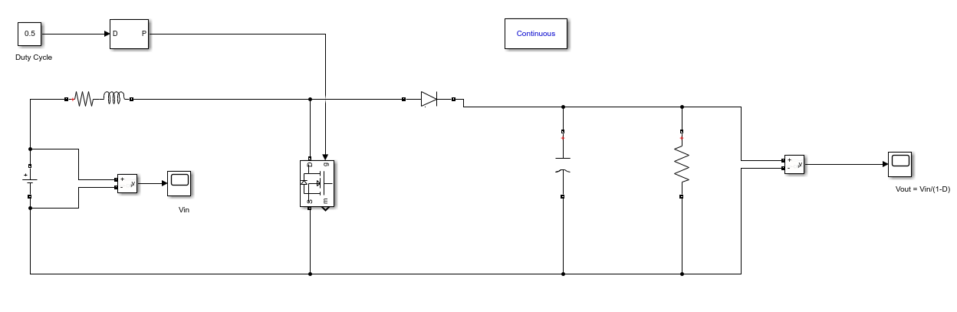

The circuit was then simulated in both light and heavy load conditions and the voltage and current waveforms of each component were plotted over 3 switching intervals in the steady state.

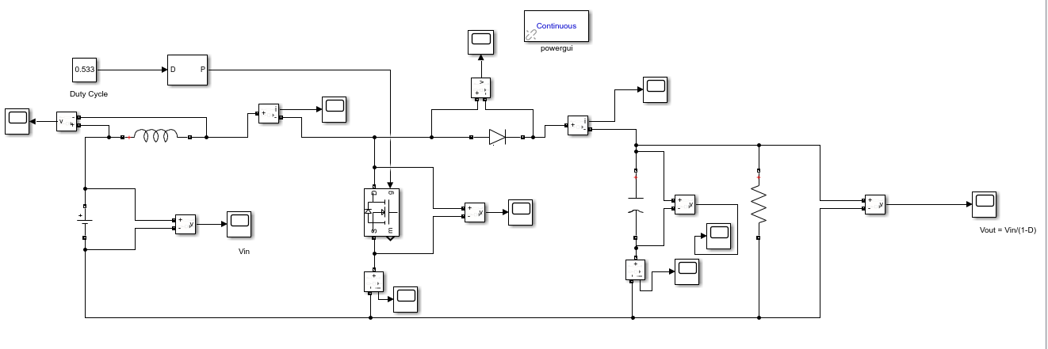Oscilloscopes were added to observe the voltage and current waveforms for each component:

**Current and Voltage waveforms**

**Capacitor Current**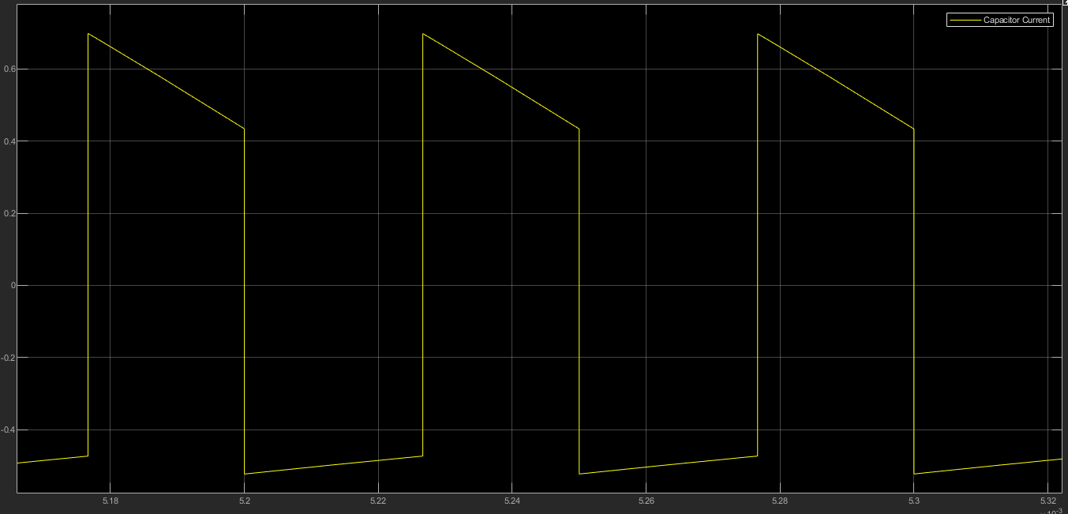

**Capacitor Voltage**

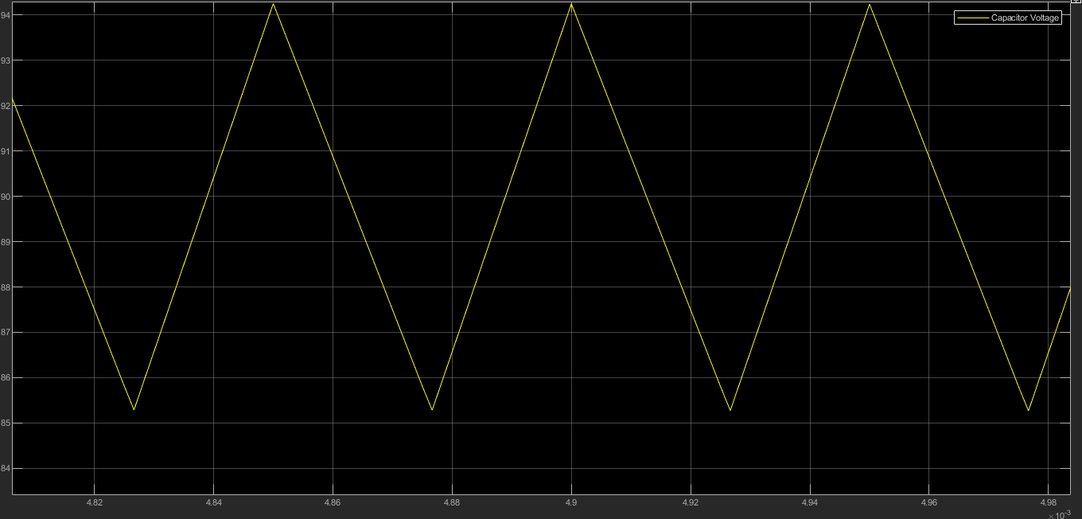

**Diode Current**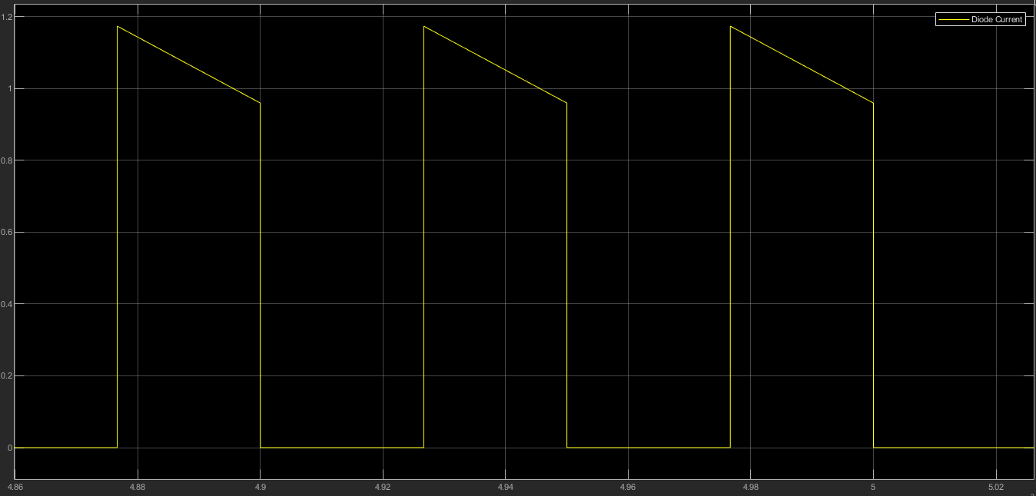

**Diode Voltage**

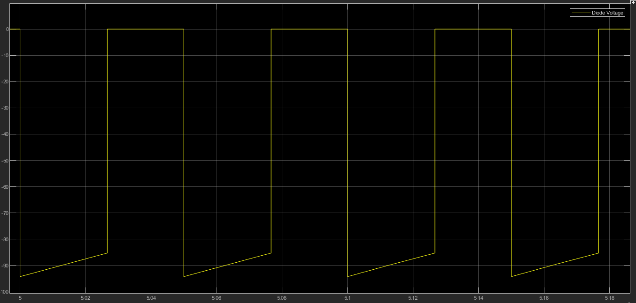

**Inductor Current**

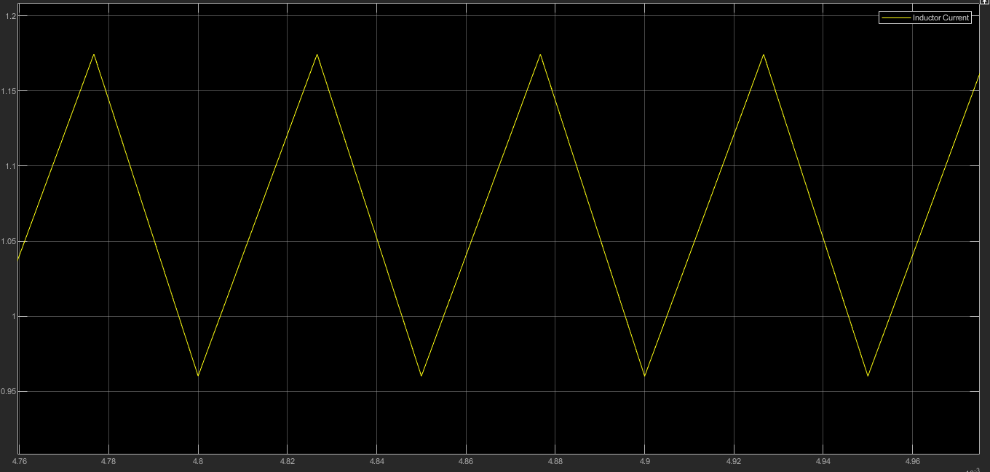

**Inductor Voltage**

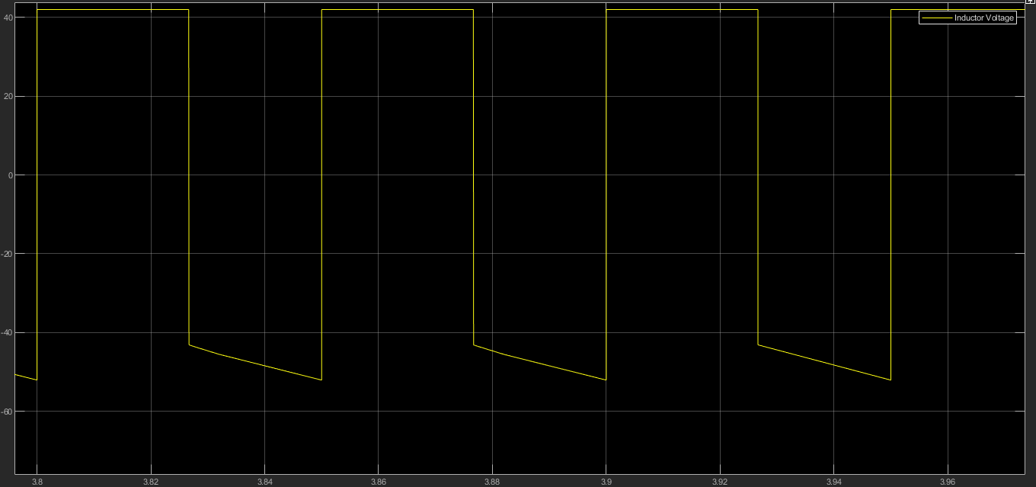

**Output Voltage**

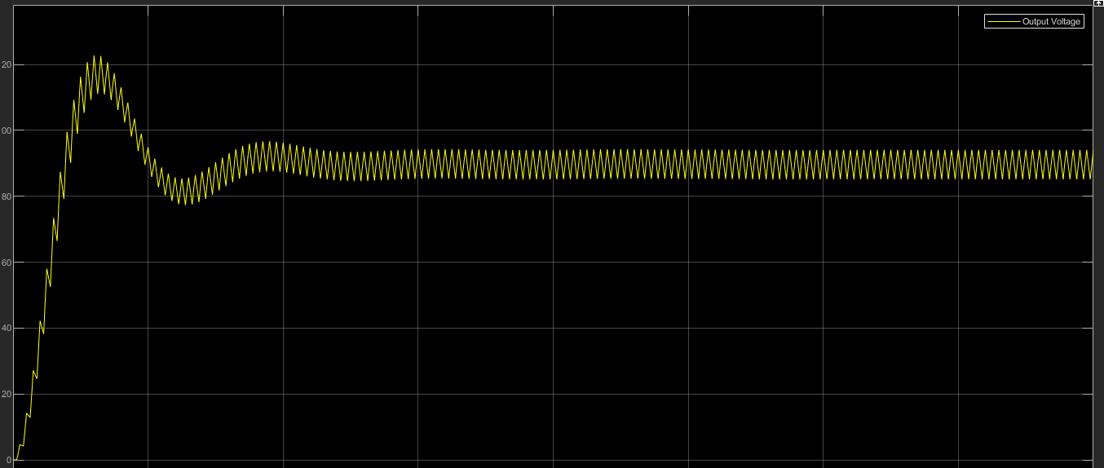

**Input Voltage**

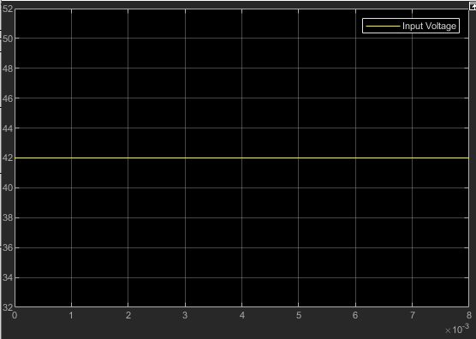

**Switch Current**

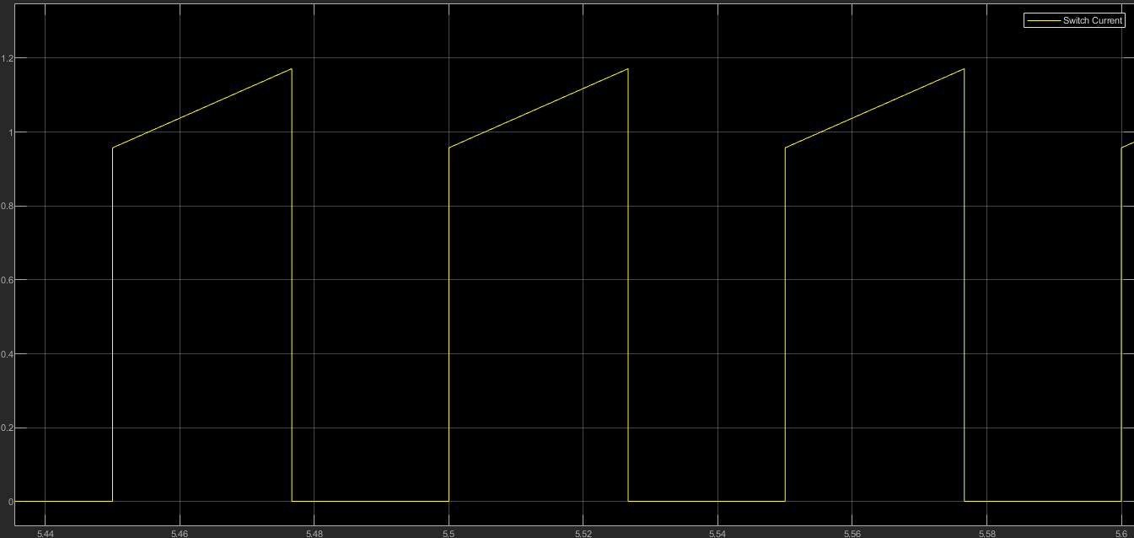

**Switch Voltage**

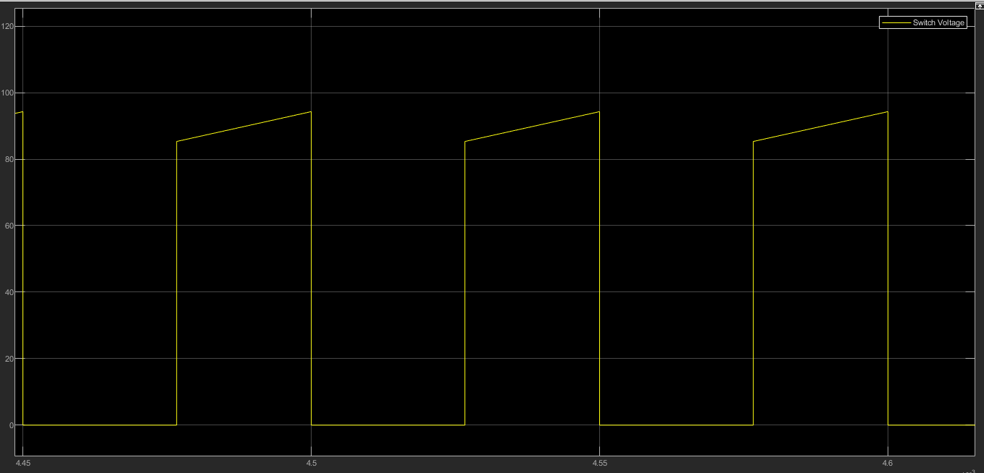

**Non-idealities added**

The diode was adjusted to have an on-state voltage drop of VDon = 0.5V as shown below

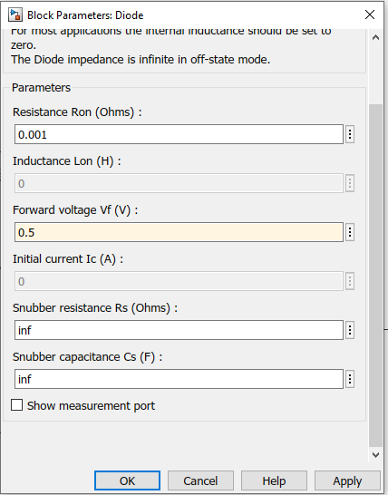

The transistor switch was given an on-state voltage drop of VTon = 0.9 V.

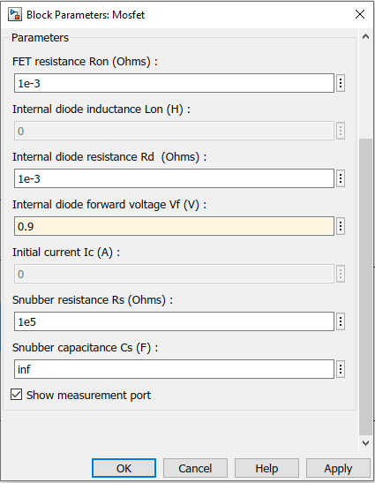

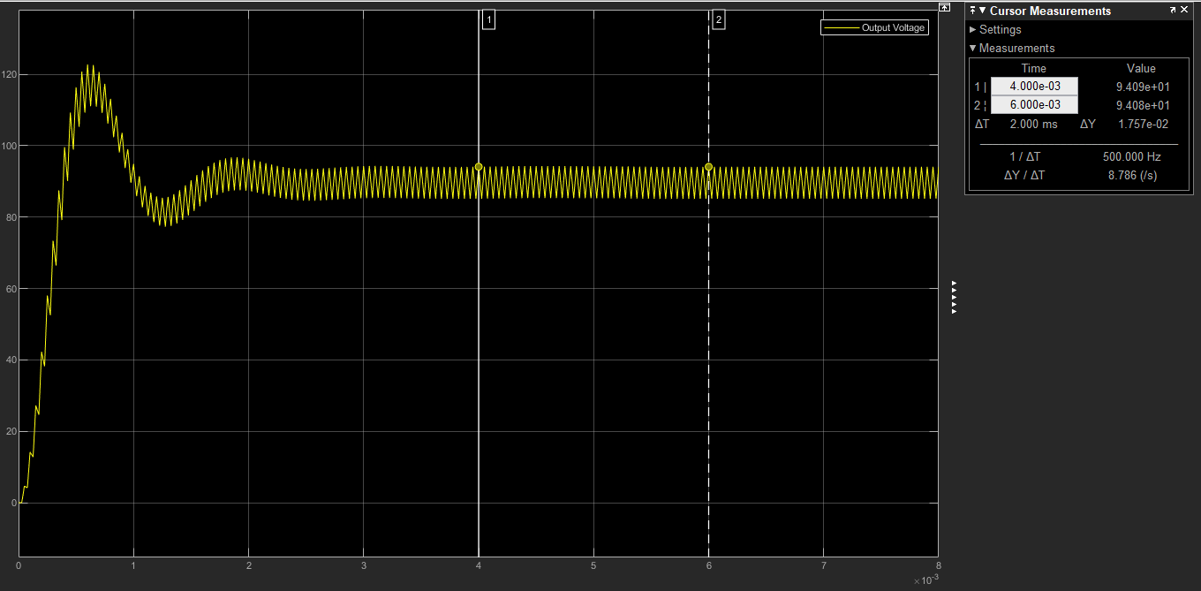Output Voltage waveform without non-idealities:

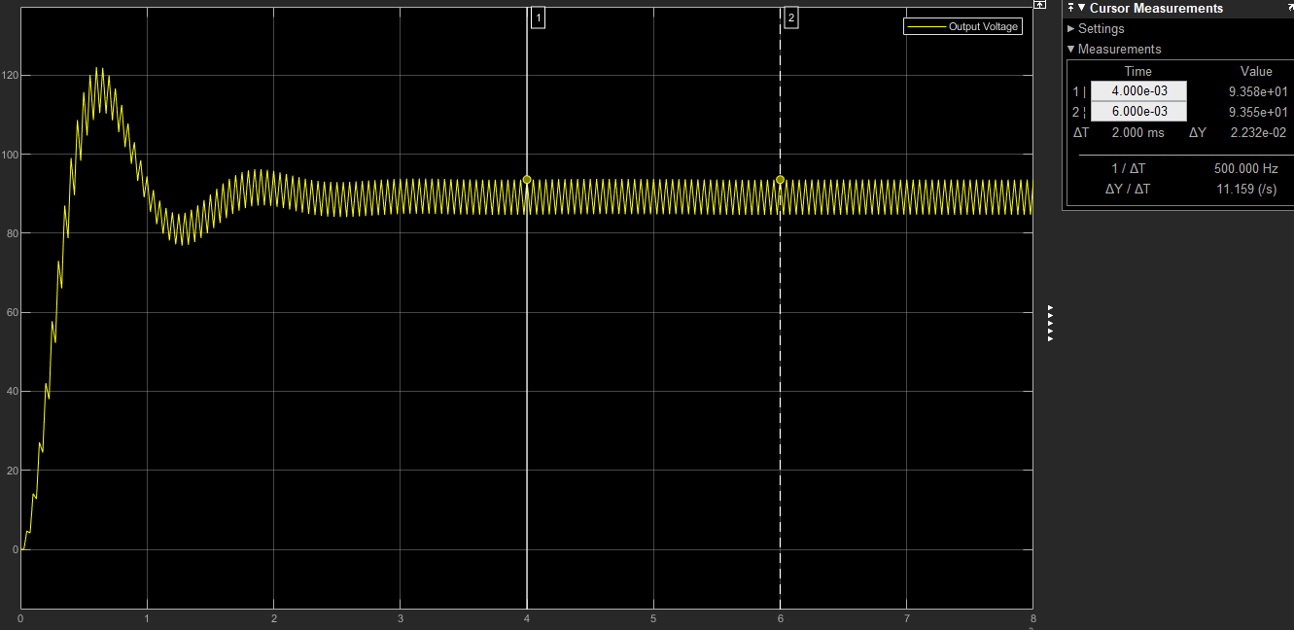Output waveform with non-idealities