

**Dean’s Dashboard User Guide**

**Module 1: Planning and Implementing a  
Dean’s Dashboard**

Draft Version 1.2: 29 June 2015

**Authors:** Rebecca Bailey, Jehu Iputo, David Potenziani, Jason Pickering, Carl Leitner

**TABLE OF CONTENTS**

Introduction to the Dean’s Dashboard 3

*Setting Targets* 4

Organizational and Technical Readiness 5

Key Performance Indicators 6

Examples of KPIs 6

*Input indicators* 8

*Contextual/Procedural indicators* 8

*Output indicators* 10

*Is your organization ready for the Dean’s Dashboard?* 10

Best Practices in Planning and Implementing a Dean’s Dashboard: Step-by-Step Guide 14

# Introduction to the Dean’s Dashboard

Every day, school leaders—such as presidents, principals, deans, directors, and department heads—must make critical decisions about the operations and management of their institutions. Sometimes those decisions are based on information and data. Other times they are based on educated guesses, because necessary data is not available or is too complex to quickly analyze. Computerized education dashboards can help to manage and make comprehensible the large amounts of data that school leaders must use to make decisions.

Dashboards extract information from different management information systems—such as finance, admissions, personnel, and infrastructure management systems—and display it in simple data visualization objects, such as charts and graphs. By translating complicated statistical analysis into clear visual representations, a dashboard empowers school leaders to define and measure key performance indicators in order to systematically track progress toward a school’s strategic goals. As high-level trends in school statistics are aggregated and visually highlighted, school leaders are able to see and quickly respond to evolving needs.

Similar to the dashboard of an automobile with its speedometer, odometer, and fuel gauge, the Dean’s Dashboard is meant to measure progress and chart trends, indicating either improvement over time or need for strategic action. The dashboard visually displays progress and trends at the chosen level of a department, school, faculty, or other larger group. Charts, graphs, maps, and other information objects can be easily customized to adjust to changing circumstances as well as address potential “what-if” questions that often arise when managing an educational institution. For example, school managers can revise thresholds and targets to encourage further progress after achieving an initial goal; add or remove key performance indicators and goals as the institution’s educational mission evolves; and modify the way trends are analyzed by, for example, disaggregating groups by age or gender (see Figure 1).

**Figure 1: Example Metrics That Can Be Tracked by the Dean’s Dashboard**

**Trends over time:** A school’s goal is to increase annual enrollment numbers. The dashboard charts the number of students newly enrolled each semester.

**Comparisons between groups:** A university aims to track the professional identity of enrolled students to understand how many of what groups are entering its programs. This figure looks at changes in enrollment for three types of health workers. Nurses have remained stable, but middle level health workers and medical students have increased in 2015, particularly for medical students.

**Comparisons within groups:** A school aims to track enrollments to see if they are aligning with its strategic goals. In this case, the school has sought to increase non-nursing students and the Dashboard can support tracking that over time—both within and across groups.

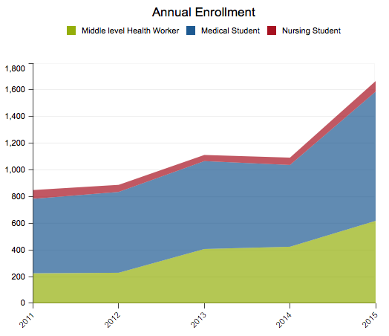

Dashboards are not meant to track single individuals or transactions. Rather, they consolidate and aggregate information collected through other management information systems. These include data systems used for finance and accounting, facilities and estate management, student information management, student records, learning management, student assessment, human resources management, alumni management, or any type of enterprise resource planning (ERP) system.

Most data systems provide some level of ad hoc reporting and dashboard capability, such as separate financial systems for budgeting and facilities systems that track the age of furniture and computers. Each provides a view of the situation from their own perspective, but by combining the data in a comprehensive dashboard, school leaders can understand the financial implications of aging computers requiring replacement in the context of the annual budget. Such approaches of integrating different systems into an all-encompassing dashboard application offer significant management and strategic benefits (Center for Digital Education 2011).

Since digital dashboards are commonplace today, the developers of the Dean’s Dashboard decided to adopt an existing platform that could be used by an academic institution. They sought an open source, reconfigurable, and sustainable application that could combine information from multiple data sources as well as have a rich set of information visualization features. The District Health Information System version 2 (DHIS 2) fit these requirements.

DHIS 2 was developed to capture and graphically display information on key performance indicators for health programs and service delivery at the health facility, district and national levels. The software is a mature, powerful, and user-friendly system that adheres to best practices in software development and implementation and is endorsed by WHO (Belay and Lippevald 2013). The system was developed by the Health Information Systems Programme (HISP), which is a global network established, managed, and coordinated by the Department of Informatics at the University of Oslo. It is being implemented in more than 40 countries, with PEPFAR, the Global Fund, and the Norwegian Agency for Development Cooperation (Norad) collaborating with HISP to expand and strengthen its use in countries. Years of development and implementation have created a large community of DHIS 2 experts who can provide ongoing technical support to its users. There are also regular DHIS 2 academies for users who wish to expand their competency in the use of DHIS 2 software to meet their needs.

As the design of DHIS 2 has little that is specific to the health context, it demonstrated good potential for adaptation to other uses. Thus, this set of manuals is designed to guide users in utilizing the existing DHIS 2 software to address the graphical reporting needs within their schools.

## *Setting Targets*

Setting targets helps an institution to focus its time, effort and resources to attaining its strategic objectives. It helps stakeholders stay aware of what is expected from them, and forms the basis for evaluation. It is advisable that the set targets are specific, measurable, achievable, realistic and time framed. An example target: *To improve retention rate by 20% in 2 years (precise and measurable)*.

# Organizational and Technical Readiness

Three areas intersect when considering implementing the Dashboard. They include the financial, human, and material resources necessary for success. These factors intersect to provide the institutional means for implementation and use. The degree of their combination and overlap can provide insight into the institution’s ability to use the Dashboard effectively. Human resources include not just the technical staff needed but also the leadership support for the endeavor. The leadership can devote financial resources needed to develop or access the material resources, especially in the form of data needed to inform key performance indicators. All of these are most useful in the context of a strategic plan and its ongoing measurement and evaluation. These areas form the backdrop and context for considering the use of the Dashboard.

Two types of readiness should be assessed by the organization to use the Dean’s Dashboard to greatest benefit: organizational and technical.

*Organizational readiness* relates to the role the Dashboard will play in the strategic path the institution is following. A couple of questions may help to determine that status: Does the institution have clear objectives for the Deans dashboard? Is there a clear message that needs to be communicated by the dashboard; what is the message and to whom is it directed? The audience could be students, academics, institutional administrators, government funding and/or regulatory agencies, and the community at large. The messages could include student enrollment data, student performance metrics, academic staff profile, teaching workloads, infrastructure capacity and utilization, research input and outputs, etc. Often, such questions are part of the planning or execution of a strategic plan, and offer opportunities to use the Dashboard to highlight progress as well as inform decision makers of information they need.

*Technical readiness* involves both the data and the technologies using them. A different series of questions come into play. Does the institution have the required data and/or a system and infrastructure for the collection of that data? In what form is the data – electronic or paper? How accessible is the data; are there legal, ethical or administrative constraints to its easy access and flow? There are various data management systems on the market – instructional data systems (such as a student information management system or a learning management system), administrative and operational data systems (such as enterprise resource planning, fiscal management, grants management), and integrated data systems that combine student data with operational and administrative data (integrated tertiary software). On the technology side of readiness, more questions come into play. Does the institution have the infrastructure to house the dashboard locally? Should the institution use a cloud-based implementation of the dashboard? Does the institution have the human resources to administer, service, support, and maintain the infrastructure for the dashboard? Finally, does the institution have budget resources for the dashboard? While open source and free to use, the Dean’s Dashboard does require technology resources to install and use as well as human resources to support the system.

# Key Performance Indicators

Performance metrics, also known as key performance indicators (KPIs), are measurements or combinations of measurements that indicate the status of a school’s instructional and administrative functions. They can be compared to a predetermined benchmark or target or serve as a simple notification. KPIs will vary based on an institution’s strategic goals and end user information needs. In higher education institutions, the general aim of an indicator system is to analyze its performance or, in other words, its strengths and weaknesses. Performance also means the institution’s ability to attain its goals.

Two prerequisites must be in place for any KPI system to succeed:

1. a functioning information system
2. clearly defined goals and objectives at institutional or program levels.

As a first prerequisite, a functioning information system should reliably contain the basic information needed to develop the indicators. Therefore, a KPI system is not the first step but rather the end result of a functioning information system that can make good use of data and communicate them clearly.

The second prerequisite is a policy or strategic plan that is sufficiently explicit and clear, providing a foundation upon which a KPI system can be constructed. A strategy or plan can facilitate the construction of the institution’s indicator system. In other words, a school should clearly define its goals and objectives in key performance areas - such as students, faculty, infrastructure, financing, and alumni – to guide the development of KPIs that are designed to measure performance in those areas.

All the indicators should be analyzed in the light of the institution’s strategic plan or its goals and objectives. The reason is that, in addition to presenting a clear, basic, and relevant description, a set of indicators should measure events and the progress of various activities that are of interest to stakeholders and administrators of educational institutions. A step-by-step best practices guide is described in [Best Practices in Planning and Implementing a Dean’s Dashboard: Step-by-Step Guide**]**

## Examples of KPIs

KPIs in the Dean’s Dashboard can include an infinite variety of issues, but for the sake of illustration three areas are the focus here: education, research, and management capacity (see exemplar information visualizations in Figures 2 and 3). In this case, it is important to have information on enrollments by discipline, trends in these over time, graduates by program and degree level, success rates and dropouts by program or discipline. If the development of a new academic program is part of the strategic plan, special attention must be paid to that program. Efforts must also be made to obtain data on the occupational situation of former students. With regard to academic staff, information should be obtained on their status, qualifications, and experience. It is important to know the sources of funding and whether trends in funding are in line with the strategic plan – for example, the development of resources generated by the institution. (Martin M., Sauvageot C. 2011.)

**Figure 2. Example Education KPI: Licensure exam pass rate at one college compared to all other colleges in the state**

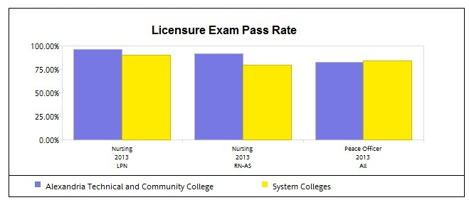

*Source: Minnesota State Colleges and Universities Accountability Dashboard (**http://www.mnscu.edu/board/accountability/index.html)*

**Figure 3. Example Management KPI: The dollar value of backlogged (deferred) maintenance on the facility over time**

*Source: Minnesota State Colleges and Universities Accountability Dashboard (http://www.mnscu.edu/board/accountability/index.html)*

Educational indicators can be grouped into input indicators, those indicators that are procedural and reflect the context of the institution offering the educational experience, and output indicators. Below are some examples of indicators, but bear in mind that every organization will develop KPIs based on its unique needs and goals.

## *Input indicators*

Application (head counts) per program in the school/Faculty/College

* Number applied by gender, race, urban/rural, socio-economic status (SES)
* Number and proportion of admission offers accepted and denied by gender, race, urban/rural, SES

Enrollment (head counts) per program in the school/Faculty/College

* By level of study i.e. Diploma/Bachelors/Postgraduate diploma/Masters/Doctorate
* By gender
* By race (in cases where race is a big issue e.g. in South Africa)
* By urban/rural divide
* By socio-economic status i.e. by either income or expenditure quintiles
* By presence or absence of a financial aid offer

## *Contextual/Procedural indicators*

Contextual and procedural indicators monitor key resources and processes required to deliver learner-centered, competency-based curricula. They can include measures related to governance and strategic planning, marketing and external relations, student throughput, personnel, infrastructure, and the procurement and management of equipment and materials. The following are example indicators in this category.

Student performance indicators (including comparison of demographic and geographic groups):

* Grades, tests
* Course repeat rate
* Year repeat rate
* Attrition rate
* Retention rate
* Academic probation rate (proportion falling below a specific grade point average)
* Extended probation rate (proportion falling below a specific grade point average for more than one term)
* Financial aid (proportion receiving financial aid)
* Academic counselling (proportion receiving academic counselling)
* Notification of at-risk students, including grades, demographics, evidence of engagement such as log-ins to school websites, participation in events and online interaction
* Notification of important course registration information (empty and full sections, scheduling, etc.)

Staffing and personnel indicators:

* Headcount of staff (by category: academic or administrative; by employment status: permanent or temporary; by gender; by race; by age group)
* Proportion of permanent to temporary academic staff
* Established academic posts (occupied and vacant) by academic rank
* Established administrative posts (occupied and vacant) by rank
* Academic staff qualifications by academic rank
* FTE student : staff ratio per discipline; per department; and per program
* Staffing at clinical practice sites (ratio of students to supervisor)
* Human resources statistics, such as promotions, raises, monthly payroll, status of top recruits, tenure information, employee performance or performance evaluations

Infrastructure indicators:

* Student Accommodation (capacity and occupancy) by gender
* Staff offices (capacity and occupancy)
* Lecture rooms (capacity and utilization)
* Tutorial and Seminar rooms (capacity and utilization)
* Clinical laboratory space (capacity and utilization)
* Simulation/Skills labs (capacity and utilization)
* Clinical facility teaching sites (capacity and occupancy)
* Community teaching sites student accommodation (capacity and occupancy)
* Usage statistics for media and library resources, campus documents, and other content
* Resource utilization, such as staff, rooms, buildings, energy, lighting, paper, print toner, equipment, IT resources, and parking permits
* IT usage statistics, such as network and application performance, system efficiency, heavy users of resources, equipment lifecycle, IT security and identification issues
* Student health services statistics, including illness tracking by location
* Notification of safety issues, emergencies or infrastructure problems

Financial indicators

* Institutional unit income by source – government grants, tuition, third stream (e.g. research grants)
* Status of pledges, tele-fundraising, funding proposals, and campaigns, alumni giving by school, department or career field
* Institutional unit expenditure by category (personnel costs, students costs, materials and equipment costs, and infrastructure costs)
* Cost of training a graduate by program (e.g. medicine, nursing, pharmacy, etc.)
* Sources of financial support (tuition) to the students (e.g. parents/family, scholarships, bursary, loans, etc.)
* Tuition payment rates (for schools that charge tuition)
* Departmental/business area expenses and revenue compared to forecast
* Financial indicators such as general ledger, accounts payable and receivable
* Purchasing information, such as status of purchase orders and notification of inventory problems
* Research information, such as status of grants and awards, or budget tracking

## *Output indicators*

Teaching output indicators (for each program of study per qualification level):

* Course success rate (percentage of students who pass a given course)
* Graduation rates
  + On time graduation rate (the proportion who graduated within the recommended number of years for the program)
  + Cohort graduation rate (among an input cohort the proportion who graduated)
  + Final year graduation rate (among those who entered the final year the proportion who graduated)
* Throughput rates (the number students of a specific cohort who have graduated either within the minimum time, or up to two years beyond the minimum time, to the number of students in the baseline enrollments of that cohort)
* Number and types of degrees awarded, and number of students enrolling but not receiving degrees
* Certification rate (among the students who graduate, the proportion who pass the certifying or licensing exam on the first attempt)

Research output indicators:

* Total annual publications by type i.e. journals, books, and conference proceedings per program
* Total research publication per permanent member of academic staff
* Total number of research publication per permanent academic staff member with a doctorate as the highest qualification.

Outcome indicators:

* Progression rates (general practice vs specialised practice, primary care vs speciality training)
* Employability rates
* Location of practice (public vs private, urban vs rural)
* Students entering graduate school or the workforce upon graduation from college, student career choices by degree

## *Is your organization ready for the Dean’s Dashboard?*

Answering these questions can help your institution understand its level of readiness to initiate the Dean’s Dashboard program. You may find it helpful to have a colleague review your responses or to answer the questions with a larger group (e.g., senior leaders).

1. Have you clearly defined the need that is driving your institution to consider implementing the Dean’s Dashboard?

* An organization is more likely to be ready to undertake a Dean’s Dashboard initiative when it has objective information to support the need for improving specific areas.

1. Does the institution have clear objectives for the Deans dashboard?

* Is there a clear message that needs to be communicated by the dashboard; what is the message and to whom is the message directed? The audience could be students, academics, institutional administrators, government funding and/or regulatory agencies, and the community at large. The message could be student enrollment data, student performance metrics, academic staff profile, teaching workloads, infrastructure capacity and utilization, research input and outputs etc.

1. Does the institution have the required data and/or a system and infrastructure for the collection of that data? In what form is the data stored – electronic or paper? How accessible are the data? Are there legal, ethical, or administrative constraints to the easy flow of data?

* These are procedural issues for data acquisition, storage, and access. While a number of types of software for data management systems in the educational sector, as mentioned above, they often contain segments of data need by purpose—financial, physical plant, human resources, etc. The combination of data from such systems is often the most useful step in providing information for decision makers. The institution must assess its ability to conduct relevant queries and construct meaningful reports to use in the dashboard.

1. Who in your organization uses information to guide decision making and process improvement?

* Dean’s Dashboard is an information system that offers visual reports on a number of indicators important to your institution. Understanding who can use that information, whether one individual or a team of persons, can affect how successful it can be for addressing your situation.

1. Is now the right time for implementing an information tool such as the Dean’s Dashboard (i.e., it will not compete with other major changes currently being made at your institution)?

* If your organization is currently experiencing many changes, it may not be the ideal moment to begin implementing the Dean’s Dashboard initiative. Attempting to manage multiple change efforts at one time may degrade your institution’s ability and employees’ willingness to implement and sustain the Dean’s Dashboard effort. The program may be viewed as a distraction rather than a solution.

1. Will your institution’s leaders support the effort required to implement and sustain the Dean’s Dashboard initiative?

* It is essential that the leaders of your institution actively support and champion Dean’s Dashboard. Leaders needs to understand the requirements of the program (e.g., identification of indicators is an iterative process spanning several weeks, technical preparation and training of system users, regular meetings to reinforce concepts and skills) and be willing to provide the personnel, time, and resources required to successfully implement and sustain the program.

1. Will your institution provide sufficient staff with the necessary skills and time to administer, service, and support the use of the Dean’s Dashboard?

* It is important to find individuals with the right mix of characteristics, both technical and business, to serve as users to increase the success of the Dean’s Dashboard initiative. They can become the facilitators of the Dashboard’s use by institutional leaders.

1. Will your institution allow time for personnel to attend technical training?

* Resources to support Dean’s Dashboard users include: Step by step user’s manual; expert community and user support group; and training opportunities.
* While the Dean’s Dashboard will be designed by participating institutions, some direct staff training is required. The full training element of the program includes up to 40 hours of classroom learning; however, your institution may decide to train only one segment (e.g., a specific indicator or set of related indicators) that may require 1 hour. To preclude disruptions and scheduling problems and to maximize learning, participants should be excused from all duties while attending class.

1. Does the institution have the infrastructure to house the dashboard locally? Does the institution have the resources to house the dashboard in the cloud?

* In terms of infrastructure needed, two options exist—in the cloud or local to the institution. Small institutions may prefer to pay for a cloud-based implementation (that is, to access and use the software entirely online) as purchasing and maintaining servers may be prohibitive. Institutions with strong ICT units may prefer to install the software locally in their data centres. Configuring and implementing the system is not overly complex, but support will be essential to new users.

1. Does the institution have a budget for the Dashboard?

* While open source software is free to use, it requires staff time and computational resources to set it up and maintain it use. Moreover, the institution will also need one or more individuals who work with its data to develop the visualization reports in the dashboard. All these functions take time and cost money, so budgeting the resources needed is a prudent step in adopting the Dashboard.

# Best Practices in Planning and Implementing a Dean’s Dashboard: Step-by-Step Guide

The following is an adaptation from the UNESCO’s “Constructing an indicator system or scorecard for higher education: A practical guide to help inform the planning and implementation process (Martin M., Sauvageot C. 2011).

Ten steps are required in developing a list of indicators or scorecard.

Step 1: Identify or define objectives.

Step 2: Create a list of ‘policy’ issues based on the objectives.

Step 3: Develop a list of indicators.

Step 4: List the data required to calculate the indicators.

Step 5: Locate the data sources available.

Step 6: Calculate the indicators.

Step 7: Verify the results.

Step 8: Analyze the indicators.

Step 9: Select the final indicators for the system.

Step 10: Select the layout of the indicator system.

From the very beginning of the process, a project manager should be designated. He or she will develop a list of the most relevant indicators for use and will oversee the various human or material resources put in place or mobilized for the project. The project manager should have solid experience in statistics, a sound capacity for analysis of the education system or institution as a whole, and the ability to run this type of project from its conception to final publication. Such an effort should be integrated into existing organizational structures for institutional sustainability. Building the list of indicators should be the topic of high-level discussion among all the departments or sections involved since they should provide a means of monitoring progress towards the goals of the institution’s strategy, by presenting an accurate picture of the current state of affairs and trends.

Therefore, it is often very useful in this process to establish a management or steering committee

comprised of representatives from each of the departments or sections concerned. The committee can be composed of people not only from the leadership of the institution, but also from component units of the university, school, or department and bring in expertise in administration, finances, physical plant, academic programs, and other relevant areas.

Once this committee has defined the main themes and objectives to measure, a working group,

comprising a small number of experts and led by the project manager, should execute the work. All aspects involved in the process should be covered.

To summarize, two groups are needed: a management or steering committee and a working group that will implement the project. This organizational structure, traditionally used in project management and operations, is indispensable. Deadlines should be clearly established on a strict schedule that governs the working group’s development of the indicators and the management committee’s policy validation process.

After two or three management committee meetings, the definitive list of indicators that will appear in the dashboard should be finalized. Only major unforeseen problems such as unavailability of data should interfere with the list validated by the management committee. After validation, the management committee gets involved again in the final discussion about the dashboard before its release (this subject will be covered below). To ensure that the indicator system will last over the long term, it is paramount to involve the groups concerned. After the first edition is published, work should begin on preparing the second, which is absolutely essential for the project’s continued success.

If indicator system production stops after the first edition, the project may falter and fail. Since it is the staff of established departments and sections who will be producing the document, they should be fully associated with the project structure, which should disappear as production of the indicator system is incorporated into their regular work. Obviously, the editor-in-chief, who reports to the project manager, must remain. All of this should be clearly specified in advance.

Once the indicators have been defined and the necessary organizational structures created, the actual work can begin. Figure 4is an example of a combined organizational structure and workflow chart of the production of an indicator system.

**Figure 4. Example of organizational structure and workflow**(Adapted from Martin M., Sauvageot C. 2011)

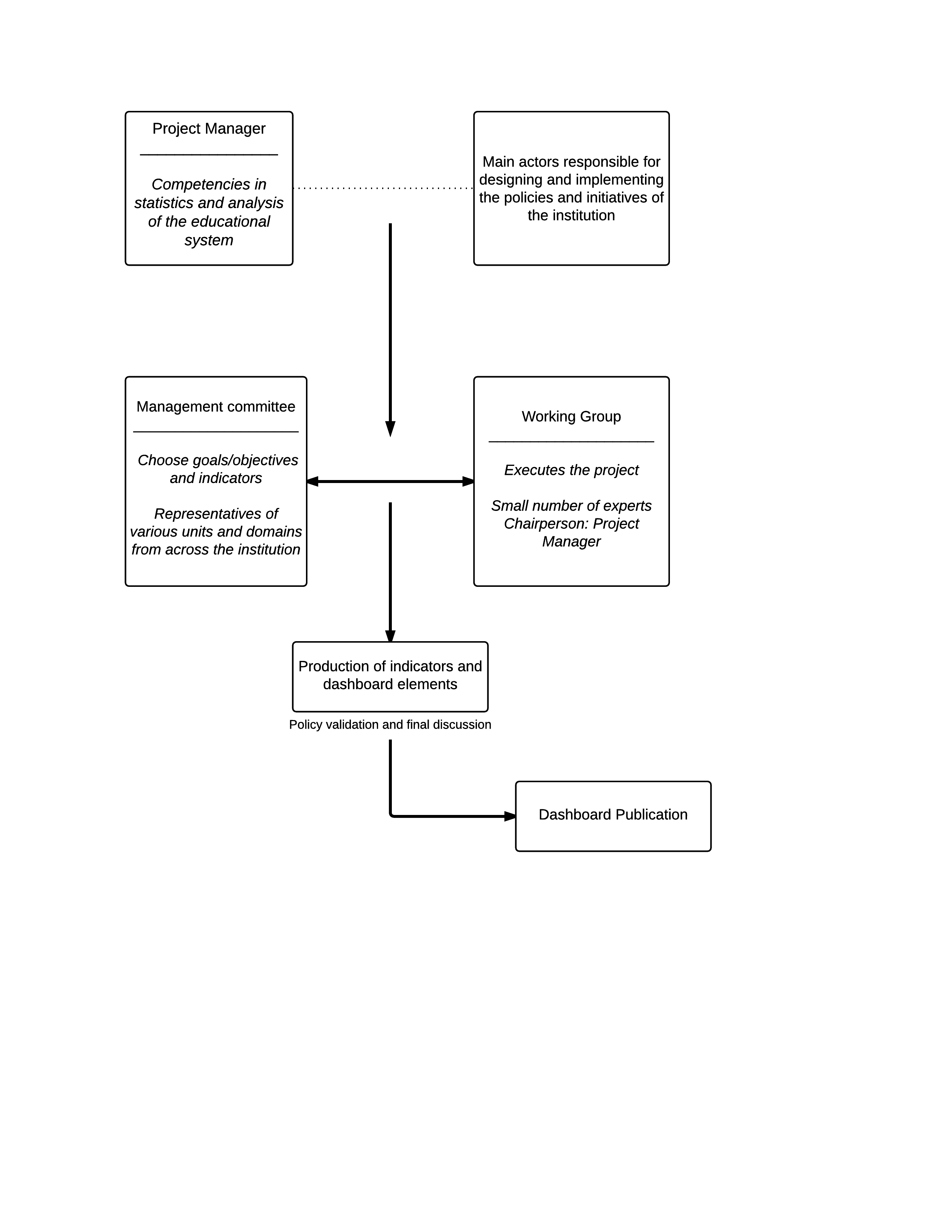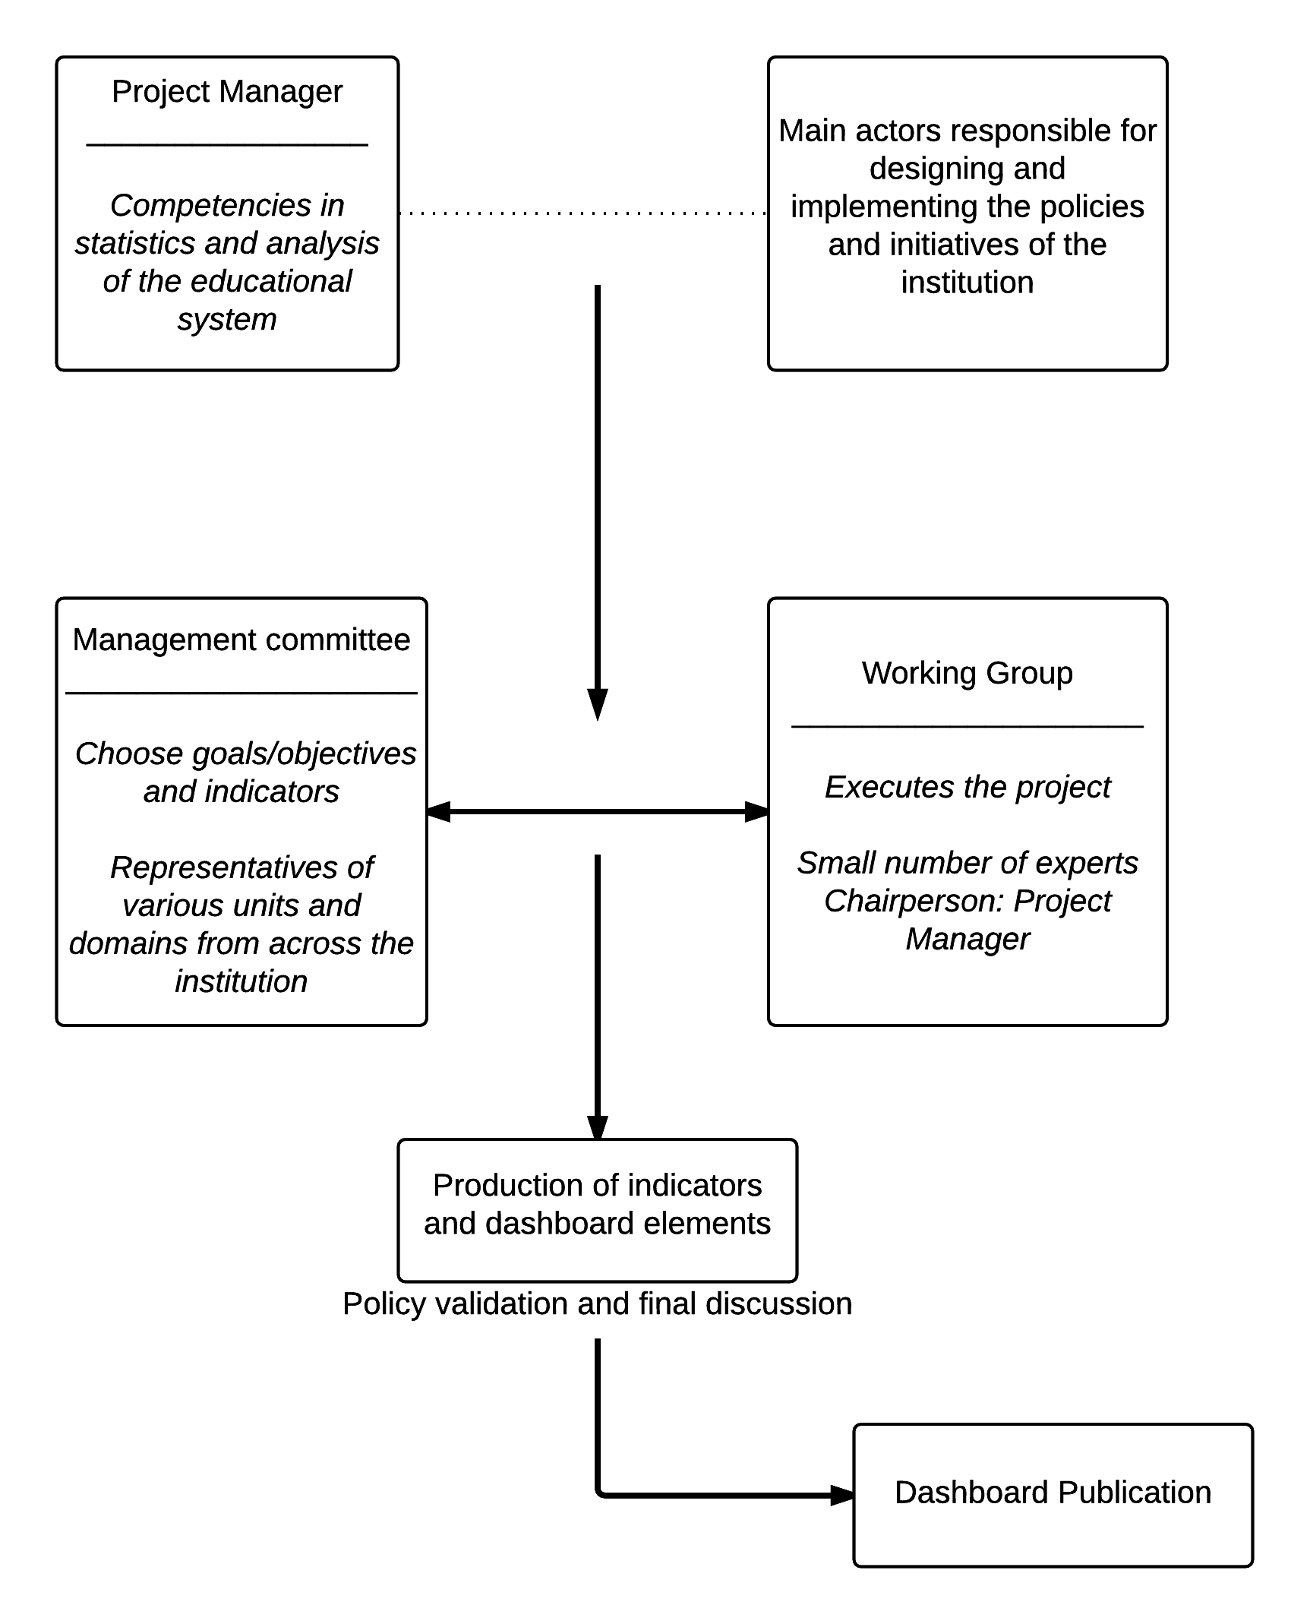

***A case study example from National University Faculty of Health Sciences of the steps the school took to define and validate indicators***:

Step 1. Meeting of the Faculty of Health Sciences Dean’s Dashboard committee.

* Objective: To develop dashboard items.
* Decision: Use the dashboard to monitor the implementation of the faculty’s strategic plan

Step 2. Review the strategic plan and identify which key performance areas to start with:

* Major Goal Identified: Scaling up the production of health professionals
* Example Key Performance Area: Graduation rates across various programs

Step 3. Identification of indicators to track in a key performance area

* Annual enrollment headcounts for the undergraduate and postgraduate courses in Nursing, Medicine and Surgery, Medical Sciences, Medical Clinical Practice, and Science in Health Promotion.
* Annual graduation headcounts for the undergraduate and postgraduate courses in Nursing, Medicine and Surgery, Medical Sciences, Medical Clinical Practice, and Science in Health Promotion.

Step 4. Identification of sources for the required data

* The undergraduate enrollment data was obtainable from the University Bureau of Planning and Institutional research. It was also obtainable from the heads of the schools of medicine, nursing, and allied health sciences.
* The postgraduate enrollment data was obtainable from the heads of the programs carrying out postgraduate training – Biochemistry, Physiology, Microbiology, Chemical Pathology, and Nursing.
* The enrollment data for the clinical registrar (residency) training was obtainable from the postgraduate office and from the coordinators of registrar training in district hospitals.
* The annual graduation data was obtainable from the University examinations office. The data was also obtainable from the office of the administrator of the Faculty of Health Sciences

Step 5. Collecting the required data

Task specific persons to collect the required data (over a 4-week period) from the identified sources:

* + University Bureau of Planning and Institutional Research
  + University Examinations office
  + Heads of Schools in the Faculty
  + Heads of Departments in the Faculty
  + Coordinators of Clinical Registrar Training at the Training Hospitals
  + Office of the Administrator of the Faculty of Health Sciences

Step 6: Collected Data

The dashboard project manager collated all the data collected. With the help of two task members, they tabulated the data, and then aggregated them into overall annual enrollment and graduation headcounts for the years 2011, 2012, 2013, 2014 and 2015.

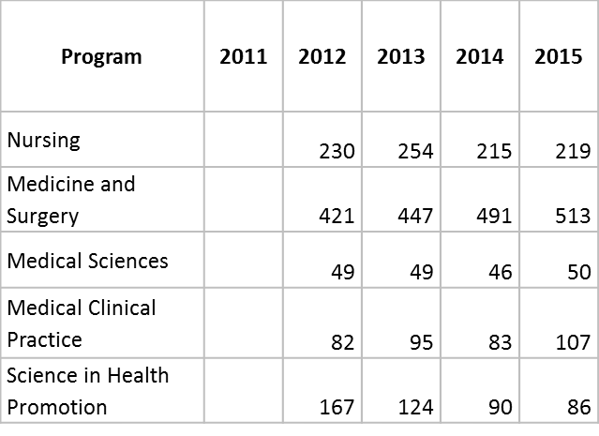

**Table 2. Graduates by Degree Program**

**Table 1. Enrollment by Degree Program**

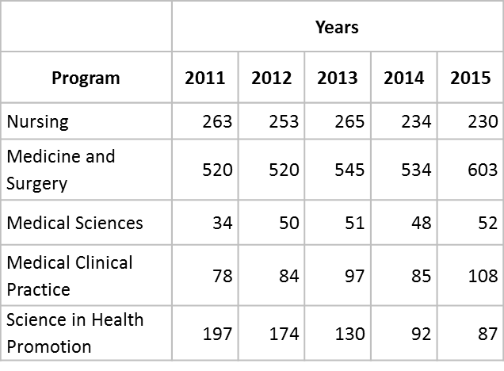

Step 7. Final data review

The National University Faculty of Health Science dashboard team reconvened to

* Review the collected primary data
* The aggregated data
* Approve the coding of the aggregated data
  + Percentages graduating by program and by year

|  |  |  |  |  |
| --- | --- | --- | --- | --- |
| **Percent Graduating** | **Years** | | | |
| Program | **2012** | **2013** | **2014** | **2015** |
| Nursing | 91% | 96% | 92% | 95% |
| Medicine and Surgery | 81% | 82% | 92% | 85% |
| Medical Sciences | 98% | 96% | 96% | 96% |
| Medical Clinical Practice | 98% | 98% | 98% | 99% |
| Science in Health Promotion | 96% | 95% | 98% | 99% |

* Approve the graphic presentation of the aggregate data.

Step 8. Entering the aggregated data on the DHIS2 using the data entry Apps

Step 9. Creating the data graphics using the DHIS2 data visualizer Apps

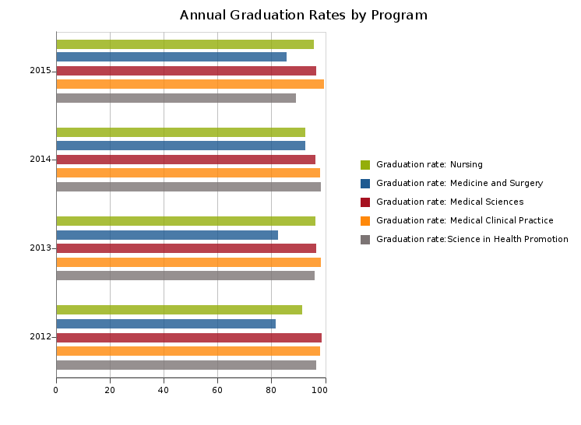

Step 10. Creating the Dashboard on the DHIS2 using the dashboard Apps.

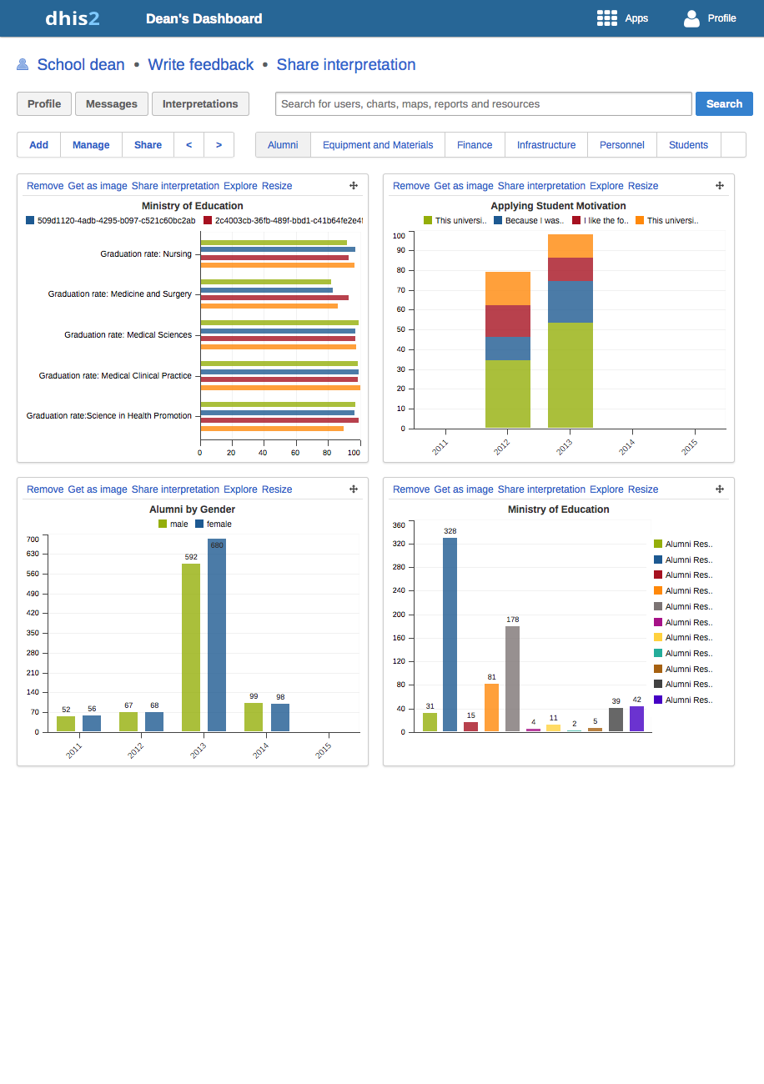

**References**

Center for Digital Education. 2011. Converge special report: The educational dashboard. Folsom, CA: Center for Digital Education.

Martin M., Sauvageot C. 2011. Constructing and indicator system or scorecard for higher education: A practical guide. United Nations Educational, Scientific and Cultural Organization (UNESCO), International Institute for Educational Planning, Paris, France. <http://www.uis.unesco.org/Library/Documents/constructing-indicator-system-scorecard-higher-education-2011-en.pdf>