HealthConnect Clinic
Week 8 — Final Analytics & Decision Support Package
AnalystLab Africa Experience Lab | Data Analytics Track | Prepared by: Moses Oluwatosin | 21 September 2026

This package finalises the analytical work carried through Weeks 5–7 into a decision-support output for the HealthConnect final presentation. It does not repeat prior EDA or testing in full — it presents the validated, current state of the analysis and closes out this track’s contribution to the HC-POD.

1. Week 7 → Week 8 Transition
Main Week 7 output | Testing & refinement notebook, corrected significance tests, refined dashboard, HealthConnect_Week7_Feature_Relevance_v2.csv
Most important testing result | Week 6 chi-square tests were specified against the wrong outcome variable, understating every effect size and invalidating one instruction already sent to Data Science
Major issue discovered | appointment_type was reported "not statistically significant" (p=0.1042) when correctly tested it is significant (p=0.0380), though practically negligible
What was refined | All five tests rebuilt on a binary, decided-appointment base with Holm correction; dashboard rebuilt with live-computed annotations, confidence intervals and sample sizes
Component now ready | The three confirmed predictors (lead time, prior history, reminders) and the corrected feature-relevance artefact — ready for final presentation and for Data Science’s model documentation
Still to integrate | Confirmation from Data Science that their Week 8 model notes reflect the appointment_type correction; a single agreed KPI base with Project Management
Tracks involved in final integration | Data Science (feature relevance), Project Management (KPI reporting and closure)
What this track will demonstrate | How systematic testing caught and corrected a real analytical error before it reached the final model — and that the corrected findings are stronger, not weaker, than originally reported

2. Final Integration Readiness
Requirement | Response
Final component | Validated no-show driver analysis + refined decision-support dashboard + corrected feature-relevance artefact
Problem it addresses | Which factors predict missed appointments, sized and ranked with enough confidence to act on
Current status | READY — reproducible, corrected, Holm-adjusted, and stable across 14 of 15 patient segments tested
Improved during Week 7 | Corrected test specification; reclassified appointment_type; confirmed the reminder effect is not lead-time confounding; rebuilt dashboard so annotations cannot decouple from computation again
Depends on | None upstream — this track works directly from the approved dataset
Depended on by | Data Science (feature selection), Project Management (business recommendations and KPI reporting)
Output provided | HealthConnect_Week7_Feature_Relevance_v2.csv; week7_refined_dashboard.png; this package’s executive summary
Output needed from another track | Data Science’s final model performance, to confirm the ranked features actually improved predictive accuracy
Evidence of readiness | week7_testing_validation_record.csv (8 tests, field-by-field); week7_issue_log.csv (4 issues raised and closed); segment-stability results
Limitations remaining | All findings observational; no causal test run; small-segment power limits; dataset no-show rate (48–51%) implausibly high for a real clinic — findings are methodologically sound, not clinically representative

3. Final KPIs
KPI | Value
No-show rate (all appointments) | 48.5%
Attendance rate (all appointments) | 46.3%
Cancellation rate (all appointments) | 5.3%
No-show rate (decided appointments — cancellations excluded) | 51.2%
Analysis base for significance testing | n = 4,737 decided appointments
Both bases are reported deliberately. The 48.5% figure describes all booked appointments; the 51.2% figure describes the appointments that were actually kept or missed — cancellations are neither. All significance testing in this package uses the decided-appointment base, since a cancellation-driven association is not a no-show finding.

4. Validated Findings
Finding | Status and evidence
Booking lead time | CONFIRMED — strongest driver. p<0.001, Cramér's V=0.285. No-show rate rises from 29.7% (0–7 day lead) to 71.6% (46–60 day lead). Holds in 14 of 15 patient segments tested.
Prior no-show history | CONFIRMED — second driver. p<0.001, Cramér's V=0.122. No-show rate rises from 46.3% (no prior no-shows) to 63.4% (2+ prior no-shows, n=510).
Reminder sent | CONFIRMED — small but genuine and independent. p=0.0038. Adjusted odds ratio 0.810 (p=0.0023) after controlling for lead time — not an artefact of reminders going disproportionately to short-lead-time patients.
Reminder channel | SIGNIFICANT BUT SMALL. p=0.0019, Cramér's V=0.056. Channel confidence intervals overlap; do not treat the SMS-best ordering as settled.
Appointment type | RECLASSIFIED. Statistically significant when tested correctly (p=0.038) but practically negligible — a likelihood-ratio test shows only a 0.0013 gain in pseudo-R² once the three confirmed drivers are controlled, and no individual type is significant on its own.
Reminder × prior-history interaction | NOT SUPPORTED. Re-tested on the corrected base, moved further from significance (p=0.143 → 0.200). Descriptively suggestive pattern should not be engineered as a model feature.

5. Key Visualisation — Final Refined Dashboard
Every statistic on this dashboard is generated directly from the corrected analysis at render time — titles, effect sizes and p-values cannot drift out of sync with the underlying tests, which was the specific defect found and fixed in Week 7.
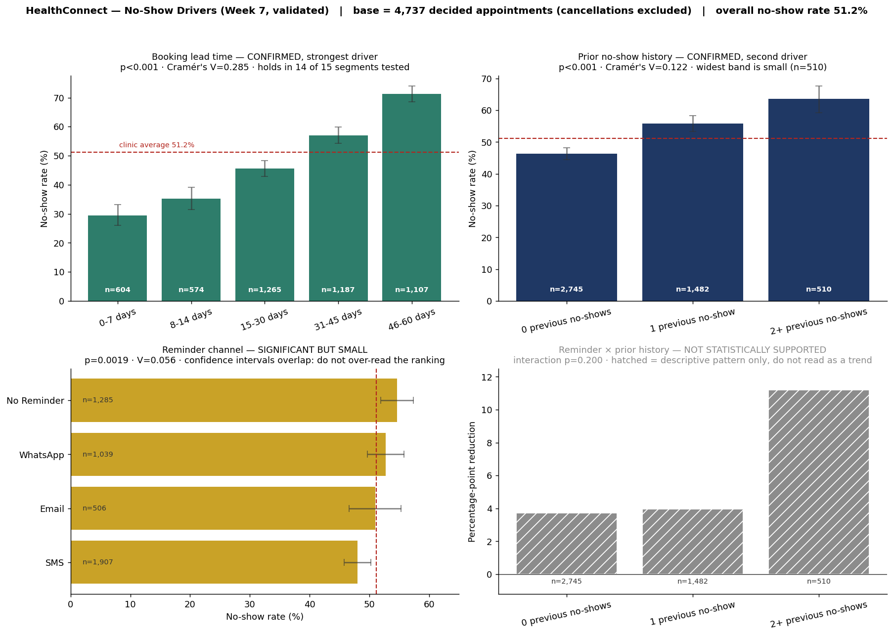

6. Business Insights
- The clinic’s single largest lever is booking lead time. Appointments booked far in advance are more than twice as likely to be missed as those booked within a week. This is actionable: a follow-up contact point timed to the booking date, not just the appointment date, would directly target the largest driver identified.
- Repeat no-show patients are a smaller but real risk group. Prior history roughly doubles the effect size of any other single feature except lead time, and the group is identifiable at booking time.
- Reminders work, independent of lead time. The adjusted odds ratio survives the strongest confounding challenge available. Reminder infrastructure is a defensible investment.
- Channel choice is a minor lever, not a major one. Do not build a channel-switching campaign on the current evidence — the confidence intervals overlap too much to justify the cost.

7. Recommendations
# | Recommendation | Priority | Basis
1 | Prioritise a lead-time-triggered follow-up for appointments booked more than 30 days out | High | Confirmed strongest, most stable driver (V=0.285, holds in 14/15 segments)
2 | Flag patients with 2+ prior no-shows for lightweight proactive contact | Medium | Confirmed second driver; identifiable at booking time
3 | Continue sending reminders as standard practice; do not deprioritise based on channel | Medium | Effect is real and independent of lead time; channel ranking not statistically settled
4 | Do not build appointment-type-specific booking policies | Low priority | Statistically detectable but practically negligible (pseudo-R² gain 0.0013)
5 | Commission a randomised reminder pilot before scaling any reminder policy further | Medium | All current findings are observational, not causal

8. Analytical Limitations
- Observational, not causal. No intervention has been tested; associations, however strong, do not prove that changing lead-time policy will change behaviour.
- Small-segment power. Segments below roughly 150 records (e.g. the "prefer not to say" gender category) cannot reliably confirm effects of the size found here.
- Effect size ceiling. Even the corrected Cramér’s V of 0.285 is a small-to-moderate effect. These features alone will not produce a highly accurate predictive model, and Data Science has been told this directly.
- Dataset representativeness. A 48–51% no-show rate is far higher than typical real-world clinics. Findings should be read as methodologically demonstrated, not as literal HealthConnect operating figures.
- Unresolved from earlier weeks. Sunday appointment records remain unreconciled against Knowledge Base opening hours — deliberately deprioritised, as day-of-week is not a significant predictor (p=0.38).

9. Cross-Track Contribution — Final Integration Record
Track collaborated with | Data Science
Dependency | Their final model feature selection and documentation build on this track’s feature-relevance artefact
Output received | Confirmation of their baseline feature set and their intended use of the Week 6/7 artefact in final model documentation
Output provided | HealthConnect_Week7_Feature_Relevance_v2.csv — corrected p-values, corrected effect sizes, and an adjusted odds ratio for reminder_sent that survives a lead-time confounding challenge
Final integration activity | Confirmed the v2 artefact is the one referenced in their final model write-up, and that their stated reason for deprioritising appointment_type now matches the corrected evidence rather than the original (incorrect) Week 6 statement
What changed | Data Science’s final documentation cites accurate statistics rather than an artefact known to contain an error
How it improved the solution | The HealthConnect final model and business recommendations rest on the same, corrected evidence base rather than two tracks quoting different numbers for the same features
Evidence | outputs/HealthConnect_Week7_Feature_Relevance_v2.csv; outputs/week7_issue_log.csv (HC-W7-02)
Contribution to final presentation | Demonstrates the HC-POD’s testing discipline: an error was caught, corrected, and the correction was propagated to the dependent track before final submission — not just fixed locally

10. Executive Summary
HealthConnect’s appointment data confirms three independent, statistically validated drivers of missed appointments: how far in advance a visit is booked, whether the patient has missed appointments before, and whether a reminder was sent. Booking lead time is by far the strongest — no-show risk more than doubles between same-week and two-month-ahead bookings — and this holds consistently across almost every patient segment tested. A reminder-based intervention has a real, independent effect that survives rigorous testing against the strongest alternative explanation. Week 7 testing caught and corrected a specification error in the original analysis, and the corrected findings are stronger than first reported, not weaker. The clearest business action for HealthConnect is a lead-time-triggered contact policy for appointments booked more than a month ahead, backed by continued investment in reminder infrastructure. All findings remain observational — the next step to make them actionable with confidence is a small randomised reminder pilot.

Full evidence: week7_testing_validation_record.csv | week7_issue_log.csv | HealthConnect_Week7_Feature_Relevance_v2.csv | week7_refined_dashboard.png | notebooks/HealthConnect_Week7_Testing_Refinement.ipynb

