Sales & Customer Analytics
Executive Report
Data Analytics Project — Phases 3 to 5
Dataset: 1,200 Orders | Period: Jan 2023 – Jun 2025
Prepared: July 2026

Executive Summary
This report presents a full exploratory analysis of 1,200 e-commerce orders placed between January 2023 and June 2025, covering 1,189 unique customers across seven product lines. The business generated $1,264,761.96 in total revenue at an average order value of $1,053.97. The analysis surfaces two urgent, connected issues: an unusually low repeat-purchase rate (0.93%) and a very high combined Cancelled/Returned rate that erased 41.09% of gross revenue. Product, payment method, and referral source performance are all remarkably even across categories, which suggests the business does not yet have a clearly differentiated "hero" product or channel — an opportunity as much as a risk.
The sections below walk through sales performance, product and customer behavior, payment and fulfillment patterns, promotional effectiveness, and time trends, followed by concrete recommendations.

Key Findings

1. Overall Sales Performance
Metric | Value
Total Orders | 1,200
Total Revenue | $1,264,761.96
Average Order Value | $1,053.97
Total Quantity Sold | 3,535 units
Average Quantity per Order | 2.95 units

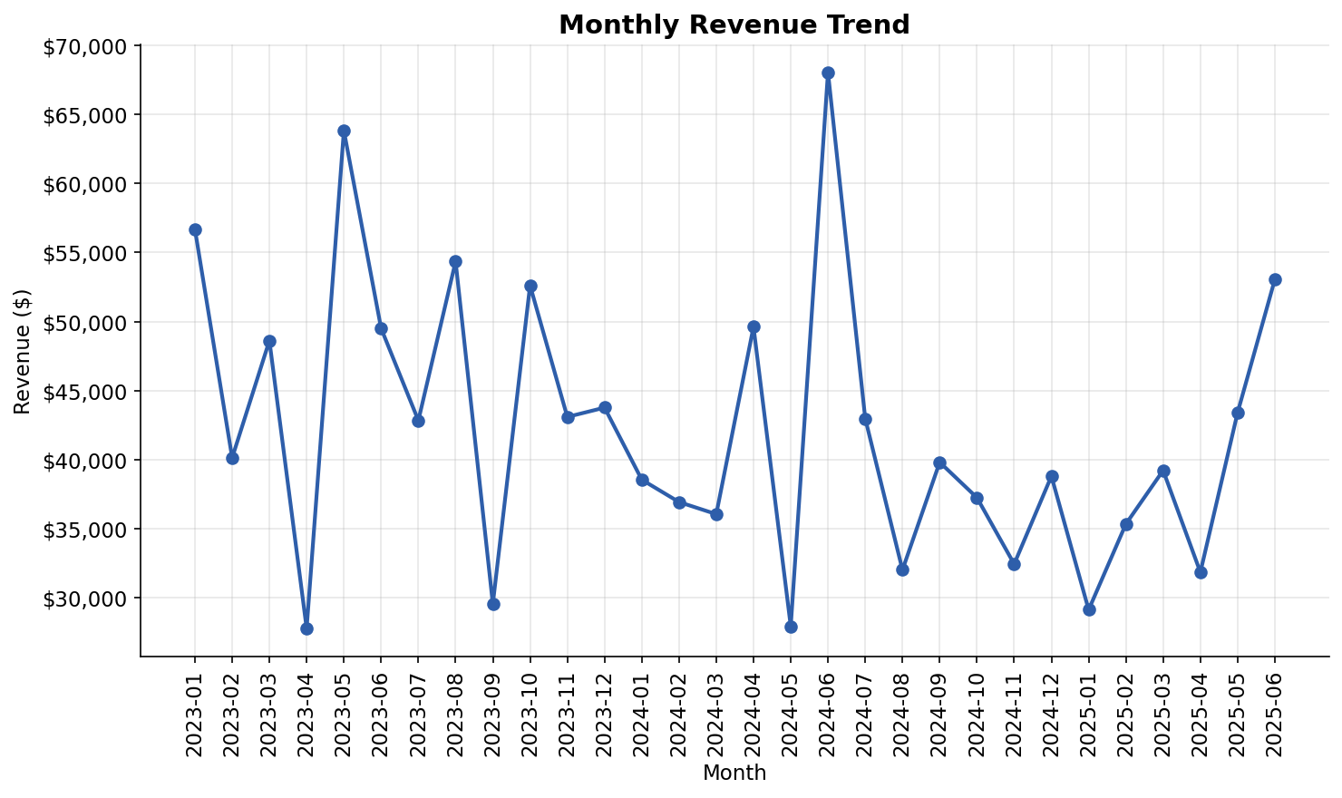
Figure 1. Monthly revenue trend, Jan 2023 – Jun 2025
Monthly revenue fluctuates in the $27K-$68K range with no sustained upward or downward trend, indicating flat overall growth over the two-and-a-half-year period rather than seasonal or structural momentum.

2. Product Performance
Product | Orders | Units Sold | Revenue | Revenue Share
Chair | 178 | 562 | $195,620.11 | 15.47%
Printer | 181 | 542 | $195,612.61 | 15.47%
Laptop | 173 | 535 | $192,126.56 | 15.19%
Tablet | 179 | 497 | $186,568.95 | 14.75%
Monitor | 163 | 480 | $175,651.41 | 13.89%
Desk | 170 | 508 | $167,459.93 | 13.24%
Phone | 156 | 411 | $151,722.39 | 12.00%

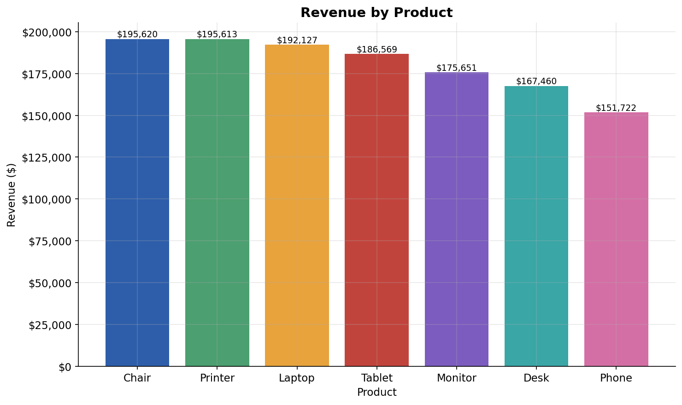
Figure 2. Revenue by product category
Chair narrowly leads on both units sold and revenue, but the spread between the top product (15.47% share) and the bottom product, Phone (12.00% share), is only about 3.5 points. No single product dominates — the catalog is broad-based rather than hit-driven.

3. Customer Behavior
Metric | Value
Unique Customers | 1,189
Repeat Customers | 11 (0.93% of customer base)
Average Spend per Customer | $1,063.72
Top Customer Spend | $5,723.23 (Customer C38840, 2 orders)

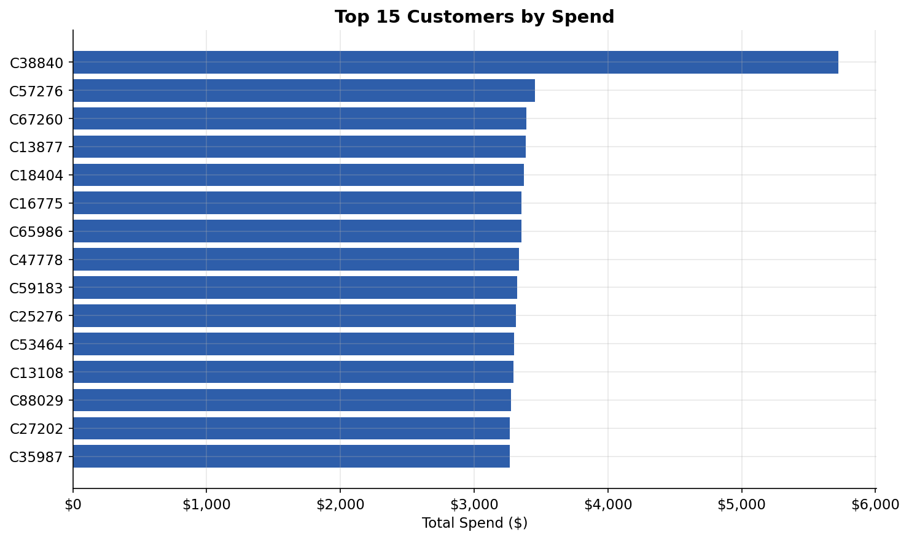
Figure 3. Top 15 customers by total spend
With only 11 of 1,189 customers (0.93%) placing more than one order, the business is almost entirely dependent on first-time purchases. This is the single most important finding in the dataset: customer lifetime value is effectively capped at one transaction for over 99% of the customer base.

4. Payment Method Trends
Payment Method | Orders | Revenue | Revenue Share
Credit Card | 234 | $263,847.63 | 20.86%
Online | 258 | $262,442.94 | 20.75%
Cash | 246 | $259,786.29 | 20.54%
Gift Card | 230 | $246,323.92 | 19.48%
Debit Card | 232 | $232,361.18 | 18.37%

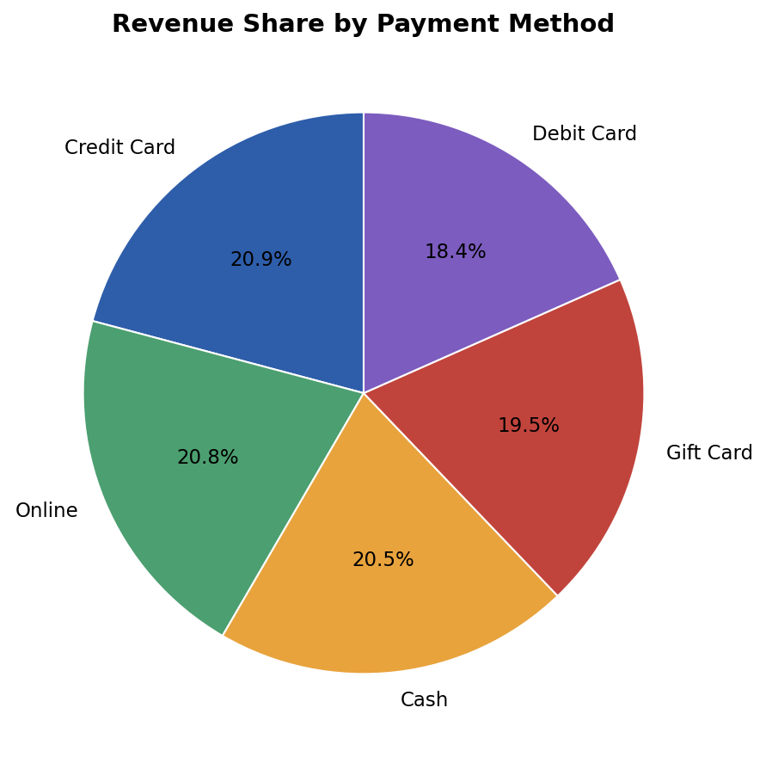
Figure 4. Revenue share by payment method
Payment method usage is almost perfectly even (18.4%-20.9% revenue share each), indicating no single channel is critical to the checkout flow and there is little risk concentration in any one payment provider.

5. Order Status & Fulfillment
Status | Orders | Revenue | Order Share
Cancelled | 250 | $276,396.21 | 20.83%
Returned | 247 | $243,277.70 | 20.58%
Pending | 237 | $256,328.15 | 19.75%
Shipped | 235 | $246,159.58 | 19.58%
Delivered | 231 | $242,600.32 | 19.25%

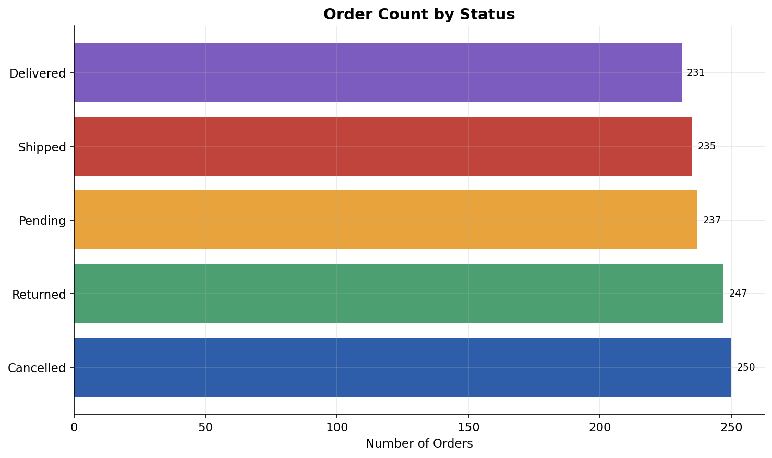
Figure 5. Order count by fulfillment status
Only 19.25% of orders reach a final "Delivered" state. Cancelled and Returned orders combined account for 41.09% of orders and $519,673.91 in revenue — 41.09% of total revenue is tied up in orders that did not result in a completed sale. This is the second major red flag in the dataset and warrants immediate operational attention.

6. Coupon & Promotion Effectiveness
Coupon Code | Orders | Revenue | Avg Order Value
FREESHIP | 313 | $335,036.99 | $1,070.41
No Coupon | 309 | $322,401.41 | $1,043.37
WINTER15 | 292 | $302,483.54 | $1,035.90
SAVE10 | 286 | $304,840.02 | $1,065.87
74.25% of orders (891 of 1,200) used a coupon of some kind. Orders with a coupon carried a slightly higher average order value ($1,057.64) than orders without one ($1,043.37) — a difference of only about 1.4%, suggesting current coupons are not meaningfully driving larger baskets and may simply be discounting purchases customers would have made anyway.

7. Referral Source Performance
Referral Source | Orders | Revenue | Revenue Share
Instagram | 259 | $275,285.45 | 21.77%
Email | 250 | $261,808.55 | 20.70%
Google | 241 | $250,441.48 | 19.80%
Facebook | 228 | $250,410.90 | 19.80%
Referral | 222 | $226,815.58 | 17.93%

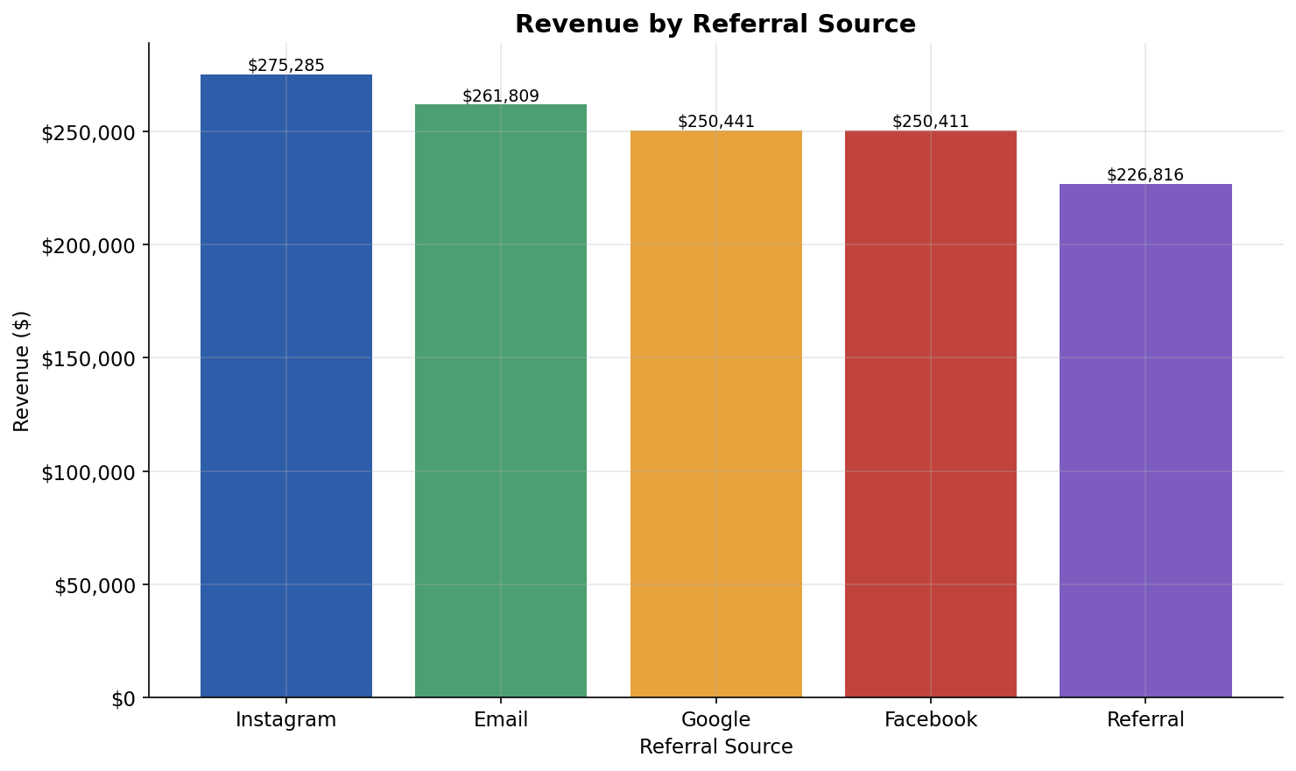
Figure 6. Revenue by referral source
Instagram is the top revenue-generating channel at 21.77% share, narrowly ahead of Email (20.70%). Word-of-mouth "Referral" traffic trails all paid/owned channels at 17.93%, the lowest of the five sources tracked.

8. Time Trends
Revenue by month ranges from a low of $27,751.71 (April 2023) to a high of $68,068.54 (June 2024), with no consistent seasonal pattern across the three years of data. Sunday is the strongest day of the week by revenue ($199,194.84 across the period), while Wednesday is the weakest ($160,519.31).

9. Outlier Detection
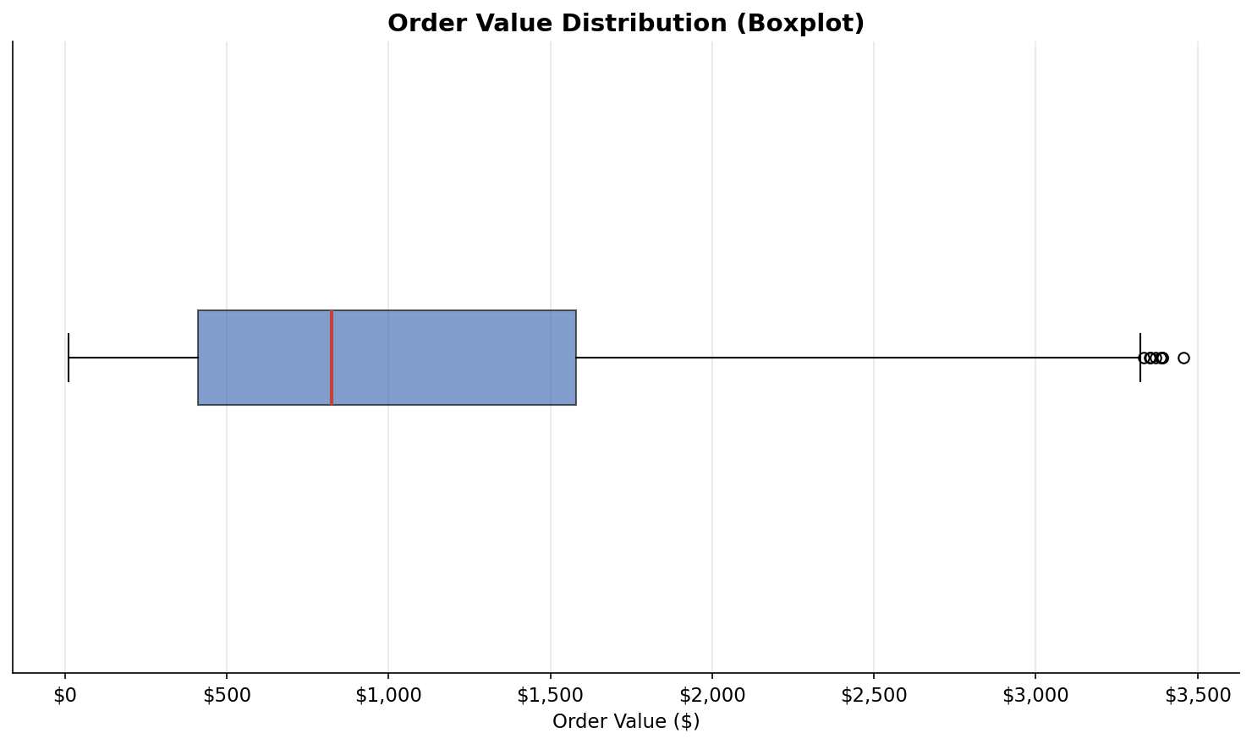
Figure 7. Order value distribution (boxplot)
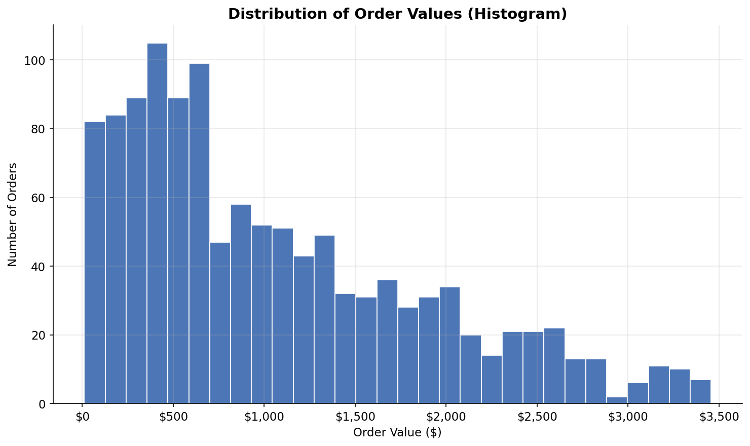
Figure 8. Order value distribution (histogram)
Using the IQR method, 8 orders (0.67%) fall outside the normal order-value range of roughly $0-$3,330 (the calculated lower bound was negative and was floored at $0), all of them unusually high-value orders rather than low ones. No outliers were detected in order quantity — every order fell within the normal 0-7 unit range. These high-value orders (e.g., a $3,456.40 Tablet order and a $3,390.95 Monitor order) are legitimate large purchases worth flagging for account management or fraud review, not data errors.

Business Insights
- Retention, not acquisition, is the core growth constraint. A 0.93% repeat-purchase rate is far below typical e-commerce benchmarks (often 20-30%+), meaning nearly every dollar of the $1.26M in revenue came from a one-time buyer.
- Order failure is eroding gross revenue at scale. With 41.09% of orders ending in Cancelled or Returned status, over $519K in booked revenue never converts to realized revenue — a rate high enough to suggest a systemic issue (checkout, fulfillment, or product-fit) rather than random attrition.
- The business is broad-based, not hit-driven. Products, payment methods, and referral sources are all clustered tightly around an even split, meaning there is no single point of failure — but also no clear "star" to double down on.
- Coupons are not clearly earning their discount. The AOV lift from coupon use (+1.4%) is marginal relative to the cost of the discount itself, raising the question of whether current promotions are profitable.
- Instagram and Email are the strongest acquisition channels, while direct word-of-mouth referral is comparatively underdeveloped despite being typically the highest-intent, lowest-cost channel available.
- A small number of high-value transactions (8 orders, largest $3,456.40) sit well above the norm and represent an under-leveraged VIP or B2B customer segment.

Recommendations
- Launch a retention program immediately: post-purchase email/SMS sequences, a loyalty or repeat-purchase discount, and win-back campaigns targeted at the 99%+ of customers who have only ordered once.
- Investigate the root cause of the 41% Cancelled/Returned rate as a top priority — audit checkout flow, payment failures, shipping delays, and return reasons to identify whether this is a single fixable bottleneck.
- Re-evaluate coupon strategy: A/B test removing or restructuring FREESHIP and WINTER15 against a control group to confirm they generate incremental revenue rather than subsidizing existing demand.
- Double down on Instagram and Email, the two top-performing referral channels, while testing structured referral/word-of-mouth incentives to lift the lagging "Referral" channel.
- Build a lightweight VIP tier for the handful of customers placing high-value orders (>$3,300), since they show clear willingness to spend well above the $1,053.97 average order value.
- Instrument monthly tracking of the repeat-purchase rate and the Cancelled/Returned rate as the two headline KPIs for the next reporting cycle, since both currently sit at levels that materially cap revenue growth.

Conclusion
The dataset points to a business that is acquiring customers steadily but not retaining them, and one that is losing a striking share of booked revenue to cancellations and returns. Product mix, payment methods, and marketing channels are all healthy and diversified, which is a strong foundation to build on. The clearest path to revenue growth is not more top-of-funnel acquisition, but fixing the two leaks identified in this analysis: near-zero repeat purchasing and a 41% order failure rate. Addressing either one would meaningfully improve realized revenue without requiring any change to the product catalog or pricing.

