1. *Essay [30%]*

Convert infix to postfix and prefix notation from expression below:

2 * 6 – 3 ^ 0 == 10 / 2 + 7 % 3

Then, evaluate the result using stack. Write down all steps and the result of the expression!

|  |  |  |
| --- | --- | --- |
| **Operator** | **Precedence** | **Associativity** |
| ^ | 4 | left to right |
| * | 3 | left to right |
| / | 3 | left to right |
| % | 3 | left to right |
| + | 2 | left to right |
| - | 2 | left to right |
| == | 1 | left to right |

1. ***Cases [70%]***

Body Mass Index (BMI) is a measurement of body fat and it is commonly used within the health industry to determine whether your weight is healthy. BMI applies to both adult men and women and is the calculation of body weight in relation to height.

$$BMI= \frac{weight (kg)}{height^{2}(m)}$$

The BMI statistical categories below are based on BMI scores and apply to adults of age 20 years and upwards.

|  |  |
| --- | --- |
| **BMI** | **BMI Category** |
| < 18.5 | Underweight |
| 18.5 - 25 | Normal |
| > 25 | Overweight |

As a programmer, you asked to create a program to calculate BMI in the **priority queue** (must be implemented using **double** **linked** **list**) **sorted** **by** **BMI** with requirement below:

1. Print all offer and print menu

Print all offer in the priority queue then print the menu consists of:

1. Add New Data
2. Delete All Data in Normal BMI
3. Exit

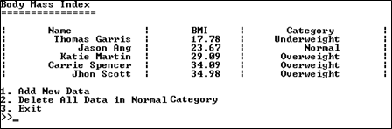

Figure 1. Main Menu

1. Add New Data

When 1st menu is chosen, user can add new data to the list. The new data is added to priority queue sorted by **BMI**.

* The **full name** **must be between 2 and 20** characters in length.
* The **weight** **must be between 35.00 and 300.00** in Kilogram (Kg).
* The **height** **must be between 0.50 and 3.00** in Meter (M).



Figure 2. Adding “Dora Tan”

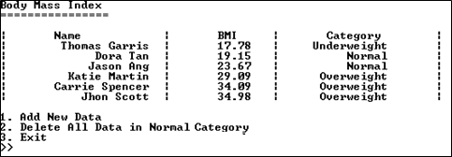

Figure 3. After Adding “Dora Tan”

1. Delete All Data in Normal Category

When 3rd menu is chosen, pop node with “Normal” category from the priority queue

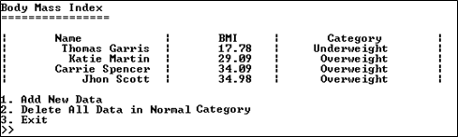

Figure 4. After 2nd chosen

1. Exit

When 3rd menu is chosen, pop all nodes explicitly to prevent memory leak, then close the program.

-- Good Luck --