Tara Moses 010630228

S. Gauch

Programming Foundations I

April 2, 2015

**Problem Statement:**

The goal of this programming assignment was to gain experience with functions by creating a game called Payday. The game was designed to let two people play against each other until the game was over, in which case the game displayed the person with the most money as the winner. The players take turns, with the current player inputting either an R to roll the dice or a P to pass their turn. At the end of each turn, the program outputs how much money the current player has. The program handled whether the user input a character other than R or P.

**Design:**

The program used a 2D char array for the board. The board was initialized randomly in a separate function. The program used a while loop to ask players 1 and 2 for their turn until someone wins. Each player’s turn is handled in the function playTurn(), which calls handleEvent() to change the money of the player depending on the space they landed on.

**Implementation:**

The sample code started with was hw5.cpp on the PF1 website. The initialization of the board was fleshed out first. Then the welcome message was written and called in main. After that, the playTurn function was outlined in comments and then written. The program overall took about three hours to complete.

**Testing:**

The program was tested frequently after each function was finished. The game was tested to make sure the board was printed out correctly after each player moved. When inputting either an R or a P to roll/pass, other characters were input to make sure the program asked the user to try again. Everything worked as expected in the end.

**Conclusions:**

Overall, the game was completed successfully. The program lets both players play, keeps up with their money, and prints out the winners at the end. If I had to do this program again, I’d make the board larger to accommodate more options and make for a longer-running game. Maybe I’d make the board a random size. Who knows, I’m a loose cannon. This program took about four hours to complete overall.

**Test Case 1:**

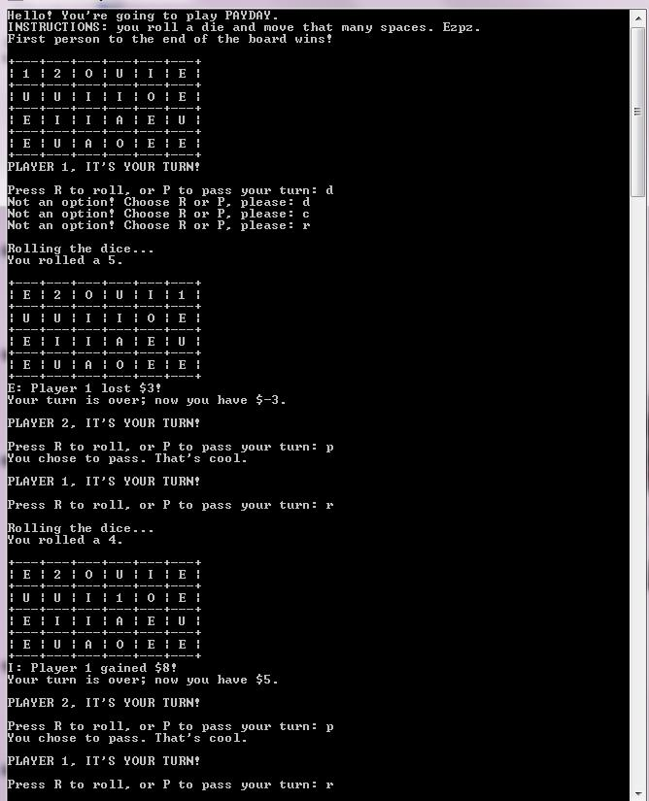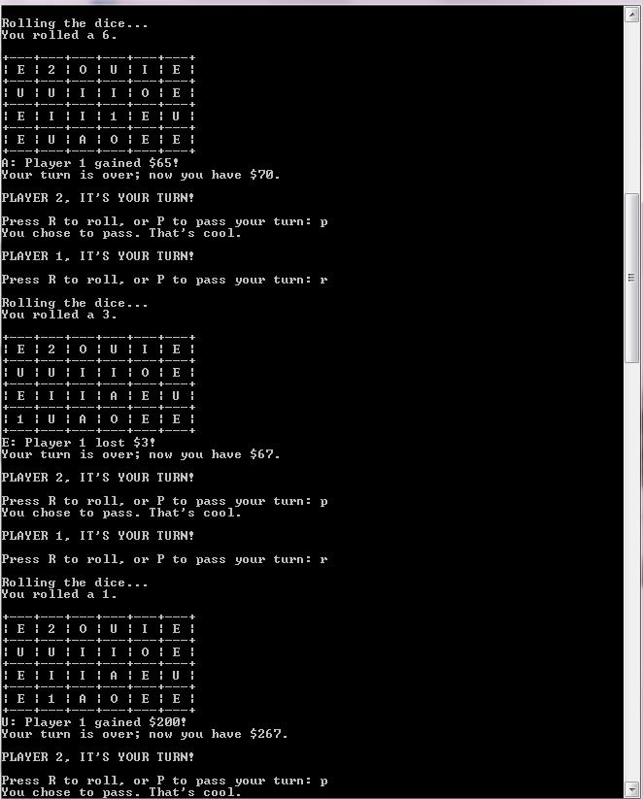**d**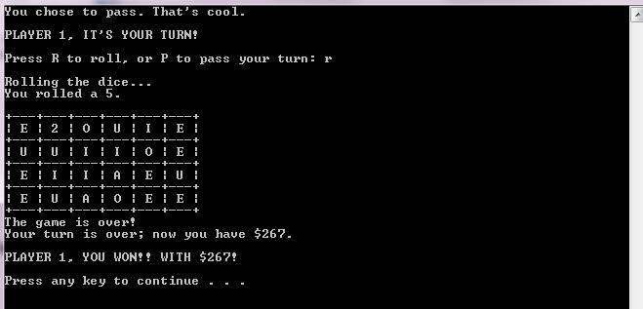

**Test Case 2:**

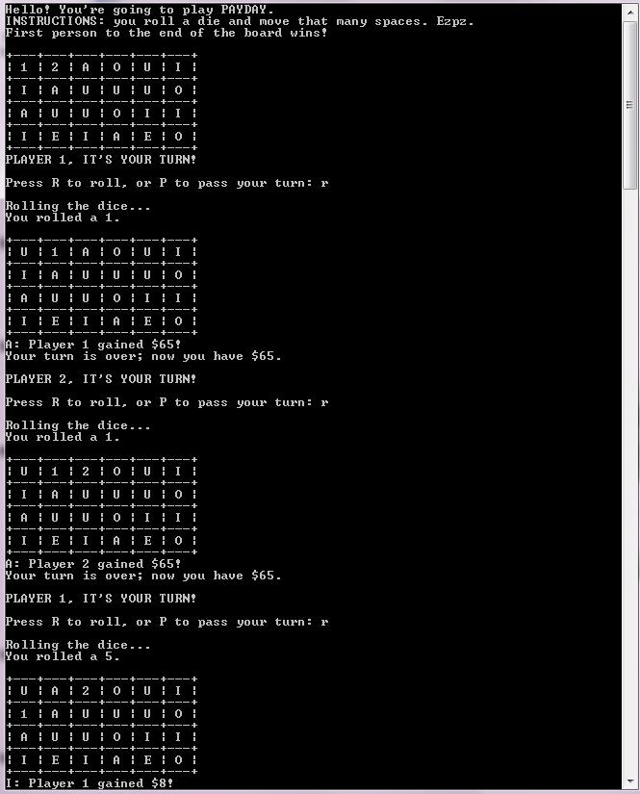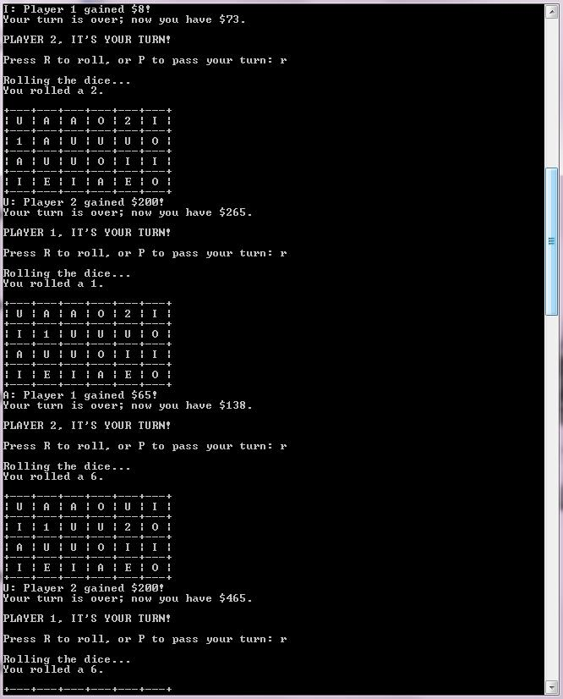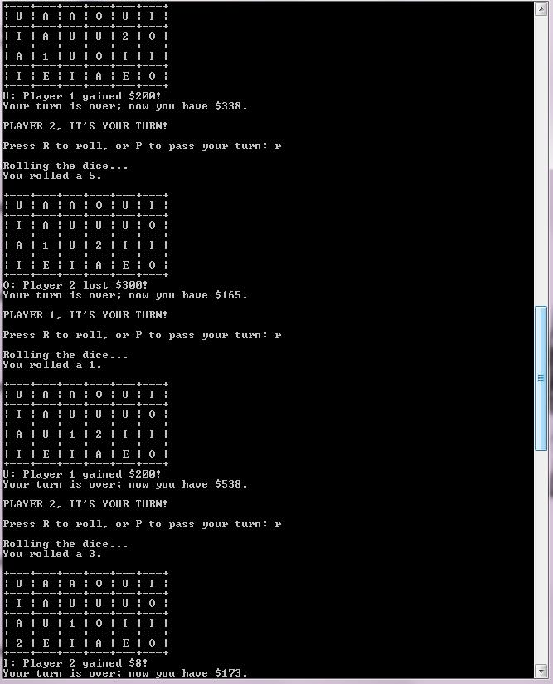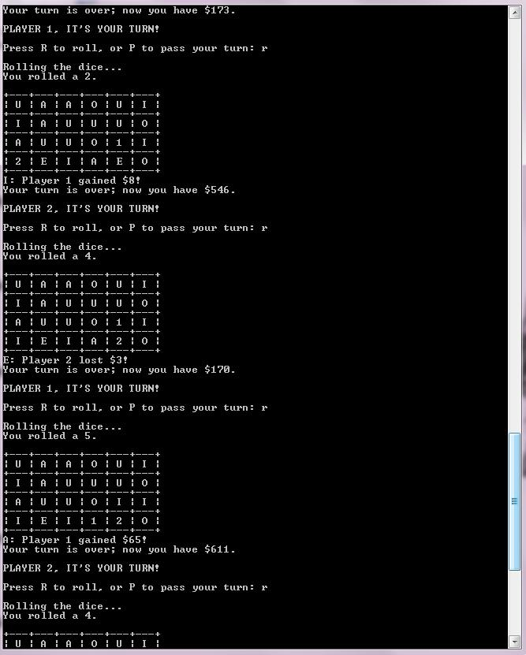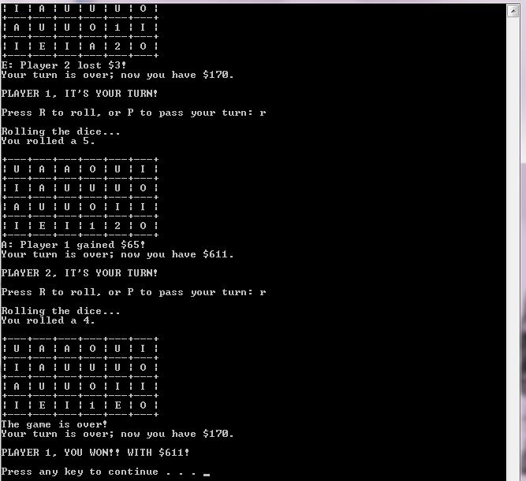

**Test Case 3:**

