**Final Report**

**Introduction**

This project is to illustrate attrition problem for company X and to suggest how to control it

***Data used:***

The data used in this project is: “Hash-Analytic-Python-Analytics-Problem-case-study-1.xlsx”

This data in xlsx form contain two data sheets.:

*Sheet1*:Existing employees

*Sheet2:* Employees who left

The sheet are loaded to as data1 and data2 as in the project code.

**Tools used in the project**

-pandas

-matplotlib

-sklearn

-seaborn

-numpy

*Machine learning algorithm used: Random Forest Classifier*

***Results***

*Model accuracy =* 0.9915555555555555

**Determining plot:**

The horizontal plot of important ie. Feature_importances shows significantly that satisfaction_level is the major contribution of employee attrition.

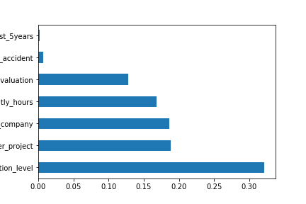

**Conclusion**

From the feat_importances_barh.png satisfaction_level emerges as the major contributing factor to employee attrition in company X.

To control it Company X should improve employee satisfaction level significantly.