TEST LOGS:

/
***************************************************************************************************
PROGRAM : Blood_Alcochol_Concentration_Chart_creator.cpp
PURPOSE : This program will create a nice BAC [Blood Alcohol Concentration] Chart for both Male and Female persons, which is
strongly correlated with driving impairment. For this reason, the program will take two integer values, [one for
getting the weight of the user, another for having the time(in minutes) since the user had his/her last drink], and a character
value [for getting the information, whether the user is 'M' for male or 'F' for female.] as inputs. After giving all these
information properly as inputs, the program will show a whole detailed BAC chart [for that particular inputs.] as an output.
Coder : Mosfiqur Rahman (mr986@drexel.edu)
Last Modified : 16th Febrruary, 2016.
***************************************************************************************************/

Test Log:- 1
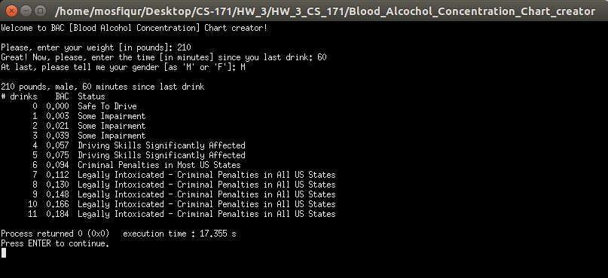

Test Log:- 2
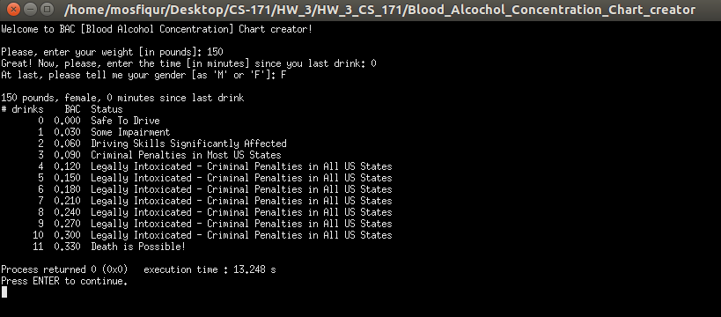
Test Log:- 3
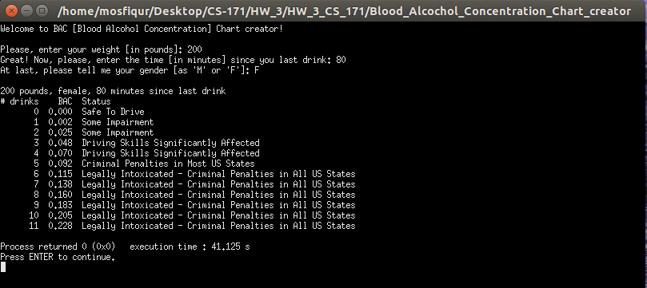
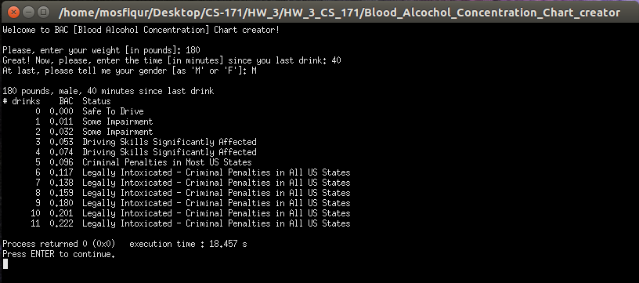
Test Log:- 4
Test Log:- 5
