To install and run our program from scratch, make sure Python 3.x and MySQL are installed on your machine.

Run a MySQL server with the supplied database backup CarRental2019.sql. This will have the data from phase 2, as well as the phase 3 Returned column.

To run the Python script, navigate in a command prompt to the directory containing the script and enter the command “python code.py”.

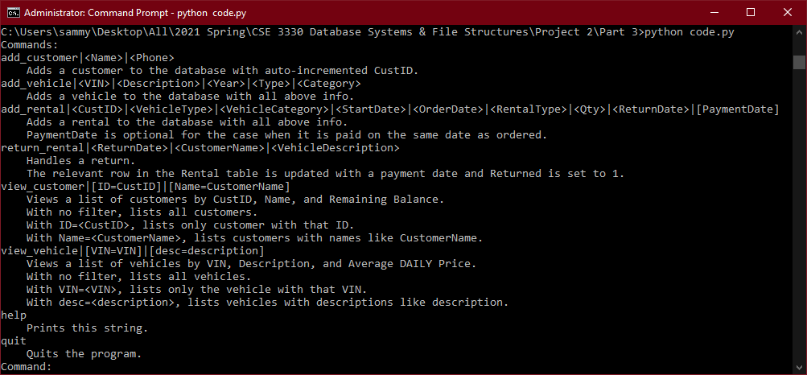

This should print out a list of accepted commands and prompt you for user input.