**Stakeholders & Onion Diagram**

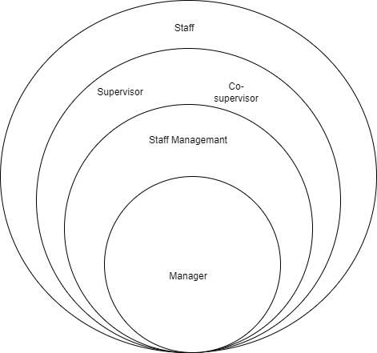

**User stories**

**Co supervisor , login to the system to check attendance and Staff members bios of the business.**

**Collect all Attendance of staff done in the business and calculate them and get the final statement for each month.**

**Supervisor view reviews and Manager give promotions to staff .**

**Requirements**

|  |  |  |
| --- | --- | --- |
| Functional requirement | Non-Functional requirement | Technical requirement |
| Handling of employee information. | performance | Fingerprint Reader |
| Attendance Management. | security | Tremor meter |
| Training and development | usability | Staff ID |
| Recruitment and onboarding | reliability |  |
| Compensation and benefits management |  |  |
| Employee self service |  |  |
|  |  |  |

**Use case diagram**

**Use-case Scenario**

|  |  |  |
| --- | --- | --- |
| **Number** | 07 | |
| **Name** | Staff management | |
| **Summary** | Add new member, get attendance, Get staffs bio | |
| **Priority** | Mainly consider about staff management | |
| **Preconditions** |  | |
| **Postconditions** |  | |
| **Primary Actor(s)** | Co-supervisor | |
| **Trigger** | Check Staff bio and attendance | |
| **Main Scenario** | **Step** | **Action** |
|  | 1 | Admin login to the system(Co-supervisor) |
|  | 2 | Checking daily attendance |
|  | 3 | Checking Daily leave sheets |
|  | 4 | Accepting leaving forms |
|  | 5 | Store and checking staff bio |
|  | 6 | Adding New members and Maintain staff list |
|  | 7 | Checking Staff information |
|  | 8 | Admin logout the system |
| **Extensions** | **Step** | **Branching Action** |
|  | 5 | 5a. Add new Account  5b. Delete Account |