**Stakeholders & Onion Diagram**

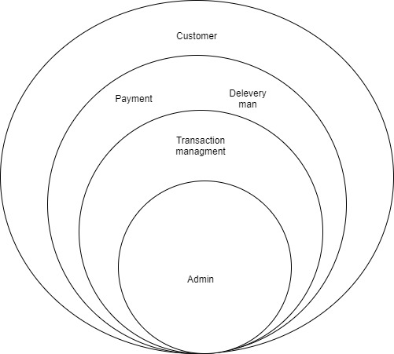

**User stories**

**Admin, login to the system to check Payment transactions and order list of the system.**

**Collect all new transactions of orders and give approvals. Then he assign the delivery man to take order.**

**Requirements**

|  |  |  |
| --- | --- | --- |
| Functional requirement | Non-Functional requirement | Technical requirement |
| Ability to initiate a transaction | performance | Fingerprint Reader |
| Verification of transaction details. | security | Tremor meter |
| Authorization and authentication | usability | ID |
| Record keeping | reliability |  |
| Exception handling | Scalability |  |
|  |  |  |
|  |  |  |

**Use case diagram**

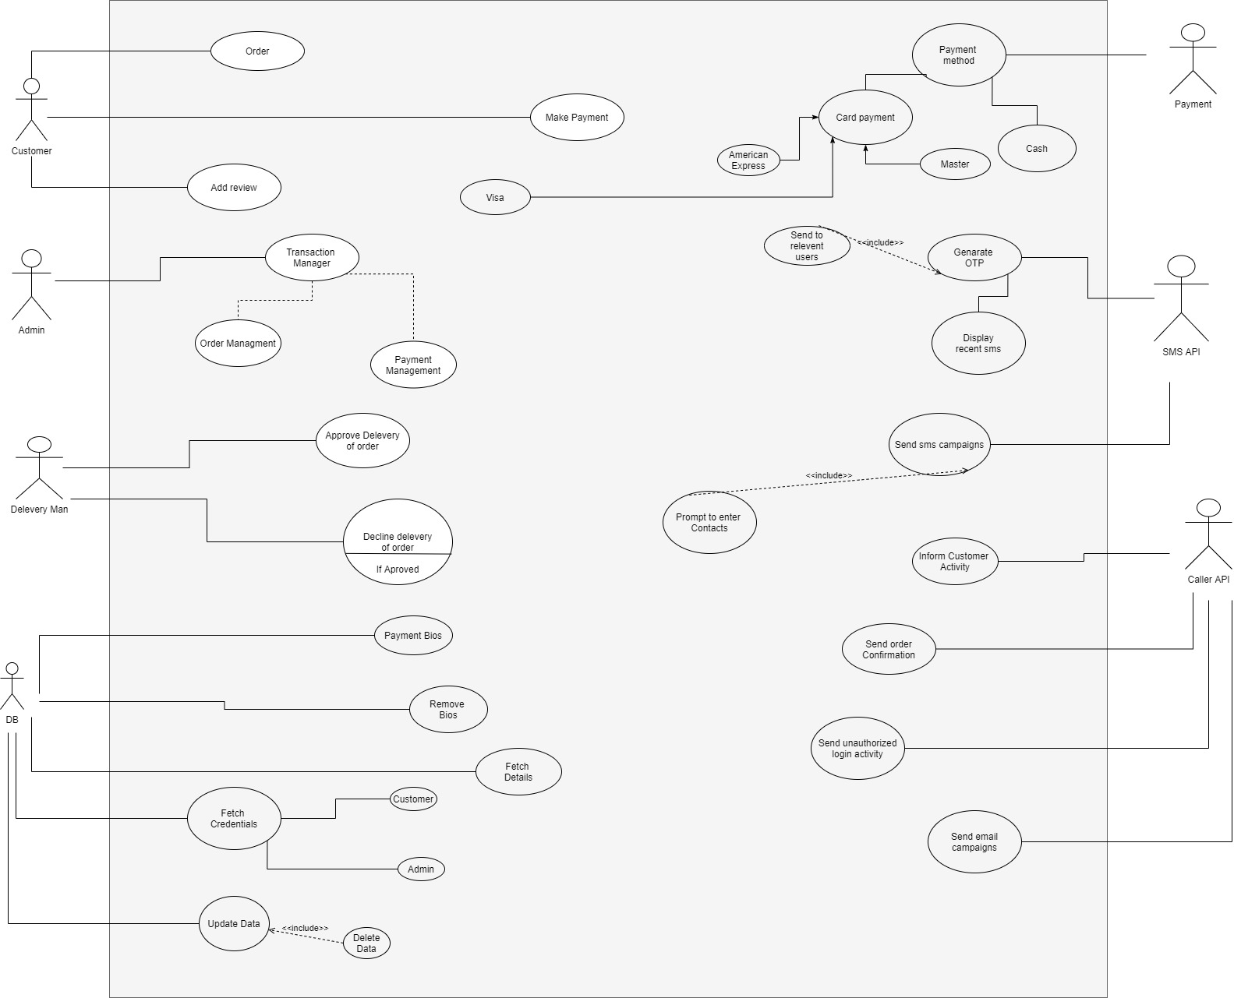

**Use-case Scenario**

|  |  |  |
| --- | --- | --- |
| **Number** | 08 | |
| **Name** | Transaction management | |
| **Summary** | Add new member, get attendance, Get staffs bio | |
| **Priority** | Mainly consider about transaction management | |
| **Preconditions** |  | |
| **Postconditions** |  | |
| **Primary Actor(s)** | Admin | |
| **Trigger** | Checking orders and payments | |
| **Main Scenario** | **Step** | **Action** |
|  | 1 | Admin login to the system |
|  | 2 | Checking daily transactions |
|  | 3 | Checking payments |
|  | 4 | Approve and decline payments |
|  | 5 | Store and checking transaction details |
|  | 6 | Adding new payments |
|  | 7 | Checking transaction information |
|  | 8 | Admin logout the system |
| **Extensions** | **Step** | **Branching Action** |
|  | 5 | 5a. Add new transaction.  5b. Delete transaction |