* **Onion Diagram**

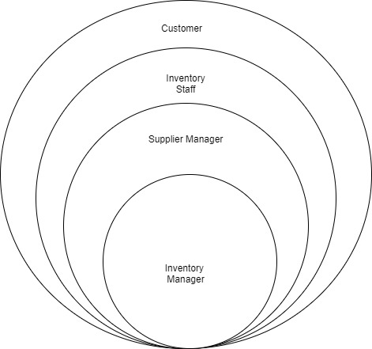

* **User stories for the direct system users.**

1. **Inventory Manager**: - I want to be able to view a real-time inventory status report so that I can keep track of my inventory levels and make informed decisions as well as I want to be able to track inventory usage by different departments or locations so that I can make adjustments to allocation as needed as well as I want to be able to view and analyze inventory data, such as sales trends and turnover rates, so that I can make informed decisions about future inventory management strategies and finally, I want to be able to integrate with other systems, such as point of sale and accounting software, so that I can streamline my inventory management processes.
2. **Supplier Manager**: I want to be able to view the purchase history of each supplier, including details of all previous orders and payments, so that I can monitor their performance and make informed decisions. As well as I want to be able to generate reports on supplier performance, such as delivery times and quality of goods, so that we can identify areas for improvement and maintain strong relationships with our suppliers and finally I want to be able to view a list of all suppliers in the system, along with their contact details, so that I can easily find and communicate with them.
3. **Inventory Staff:** As an Inventory Staff I want to be able to generate reports on inventory levels, sales trends, and other relevant data so that I can make informed decisions about ordering and stocking products as well as I want to be able to receive notifications when inventory levels are low so that I can order more products to replenish stock.

1. **Customer:** As a customer, I want to be able to search for products based on keywords, so that I can quickly find the items I am looking for as well as I want to be able to view detailed product information, including images, descriptions, and specifications, so that I can make an informed decision before purchasing.

* **Functional nonfunctional and technical Requirements**

Functional Requirements: -

1. **Inventory tracking: -** The system should be able to track all items in inventory, including their quantity, location, and status (e.g. in stock, on order, backordered).
2. **Processing orders: -** The system should be able to receive and process orders, updating inventory levels in real time.
3. **Integration with other systems: -** To facilitate smooth data flow and minimize manual input, the system should be able to interact with other systems, such as accounting or shipping software.
4. **Barcode scanning: -** Barcode scanning should be supported by the system to enable effective inventory management.
5. **Alerts and notifications: -** When inventory levels drop below a predetermined level or when an order is received, the system should be able to send warnings or notifications.
6. **Reporting: -** Reports on inventory levels, order history, and other pertinent data ought to be produced by the system

Non-functional Requirements: -

1. **Performance: -** A lot of data and transactions should be processed by the system quickly and accurately.
2. **Scalability: -** To adapt to variations in inventory size, the system should be able to scale up or down as necessary.
3. **Reliability: -** In order to reduce downtime and guarantee business continuity, the system must be dependable and capable of handling high availability.
4. **Security: -** Sensitive data, such as inventory levels, price ranges, and client information, should be protected by the system's security.
5. **Maintainability: -** The system must have well-structured code and comprehensive documentation, and should be simple to update.
6. **Accessibility: -** Users with disabilities, such as those who utilize assistive technologies to access digital material, should be able to use the system.

Technical Requirements: -

1. Barcode Readers.
2. QR Code Scanners.
3. Product Tracking Stickers.
4. Printers.
5. Monitors.
6. Location Trackers.

|  |  |  |
| --- | --- | --- |
| **Number** | DA04 | |
| **Name** | Inventory Management | |
| **Summary** | Add New products, Store finished Products, Distribute Raw materials | |
| **Priority** | 4 | |
| **Preconditions** | Mainly consider about Store Products and Distribute Raw materials | |
| **Postconditions** | Update daily workload of inventory and get all work report | |
| **Primary Actor(s)** | Inventory Manager | |
| **Trigger** | Store Raw materials and Distributing products | |
| **Main Scenario** | **Step** | **Action** |
|  | 1 | Admin Log using his factory ID and password. |
|  | 2 | Checking daily delivery schedule |
|  | 3 | Check orders and payments |
|  | 4 | Check Store capacity and material details |
|  | 5 | Check Raw material Quantity |
|  | 6 | Order Empty materials from Suppliers |
|  | 7 | Check Store Activity |
|  | 8 | Log out |
| **Extensions** | **Step** | **Branching Action** |
|  | **4** | 4.a) Update Raw material and remove materials |
|  |  | 4.b) Check store input capacity |

* **Use-case Scenario**
* **Use case Diagram**

