

**Sri Lanka Institute of Information Technology**

**Information Technology Project (IT2080)**

ITP_WD_B02_02

Project Proposal

Web Portal/Centralized Platform for Dean Apparels (PVT) L.T.D.

|  |  |  |
| --- | --- | --- |
| 1. | M.S.M. SHABEER | IT21304088 |
| 2. | Jayawardhana B.M.W.P | IT21262654 |
| 3. | Jayasinghe S.V.M.T | IT21314742 |
| 4. | Yapa Y.M.T.N.S | IT21298912 |
| 5. | Ranasinghe P.A.T.D | IT21282140 |
| 6. | Ranathunge S.W.H.D.D. | IT21247668 |
| 7. | Chathuranga M.K.I.S | IT21271878 |
| 8. | Bandara D.M.J.K | IT21261800 |

Table of Contents

1. Background 3

2. Problems 4

3. Motivations 5

4. Aim 6

5. Objectives 6

6. System Overview 8

1. Delivery Management 8

2. Employee Management 10

3. Inventory Management 11

4. Supplier Management 13

5. Staff Management 13

6. Transaction Management 14

7. PayRoll Management 15

8. Customer Management 16

7. Literature Review 18

8. Methodology 20

9. Gantt Chart 27

10. Evaluation Methods 28

11. References 29

# Background

A small business called Dean Apparels focuses on creating, producing, and selling men's fashion clothing. The business was founded in 2011 and is situated in one of Kurunegala's tiniest industrial districts named "IBBAGAMUWA." There are about 200 people working for the family-run company, including delivery drivers, staff, employees, and loyal customers.

A variety of formal and informal clothing, such as shirts, pants, T-shirts, and trousers, are among the company's offerings. Due to its distinctive designs and superior goods, the business has developed a large following of customers. In order for clients to be happy with the value they receive for their money, the primary objective is to maximize product output with quality .Every staff member and every worker in this community is valued.Unfortunately, the business has encountered a number of difficulties in running its business and satisfying the rising demand for its goods because Over the previous few years, Dean Apparels has operated with a manual management system.

As a result, they have made the decision to put an enterprise resource planning (ERP) system in place to organize their processes and boost productivity.

The ERP system will assist Dean Apparels in automating a variety of activities, including sales, inventory, production, financial management, and others. By doing this, the errors and inconsistencies will be decreased, and controlling the business' operations will take less time and effort. The employees of the business are sure that the ERP system would help them fulfill the rising demand for their goods and boost their marketability.

# Problems

**“Dean Apparels” faces challenges in its business operations where the majority of work is done in a manuall based approach.** Product distribution, production sales, inventory management, and financial administration are all part of the business' operations. Excel is used to maintain the company's sales and inventory data, which frequently results in mistakes and discrepancies. A group of staffs oversees the production process and manually logs their working hours and the raw materials consumed. This results in production process delays, inefficiencies, and decreased maintainability.

Below are some of the key concerns that are being faced by the client due to the current management system that they are following.

* The method currently used to inform customers of their order statuses via SMS or phone calls may cause significant hassles. Such alerts might not be seen, which prevents orders from being processed or delivered at the planned time.
* Financial management at Dean Apparels is a significant issue as well because it is challenging to manually track and control the company's costs and earnings. The proprietors of the firm frequently work long hours monitoring the company's finances, which diverts their attention from other crucial facets of the enterprise like product quality and customer service.
* Manual information handling involves a number of difficulties and delays.
  + Procedures like order management, payroll management, and leave management show this (where an employee is required to fill in a form that may take several weeks or months to be approved)
  + Managing paperwork Some of these procedures are susceptible to human mistake; documents could end up in the wrong hands or get lost.
  + Report creation is quite time-consuming and costly.
  + Poor user experience
  + It can be challenging to keep backups for a lengthy period of time (storing and safety), and is exceedingly challenging to retrieve and track data from the relevant inventory.
* Because the current systems do not support employee self-service, employees cannot access and manage their personal information without going through managers or HR departments
* Another issue is that the corporation stores all employee data at its corporate headquarters, making it impossible to immediately access employee data from distant locations.
* Additionaly, order tracking is inefficient and it's very impossible to save customer and order-specific credentials.
* Dean Apparel is up against fierce competition from other fashion garment manufacturers. Owners of the business are aware of the necessity for an effective and automated system to manage operations and maintain a competitive edge.
* According to reports, a fire accident resulted in the destruction of some of the crucial resources that make up the customer-based payments, and no backups were made, resulting in the loss of all data and a close to zero customer satisfaction rating for the services.

Accordingly, the company faces major issues due to the above-mentioned couple of points on a daily basis. Eliminating brand quality degradation from market standards is crucial to maintaining the company's reputation and retaining customer loyalty. Moreover, the manual-based operations have led to inconsistent inventory levels and inefficient supply chain management, resulting in delayed order fulfillment and dissatisfied customers. These challenges have impacted the company's growth potential and overall profitability.

# Motivations

The association's operational manual approach will be replaced by a centralized management system that allows for more timely and effective operations. Anyone with a rudimentary understanding of computers may operate it with ease because it enables a user-friendly environment. By implementing this automated system, Dean Apparels can not only overcome the challenges posed by their current manual-based operations but also enhance their operational efficiency, productivity, and accuracy. This will allow them to save time and resources, reduce errors, improve customer satisfaction, and increase their competitiveness in the market.

* The system makes calculations and report generation easier.
* Customers and employees can simply communicate among themselves thanks to the new technology.
* The system will be efficiently and effectively managed to preserve data accuracy.
* In comparison to manual payment methods, using the system's payment interface is more simpler.
* Automate order management and customer inquiries to increase customer satisfaction, loyalty, and enhance company reputation.

# Aim

This project's aim is to create an integrated enterprise resource planning (ERP) system for Dean Apparels that will automate and streamline their business processes, improve data quality and accuracy, boost productivity and efficiency, and improve overall operational performance. Every area of the business activities will be covered by the system, including

* Inventory Management
* Customer Management
* Transaction Management
* Supplier Managemnt
* Payroll Management
* Delievery Management
* Staff Management
* Employee Management

The solution will do away with the requirement for manual processes, which will cut down on human error, redundant data, and inconsistent data. Additionally, the system will offer real-time analytics and insights to assist in data-driven decision-making and let the business react swiftly to shifting market demands. The ERP system will include a wide range of features and functionalities to satisfy the particular requirements of Dean Apparels. It will be scalable, adaptable, and user-friendly. The project's goal is to offer a dependable, secure, and affordable solution that will promote business expansion and give the organization a competitive edge over other top brands in the industry.

# Objectives

This centralized web-based platform will provide an intuitive user interface and automate manual tasks, enhancing data accuracy and lowering error-related expenses. Additionally, the project will work to deliver data analytics in order to assist data-driven decision-making, optimize inventory levels, boost customer happiness, and strengthen supplier relationships and many more. The system will be safe, scalable, and adaptable, with the capacity to support expansion in the future and adjust to shifting business requirements. By meeting these goals, Dean Apparels will boost its productivity and marketability. Some of the steps that are being followed are listed below.

* Define the user requirements through observations, meetings,discussions and surveys.
* Possible improvements shortcomings of the current system and how the new system addresses them.
* Create wireframes and deliver them to the customer for input, then make any necessary modifications.
* Enhancing UI/UX for user Friendly Interactions With The System
* Create E.R. or E.E.R. diagrams to identify the database's conceptual high-level model before creating its relational schema.
* Create the system's database.
* Implement Functionalities According to the Newest Updates Included
* Build distinct components and periodically solicit input from clients to make any required adjustments. Unit testing should be done at the end to make sure the components function as planned. Integration testing could be done after the components have been combined to make sure the entire system works as it should.
* Provide the client a fully operational product or giving the Initilize release of the product to the client thus future updates will be performed according to the relevant sprints.
* Provide continuing technical support and instruction to staff members on how to use the new system.
* Use client feedback to evaluate the system's effectiveness.
* Continually improve system functionality based on user feedback and performance metric analysis.

The project will have achieved its goals of providing a user-friendly, scalable, and adaptable solution that will support the company's growth and competitive advantage in the market. Increased customer satisfaction and loyalty as a result of the ERP system's effective installation will boost the business's standing and revenue growth.

# System Overview

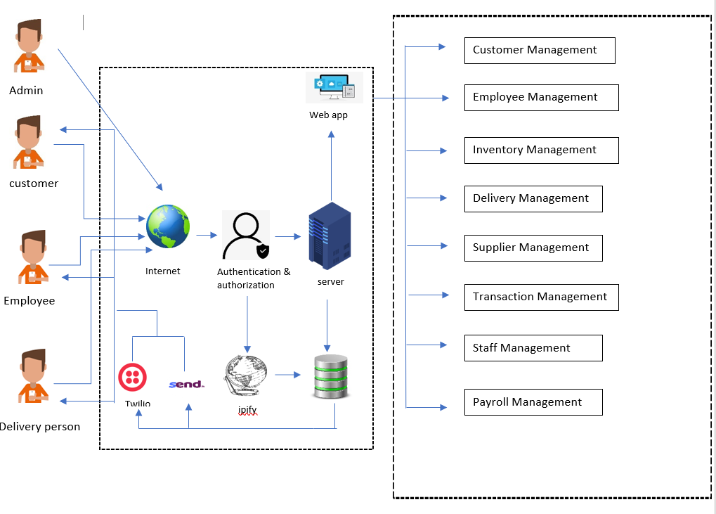

*Fig 0.0 The Above Shows The System overview of DEAN_APPARELS*

## Delivery Management

The delivery management component is developed to deliver stock to the customer, manage delivery and order information, and solve issues. The deliveryman will deliver the goods to the customer, and he can log into the system with a unique account type.

This component is developed based on Deliveryman. Also, the customer can see the bundles they have ordered in the delivery list.

**Functional Requirements**

* **Delivery persons access the system :** After the deliveryman logs into the system, he will see the orders to be delivered today. All the information will be displayed in this list. (Delivery time, Date, Address). He can also view his salary vehicle details and payment information through the profile
* **Location Tracking.(Google map API) :** This task is done by the deliveryman. Through this, the distance to the location to be delivered and the speed at that the vehicle can go to that location is tracked using satellite technology and given to the delivery person.
* **Update the information about the delivery :** The information should be updated after the delivery person has delivered the relevant consignment to the customer. It includes the time, date, and place where the goods were delivered, the name of the person who received them, and the national identity card number.
* **Display the delivery details :** This information is displayed on the delivery manager’s dashboard. He can see the orders delivered today and the orders to be delivered. This information is regularly updated by the delivery persons. And the customer can also see the delivery list through his profile. He can see it by using the search box and filtering it.
* **Generate report using delivery details :** The data displayed above should be downloadable separately as a report(Daily and Monthly). These can be analyzed and problems that arise can be resolved.

**Non-Functional Requirements**

* **Reliability :**The delivery management component rests entirely on data. Therefore, customers’ IDs, names, and addresses should be secured. Also, delays or downtime can impact delivery schedules and customer satisfaction.
* **Performance :**The delivery management system must be designed to perform efficiently and quickly, with fast response times and minimal delays. The system should be able to handle high volumes of requests and transactions without slowing down or crashing and should provide real-time updates on the delivery status and driver locations
* **Scalability :** As the delivery management system grows and expands, it must be able to handle increasing volumes of orders, drivers, and customers. The system should be designed to scale up or down as needed to meet changing demands, without impacting its performance or functionality.

**Technical Requirements**

* **GPS tracking :** The delivery management system must be able to use GPS technology to track the location of delivery vehicles and provide real-time updates on delivery status. The system should be able to display driver locations on a map, calculate estimated arrival times, and adjust delivery routes based on traffic conditions and other factors.
* **QR Code Scanners** : QR codes can be printed on packages to uniquely identify them and link them to specific delivery orders. Delivery drivers can use a QR code scanner to quickly and accurately identify the correct package to deliver, reducing the risk of errors or mis deliveries.
* **Mobile optimization** :The delivery management system should be optimized for use on mobile devices such as smartphones and tablets, as many delivery drivers use these devices to manage their deliveries. The system should be able to support multiple platforms and screen sizes, with a responsive design that adapts to different devices and orientations.

## Employee Management

Requirements for an employee management system typically fall into three categories: functional requirements, non-functional requirements, and technical requirements.

**Functional Requirements**

The functional requirements of an employee management system describe the necessary features and functionalities required to meet user needs. These requirements cover areas such as employee information management, time tracking, performance management, payroll, and training management.

* **Employee onboarding and offboarding processes:** The system should allow HR to easily add and remove employees from the system.
* **Employee information management:** The system should be able to store and manage all employee information such as personal details, job title, salary, and employment history. And also employees can update the their profile and view paysheets as well.
* **Time and attendance tracking:** The system should allow employees to clock in and out, track their hours worked, and manage their time off. The system provide the punch process for marking attendance and calculate the work hours. Furthermore , can apply for leave.
* **Performance management:** The system should provide tools for managing employee performance, including setting goals, tracking progress, and providing feedback.
* **Training and development management:** The system should provide tools for managing employee training and development, including scheduling and tracking employee progress and assigning permanent IDs after trained.
* **Reporting and analytics:** The system should provide robust reporting and analytics capabilities to enable data-driven decision-making by HR managers. And also employees can providing there suggestions and reporting.

**Non-Functional Requirements**

* **Usability**: Usability refers to how easy it is for users to use and navigate the employee management system. The system should be intuitive and user-friendly, with a simple interface that requires minimal training.
* **Reliability**: Reliability refers to how available and responsive the system is at all times. The system should be up and running 24/7, with minimal downtime or disruptions. It should be able to handle high volumes of traffic and usage without compromising performance.
* **Security**: Security refers to how well the system is protected against unauthorized access and data breaches. The system should have strong encryption and multi-factor authentication to ensure that employee data is secure.
* **Maintainability**: Maintainability refers to how easy it is to maintain and update the system over time. The system should be designed with a modular and extensible architecture, allowing updates and changes to be made without affecting the rest of the system.

**Technical Requirements**

* **Platform**: The platform requirement refers to the underlying technology platform that the employee management system should be built on. The system should be built on a platform that is scalable, flexible, and secure, such as a cloud-based platform or a container-based platform..
* **DBMS :** The database requirement refers to the type of database management system (DBMS) that the employee management system should use. The system should use a database that is scalable, secure, and reliable, such as a relational database management system (RDBMS).

## Inventory Management

**Functional Requirements**

* **Inventory Tracking: -** Real-time tracking of inventory levels must be performed with inventory management system. Tracking incoming and exiting inventory as well as the present stock levels for each product is part of this. This is crucial to guarantee that the company has the inventory required to satisfy client demand.
* **User management: -** In order to control access to various features and functions based on user permissions and roles, the system should include user management features. For the protection of data security and preservation of system integrity, this is crucial.
* **Integration: -** To simplify procedures and improve productivity, the inventory management system should be able to interact with other systems, such as delivery management and transaction management systems.
* **Analytics and Reporting: -** Reports and analytics on inventory levels, order history, and other important parameters must be produced by the system. As a result, the company will be able to spot trends and decide on inventory management with knowledge.

**Non-Functional Requirements**

* **Real time Performance: -** To be able to handle the amount of data it should process. an inventory management system needs to operate at an excellent level. This means that it must be able to process data in real-time, respond to requests from administrators and personnel without latency, and support multiple concurrent users without experiencing any lag.
* **Accuracy: -** an inventory management system must be able to function without errors or system breakdowns in order to be considered dependable. This can be accomplished by placing in place backup and recovery procedures in the case of a failure, as well as rigorous testing and quality assurance processes.

**Technical Requirements**

* **Barcode reader: -** A system for managing inventories must include this function. To manage stock movements and ensure accurate inventory counts, the system requires to include barcode scanning. Furthermore, barcode scanning can aid to expedite picking, lower error rates, and boost production.
* **Bill Counter: -** the usage bill counter is an essential feature in an inventory management system that helps businesses to manage their inventory levels effectively and efficiently.

**Functional Requirements**

* Add new vendors to the system.
* Update the data on current suppliers and delete them if the company doesn't purchase raw materials from them.
* Find the suppliers using the supplied supplier ID or supplier name.
* Create supplier directories with important details and a list of the products offered by each provider.
* Enter the Good Reciept Note To the Sytem

**Non-Functional Requirements**

* Suppliers should be reachable by employees, and ordering should be simple.
* The Sytem Should Be Available For Any Supplier.

## Supplier Management

**Functional Requirements**

* **Purchase order management :** Raw material and accessory buy orders, as well as workflows for order approval and tracking, should be able to be created and managed by the system.
* **Quality control** : The system should be able to perform quality control checks on supplies of raw materials and accessories, as well as inspection processes and supplier quality ratings.
* **Reporting and analytics** : he system should offer capabilities for reporting and analytics that give insights into supplier performance, prices, and risks as well as openings for cost- and time-saving optimization.

**Non-Functional Requirements**

* **Performance :** The supplier management system should be designed to ensure high performance, reliability, and availability. The system should be able to handle large amounts of data and transactions without slowing down or crashing.
* **Security :** The supplier management system should be designed with strict security measures to prevent unauthorized access, data breaches, and theft. The system should also ensure data confidentiality, integrity, and availability.
* **Scalability :** The system should be able to handle an increasing number of suppliers and transactions without compromising its performance and security.

**Technical Requirments**

* Laptop
* Printer
* Barcode reader

## Staff Management

**Functional Requirements**

* **Create and manage staff schedules** : The system ought to be able to browse and control plans. Schedules should be able to be changed, removed, and copied using the system. Any time a staff member's timetable is changed, the system should let them know.
* **Ability to track staff attendance and absences :** Ability to track staff attendance and absences.
* **Ability to view and update staff information, such as contact details and job titles :** Users with the proper permissions should be able to view and edit staff information in the system, and that information should include contact information like phone numbers, email addresses, and work titles.

**Non-Functional Requirements**

* **Performance :** The ability of a system to achieve specific performance standards or objectives, such as reaction time, throughput, or scalability, is referred to as performance, which is a non-functional requirement
* **Security :** How well the system is guarded against unauthorized entry and data breaches is referred to as security. To guarantee that employee data is safe, the system should have strong encryption and multi-factor authentication.

**Technical Requirments**

* **Database :** The Staff management system should use a particular form of database management system, according to the database requirement. A relational database management system, for example, should be used because it is scalable, private, and reliable.
* **Fingerprint Reader :**  A scanner used to identify a person's fingerprint for security purposes. After a sample is taken, access to a computer or other system is granted if the fingerprint matches the stored sample.

## Transaction Management

**Functional Requirement**

* **Payment Processing :** Payments should be processed by the system using a variety of payment mechanisms, including credit/debit cards.
* **Transaction Reporting :** The system ought to be able to produce reports on transactional operations, including the volume, frequency, kind, and status of transactions.
* **Transaction monitoring :** The system should allow employees to clock in and out, track their hours worked, and manage their time off. The system provide the punch process for marking attendance and calculate the work hours. Furthermore , can apply for leave.

**Non-Functional Requirements**

* **Maintainability:** Maintainability refers to how easy it is to maintain and update the system over time. The system should be designed with a modular and extensible architecture, allowing updates and changes to be made without affecting the rest of the system.
* **Security:** All transactions ought to be secure and shielded from unauthorized access, according to the system. To prevent unwanted access to the system, transactions should be encrypted, and suitable authentication and authorization methods should be in place.
* **Reliability:** The system must be dependable and offer assurances that transactions are handled properly. To enable traceability and error analysis, the system must be able to recover from errors and offer means for auditing and logging transactions.
* **Performance :** Software systems that involve transactions, such banking systems, e-commerce platforms, and database applications, must carefully handle their transactions. The following are examples of non-functional transaction management requirements

**Technical Requirments**

* **Money Detector :** Sometimes known to be the currency validator due to the bulk amount of transactions are done the company could use this type of gadgets in order to secure there Payments based criteria.

## PayRoll Management

**Functional Requirments**

* **Payroll Processing :** Payroll should be calculated by the system using information such as employee pay rate, hours worked, and other pertinent details. Along with handling deductions, taxes, and other payroll-related tasks, it should.
* **Time and Attendance :** The system should have the ability to track employee time and attendance, including clock-in and clock-out times, vacation and sick time, and any other time-off requests.
* **Report generating :** To assist the user in tracking payroll costs, employee hours, taxes, and other pertinent metrics, the system should offer a variety of reports.
* **Security and Access Control :** To protect sensitive employee data and guarantee that only authorized personnel can access the system, the system should have strong security features.

**Non-Functional Requirments**

* **Scalability:** The system must be able to handle both the rising employee population and the growing complexity of payroll calculations.
* **Usability :**The interface must be simple to use, with clear instructions and error messages.
* **Reliability :** The system should be able to recover from failures without losing data, be available around-the-clock, and have backup and recovery procedures in place.
* **Maintainability :**The system should be simple to update, maintain, and change to meet evolving business requirements.

**Technical Requirments**

* **Finger Print Scanner :** The steps that must be taken in relation to the attendance recording and, consequently, the salary computations, are outlined.
* **Printer:** The salary slip will be produced using the E-bill format, and a carbon duplicate will also be produced based solely on the employee's needs.

## Customer Management

The customer data and interactions are tracked by a customer management system at the apparel manufacturer DEAN APPARELS. Workers should be able to enter, edit, and examine customer information in the database and maintain track of orders, preferences, and previous purchases made by customers. Resources for addressing customer inquiries, complaints, and suggestions must also be included. Finally, the customer management system should enable DEAN APPARELS to provide its customers with a tailored and efficient service.

According to the analysis, the set of requirements is pointed out below.

**Functional Requirments**

Functional requirements outline the precise features and capabilities that Dean Apparels' customer management system must have in order to satisfy the needs of its users. These responsibilities frequently include things like managing customer information, processing orders, tracking deliveries, providing customer service, and managing Inqueries and many more. The system should, for instance, be able to manage and retain all client information, process orders quickly, monitor customer progress, offer tools for managing customer assistance, and enable efficient customer management.

* **Customer Profile Handling :** Information about the customer, including name, contact information, addresses, purchase history, preferences and etc… should be able to be stored and managed by the system.
* **Take actions for Customer inqueries and FeedBacks :** The system should include tools for keeping track of customer support requests and quickly and effectively addressing problems. This might have functions like a help desk and customer feedback management.
* **Manipulating a Customer :** As a result, the system should be able to activate and deactivate customers who break business rules, regulations, and agreements.
* **Steady Communication With the Customer :** The system should include features for contacting customers by phone, email, social media, and other means. This involves disseminating specialized messaging, sales pitches, and transactional updates.
* **Generate Reports :** It should be able to provide reports using reliable and accepted data to make decision-making simple ( ex sould e able to generate monthly customer survillince based reports)
* **Live Analytics :** The system should provide a function that allows real-time data to be anticipated using graphs or charts.

**Non-Functional Requirments**

For a customer management system, non-functional requirements are those that discuss the features or qualities of the system rather than the particular tasks it completes. Non-functional needs for a customer management system could, for instance, be

* **Scalability:** The system should be scalable, able to handle a growing number of users and data over time without sacrificing performance or reliability.
* **Portability :** Cross-platform functionality: The system must be able to function on different operating systems and hardware, including Windows, macOS, Linux, and mobile devices.
* **Usability :** Systems must have high usability, with a user-friendly interface and intuitive navigation, to enable quick access to information. This promotes user adoption and satisfaction, regardless of technical competence.
* **Scalability :** Make sure the system is scalable in order to account for future expansion and shifting business requirements.

**Technical Requirments**

The technical requirements needed to support the customer management system are also quite low because it is a reasonably simple component in comparison to other modules of the ERP system. Yet, a trustworthy and secure foundation should still be used to build the system.

* **Printers :** These technical requirements ensure that the customer management system can efficiently and effectively generate reports for analysis and decision-making purposes.

# Literature Review

**Existing Solution**

When identifying similar existing solutions for the client's problem, it is important to consider both off-the-shelf software solutions and custom-built systems. In the case of apparel management systems, there are several software solutions available in the market, including Oracle ERP Cloud, SAP S/4HANA could be figured out as examples.

The German software company SAP SE created SAP S/4HANA, an ERP software program. It is intended to deliver real-time insights into a company's activities while also streamlining and simplifying business procedures. The application's in-memory computing platform, SAP HANA, enables faster processing of massive data sets, enhancing performance and accelerating transaction processing.[1]

* **Advantages**
  + **Intergrations :** simple to interface with other systems, such as supply chain management (SCM) and customer relationship management (CRM) systems. This enables businesses to acquire a thorough picture of their operations and make better decisions.
  + **Real-time insights :** The ability to offer real-time insights into business operations is one of SAP S/4HANA's primary features. As a result, businesses are able to make wise choices and react rapidly to shifting market conditions.
  + **Streamlined processes:** Many tools and capabilities provided by SAP S/4HANA can assist businesses in streamlining their operations and lowering inefficiencies. For instance, the system has automation features that can do away with manual chores and lower the possibility of mistakes.
* **Disadvantages**
  + **High training costs:** Especially for smaller businesses with tighter budgets, training staff members to utilize SAP S/4HANA can be time-consuming and expensive.
  + **High resource usage:** SAP S/4HANA uses a lot of computational power, which might be difficult for smaller businesses with tight IT budgets.
  + **Restricted adaptability:** Because SAP S/4HANA is a highly organized system, the organization's ability to adjust to shifting business requirements may be constrained.
  + **Implementation procedure is difficult and time-consuming:** The configuration and customization of SAP S/4HANA to fit the unique demands of the organization requires a significant amount of time and money.
  + **High implementation costs:** Due to the price of hardware, software licenses, and consulting fees, implementing SAP S/4HANA can be costly.

Furthermore, with the help of Oracle ERP Cloud, a comprehensive solution for a variety of modules available such as financials, procurement, inventory, supply chain, and manufacturing management ,The technology is highly adaptable and may be tailored to satisfy the particular requirements of clothing producers. The fact that Oracle ERP Cloud is created on a cutting-edge, cloud-based platform that enables simple integration with other cloud services is one of its benefits. However, the system can be difficult to set up and manage, and its implementation could call for a substantial amount of resources and knowledge.

Lets Peek into some several advantages and disadvantages.

* **Disadvantages**
  + **Limited customization options:** Oracle ERP Cloud provides little customization options, and any modifications made to the software may prevent it from receiving future updates (Oracle, n.d.). Organizations that demand a high level of customization to match their unique business needs may face difficulties as a result of this.
  + **Limited reporting capabilities :** The reporting capabilities of Oracle ERP Cloud may not be sufficient for organizations with complex reporting needs. This can result in the need for additional software or customization, which can increase costs and complexity (Gartner, 2021).[2]
  + **Complex user interface:** Because of its intricate user interface, Oracle ERP Cloud might present novice users with a challenging learning curve (Gartner, 2021). This may have an effect on production and raise the cost of subsequent training.[3]
  + **High implementation costs :** Oracle ERP Cloud is known to have high implementation costs, which may not be feasible for small businesses with limited budgets. In addition, the ongoing maintenance costs can also be significant (Boersma, 2021).[4]
  + **Integration challenges:** While Oracle ERP Cloud is designed to integrate with other Oracle products, it may not be compatible with other third-party applications. This can result in additional time and costs spent on integration efforts, as well as potential data inconsistencies (Boersma, 2021).[5]
* **Advantages**
  + **Improved collaboration:** Businesses can operate more productively and efficiently thanks to Oracle ERP Cloud, which enables real-time collaboration across teams, departments, and locations.
  + **Advanced automation:** Advanced automation is used by Oracle ERP Cloud to automate operations and minimize human involvement. As a result, processing times are sped up, errors are decreased, and efficiency is raised.

While these existing systems offer some benefits for apparel manufacturers, they may not fully address the specific needs and challenges faced by the client. For example, the client may require customized workflows and reporting features that are not available in **Commercal-off-the-shelf** ERP solutions. Additionally, the client may have unique business processes that are not supported by existing systems.

So, it is necessary to develop a new system that is tailored to the client's specific needs and requirements. This new system can be designed to address the client's specific pain points, and can be more efficient and cost-effective than using an off-the-shelf ERP solution that requires extensive customization. Additionally, a custom-built system can offer greater flexibility and scalability, allowing the client to adapt to changing business needs and market trends over time.

Therefore by understanding the above-mentioned points, a custom-designed web portal would be beneficial. Since it is targeted solely at the client, there would be minimum performance issues. Although the initial cost of purchasing the web portal is expensive, there are no monthly payments for renewal, except for minor upgrades. Moreover, since it is web-based, the portal becomes cross-platform, where users can access it even using a smartphone. This improves the reliability as well.

# Methodology

* **Requirements engineering methods :**
  + **Feasibility Study :** This assesses the viability of a proposed plan or project. A feasibility study evaluates a project's viability to determine its likelihood of success.
  + 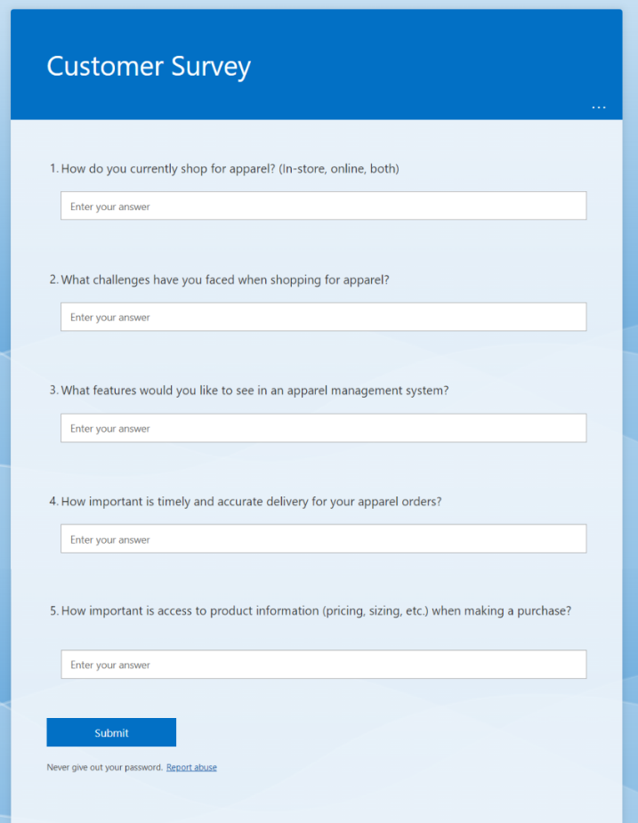**Interviews with stakeholders :** With this method, stakeholders are interviewed in-person or virtually to learn about their requirements, expectations, and concerns. Users, clients, managers, subject-matter experts, and other pertinent people can all be stakeholders.
  + **Prototyping :** To get input from stakeholders, a simplified version of the system or a component of the system is created as a prototype. This method can be used to verify requirements, evaluate usability, and spot potential design flaws.
  + **Surveys :** Surveys are a common way to get input from many different stakeholders. In-person, email, and internet methods can all be used to conduct surveys, which can be made to collect quantitative or qualitative data. *Fig 1.1 Delivery_Surveys***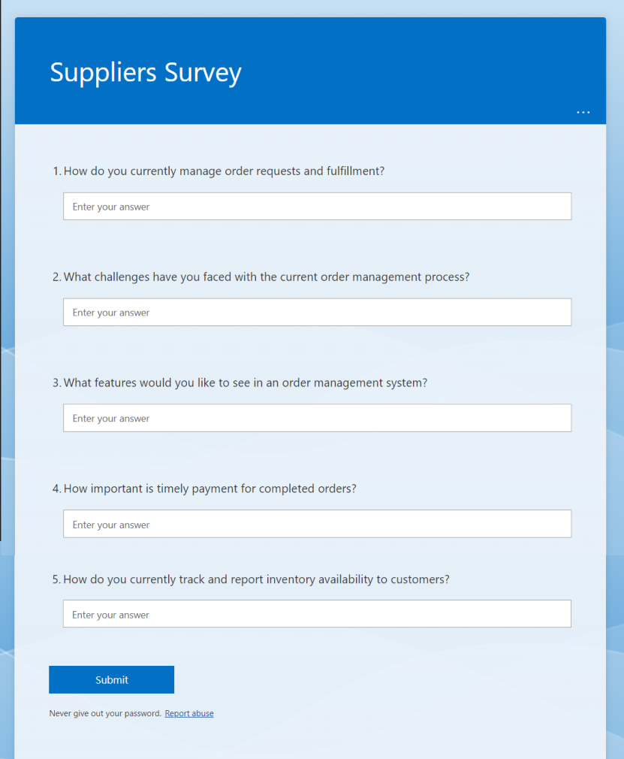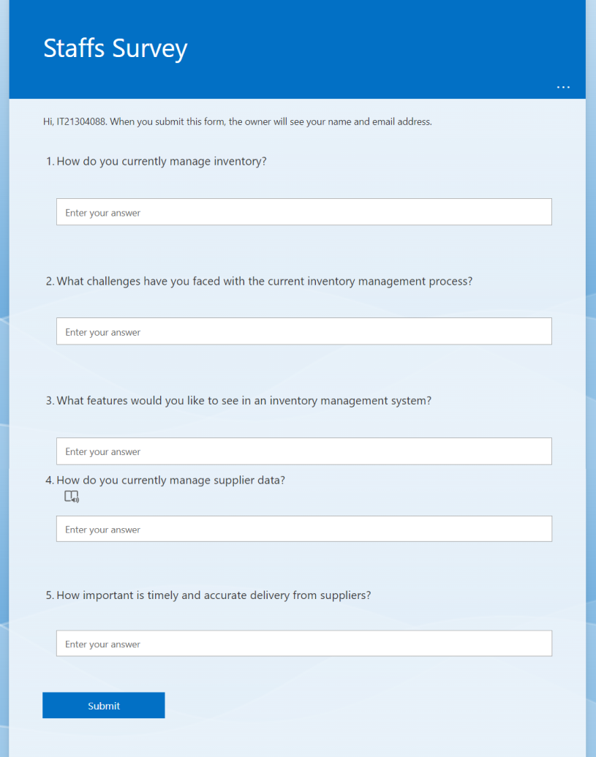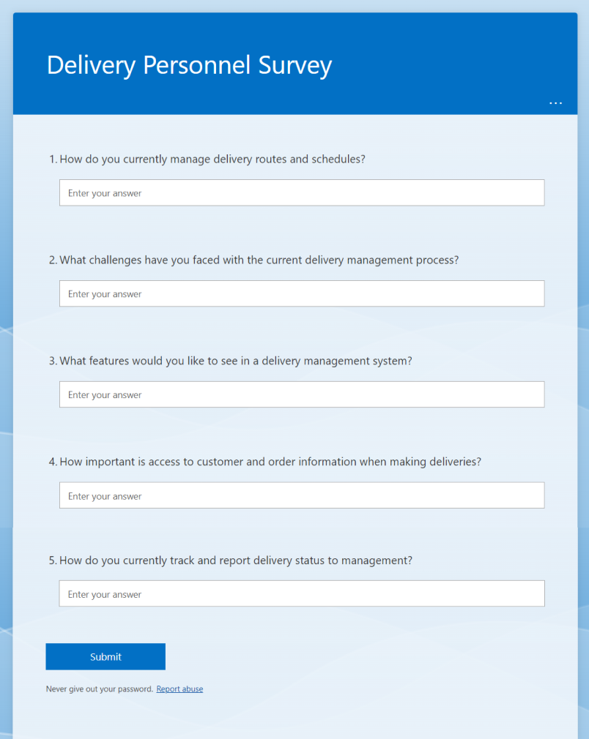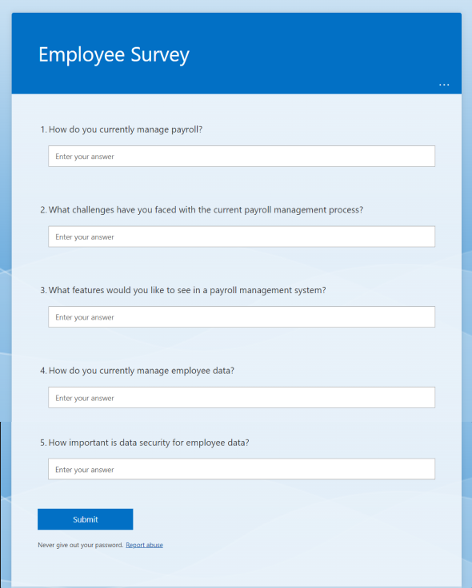** *Fig 1.2 Employee_Surveys Fig 1.3 staff_Surveys*

*Fig 1.4 Supplier_Surveys*

*Fig 1.5 Supplier_Surveys*

* **Design Methods :**
  + **Use Case Designs :** A method for capturing a system's functional needs from the viewpoint of its users is use case modeling. Use cases are examples of scenarios that show how users interact with a system to accomplish particular objectives. Identifying the actors (users or external systems), their objectives, and the processes they take to get there requires use case modeling. Use cases offer a means of explaining a system's requirements in terms that stakeholders can comprehend and can be employed to direct system design and development.
  + **Object-oriented design :** this is a programming paradigm founded on the idea that objects are instances of classes. In OOD, the system is modeled as a group of communicative objects working together to carry out tasks. The goal of object-oriented design is to create systems that are modular, expandable, and manageable by identifying the objects, their attributes, and their relationships.
  + **Unified Modeling Language (UML):** UML is a common notation for representing software systems. UML diagrams offer a graphic depiction of several system characteristics, including a system's structure, behavior, and interconnections.
    - Class diagrams, which show how classes interact with one another in a system,
    - use case diagrams, which show how actors interact with a system's use cases,
    - sequence diagrams, which show how objects interact over time,

and many more types of diagrams are all included in UML.

* **Testing Methods:**

The performance, dependability, and quality of software applications are all supported by testing, which is a crucial component of software development. Testing comes in a variety of forms, each with its own goals and objectives, such as unit testing, integration testing, system testing, and acceptance testing.

* + **Unit testing :** form of testing that concentrates on testing specific software program parts or pieces. It involves testing code at a low level, such as specific functions or procedures, and is often done by developers. Early error detection and correction are the objectives of unit testing.[6]
  + **Integration testing :** focused testing that examines how several software application modules or components function together. It usually takes place after unit testing and entails examining how well various system parts integrate with one another. Integrity testing aims to locate and correct faults brought on by the interaction of various components.[7]
  + **Acceptance testing :** examines a software program from the viewpoint of the end user. It usually follows system testing and entails putting the system to the test in a real-world setting to make sure it satisfies the user's requirements and expectations.[8]
  + **System testing :** testing that examines the system as a whole. It usually follows integration testing and involves putting the system through its paces in various settings. System testing's objective is to verify that the software program complies with specifications and operates as expected.[9]
* **Development Tools and Technologies:**
  + **Eclipse IDE:** Java, C++, and Python are just a few of the programming languages that may be used in Eclipse, an open-source integrated development environment (IDE) for creating software applications. Code editing, debugging, and deployment tools are only a few of the many functions and plugins offered by Eclipse. Enterprise apps, web applications, and mobile applications are all frequently created using it.[10]
  + **Figma :** As a potent cloud-based substitute for Sketch and Adobe X.D tools, Figma stands out. The best thing is that it offers a range of capabilities that work well whether you're a lone designer or part of a larger team, with no restrictions on free users. FIGJAM, an online whiteboard that works with Figma, might be used to generate ideas and map user flows. [11]
  + **GIT :** Git is a distributed version control system designed to efficiently and swiftly manage projects of all sizes. It is free and open source. Git is simple to use, takes up little space, and works rapidly. It outperforms SCM products like Subversion, CVS, Perforce, and ClearCase due to features like reasonably priced local branching, useful staging zones, and a variety of procedures. [12]
  + **Jira :** JIRA is a well-liked program for scheduling tasks, keeping track of issues, and managing projects. It was created by Atlassian and is popular in the software development industry, but it can also be used to manage other kinds of projects. JIRA has a number of functionalities, such as:[13]
    - **Agile project management:** With tools like sprint planning, backlog management, and burndown charts, JIRA supports agile approaches like Scrum and Kanban.
    - **Customizable workflows:** Teams can design unique workflows in JIRA to track progress and correspond with their development processes.
  + **Java :** Java is a popular object-oriented programming language for creating web-based business applications as well as mobile apps. Java offers a number of characteristics, such as robustness, platform independence, and intelligent memory management. Large-scale applications including financial systems, e-commerce platforms, and scientific applications are frequently developed using it.[14]
  + **MySQL :** prominent relational database management system (RDBMS) that is open-source and used for data storage and retrieval. It is well-known for its scalability, speed, and dependability and is frequently used in web applications. Data retrieval, integration, analysis, and storage are just a few of the services that MySQL offers.[15]
  + **Apache Tomcat v9.0 :** An open-source web server called Apache Tomcat is used to host and control online applications. Among the advantages it offers are website management, security, performance, and scalability. JavaServer Pages (JSP), Servlets, and WebSockets are only a few of the web programming technologies supported by Tomcat, which is frequently used to host Java-based web applications.[16]
  + **Bootstrap v5.0 :** A well-liked front-end web development framework called Bootstrap 5.0 gives programmers access to a variety of tools and resources for making responsive, mobile-first websites and online applications. It provides a collection of pre-made templates and themes to speed up development as well as a set of CSS classes and JavaScript elements for creating user interfaces and layouts.[17]
  + **JQUERY :** For quick web development, jQuery is a JavaScript library that makes it simple to manipulate HTML documents, handle events, and connect with AJAX. It provides an easy-to-use syntax for choosing and modifying HTML components and makes routine activities like event handling and animation more straightforward.[18]
  + **API’s :** Application Programming Interface is referred to as API. It is a collection of procedures, instruments, and conventions for creating software programs. By offering a standardized method for various systems to connect with one another, APIs make it easier to design software by defining how various software components should interact with one another. APIs can be used to gain access to information, features, or services offered by other programs or systems. They can be accessed by developers through a variety of programming languages and development tools, and they are frequently used to create web applications and mobile applications.[19]
    - **SENDlk :** To communicate with SMS messages, the system includes an API interface.
    - **TWILLIO :** Enaling Voice Call Facilities
    - **Google Email Services :** Newsletter and email clarifications to personnel, clients, and customers
    - **IPIFY** : Ipify API provides a reliable way to retrieve public IP address in various languages. Offers both commercial and non-commercial use plans.[20]
* **Intergration Methods :**

In order for a software system to function as intended, several pieces or components must be combined. This process is known as integration. Version control and continuous integration are two crucial integration techniques in software development.

* **Version Control :** the process of monitoring and controlling source code modifications throughout time. Git and other version control systems (VCS) enable developers to work together on code modifications, track changes over time, and roll back to earlier versions as necessary. Git is a well-liked version control system (VCS) that enables developers to make and merge branches, track code changes, and work with others on code changes.
* **CI/** **Continuous integration :** In software development that entails often, preferably many times per day, integrating code changes into a shared repository. The danger of significant errors or disputes later on is decreased because to this method, which enables developers to identify and fix problems early in the development process. Using systems like Jenkins, Travis CI, or CircleCI, CI entails automating the process of creating, testing, and deploying code changes.
* **CD/** **Continuous Delivery :** a technique used in software development that automatically builds, tests, and deploys code updates to live environments. Software may be developed more rapidly, effectively, and dependably with CD's assistance.
* **Alternative Solutions and Justifications**
* **Alternatives**
* **Requirements engineering:**
* User stories
* Personas
* **Design Methods**:
* Structured design
* Flowcharts
* **Development tools:**
* Visual Studio IDE
* Mongo DB
* C# programming language
* IIS web server
* **Testing:**
* Test-driven development (TDD)
* **Integration:**
* Docker containers
* **Justifications**
  + MongoDB is not strong ACID (Atomic, Consistency, Isolation & Durability) when compared to many other RDBMS systems. In MongoDB, there is no provision for Stored Procedure or functions, so you can't implement any business logic in the database level, which you can do in any RDBMS systems.[21]
  + User personas tend to overemphasize demographic information. What makes this problematic is that it encourages a superficial comprehension of human behavior, which can result in prejudiced preconceptions based on gender, race, age, and economic status.
  + The primary disadvantage of TDD is how quickly development moves forward. While TDD is the best option for creating a high-quality product, it inevitably slows down development until it becomes the team's culture and way of thinking.
  + Although container technologies like Docker have improved in security over time, they are still not impenetrable. They are essentially less secure than VMs since they use host-based code libraries. Hence, malicious software may be able to escape a container and infect the host environment due to Docker vulnerability.

So It could be concluded the chosen techniques, devices, and technologies have been chosen for their efficacy, applicability, and accessibility. Eclipse IDE and Java are popular in the business and have strong support, making them a solid option for development. A widely used open-source database management system with a sizable community, MySQL is a reasonable choice for the project. A popular web server with high traffic capacity, Apache Tomcat is a good fit for the suggested garment management system.

# Gantt Chart

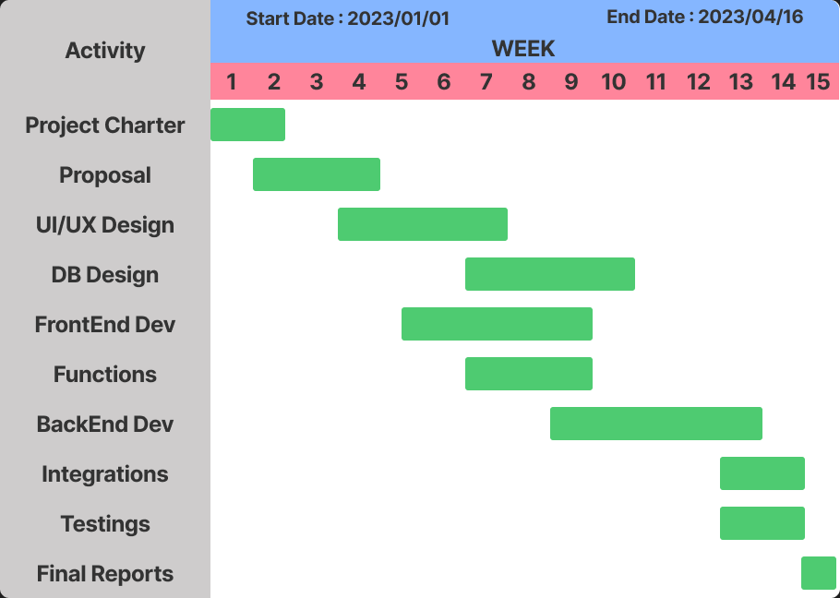

*Fig2.0 Above Illustrates The Gantt Chart Related To The First Initial Realease*

# Evaluation Methods

Assessing a system's efficacy, efficiency, and suitability in achieving its intended goals is part of the evaluation process.Some Main Techniques are

* + **Evaluation Via Expert Analysis**.
    - **Review by specialists:** Software engineering and enterprise resource planning (ERP) system professionals will assess the system. To make sure the system satisfies the client's needs and industry standards, the experts will evaluate the system's design, functionality, and usability.
    - **Expert assessment:** Based on their examination and analysis, the experts will offer their assessment of the system's overall performance and efficacy.
    - **Security testing:** To make sure that user data is shielded from any unwanted access or cyber-attacks, the system will be tested for its security features, including authentication, authorization, and data encryption.
  + **Evaluation Via User Analysis**
    - **Surveys :** Use surveys and interviews to gather user feedback. Users can be given surveys to learn how satisfied they are with the system overall, and users can also be interviewed to learn more detailed comments and insights regarding the system.
    - **Beta Versions :** Release the app's beta version to the market so that evaluation can be done quickly through user interactions.
    - **Monitor System Usage :** To determine how successfully the system is being accepted and used by users, monitor system usage data. Metrics like login frequency, transaction volume, and user engagement may be included in this data. System upgrades and user education can remedy any problems or underutilized regions.

Ultimately, it's crucial to include users in the evaluation process to make sure the system is user-friendly and satisfies their needs. The system can be updated and developed to offer a better user experience and to optimize its overall value to the business by incorporating user feedback and insights.

So it could be concluded that the evaluation procedure aids in locating any problems or potential areas for improvement and offers perceptions on how well the system satisfies user needs. It also enables decisions to be made about whether to keep using the system as is, make changes to it, or completely replace it. Overall, assessing a system is crucial to verifying that it is satisfying user needs and accomplishing its intended objectives.

# References

[1] S. SAP, "SAP S/4HANA," SAP, 2021. [Online]. Available: <https://www.sap.com/products/s4hana-erp.html>.

[2]M. Boersma, "The Pros and Cons of Oracle ERP Cloud," TechTarget, 2021. [Online]. Available: <https://searcherp.techtarget.com/feature/The-pros-and-cons-of-Oracle-ERP-Cloud>.

[3]Gartner, "Oracle ERP Cloud," Gartner Peer Insights, 2021. [Online]. Available: <https://www.gartner.com/reviews/market/cloud-erp-suites/midsize-enterprises/vendor/oracle/product/oracle-erp-cloud>.

[4]Gartner, "Oracle ERP Cloud," Gartner Peer Insights, 2021. [Online]. Available: <https://www.gartner.com/reviews/market/cloud-erp-suites/midsize-enterprises/vendor/oracle/product/oracle-erp-cloud>.

[5]M. Boersma, "The Pros and Cons of Oracle ERP Cloud," TechTarget, 2021. [Online]. Available: <https://searcherp.techtarget.com/feature/The-pros-and-cons-of-Oracle-ERP-Cloud>.

[6]"Unit testing", Guru99. [Online]. Available: <https://www.guru99.com/unit-testing-guide.html>. [Accessed: Feb. 23, 2023].

[7]"Integration testing", SoftwareTestingHelp. [Online]. Available: <https://www.softwaretestinghelp.com/integration-testing-tutorial/>. [Accessed: Feb. 23, 2023].

[8]"System testing", Guru99. [Online]. Available: <https://www.guru99.com/system-testing.html>. [Accessed: Feb. 23, 2023].

[9]"Acceptance testing", Guru99. [Online]. Available: <https://www.guru99.com/acceptance-testing.html>. [Accessed: Feb. 23, 2023].

[10]Eclipse IDE: "Eclipse IDE for Java Developers". Eclipse Foundation. Available at: <https://www.eclipse.org/downloads/packages/release/2021-09/r/eclipse-ide-java-developers>. Accessed on: 2023-02-24.

[11]Figma. (n.d.). Figma: the collaborative interface design tool. Available at: <https://www.figma.com/>

[12]"About Version Control", Git. [Online]. Available: <https://git-scm.com/book/en/v2/Getting-Started-About-Version-Control>. [Accessed: Feb. 23, 2023].

[13]Atlassian. (2022, February 23). Jira | Issue & Project Tracking Software | Atlassian. Available at: <https://www.atlassian.com/software/jira>

[14]Java programming language: Oracle. (2021). Java Programming Language. Available: <https://www.oracle.com/java/>.

[15]MySQL database management system: Oracle. (2021). MySQL :: MySQL Community Downloads. Available: <https://dev.mysql.com/downloads/>.

[16]Apache Tomcat web server: Apache Software Foundation. (2021). Welcome to Apache Tomcat. Available: <https://tomcat.apache.org/>.

[17]Bootstrap. [Online]. Available: <https://getbootstrap.com/docs/5.1/getting-started/introduction/>. [Accessed: Feb. 23, 2023].

[18]jQuery. [Online]. Available: <https://jquery.com/>. [Accessed: Feb. 23, 2023].

[19]"APIs: What they are, and why they matter", Red Hat. [Online]. Available: <https://www.redhat.com/en/topics/api/what-are-application-programming-interfaces>. [Accessed: Feb. 23, 2023].

[20]ipify API Documentation. [Online]. Available: <https://www.ipify.org/>. [Accessed: Feb. 23, 2023].

[21]MongoDB. (2021). MongoDB Download Center. Available at: <https://www.mongodb.com/try/download>. Accessed on: February 23, 2023.

# 