***Personal***

***Statement***

***Professional***

***Portfolio***

***Education***

***BS (SE)***

**K.Mustafa Ahmed Butt**

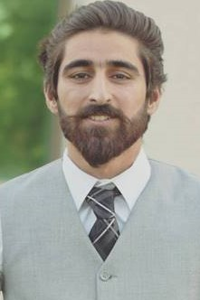

I am a Front-end Developer, CSS Expert & web developer.I've done BS(hons) in computer science and choose the development as my profession. A love of combination of web technology and visual art attract me into web design and front-end development, and I'm always curious to create, to improvise, and to deliver the best design that fits with what user wants and needs.

**Software Engineer**

*My knowledge level in software engineering*

* Communication skills 75%
* Photoshop 80%
* Illustrator 80%
* JavaScript 85%
* HTML & CSS 90%
* Bootstrap 90%

<https://moshe31.github.io/>  
<https://github.com/moshe31/animation-modal>  
<https://dev-work85.github.io/>

<https://github.com/moshe31/Red-planet>

<http://www.ranvijay.me/>

* **Aptech** **2016**

I have done 2 months web development course where i have enhance my skills.

* **COMSATS** **2014-2018**

I have done BS(SE) .

* **Army** **Public** **College** **2012-2014**

I have done my FSC with qualified marks of 783.

* **Army** **Public** **School** **2000-2012**

I have done my SSC with satisfactory marks of 823.

***CNIC***

82102-8419421-7

***Date of Birth***

25/08/1995

***Telephone***

+92-3058600979

***Email***

[moshedev31@gmail.com](mailto:moshedev31@gmail.com)

***Address***

House no 199, street #6 Peshawar road Rawalpindi

Rawalpindi 46000

Pakistan

***TECHNOLOGIES***

***Back End***

.

***Front End***

HTML, CSS, W3.CSS, JavaScript, JQuery, Bootstrap.

***Databases***

SQL Server 2014, MySQL

***Tools***

Adobe Dreamweaver, MYSQL, MS Office, Adobe Photoshop, XAMPP and Brackets. Visual studio code.

­

+