Table of Contents
I. The Aims of Tort Law 1
A. General Stuff 1
B. Overview 2
C. Aims of Tort law and Who Should Pay and Why 2
1. Aims of Tort Law and When We Should Require Fault 3
II. Negligence 3
A. The Objective Reasonable Person Standard 3
B. Who Decides – Judge v Jury: 4
C. Ways of Measuring “Reasonable Person” 4
1. External Standards 4
2. Custom 4
3. BPL (Hand Formula) 4
D. Tailoring the Standard 5
Duty 6
Causation 7
Lost Chance 7
Market Share Liability 7
Strict Liability 7
Property Torts 7
Remedies 8
Compensatory Damages 8
Statutory Damages 8
Punitive Damages 8
Injunctions 8

The Aims of Tort Law

General Policy Points
- We don’t like to punish just for risk creation.
- Tort law may sometimes adapt to changing times- EG custom, evolution of injunction test

Overview

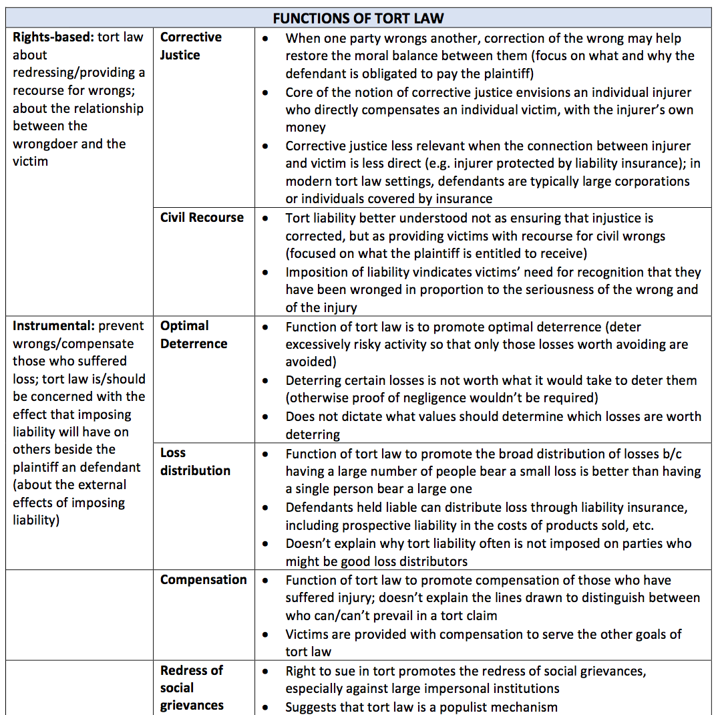

- Tort law might also be a mixed system; which one or combination of these goals is more important will vary given the circumstances

Deciding Who Should Pay Based on Aims of Tort Law (Includes Examples from Cases)

- Deterrence
  - Hammontree:
    - We don’t want to over-deter people who aren’t dangerous drivers.
    - Social implications of discriminating/shutting away people just because they have a disability.
  - Who is in a better position to protect against the risk?
- Corrective justice
    - Argue based on how direct the connection is between P and D. Does D have insurance?
- Fairness
  - Two relatively innocent parties: In cases like Hammontree (epilepsy), both parties are innocent. Does fairness dictate that business owners having more resources than individuals should pay, especially because the seizure was beyond J’s control? Or are resources irrelevant because payment isn’t about who has what?
  - Who is in a better position to protect against the risk?

- Aims of Tort Law and When We Should Require Fault (Strict Liability vs Negligence)

    - Alternate Scheme: New Zealand No Fault System: As long as injury falls within legislative scheme, you are covered regardless of fault or when injury happened
      - Serves Fairness
        - P does not have to suffer for judgment proof defendants
        - City steps in where there are two relatively innocent parties. Neither is unfairly burdened
      - Serves Civil Recourse: Plaintiff’s harm is always recognized, and they are given the right to recover for it
      - Does not serve corrective justice – no moral balance restored between 2 parties
      - Does not serve deterrence either for P or D
      - Goes both ways on administrative costs:
        - Might be more efficient to let accident occur; but city is still giving money
        - Decreases expensive fact findings and trials that go into negligence determination.
    - Hammontree arguments for staying with negligence:
      - Difference from Product Liability Cases, where there is strict liability for manufacturers: Manufacturers are distributing goods to public at large. Not just about insurers bearing cost.
      - Maloney rejected SL where fact patterns can get complicated
      - Overinclusive – Driver might be struck by illness he could not have foreseen because of no prior history. Unfair to impose fault.
      - Legislature should decide.

Negligence

The Objective Reasonable Person Standard

- Objecitvity
Pros of Objectivity | Cons of Objectivity
Cost/East of Adjudication—including mental ability creates line drawing issues/less measurable
Jury doesn’t have to enter D mind; D doesn’t have incentives to mislead jury about characteristics. | Jury already looks at state of mind in criminal cases
Activity Levels: Objective standard influences activity levels and informs society on self- protective care they need to take.
Optimal Deterrence: Incentive for highest care and more uniform care on D’s part, easier for self-protective care on P part. | For Ds to exercise all care and skill they must actually know the standard
Fairness – everyone treated equally. If some exempt, they benefit from higher care of other people without taking care themselves. | Fairness doesn’t always mean treating everyone the same

Who Decides – Judge v Jury:
  - Currently, jury decides what a reasonable person would do.
    - Pros:
      - Reflects community norms.
      - Maybe more appropriate when it is a question of community norms. Jury is more competent to decide that.
        - Eg Vaughn – in early 19th century, jury would probably know how far hay should be kept to avoid fire.
        - Today – equivalent should be whether D took care in changing lanes on 4 lane highway.
      - Can take circumstances into account – Eg did you recklessly change lanes because you were driving your friend to the hospital?
    - Cons/When it may not be a good idea
      - Inconsistency – Different fact patterns and different values might lead juries to go different ways on similar cases. Nothing about negligence requires perfect consistency.
        - When certain fact patterns appear in the same form over and over, and we don’t want juries deciding inconsistently, maybe give it to judge and make it a rule.
          - Counterargument: Can be overinclusive. Circumstances where following the law would be more dangerous; or rule out all the possibilities and show that in all of them, following the rule is more dangerous
            - EG Pokora: 1) He gets out and gets hit by train 2) He gets out, thinks it’s fine, gets back in car and ends up getting hit by train
            - EG things falling out of bins on airplanes.

Ways of Measuring “Reasonable Person”

External Standards

Custom
- Hurts the first sued.
- Discouraging innovation and other opportunities to be safe.

BPL (Hand Formula)
Pro of Using BPL | Cons of Using BPL
Elicits concrete thought on whether a risk is worth taking | Attempts to replace the traditional reasonably prudent person standard with an impersonal, economic standard
Taking worthwhile risks increases social welfare. Optimal deterrence – avoid accidence worth avoiding  How to handle immeasurability: (1) come up with measurable precautions (2) take advantage of immeasurability: whatever it would have cost you, that’s not worth risking someone’s life (3) juries can do anything: they already need to come up with measures for someone’s life/limbs (4) Don’t need to come up with exact numbers: just say something like B is large, P is low | Immeasurability: Unrealistic to think that these factors can be assigned monetary values and compared via a common metric (Human life, value of jobs, etc)
Fairness: we should refrain from creating “unreasonable” risks to others but remains free to create “reasonable” risks  Info Costs can be reduced by selecting specific precautions and comparing it with the defendant’s actual conduct | Information Costs: costs to parties and the court of obtaining reliable information about B, P, and L in any given case inflate administrative costs & error costs, because if reliable information is difficult to obtain, Hand-Formula judgments will often be wrong
For repeat players in tort suits, they probably follow this standard already | But most others (non-repeat players) don’t think this way; especially during emergencies. Infact, D might have tried in good faith to make the right choice.
But tort law requires this anyway (juries determine compensation)  How to handle jury instructions: (1) say “do a cost/benefit analysis” (2) give factors to consider (like those listed in the Restatement) | Commensurability: Requires that we place a dollar value on human safety. Juries tend not to like this cost/benefit analysis  Companies may avoid cost benefit analysis so it doesn’t get into a prosecutor’s hands. (GM ignition switch disaster).
 | Doesn’t take D’s good faith decision into account, nor does it take momentary lapses into account

Tailoring the Standard

Rationales for Current Tailoring/Not Tailoring
- Tailor Children
  - Observable: People have notice they are dealing with a child
  - Corrective Justice More Attenuated: More likely to be covered under parent’s insurance policies
  - Requires line-drawing (17-18)
  - Area for change: Empirical evidence based on different brain function development of boys and girls. Take it into account for kids? For adults?
- Tailor Superior Ability
  - Fairness – Live up to full capacity
  - Optimal Deterrence – highest care possible
  - Counterarguments:
    - Don’t people act on instinct sometimes?
- Tailoring Physical Infirmity
  - Observable
    - Counter: You can classify some illnesses as mental or physical infirmity. Take Ramsbottom’s stroke.
  - Fairness
    - Counter – can cut either way
- No tailoring for Mental infirmity
  - Efficiency: Not observable (contrast physical)
  - Deterrence: Having it as defense can create perverse incentives
  - Counterarguments:
    - Fairness?
    - Severe mental infirmities might be observable
  - Area for Change: Science is changing the way we think about mental infirmity
- No Tailoring for Mental ability
  - Not measurable
  - Perverse incentives for deterrence.

Opportunities for Tailoring:
  - Advanced technology as an argument for lowering a heightened standard back to reasonable care:
    - Ex Bethel – Heightened standard for common carriers –“As far as human prudence and foresight can go”
      - Do we no longer need a heightened standard of care or does ordinary care under the circumstances already account for cases in which heightened care is required?
  - Heighten it for dangerous instrumentality?
    - Straw buying for guns:
      - For:
        - Jury might not know what do with reasonable standard
        - Send message to carriers – They won’t want to lose their license over one sale
        - Informational Asymmetry: Who is better positioned to bear loss?
      - Against:
        - Circumstances might indicate what was reasonable. EX in Bethel the straw buyer was right there and indicated that it was a straw transaction
        - Minimal effect on deterrence: Are you really deterring a small number of bad repeat players, or putting a higher standard on everyone else?

- Emergencies:
  - For:
    - How can jury imagine what is ordinary in extraordinary circumstances.
    - Deterrence and Foeseeability: We don’t foresee emergencies and you can’t really deter in that setting.
    - Fairness – sometimes parties act on instinct.
  - Against:
    - Institutional Competence: jury knows what it’s like to be in an accident…that’s the whole point of sending cases to juries
    - Fairness: Must still apportion liability between two parties
    - Emergencies aren’t entirely unforeseeable
  - Alternative Scheme: Michigan has a best judgment rule as long as the person didn’t create the emergency.

Duty
- Duty to warn – tension between consumer sovereignty and obviously dangerous products (we didn’t really talk about it in class. It was in Abraham)
  - If you want to argue that D didn’t have duty to warn, you want to show that the warning would not have made a difference. One possible way is to show that for the activity considered, consumers always disregard the warning. EG: consumers always remove guard off power tools despite warnings not to do so.
- Informed consent:
  - Reasonable patient standard – Jury decides. Need expert evidence on what risks and benefits are, but not what breach is. Jury decides
  - Reasonable doctor – Industry decides
  - They might converge because physicians give more info out of concern.
- Special Relationship – Psychiatrist and Patient – Tarasoff
  - Arguments against Tarasoff result:
    - Liability is far reaching
    - Confidentiality might be important to treat mentally ill patients in the first place. So actually having a chilling effect on not only the cure, but the profession.

Causation
- But for causation – exposing P to risk is a wrong in itself. We are missing those who are blameworthy. The only reason we don’t recognize that is that it’s impractical -> Ton of suits and those plaintiffs don’t need the money.
- Multiple sufficient causes: Why do we think differently when its 2 tortious actors vs 1 tortious actor + 1 act of god?
  - Moral luck
- Proximate cause – cut off liability later. Duty cuts off liability as a matter of law.
- Eggshell plaintiff rule: Who is in a better position to guard against the risks? The ‘eggshell plaintiff’ might know more about their condition and be in a better position to guard against the risk.
- Maybe alternative liability deals with information asymmetry.

Lost Chance
- Maybe limited to medical cases because less reliable statistical data about probability of harm in other fields
- Without lost chance, arbitrary line drawing – 49% chance before doctor vs 51% chance without doctor
- Difference in lost chance cases – patient carries increased risk of harm forever
- Reason for requiring accompanying death (possibly): giving resources to those who need it most.
- Possible reform: Allow recovery even when patients have over 50% chance of survival

Market Share Liability
- May depart from causation.

Strict Liability
- Not entirely clear that SL🡪 Only activity levels and N 🡪 Only care
- Why we don’t apply SL:
  - Effect on victim incentives
  - Over-deterring socially desirable activities
  - Coordination benefits
  - Blameworthiness
- Maybe first bite rule can extend elsewhere

Property Torts
- Who can best bear the risk
- Why P should pay for private necessity – chose to risk damaging property to save own
- Boomer and Ebay – more standards based; departed from more rules based approaches
  - Maybe want rules for business method patents
- Coase theorem: May want to stick liability to party that can free up bargaining power, either because they are holding out or being strategic.

Remedies

Compensatory Damages
- No pure economic loss – draw lines some other way (contract, but-for causation, even geography) OR maybe you want crushing liability
- Law’s concern that people would be reluctant to participate in socially beneficial activities if they were concerned that liability for an accident extended to its innumerable effects.

Statutory Damages
- Pros: Rule, predictable and everyone gets something
- Con: Inflexible, not in line with aims of tort law, may still be profitable to infringe, claims can stack up

Punitive Damages
- Repeat punitive damages
- By letting jury decide, society decides how much to punish defendants and what harms to recognize.

Injunctions
- Test whether injunction should be awarded for nuisance:
  - In valuing D’s activity to community as a whole, the doctrine doesn’t consider whether P gets the benefit.
  - Doesn’t account for disparity in resources.
- Ebay
  - Rejected bright line rule for awarding injunctions – used 4 part test.
  - Automatic injunction ignores public interest
  - BUT undermines right to exclude from property.

